PUBLICATION AGREEMENT FORM

I, the undersigned,

Name : Wenny Pratiwi

Email address : wennypratiwi962@gmail.com

ABS-Code : 4548

Paper Title : Easy English Teaching in LEE Online Course

Focal Conference : International Conference on English Language teaching,

Literature, and Linguistics (ICOELTICS)

as the corresponding author of the paper submitted to the 5th ICoSI 2021 UMY under the above ABS-Code and Paper Title. I hereby acknowledge and agree that the paper is processed to be published at Journal of Foreign Language Teaching and Learning with the assistance of ICoSI Committee.

Surakarta, September 25th, 2021

Corresponding author

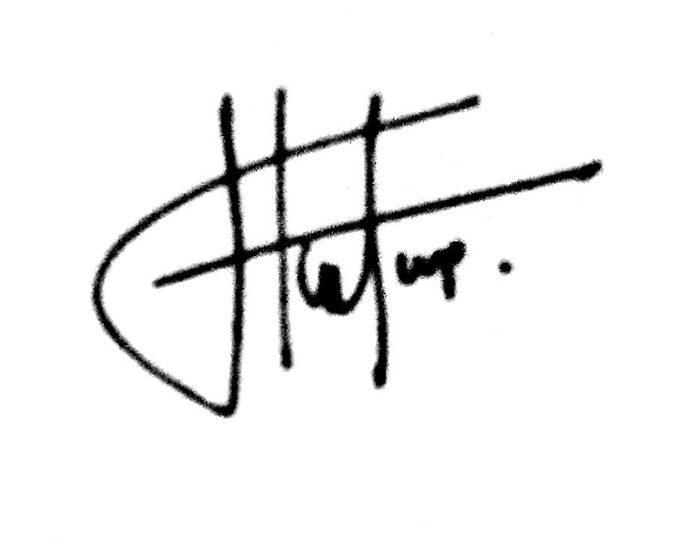

(Wenny Pratiwi)