Acceptance of Abstract

Ref: SIP-2019-PRES-05—003

Dear Taufik, Muazzinah and AI-AdIy Darniyus,
I am pleased to inform you that your abstract entitled “Transparency in Procurement of Goods and Services through E-Procurement at LPSE Banda Aceh City" has been accepted for oral presentation in International Symposium on Indonesian Politics 2019 after peer review by the editorial board. Please note that the conference will
be held on 2 ^{t}h June 2019 at Hotel Grasia-Semarang* and research workshop on 26^{t}h June 201 9 at Universitas Negeri Semarang. You are hereby requested to email your PPT, draft
article and payment proof at seminarpolitikindonesia@mail.unnes.ac.id by 1 U h day
201 9. Participants who can’t ensure their presences at conference venue are allowed to present virtually through video conferencing (Skype).

For future correspondence, use this SIP-2019-PRES-05-003 as reference in email
title. If you have any queries, feel free to contact any of the undersigned accordingly.

INTERHATIONALSY. POS
ON INDONESIAN POLITI 9
Cah o SeMyono
Chairman of International Symposium on Indonesian Politics 201 9
E-mail: cahyo.seftyono@mail.unnes.ac.id

Contact: +62 813-1 016-91 23

*Will be informed later

Invoice No. 05-003
To: Taufik, Muazzinah and AI-AdIy Darniyus

Payment Details

Title account Nugraheni Arumsari
Bank name : Bank Mandiri Account Number : 1350002306130
Date: 22-4-2019

ITEM | FEE
Conference and Workshop Fee | 2.000.000 IDR
Co-Author Fee @5OO.000 IDR | 1.000.000 IDR
Total | 3.000.000 IDR

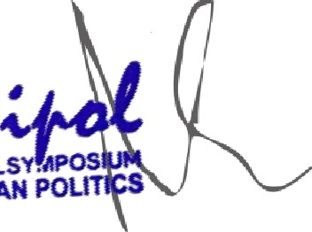
juTERHAVotj ALSY. APO9 of tNOONESlAN POL
Cahyo SeMyono Chairman of International Symposium on Indonesian Politics 201 9
E-mail: cahyo.seftyono@mail.unnes.ac.id Contact: +62 813-1 016-91 23

Kindly email us your payment proof to seminarpolitikindonesia@mail.unnes.ac.id. Kindly indicate your name abstract title when you send us your payment proof which will help us for reference for all further communication.

Note:
Conference fee includes conference kit, conference day lunch, hi-tea and participation certificate. However, conference fee does not include translation assistant, accommodation and transport. The authors are requested to send the payment proof to seminarpolitikindonesia@mail.unnes.ac.id without fail to avoid any confusion at the later stage.

