Tourism Marketing Strategy Of Legenda Tapaktuan Tourist Attraction In South Aceh District, Aceh Province

**Anismar 1, Iskandar Zulkarnain 2, Syukur Kholil3, Suswanta4**

1 Communication Study Program, Universitas Malikussaleh, Lhokseumawe, Aceh, Indonesia

2 Communication Study Program, Universitas Sumatera Utara, Medan, Sumatera Utara, Indonesia

3 Communication Study Program, Universitas Sumatera Utara, Medan, Sumatera Utara, Indonesia

4 Universitas Muhammadiyah, Yogyakarta, Indonesia

**[](http://dx.doi.org/10.18196/jgpp.811338)***Corresponding Author:* [anismar@unimal.ac.id](mailto:anismar@unimal.ac.id)

https://doi.org/10.18196/jgpp.v8i3.11715

|  |  |
| --- | --- |
| **Article Info** |  |
| **Article History;**  **Received:**  xxxx-xx-xx  **Revised:**  xxxx-xx-xx  **Accepted:**  xxxx-xx-xx | **Abstract:** This research aims to identify and generate the marketing strategy in developing the Legenda Tapaktuan tourist attraction which will serve as a reference for various parties in the future. This research uses a descriptive method with a qualitative approach. The study shows that the South Aceh District Tourism Office has tried to promote not only through travelling out of town, but also through online media. To make the Legenda Tapaktuan tourist attraction more advanced, the South Aceh District Government carried out the first promotional strategy, namely advertising, promoting Tour & Travel Online services on a number of social media platforms such as Instagram, Facebook and Twitter. The government also promoting a number of tour packages by participating in expo activities outside the region to introduce and re-promote tourist destinations, especially the Legenda Tapaktuan tourist attraction as an icon of South Aceh. The tourists can simply download the application which provides many features that can be used such as directions, maps, accommodation, and procedures for traveling to the location. This application also provides transportation features which will make it easier for tourists to visit tourist sites. The Tourism Office designed this application to make it easier for tourists to travel independently.  ***Keyword:*** *Marketing Strategy 1; Tourism 2; Legend 3; Tapaktuan 4;* |

# **INTRODUCTION**

Attractive tourist destinations such as beach attractions, cultural and historical sites, and mountainous tourist objects. Tourist destinations in South Aceh Regency are always crowded with visitors from the western and southern regions of the Aceh province, such as Meulaboh, Nagan Raya, Calang, Subulussalam, Blang Pidie and other areas.

According to data from the South Aceh Regency Regional Tourism Development Master Plan (RIPPARDA) 2020-2035 in 2020, tourists who visited tourist objects in Tapaktuan in 2019 totaled 460,749 people; the average visit length was three days, while regional income reached Rp. 2,832,119,887.

In addition to its beautiful natural potential, South Aceh Regency is also known for its rich artistic and cultural works of its people to serve as superior products for Tourism Destinations (DTW) at the National Level. The types of tourist objects in South Aceh Regency, especially in Tapaktuan which are well-known to this day, include marine tourism objects along the Tapaktuan City, waterfalls, cultural sites and historical attractions such as the Legenda Tapaktuan (Tuan Tapa).

In recent years, the development of the Legenda Tapaktuan tourist attraction has begun to develop since the facilities such as: roads, toilets, rice stalls, internet networks, prayer rooms and ATMs are already provided. The Government of South Aceh Regency, in the past few months, has built a tourist pavilion in the Gunung Lampu Area, Gampong Pasar, Tapaktuan Sub-District. The building resembles a corridor that protrudes into the sea for about 20 meters. The building is one of the accesses to make it easier for tourists to visit "Footprints of Tuan Tapa" and to directly enjoy the beauty of the sea in Tapaktuan.

According to (Cristobal-Fransi et al., 2020; Lumbanraja et al., 2019) the attractiveness of tourist destinations is the main motivation for tourists to make visits. The strength of the attraction of all destinations, including natural attractions, is highly dependent on attractions, amenities, accessibility, and marketing. Marketing plays a very important role in tourism because customers need to see, feel or try the product they are going to buy. To be able to value a product one has to travel to the destination.

The potential of the Legenda Tapaktuan tourist attraction, which is very prospective, needs to have the right marketing strategy according to the character of the existing potential tourist attraction. Along with the development of existing tourist objects, there will also be an increase in tourist visits to South Aceh in general.

Marketing needs to be done since people don't know the whereabouts of the destination to be visited. Marketing is also related to a consumer. Every marketing has various combinations of goals (among them, survival, financial, and social), which it wants to realize through product offerings. However, not all possible product alternatives can be produced since it is dependent on the competence and capacity of resources (capital, human resources, raw materials, time, entrepreneurship, and so on). Meanwhile, every consumer has various goals and desires (Neneng Nurmalasari & Masitoh, 2020; Senjaya, 2021; Sulistiyani et al., 2020). Marketing activities are very closely related to business. A successful tourism business has at least four important philosophies, namely (1) having a visitor-guest orientation, (2) having clear analytical procedures and concepts, (3) strategic decisions supported by a strong organizational structure, appropriate and (4) a planning function that integrates with various destination environments (Senjaya, 2021).

All related destinations in a national tourism industry development plan must link the relationship between tourism and other sectors such as environment, health, agriculture, and culture. This linkage needs to be continuously maintained and cannot be left to one party alone. This must be firmly included in the framework of institutional coordination and inter-functional planning (Chan, 2013). The government and destination leaders must consistently place the development of green tourism as a priority issue, both at the national and regional levels (Sultan, 2013).

In a global context, competition in various tourist destinations for international tourists, foreign tour operators and individual tourists present an increasing choice. To face competition, companies or tourism actors must struggle to form a clear identity and image in the international market (Griskevicius et al., 2012).

Customer satisfaction in the tourism industry is strongly influenced by the way and the level of service (hospitality) delivered, and the physical appearance and personality of the business. It is very important that the elements are marketed in the best way possible to convince people to come and enjoy the products offered. Equally important is the ability to generate repeat product purchases. Thus, marketing becomes a way to reach potential markets which is done in an effective way so that a strategy is needed.

**Research Road Map**

The research road map planned by the researchers themselves consists of three stages, which are interrelated. The first stage, related to the potential of the Legenda Tapaktuan tourist attraction. After knowing its potential, the second stage is the marketing stage. The goal is that the existing potential can be known by many tourists to grow tourists' plans to visit the Legenda Tapaktuan tourist attraction. The third stage is making the village a tourist attraction Legenda Tapaktuan namely Panjupian Village, Tapaktuan District, to be used as a tourist village in the future, because with this tourist village, you will get assistance for the development of tourism objects from the Ministry of Tourism and Creative Economy. For more details on the research road map that the researchers conducted can be seen in the image below:

Figure 1

Research Road Map

**Research Road Map**

2021

Potential Tourism Object “Legenda Tapaktuan”

2022

Tourism Object Marketing Strategy “The Legenda Tapaktuan

2023

Making Panjupian Tourism Village

Making a Tourist Destination Area (DTW)

National level

**Research Achievement Targets**

1. Knowing the Potential of Tourism Objects
2. Exploring other tourist objects as a support

3. Future Planning Solutions

1. Creating a Marketing Strategy
2. Knowing the Obstacles

3. Suggestions for Tourists

1. Making an Ideal Tourism Village
2. Input for Tourism Actors
3. Become an Example of Tourism Development

*Source: Researcher Analysis, 2022*

**Marketing Models**

According to (Kotler & Bliemel, 2001; Lo & Tseng, 2021; Mostafavi et al., 2021), a model is a pattern, example, and reference of something that will be made or produced. Marketing is a social and managerial process by which individuals and groups obtain what they want through creating and freely exchanging something of value with others. Marketing is not just how to sell products but must be able to provide satisfaction for consumers in the long term. While the goal of marketing is to identify customer needs and meet those needs properly, so that all products sell themselves.

Furthermore, Kotler explained that tourism marketing emphasizes even more about who the market segment really is and how it behaves, the emphasis is on how to communicate to the market that the product offered (destination) is superior and different from other products. Conventional promotional media cannot always be used for tourism products, especially special interest tourism products. Marketing consists of 7 P, namely product, positioning, price, promotion, place, packaging, partnership. Tourism marketing is a system and coordination that must be carried out as a policy for tourism industry companies or groups, both private and government, within the local, regional, national or international scope in order to achieve tourist satisfaction by obtaining reasonable profits.

Promotion is part of marketing, marketing activities try to spread information, influence/persuade, and/or remind target markets for their products to be willing to accept, buy and be loyal to the products offered by the company concerned (Malikhah, 2019; Prakoso, 2021), while promotion is an effort or company activities in influencing "actual consumers" and "potential consumers" to make purchases of the products offered, now or in the future.

Actual consumers are consumers who directly buy the products offered at the time or immediately after the product promotion is launched, while potential consumers are consumers who are interested in purchasing the products offered by the company in the future. Tjiptono further explained that the purpose of promotion includes four things, namely introducing, persuading, modifying and shaping behavior and reminding about the product and the company concerned. In principle, by introducing or informing consumers of new products, it is hoped that consumers will be influenced and persuaded to switch to these products. The next stage is more about efforts to remind consumers to remain loyal amidst the many old and new competitors.

Promotion will be more effective through the promotion mix, which is an optimal combination of choosing the most effective types of promotional activities in increasing sales. According to (Kotler & Bliemel, 2001; Penrose, 1959)there are five types of promotional activities, including: 1.Advertising (Advertising), which is a form of non-personal promotion using various media aimed at stimulating purchases.2. Face-to-Face Sales (Personal Selling), which is a form of personal promotion with oral presentations in a conversation with prospective buyers aimed at stimulating purchases. 3. Publicity, which is a form of non-personal promotion regarding certain services or business entities by reviewing information/news about products (generally of a scientific nature). Sales Promotion, which is a form of promotion carried out by using marketing personnel who are experts in their fields. Direct Marketing (Direct Marketing), which is a form of personal selling directly intended to influence consumer purchases.

**The Sustainable Value Green Tourism Marketing Model**

Marketing scientists conduct research to find green marketing theories, concepts and practices as an alternative to traditional marketing which has been widely recognized as an exchange process to pursue profits through customer satisfaction, motivated by the desire to realize the ideals of sustainability. Even more so in the tourism industry, where tourism is not only an economic phenomenon, but also a social, cultural, environmental and other natural resource phenomenon. The concept of social marketing (societal marketing concept) introduced by Kotler has not been able to fully provide answers to the challenges of sustainability (sustainability) of tourism itself, because the goals, viewpoints and strategies used for different products (Bastos et al., 2022; Finkler & Higham, 2020; Little et al., 2019).

According to (Jamrozy, 2007), sustainable tourism destination marketing must have a more holistic, broader and more balanced perspective as well as the tourism phenomenon itself, and develop a combination of a system-based approach and a living system-based approach view) in developing a sustainable tourism marketing model (Bellhouse, 2004; Yamada, 2020). Marketing activities to achieve profits through an exchange process that satisfies customer desires are built through a marketing process that prioritizes the sustainability of the living system that takes place in the relevant tourism destination (sustainable living system).

Figure 2

*Suistainable Value Tourism MarketingModel*

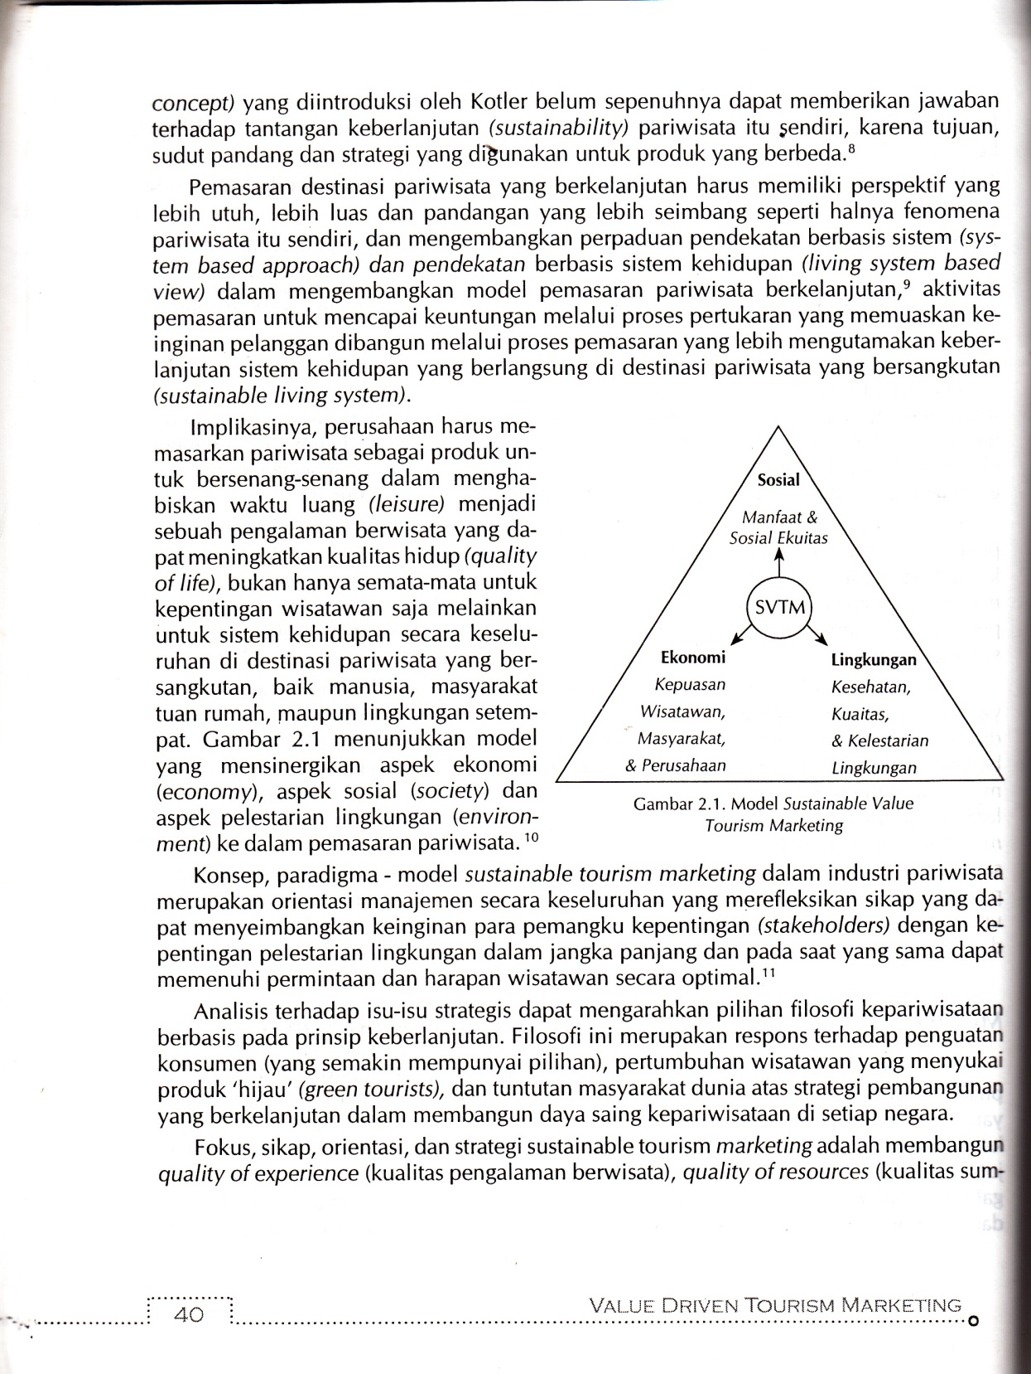

The implication is that companies must market tourism as a product to have fun in spending free time (leisure) into a travel experience that can improve the quality of life (quality of life), not only for the benefit of tourists but for the whole life system in the tourism destinations, both humans, host communities, and the local environment. Figure 2.1 shows a model that synergizes economic, social (society) and environmental (environment) aspects into tourism marketing.

The concept and paradigm-model of sustainable tourism marketing in the tourism industry is an overall management orientation that reflects an attitude that can balance the wishes of stakeholders with the interests of environmental preservation in the long term and at the same time can meet the demands and expectations of tourists optimally (Guo et al., 2019; Santos-Roldán et al., 2020)

**RESEARCH METHOD**

The design in this study is something that is planned about the course of this research from the initial stages to the final stages, for details can be seen in the image below:

Figure 3

Research Flow

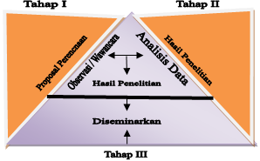

*Source: Researcher Analysis, 2022*

**Data Collection Technique**

The data collection techniques in this study are:

1. Observation. Observation is carried out by making direct observations when people carry out an activity related to this research problem. In its implementation, it refers to several benchmarks, namely:
   1. Observation is based on direct observation, which allows researchers to observe themselves.
   2. Researchers record behaviors and activities that occur in real situations.
   3. Researchers record events in situations related to knowledge related to the data needed.
2. Documentation. Expected data documentation through a documentation approach can be reflected through notes or written materials related to the case under study, whether related to individuals, groups or related agencies.
3. Interviews. The interviews were carried out in an informal and open manner. Informal interviews, aimed at creating a relationship between the interviewer and the informant, in an ordinary, free and reasonable atmosphere. Open interviews are intended to reduce the variations that occur between informants, so as to reduce the possibility of bias.

For the District Government, the researcher wants to explore the extent of the tourism marketing strategy program that has been implemented so far, and what obstacles are faced in tourism development in South Aceh District in general, as well as how to plan tourism programs in the future. This research is also an attempt in designing the right *Legenda Tapaktuan* tourism marketing strategy. The types of data needed in this study are:

1. Primary data, including the response of the government, community and related parties to the tourism marketing program that has been running so far, as well as observations related to the implementation of marketing on the *Legenda Tapaktuan* tourist attraction.
2. Secondary data, namely data obtained from government agencies or institutions related to this research. Secondary data can be in the form of research results, documents and books related to the required data. This secondary data collection was carried out before or simultaneously with the field study. This is intended to accelerate understanding of field conditions and what information must be collected.

Sources of data according to Lofland in (Moleong, 2017, 2019), states that qualitative research is words and actions. So data is obtained from data sources that can provide information, both humans (informants) about the world of tourism or situations observed in research. The key informants who became sources in this study were: Head of the South Aceh Tourism Office, South Aceh Ulema Consultative Council (MPU), Chair of the South Aceh Regional Planning Agency (Bappeda), domestic tourists, religious leaders in South Aceh, tourism services provider in South Aceh District.

Table 1

Informant matrix

|  |  |  |
| --- | --- | --- |
| No | Institution | Position |
| 1  2  3  4  5 | Bappeda, Aceh Selatan Regency  Tourism Office, Aceh Selatan Regency  Ulema Consultative Council (MPU)  Domestic Tourists/International Tourists  Tourism Services Provider | Head  Head  Head  -  Head |

*Source: Researcher Analysis, 2022*

**Data Analysis**

Data analysis in this study was carried out in an inductive descriptive manner. Data is analyzed in direct form continuously, by grouping data according to the research problem. Furthermore, all data were analyzed based on research results obtained in the field through observation, documentation and interviews with all research target informants. For more details in analyzing the results of this study can be seen in the image of the stages of analysis below:

Figure 4.

Picture of Data Analysis Stages

n

Observation

Documentation

Interview

Data Analysis

*Source: Researcher Analysis, 2022*

**RESULT AND DICUSSION**

The legendary tourist attraction of Tapaktuan is located in Tapaktuan District, and the capital city of South Aceh Regency is not only known as a city with natural charm but is also known for its history, culture and religion. From the history of the city of Tapaktuan, it is associated with the Legend of the Dragon Princess and Tuan Tapa, which has become folklore for generations. This history is the basis for Tapaktuan being known as Dragon City. Evidence of the *Legenda Tapaktuan* is a favorite tourist destination for tourists from various regions.

Geographically, South Aceh District is located at the coordinates of 020 22' 36"-040-06' North Latitude (LU) 960 35'340" East Longitude (BT) with an area of 3,841.60 km2. The boundaries of the South Aceh Regency Regency include: to the east which is bordered by Southeast Aceh district, to the west by the Indian Ocean, to the north by Southwest Aceh district, and to the south by Subulussalam Municipality, (South Aceh in figures: 2018).

Geographically, South Aceh District consists of 16 Districts, 43 *Mukim*, and 247 Villages (Gampong) with a population growth rate of 2,968 people or 10.0% per year. The topography of the South Aceh Regency area has a height of 500 m above sea level. South Aceh District is an area with a wet tropical climate with an average rainfall ranging from 2,861 mm – 4,245 mm. January to August is the dry season and September to December is the rainy season with temperatures in South Aceh District 26-31 oC.

The topographical conditions of South Aceh District vary greatly, consisting of lowlands, undulating, hilly, to mountainous. The area of South Aceh Regency is 4,173.82 km2 which stretches from north to south. Central Kluet District is the district with the largest area in South Aceh, namely 801.08 km2. While the area of the smallest sub-district is Labuhanhaji sub-district 54.83 km2.

**Economic Conditions**

The majority of Tapaktuan people rely on the government agency sector. Agricultural and plantation products that are quite prominent in the Tapaktuan area are nutmeg. Nutmeg grows well in Tapaktuan. Nutmeg is very much cultivated by the Tapaktuan people in various ways such as making sweets or nutmeg cakes, nutmeg syrup, and others. For more details shown in the following pie chart:

Figure 5

Percentage of Population by Field of Business 2017

Source: South Aceh BPS data 2018

According to (Hayes, 2013), the majority of the people of Tapaktuan city are inhabited by the Aneuk Jamee tribe. The name Aneuk Jamee (Acehnese) means "newcomer". This name is used to describe the Minang people originating from Lubuk Attitudeing, Pariaman, Rao, and Pasaman who started migrating to the area in the 17th century. Gradually, they assimilated with the Acehnese in the area. The process of assimilation was facilitated by common Islamic beliefs. However, in the end they felt that they were neither Acehnese nor Minangkabau, but a new society that had its own culture and language. While in South Aceh District in general, many Aneuk Jamee tribes also live in Samadua District, North Kleut District, South Kluet and Labuhan Haji District.

The illustration of the Tapak Tuan Legend tourist attraction can be seen in the following image:

Figure 6

Illustration of the *Legenda Tapaktuan*

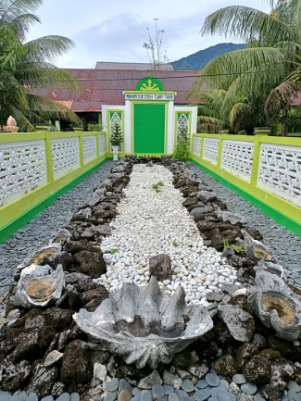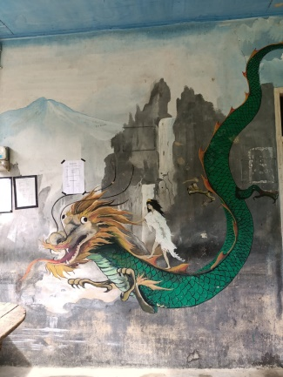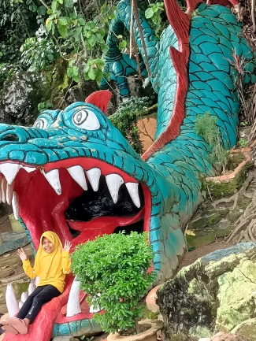

Picture (a) Picture (b) Picture (c)

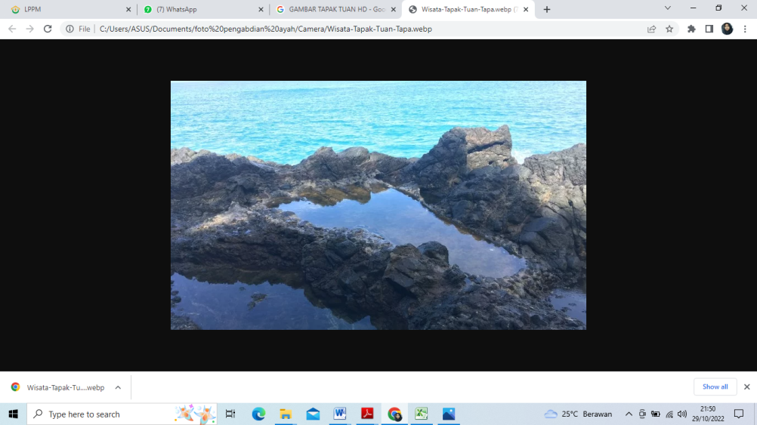

Picture (d)

**Figure 6.** (a) The youngest daughter is playing with the dragon (b) Photo of the male dragon (c) Tgk Syeh Tuan Tapa's grave (d) Tgk Syeh Tuan Tapa's footprint.

**Tourism Objects**

Tourist objects are all destinations that have uniqueness, beauty, and value in the form of diversity of natural, cultural and historical wealth. South Aceh is famous for the *Legenda Tapaktuan* which is one of the forms that it uses as a tourist attraction in Tapaktuan. The tourist attractions in Tapaktuan are all related to the *Legenda Tapaktuan*, such as *Tapak Tuan Tapa* tours, *Tuan Tapa's Tomb*, *Dragon Statues*, *Putri Naga Baths*, *Pulau Dua*, and *Air Tingkat Tujuh*.

* 1. *Tapak Tuan Tapa*

The location of the *Tapak Tuan Tapa* (Legenda Tapaktuan) tourist attraction is located at the foot of Mount Lampu which is not too far away. It is about 1.3 kilometers from Tapaktuan City. Tuan Tapa's footprint has its own charm that makes people curious when they hear that there is a giant footprint. Its location by the sea is also an added value.

*Tapak Tuan Tapa* is one of the legendary tourist attractions of Tapaktuan. The legendary *Tapak Tuan Tapa* tour is visited by many tourists, both local and foreign tourists. Evidence *of Tuan Tapa's footprints* was also explained by Mukhsin (Head of the South Aceh Regency Tourism Office) as follows:

Tapak kaki Tuan Tapa yang sebenarnya yaitu berukuran ± 1 M, dan untuk mengenang atau menjadikan bukti jejak kaki Tuan Tapa tersebut, masyarakat setempat mengambil inisiatif untuk menyemen agar bekas jejak kaki Tuan Tapa tidak hilang dan bisa dikenang serta menjadi bukti bahwa benar adanya cerita legenda Tuan Tapa yang dikisahkan dalam legenda Tapaktuan. Pada awalnya penyemenan tapak kaki tersebut dilakukan di tapak kaki yang asli yang berukuran ± 1 M, namun pada saat pengerjaan penyemenan terjadi kejadian mistis yang menimpa pekerja, sehingga membuat pekerja tersebut jatuh sakit hingga meninggal dunia. Dari kejadian ini membuat masyarakat percaya bahwasanya kejadian mistis yang menimpa pekerja itu ada kaitannya dengan marahnya Tuan Tapa. Sehingga membuat masyarakat memutuskan untuk tidak melanjutkan menyemen tapak kaki Tuan Tapa ditempat yang asli. Kemudian masyarakat memikirkan bagaimana cara untuk mengenang tapak kaki Tuan Tapa agar tidak hilang dan menjadi sebuah bukti sejarah dari legenda Tapaktuan. Akhirnya masyarakat memutuskan untuk membuat jejak kaki Tuan Tapa ditempat yang lain yang juga bersebelahan dengan jejak kaki Tuan Tapa yang asli. Namun ukuran yang dibuat jauh berbeda dan lebih besar dari yang asli yaitu berukuran ± 6x2,5 M.

The actual footprint of Tuan Tapa is ± 1 M in size, and to commemorate or make evidence of Tuan Tapa's footprints, the local community took the initiative to cement it so that Tuan Tapa's footprints were not lost and could be remembered and proved that the legend of Tuan Tapa was true. Tapa is told in the Legenda Tapaktuan. At first the cementing of the soles was done on the original footprints measuring ± 1 M, but during the cementing process a mystical incident occurred which befell the worker, causing the worker to fall ill and die. This incident made the community believe that the mystical incident that happened to the worker had something to do with Tuan Tapa's anger. So that made the community decide not to continue cementing Tuan Tapa's footprints in the original place. Then the people thought about how to commemorate Tuan Tapa's footprints so that they would not be lost and become historical evidence of the Legenda Tapaktuan. Finally the community decided to make Tuan Tapa's footprints in another place which is also next to the original Tuan Tapa's footprints. However, the size made is much different and larger than the original, which is ± 6x2.5 M in size.

* 1. Panjupian Baths

Panjupian is the name of a village in Tapaktuan District, South Aceh. It is one of the destinations related to the story of Legenda Tapaktuan. The distance from the capital city of South Aceh Regency to this village is relatively close, which is only about 5 kilometers away. The location of this village is on the Tapaktuan-Medan highway. It is in this village that there is a tourist spot known as the *Pemandian Putri Naga*.

The natural conditions in Panjupian village are cold because it is located in a mountainous area and close to the coastline, making bathing attractions the main target for local residents who want to travel. One of the most visited tourist attractions is the *Pemandian Putri Naga* tour. The water in this natural bath is very cold because it is water from the mountains so that it makes the atmosphere cool and comfortable.

The *Pemandian Putri Naga* is visited by tourists on holidays, especially when school holidays such as the day after Eid al-Fitr/Adha, "tulak bala", and other holidays. This is supported by its strategic position and the safety of children on vacation is more guaranteed. From the researcher's interview with the head of the South Aceh Tourism Office (Mukhsin, ST), it identified that around twenty thousand tourists visited the tourist attraction in 2020. (interview on 29 September 2022).

The following is data on tourist visits to the location of the Panjupian village tourist attraction (Dragon Princess Bath):

Table 2

The number of visitors to the Princess Naga/Ie Sejuk Panjupian Bathing Tourism Object

|  |  |  |  |
| --- | --- | --- | --- |
| Year | Domestic | Foeign | Total (person) |
| 2019  2020 | 15000  18300 | 150  167 | 15150  19239 |

*Source: Tourism Office, 2021*

This tourist attraction is a small river that comes straight out of rock crevices. The water is clear and the flow is not too fast and is safe for children. In addition, the natural conditions around which are at the foot of the mountain create a fresh atmosphere and make the mind calm with natural scenery that is still green and overgrown with trees, so that the water discharge is always maintained.

The setting of cool, clear river water, and making bathing pools shaped like *Tuan Tapa's footprints* was done to attract tourists to visit the *Pemandian Putri Naga*. There are equipped with tourist huts, stalls, places of prayer, and designed in such a way that it completely blends with nature. At this tourist attraction there are several restaurants that provide various kinds of food, such as meatballs, Acehnese noodles, white rice and other types of food.

The name of the *Pemandian Putri Naga* is because in a legend it is said that the *Putri Naga* (Princess) often bathed in the Panjupian Bath. This story is also very influential in increasing the number of tourists. This is also a benefit for the local community.

Based on the observations of researchers at the beginning of September 2022, activities at this tourist attraction, apart from providing a place to relax, there is also a bathing place for visitors. The visitors are charged an entry fee of five thousand rupiah per person for two-wheeled vehicles, and four up to fifteen thousand for four wheels.

1. Tapaktuan City

Tapak Tuan City is a capital city of South Aceh Regency. The city is also known as Dragon City. A number of Dragon Statues have also been carved to commemorate the story and have been planted in the urban center of Tapaktuan city. One of the large dragon statues that has become a tourist destination is the dragon statue which is located right next to the official residence of the South Aceh Regent. A Dragon Statue with its mouth gaping and its tongue sticking out is located on a hill. The statue symbolizes the power of the dragon against *Tuan Tapa*. This location is visited by many residents on holidays, just to see the famous statue and also to take pictures. The dragon which is the icon of Tapaktuan City, can be seen in figure 6 (b) above.

Another dragon statue built by the South Aceh Government is a giant dragon statue which is on the edge of the Tapaktuan city road and close to the office of Educational Services. The making of this dragon statue aims to show everyone who passes through the Tapaktuan area that a dragon is a symbol or icon of the city.

Tuan Tapa's Tomb

The location of Tuan Tapa's tomb is in *Padang Village* which is adjacent to *Pasar Village*. *Tuan Tapa's* tomb is also a tourist attraction that is visited by many tourists because many visitors are curious about how big *Tuan Tapa's* tomb is. The people want to see directly the whereabouts of *Tuan Tapa's* grave.

Based on the results of an interview with South Aceh cultural observer Syukriadi on September 30 2022, the *Legenda Tapaktuan* tells about the Tomb of *Tuan Tapa*. *Tuan Tapa's* tomb is one of the places visited by tourists. *Tuan Tapa's* tomb is located in *Pasar Village*. Some of the tourists who visit *Tuan Tapa's* Tomb are tourists who deliberately go to release their vows, pray for blessings, and some people think that *Tuan Tapa's* Tomb is a sacred place. Mr. Syukriadi explained about the origin of Tuan Tapa's Tomb:

“Sebenarnya Makam Tuan Tapa ini bukan merupakan Makam seperti Makam orang meninggal pada umumnya, melainkan Makam Tuan Tapa dibangun karena konon katanya dahulu Tuan Tapa beristirahat terakhir kalinya berada di kawasan tersebut. Setelah itu beliau tidak pernah terlihat lagi dan menghilang begitu saja. Oleh karena itu, masyarakat Gampong Pasar membangun Makam sebagai tempat terakhir Tuan Tapa berada dan menjadi tempat yang bisa dikenang oleh banyak orang”.

"Actually Tuan Tapa's Tomb is not a tomb like the graves of dead people in general, but Tuan Tapa's Tomb was built because it is said that Tuan Tapa had his last rest in the area. After that he was never seen again and just disappeared. Therefore, the people of Gampong Pasar built a grave as the last place where Tuan Tapa was and became a place that many people can remember.”

From the results of these interviews it can be seen that the community is making efforts to attract tourists to visit Tapaktuan, one of which is by reproducing the Legenda Tapaktuan as a tourist attraction in South Aceh. The commodification that was carried out by the community was to make the size of Tuan Tapa's grave very large, so that people were curious about Tuan Tapa's grave. In addition, there is also a caretaker who is assigned as the caretaker of Tuan Tapa's Tomb.

**Promotion Strategy**

Tapaktuan District has a myriad of interesting tourist objects that attract many visitors. The Tourism Services together with the *KSW* management, made market conditions in the tourism sector continue to advance by establishing several promotional strategy items, as follows:

**a. Advertising and Tour & Travel Services**

The first promotion strategy is by advertising and promoting Tour & Travel Online services on a number of social media platforms. The promotion is done by distributing pamphlets on Instagram, Facebook and Twitter. A number of tour packages entering the new normal era by participating in expo activities outside the area is also one of the strategies employed to introduce and re-promote tourist destinations, especially the *Legenda Tapaktuan* tourist attraction as an icon of South Aceh.

The tourists can download a tourism application. The application has many features that can be used such as directions, maps, accommodation, and procedures for traveling to the location. This application also provides transportation features, which will make it easier for tourists to visit tourist sites. The Tourism Services designed this application to make it easier for tourists to travel independently without having to look for travel services. This is one of the strategies used to provide the right and easy solution.

**b. Promotion of Storynomics Tourism**

This strategy began to be implemented on April 30 2021 by the Indonesian Ministry of Tourism and Culture. As we know, the impact of the COVID-19 pandemic has been felt in various sectors, including the tourism and creative economy sectors. Various ways have been carried out to restore the national economic sector including the regions, one of which is by developing storynomics tourism, namely a tourism approach that prioritizes narratives, creative content, living culture, and uses the power of culture as the destination's DNA. In other words, storynomic tourism is carried out to package the beauty of the charm of the *Legenda Tapaktuan* tourist destination in an interesting story, so that it can become an attraction for domestic and foreign tourists to travel to a number of destinations in South Aceh Regency. As in the *Legenda Tapaktuan* tourist attraction, the narrative developed with creative content is in the form of a 1-minute video presented with a cartoon character to explain the *Legenda Tapaktuan*.

Every tourist destination in South Aceh Regency has different historical, geological and geographic heritage. This uniqueness will be an added value in promoting South Aceh through storynomics tourism. The form of promotion that has been carried out so far in South Aceh District is in the form of the internet or publications based on social networks that are used as media publications. In practice, the Tourism Services Office uses the internet as a communication strategy to promote tourist attractions in South Aceh. One of the social media used by the Tourism Office is the Facebook account “Tapaktuan Kota Wisata Aceh, Instagram “Wisataacehselatan_”, Whatsapp, and YouTube “Wisata Aceh Selatan” or “New Tourism in South Aceh”. The following can be seen several forms of promotion carried out at the *Legenda Tapaktuan* tourist attraction:

Figure 7

A Calendar of The *Legenda Tapaktuan* Tourist Attraction.

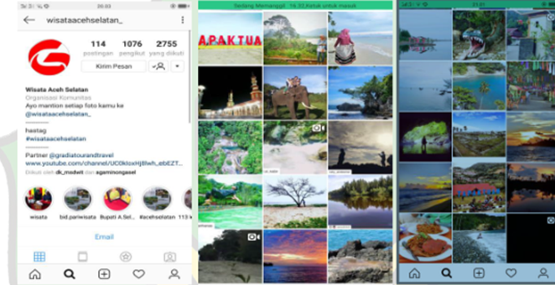

Figure 8

Brochures of Tourism Attraction in South Aceh Regency

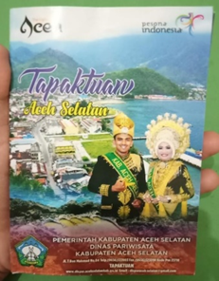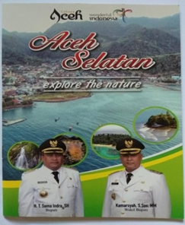

In addition to conducting promotions through social media, brochures and printing calendars in the form of views of South Aceh Regency tourist objects. The Tourism Office also carries out promotions by providing counseling or understanding to communities about the benefits of tourism in their respective areas. Counseling provided by the Tourism Office is also in the form of a tourism awareness forum. It is hoped that people can preserve the environment for tourist objects in their respective areas.

# **CONCLUSION**

The marketing strategy carried out at the *Legenda Tapaktuan* tourist attraction has not been fully on target and successful, because only local tourists are promoting via social media, and even then it has not been structured and planned carefully. Visitors only use the cellphones they use with all the limitations and just for fun. Meanwhile, the Tourism Services has very limited program, this is due to the limited budget available and the lack of human resources in the field of marketing, while preferences are very important for approaches in different marketing channels.

Until now, to market the *Legenda Tapaktuan* tourist attraction only done through the Facebook account “Tapaktuan Kota Wisata Aceh”, Instagram "Wisataacehselatan_", Whatsapp, and YouTube "Wisata Aceh Selatan" or "Wisata Baru Aceh Selatan". While through electronic media such as television through film or documentary has never been made yet, even though this strategy, for the current conditions, is still considered effective in influencing visitors to visit a tourism destination. Meanwhile, the global competition is high since many tourism attractions around the world compete to hook as many visitors as possible using various strategies.

Marketing communications play a strategic role in tourism, because potential tourists need to see, feel or try the product they are going to buy. Therefore, the focus of tourism marketing is actually on how to communicate the value of tourism products. Tourism products are not only limited to natural beauty but also the ease of accessing destinations, infrastructure, public services and those of personal needs (banks, telecommunications, health services, and others). This convenience aspect must be highlighted as one of the strategies in marketing communication since it is a key factor that influences tourists' decisions to visit.

# **REFERENCE**

Bastos, A., Veludo-de-Oliveira, T., Yani-de-Soriano, M., Atalla, M., & Gualano, B. (2022). Leveraging macro-social marketing to achieve sustainable development goals: a city-wide intervention addressing obesity in Brazil. *Journal of Social Marketing*, *12*(1). https://doi.org/10.1108/JSOCM-09-2020-0187

Bellhouse, D. R. (2004). The reverend thomas bayes, FRS: A biography to celebrate the tercentenary of his birth. *Statistical Science*, *19*(1). https://doi.org/10.1214/088342304000000189

Chan, E. S. W. (2013). Managing green marketing: Hong Kong hotel managers’ perspective. *International Journal of Hospitality Management*. https://doi.org/10.1016/j.ijhm.2012.12.007

Cristobal-Fransi, E., Daries, N., Ferrer-Rosell, B., Marine-Roig, E., & Martin-Fuentes, E. (2020). Sustainable tourism marketing. In *Sustainability (Switzerland)* (Vol. 12, Issue 6). https://doi.org/10.3390/su12051865

Finkler, W., & Higham, J. E. S. (2020). Stakeholder perspectives on sustainable whale watching: a science communication approach. *Journal of Sustainable Tourism*, *28*(4). https://doi.org/10.1080/09669582.2019.1684930

Griskevicius, V., Cantú, S. M., & Van Vugt, M. (2012). The evolutionary bases for sustainable behavior: Implications for marketing, policy, and social entrepreneurship. In *Journal of Public Policy and Marketing* (Vol. 31, Issue 1). https://doi.org/10.1509/jppm.11.040

Guo, Y., Jiang, J., & Li, S. (2019). A sustainable tourism policy research review. *Sustainability (Switzerland)*, *11*(11). https://doi.org/10.3390/su11113187

Hayes, A. (2013). All about the role of … EMTAS consultant. *Nursery World*, *2013*(8). https://doi.org/10.12968/nuwa.2013.9.8.1119371

Jamrozy, U. (2007). Marketing of tourism: a paradigm shift toward sustainability. *International Journal of Culture, Tourism and Hospitality Research*, *1*(2). https://doi.org/10.1108/17506180710751669

Kotler, P., & Bliemel, F. (2001). Marketing-Management: Analyse, Planung und Verwirklichung. In *10. Aufl., Stuttgart* (Vol. 47, Issue 3).

Little, V. J., Lee, C. K. C., & Nair, S. (2019). Macro-demarketing: The Key to Unlocking Unsustainable Production and Consumption Systems? *Journal of Macromarketing*, *39*(2). https://doi.org/10.1177/0276146718823885

Lo, C. L., & Tseng, H. T. (2021). THE ROLE OF SELF-CONGRUENCE, MARKETING MODELS, AND PRODUCT CONSPICUOUSNESS IN COLLEGE STUDENTS’ ONLINE COSMETICS SHOPPING. *Journal of Electronic Commerce Research*, *22*(1).

Lumbanraja, P., Lubis, A. N., & Hasibuan, B. K. (2019). Sustaining lake toba’s tourism: Role of creative industry, green tourism marketing and tourism experience. *Asian Journal of Business and Accounting*, *12*(1). https://doi.org/10.22452/ajba.vol12no1.9

Malikhah, I. (2019). Pengaruh Mutu Pelayanan, Pemahaman Sistem Operasional Prosedur Dan Sarana Pendukung Terhadap Kepuasan Mahasiswa Universitas Pembangunan Panca Budi. *Jurnal Manajemen Tools*, *11*(1).

Moleong, L. J. (2017). Metodologi Penelitian Kualitatif (Edisi Revisi). *PT. Remaja Rosda Karya*.

Moleong, L. J. (2019). Moleong, ” Metodologi Penelitian Kualitatif Edisi Revisi”. Bandung : Remaja Rosdakarya. *PT. Remaja Rosda Karya*.

Mostafavi, F., Zamani-Alavijeh, F., Mansourian, M., & Bastami, F. (2021). The promotion of healthy breakfast and snacks based on the social marketing model: a mixed-methods study. *Journal of Health, Population and Nutrition*, *40*(1). https://doi.org/10.1186/s41043-021-00245-y

Neneng Nurmalasari, & Masitoh, I. (2020). Manajemen Strategi Pemasaran Pendidikan Berbasis Media Sosial. *Jurnal.Unigal.Ac.Id*, *volume 4*(3).

Penrose, L. S. (1959). Self-Reproducing Machines. *Scientific American*, *200*(6). https://doi.org/10.1038/scientificamerican0659-105

Prakoso, F. adi. (2021). Analisis Pengaruh Lokasi Dan Distribusi Terhadap Manajemen Rantai Pasok Pangan Di Masa Pandemi Covid. *Jurnal Manajemen, Ekonomi, Keuangan …*, *2*(1).

Santos-Roldán, L., Canalejo, A. M. C., Berbel-Pineda, J. M., & Palacios-Florencio, B. (2020). Sustainable tourism as a source of healthy tourism. *International Journal of Environmental Research and Public Health*, *17*(15). https://doi.org/10.3390/ijerph17155353

Senjaya, M. (2021). Strategi Pemasaran Jasa Terhadap Perilaku Konsumen. *PRISMAKOM*, *18*(1).

Sulistiyani, S., Pratama, A., & Setiyanto, S. (2020). Analisis Strategi Pemasaran Dalam Upaya Peningkatan Daya Saing Umkm. *Jurnal Pemasaran Kompetitif*, *3*(2). https://doi.org/10.32493/jpkpk.v3i2.4029

Sultan, R. M. (2013). A green industry for sustainable trade strategies: the case of the manufacturing sector in Mauritius. *International Journal of Green Economics*, *7*(2). https://doi.org/10.1504/IJGE.2013.057446

Yamada, N. (2020). Pelagius’ view of ideal Christian women in his letters: Critical perspectives of recent pelagian studies comparing chrysostom’s view in his letter to Olympias. *Scrinium*, *16*(1). https://doi.org/10.1163/18177565-00160A17