**DA’WAH COMMUNICATION OF *BEDHAYA TUNGGAL JIWA* DANCE AT *GREBEG BESAR* CEREMONY IN DEMAK REGENCY**

**INDRIANA ARNINDA DEWI**

**R.M PRAMUTOMO**

Graduate Program of ISI Surakarta

Master Program of Arts Creation and Studies

[NIindhaonix@gmail.com](mailto:NIindhaonix@gmail.com)

[rmpram@yahoo.com.sg](mailto:rmpram@yahoo.com.sg)

***ABSTRACT***

*Bedhaya Tunggal Jiwa dance is a group dance existing and developing in Demak Regency. It is included in a series of processions at Grebeg Besar religious ceremony in Demak Regency as a guest welcoming dance. Grebeg Besar is a religious ceremony taking place in Demak Regency that is held once a year, precisely on Eid al-Adha. The existence of Bedhaya Tunggal Jiwa dance at Grebeg Besar is one of the media to harmonize culture and religion. The performance contains da’wah elements, so every part of Bedhaya Tunggal Jiwa contains various messages communicated to the public. The overall message focuses on its efforts to remind people to always do good or call for something good for themselves and others. These messages can be identified through movement, makeup fashion, floor pattern, property, and dance music. The method used in this study was qualitative research method with ethnocoreology approach by adopting the concept of form by Suzanne K Langer and the concept of art communication by Santosa. The field study was carried out to obtain objective data carried out through observation, data analysis, and report writing.*

***Keywords***: Form, Da’wah communication of *Bedhaya* *Tunggal Jiwa* dance.

**INTRODUCTION**

According to Aep Kusnawan, da’wah in a limited capacity is understood by the general public as a lecture or *tabligh* on the Islamic teachings. Generally, it is delivered verbally by *da’i*, *kyai*, and *ulama* on the minbar in *majlis ta’lim*, mosques, or religious spaces (2004: 15). Etymologically, the term da’wah originates from Arabic and the words *da’a, ya da’u,* and *da’watan* which mean invitation and call. In fact, da’wah activities in Islam are not exclusive activities, limited only to certain groups and only performed in *tabligh* spaces or on the minbar.

Sambas explains that da’wah activities consist of several elements, namely the subject or performer (*da’i*), message (*mawdhu’*), method (*uslub*), media (*washilah*), and object (*mad’u*) (Sambas, 2004:129-130). Furthermore, with the development of time and creativity and innovation, the da’wah packaging is more attractive. The efforts to develop da’wah has long been carried out by many Muslims. Da’wah that incorporates art elements or combines several art elements is an indication that has contributed to the development of Islamic da’wah in Indonesia (Java).

Demak Regency is one of the cities which has developed a way of da’wah through art media. The government addressed the rapid increase in era development, rapid growth of Islamic schools and significant decrease in culture with four strategies, namely creation, art, innovation and preservation. Thus, the Demak Regency government created an innovation at *Grebeg Besar* Demak ceremony by using dance as a medium for conveying Islamic messages and calling for kindness, without losing the essence of the ceremony.

*Grebeg Besar* ceremony is believed by Demak people as a da’wah medium of the *wali*, especiallySunan Kalijaga. Hence, this ceremony is held by the Demak Regency government every Eid al-Adha *(10 Dzulhijjah)* as a tradition of expressing gratitude for the endeavor of the ancestors, especially the endeavor regarding Islamic *syiar* made by Sunan Kalijaga, and obeying the will to clean Sunan Kalijaga’s heirloom in the form of *kotang ontokusuma* (inscribed with *syahadad*) and *kyai* Carubuk’s kris.

Since then, the *Bedhaya* *Tunggal Jiwa* dance choreographed by Dyah Purwani became a procession of important events at *Grebeg Besar* ceremony and an important element of the ceremony. Dyah received guidance from the Demak government in choreographing *Bedhaya* *Tunggal Jiwa* dance, so several messages presented in *Bedhaya* *Tunggal Jiwa* performance were carefully considered.

*Bedhaya* *Tunggal Jiwa* dance conveys messages reflected in the elements that constitute the dance performance. The moral value can be identified from the performance, meaning of each movement, floor pattern, and meaning of *lir-ilir* song. It is hoped that *Bedhaya* *Tunggal Jiwa* dance performance can convey messages from the government to the local community, as a medium to remind people to always carry out Islamic Shari’a as practiced by Sunan Kalijaga (Bowo, interview on February 23rd, 2018).

A research problem can be formulated from the background that has been explained: how does da’wah communication of *Bedhaya Tunggal Jiwa* texts at *Grebeg Besar* Demak ceremony? This study is to examine things related to the direction of da’wah communication that occurs within the scope of *Grebeg Besar* ceremony. The results of this study are expected to be a contribution to the scientific reference of performance arts study and increase the public insight on *Bedhaya Tunggal Jiwa* dance and can contribute to the Demak Regency government.

This study used a qualitative method with ethnocoreology approach as a scientific discipline using the Suzanne K Langer concept that views form as a result of a comprehensive unity of a relationship of various interrelated factors or a way in which all aspects can be arranged (Langer, 1988: 15). In addition, according to Santosa, the art communication concept is the process of delivering and receiving ideas that occurs between two sources that have different functions (Santosa, 2011, 48). The two concepts were utilized by the author to describe and analyze the direction of communication built through the *Bedhaya Tunggal Jiwa* dance performance at *Grebeg Besar* ceremony in Demak Regency.

**DISCUSSION**

*Bedhaya* *Tunggal Jiwa* is a dance existing and developing in Demak Regency. In addition to a welcoming dance for officials and all Demak people, it functions as an art development and preservation in Demak Regency. If it is observed, the activity focuses on invitations and calls for doing good deeds. It is presented as a whole as an accompaniment to the regent and staffs in welcoming guests of *Grebeg* celebration during the procession of handling over the anointing oil at the pendhapa area of Demak Regency since all the people and city officials gathered at this time.

1. ***Bedhaya* *Tunggal Jiwa* Dance Structures at *Grebeg Besar* Ceremony in Demak Regency**

*Bedhaya* *Tunggal Jiwa* dance is a work which working process is based on the traditional movements of Surakarta and Yogyakarta styles. Dyah used the basic movements of female dance so that everyone can do it, just like *wali*’s simple teachings that are easy and well received by the community. (Dyah, interview on August 24th, 2017). *Bedhaya* *Tunggal Jiwa*dance performance structures are divided into three parts, namely *maju beksan*, *beksan*, and *mundur beksan.* The explanation of the structures is as follows:

1. *Maju beksan*

*Maju beksan* in *Bedhaya* *Tunggal Jiwa* dancebegins with nine dancers walking in *kapang-kapang* from the *dalem ageng* of the regent to the *pendhapa ageng* of the regent, accompanying the regent and government staffs in welcoming the guests. Walking in *kapang-kapang* is Javanese that means walking slowly. One dancer acts as a leader followed by eight dancers who walk in two lines. Then, the dancers slowly face left (facing the regent) and turn their back on the guests. Then, the dancers sit cross-legged and form the *imam* and *makmum* floor pattern with one of the dancers sitting in the front.

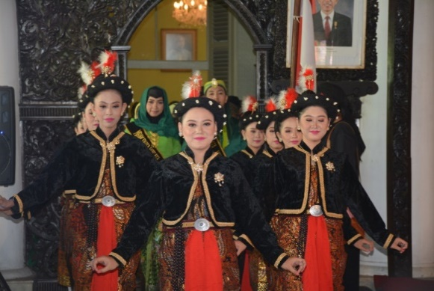

**Figure 1**. The procession of walking in *kapang-kapang* from the *dalem ageng* of the regent to the regency pendhapa (Government Documentation, 2018).

1. *Beksan*

*Beksan* is a Javanese word which means dance or a form of dance. *Beksan* here means a series of *Bedhaya* *Tunggal Jiwa* dance from the beginning to the end. The *Bedhaya* *Tunggal Jiwa* dance performance begins with *sembahan*, which means respect for the regent and Demak Regency government officials, in cross-legged sitting position, then sitting in *jengkeng sembahan* position followed by standing up to do *lembahan separo, sekar suwun, laras sawit, lincak gagak, golek iwak, rimong sampur, perangan,* and *bersuka ria* movements*.*

1. *Mundur beksan* *(Pagar Ayu)*

*Mundur beksan* is a term taken from Javanese that means one of the dance structures arranged to end a dance (Sunarno, 2014:57). *Mundur beksan* in the *Bedhaya* *Tunggal Jiwa* dance performance begins with *jengkeng nikel warti*, then *sembahan akhir* and ends with *srisig* backward forming two lines of *pagar ayu* to make way to the leader of *patangpuluh* soldiers facing the regent to receive the anointing oil.

**B. Da’wah Communication of *Bedhaya* *Tunggal Jiwa* Dance in the Scope of *Grebeg Besar* Ceremony in Demak Regency**

Da'wah patterns are interpreted as communication patterns. da'wah according to hilman latief is 'a call to Islam' or 'Islamic propagation'. in other contexts da'wah signifies social welfare and missionary activities. legitimized by the idea of ​​universal values ​​of Islam (rahmatan li al-alamin). Hilman explained that da'wah activities could be in the form of sending da’i to a Muslim minority region, zakat, sadaqah and even fighting Christianization in the majority Muslim region ( Hilman Latief, 2012,Vol 6, No 2).

Communication is the process of delivering and receiving ideas or codes. In his book, Santosa explains that communication occurs between two sources (or two groups), each of which has a different function, namely as the information sender and information recipient (Santosa, 2011:48). If Santosa’s study suggests that communication through music is in the aesthetic realm of communication, on this occasion, communication in the aesthetic realm occurs in the atmosphere of religious ceremony, namely the *Grebeg Besar* ceremony of Demak.

Looking at the communication process that occurs during the *Grebeg Besar* Demak ceremony, especially in the procession of handling over the anointing oil that begins with the *Bedhaya Tunggal Jiwa* dance performance containing purposes and goals conveyed to the public. *Grebeg Besar* Demak is seen as a ceremony which has become a tradition of Demak people from generation to generation. In this case, the public acts as the ceremony performers and audience. Therefore, the communication occurs between the people who deliver the message and the people who receive the message. According to Santosa, there are three stages of communication process, namely message packaging, message delivery, and message content. The followings are the da’wah communication of *Bedhaya Tunggal Jiwa* dance:

1. **Message Packaging**

In the message packaging process, the activities of developing and considering the message are carried out carefully by dancers and choreographers since the *Bedhaya Tunggal Jiwa* dance performance is in the context of religious ceremony, so the message packaging process does not stand alone. It was developed with foundation of thinking, concepts and public attitudes since *Grebeg Besar* ceremony is very close to community lives. This is confirmed by Santosa’s statement in his book that the message packaging process is strongly influenced by the aspirations of some people, both individual and in groups (Santosa, 2011, 139).

Dyah, as the choreographer, further explains that the message packaging process of *Bedhaya Tunggal Jiwa* dance was not carried ouf without careful consideration. The packaging process was done carefully. The interpretation of each performance element was done under the guidance of Head of Cultural Division, so the dance performance is not out of context, performance purpose, and audience orientation. It is hoped that the message packaging through *Bedhaya* *Tunggal Jiwa* dance performance can meet the audience and environment’s needs.

An investigation on the environment where the tradition exists and develops is one of the main orientations so that the material presented can adjust and be adjusted to the local culture. The era of Demak Kingdom is assumed as the era where Javanese create art inspired by the acculturation of Javanese culture and Islamic elements. The communication established later is expected to have a good impact on the atmosphere of *Grebeg* *Besar* ceremony since the public assumes that a series of *Grebeg* *Besar* ceremony is not only a spectacle but also a guidance.

1. **Message Delivery**

Message delivery in this discussion was done through dance performance performed by dancers and *gendhing* played by gamelan players. Regarding the nature of art communication, Desmon Morris explains in Pramutomo that the *anthropology of human movement* is important in presenting communication patterns of a choreography. Shown in Morris concept, there are types of movements communicated in the form of gestures and behaviors*.* Gestures mean meaningful movements produced by the body while behaviors mean behavioral patterns stylized in movement and become human communication needs (Morris in Pramutomo Vol. 11, 2013).

The followings are meanings contained in movements, floor patterns, properties, and dance music. The meanings are communicated to the community as media to deliver messages:

1. Table of the Meaning of *Bedhaya* *Tunggal Jiwa* Dance Movement Motives

|  |  |
| --- | --- |
| Movement Motives | Movement Meanings |
| *Sembahan* | Worshipping Allah who creates the earth and everything in it. Worshipping has a variety of meanings with the same context, namely the expression from the heart as a sign of respect for the existence of the Almighty, the Almighty can be interpreted as God, the creator of the world, or King who has a high position. |
| *Lembehan Separo* | Human must seek kindness in their lives, if they have got it, it should be transmitted to others. Seeking for kindness can be done in various ways, such as interaction with others, nature, and the creator. As social beings who have intelligence, *ikhtiar* (attempt or effort) that is done has purposes, namely *Ridho* (blessing) from Allah SWT and establishing good relations with others and the nature. |
| *Laras Sawit* | Human must be able to distinguish good and bad deeds in their lives. In interpreting the *laras sawit* movement, Dyah was inspired by human lives which sometimes gets out of control, can no longer distinguish between good and bad deeds. With the existence of the meaning of the *laras sawit* movement, it is hoped that the people who attend *Grebeg* ceremony will always be able to sort out the bad things in their lives. A reminder which comes through *Bedhaya Tunggal Jiwa* dance movements can be mutual contemplation. |
| *Lincak Gagak* | Uniting the will/intention in the heart. In this case, uniting the will is an effort to contemplate in the heart. As taught by the *wali*, we should go through three processes before doing something, namely contemplating in the heart, thinking logically, and contemplating before taking action (Arief, 2014, 124). All considerations are necessary in doing things, so heart and mind can be in line. |
| *Golek Iwak* | Looking for a peace of mind, by doing Islamic Shari’a which has been taught. As in Sunan Kalijaga teachings, we have to leave all value systems which are not in accordance with Islamic teachings. Fix the value system which can be improved according to the Islamic teachings (Arief, 2014, 153). |
| *Rimong Sampur* | After obtaining things that are considered good (values of Islamic teachings) then use or implement them well in life, it is hoped that they can be our salvaltion in the afterlife. This movement also has the meaning of maintaining good relationships that have been build with others and relationship towards God since peace is the goal of religious and state people. |
| *Perangan* | Regarding the severity of human in fighting personal lusts that are not good and always tempt human faith. Accordingly, as servants of God, they must always carry out HIS commands and stay away from HIS prohibitions. |
| *Bersuka ria* (revelry) | Even though they are happy, human cannot be immersed in joy. *Bersuka ria* (revelry) is a movement inspired by prayer beads, which are connected one to another. |

1. The Meaning of *Bedhaya* *Tunggal Jiwa* Dance Floor Patterns

The performance of *Bedhaya* *Tunggal Jiwa* danceconsists of several floor patterns, but there are two floor patterns which have characteristics. The first is the *imam* and *makmum* floor pattern, as suggested by the Demak Regency government. The floor pattern highlights one of the dancers as a symbol of the leader in front, like *wali* and *ulama* who become the role models in religious and social life.

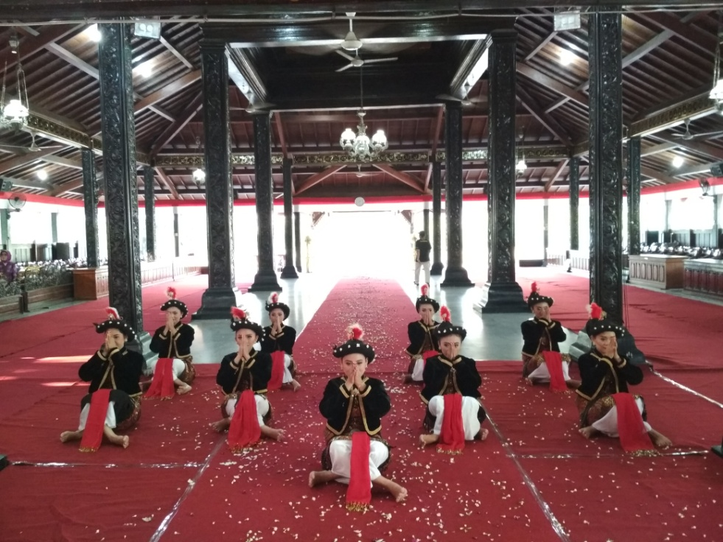

**Figure 2.** The *Imam* and *Makmum* Floor Pattern ( Indriana , Documentation, 2017)

Second, Dyah also adopts the concept of sequential prayer beads that has no end on the *bersuka ria* movement floor pattern. Each dancer moves and ends with rotating on each axis. This pattern means togetherness toward the welfare in the afterlife. Overall, the dancers do not raise their hands too high during the entire performance to maintain good manners.

1. The Meaning of Property

The property used in *Bedhaya* *Tunggal Jiwa* dance is prayer beads. It is a tool used by *wali* to do *dhikr*, mentioning Allah SWT names. The prayer beads are used in the *perangan* movement, which means the war against worldly lusts. The prayer beads act as a counterbalance so that we always remember Allah SWT by always mentioning HIS names on each prayer bead. The selection of prayer beads is considered to be able to represent and support the messages to be delivered at the dance performance.

1. The Meaning of *Ilir-ilir* Song

The song which becomes the characteristic of *Bedhaya* *Tunggal Jiwa* dance performance is *Ilir-ilir. Ilir-ilir* song is one of Sunan Kalijaga’s *karamah*. *Ilir-ilir* song not only contains explicit meaning, one of its implicit meanings is that human should carry out the provisions of Islamic Shari’a in life in order to build relationships with God and others. The social culture of Demak people is built due to the history formed by the predecessor, namely Sunan Kalijaga (as the songwriter), so *Ilir-ilir* song is not only a song but also a message reminding the community to prepare themselves for an eternal life, namely the afterlife.

1. **Message Contents**

Furthermore, the movements in *Bedhaya* *Tunggal Jiwa* dance performance are assumed to have value and message by the local community. The value serves as a guideline for human life in social life, in which the concept covers a broad scope. The value of a culture lies in the emotional nature of soul of individuals who belong to the community. The value components include mutual cooperation, religion, leadership, ethics, and aesthetics and responsibility.

The cooperation between the community and the government is the core of the implementation of *Grebeg* *Besar* ceremony. A cooperation attitude is needed in the implementation of the series of *Grebeg* *Besar* ceremony, from its preparation, implementation to the end. Starting from the community, city officials, civil servants, enlisted headmen, sub-district heads, village heads, *karawitan* groups, dancers, and all the ceremonial executive committees, all of these become one in term of energy and mind for the implementation of *Grebeg Besar* ceremony, including *Bedhaya* *Tunggal Jiwa* dance performance.

The community believes that the climax of *Grebeg Besar* ceremony has a variety of education and extraordinary life values. The life values underlie every activity that contains teachings about beliefs, norms and rules in each procession. The community believes that the teachings conveyed by *wali* of the Prophet Muhammad are true teachings since every Islamic community wholeheartedly carries out and practices Islamic teachings. Apart from that, what can be observed from the messages conveyed through the procession that takes place in Demak Regency hall is that there is a responsibility message in the procession, this responsibility is reflected through the attitude of the enlisted headmen when entrusted by the regent in delivering the anointing oil to Sunan Kalijaga tomb. Through the procession, it can be concluded that human as social beings should be trustworthy when they take on a responsibility.

**CONCLUSION**

The existence of *Bedhaya* *Tunggal Jiwa* dance in *Grebeg Besar* Demak is a procession that cannot be separated from the *Grebeg Besar* ceremony itself. The *Bedhaya* *Tunggal Jiwa* dance has become part of *Grebeg Besar* for almost 30 years. On the other hand, the presence of *Bedhaya Tunggal Jiwa* dance is the government’s effort to develop arts in Demak Regency. This dance is a medium to unite culture and religion, so messages about good deeds must exist in *Bedhaya Tunggal Jiwa* dance performance. On this occasion, the Demak government’s strategy is an effort to get culture to coexist with Demak’s social life which has a strong religion value. Thus, an innovative art packaging that contains Islamic value is needed.

Regarding the description above, it can be concluded that the *Bedhaya Tunggal Jiwa* dance performance can be categorized as a da’wah communication medium carried out at *Grebeg Besar* ceremony in Demak Regency. There are several da’wah elements that can be observed from the phenomenon, among others are (1) da’wah subjects or performers, (2) da’wah messages, (3) da’wah methods or ways of delivery, (4) da’wah places or da’wah delivery areas, (5) da’wah targets. The five elements are contained in *Bedhaya Tunggal Jiwa* dance performance at Grebeg Besar ceremony in Demak Regency.

Various meanings contained in *Bedhaya Tunggal Jiwa* dance performance are reflected in the meaning of each movement, floor pattern, property and dance music. The implementation of Islamic concepts in *Bedhaya Tunggal Jiwa* dance performance is because the socio-cultural of Demak Regency is seen is as the center of the spread of Islam and the history of Sunan Kalijaga that is believed to be a figure who introduced *Grebeg* *Besar* ceremony as a da’wah medium. As a consequence, *Grebeg* *Besar* continues to be carried out annually as the counterbalance of social life of Demak people in relationships between individuals, environment, culture and beliefs in heirlooms from generation to generation.

It is hoped that the existence of *Bedhaya* *Tunggal Jiwa* dance at *Grebeg* *Besar* ceremony is able to be used as a means to call on good deeds (*ma’ruf*), prevent despicable acts, and build a spirit of togetherness and discipline between the regent and his community to achieve prosperity and *ridho* (blessing) from Allah SWT. Consequently, the dance contains a call or invitation to follow something that is related to morality, in the form of change toward a better state, to uphold kindness and destroy falsehood.

**REFERENCES**

Arif, M. *Kumpulan Karamah dan Ajaran Wali Sanga*. Yogyakarta: Safirah. 2014

Eka S. 2008. “Seni Dalam Perspektif Islam”. *Islam Future* vol. VII, No 1.

Kusnawan. Aep. 2004. *Berdakwah Lewat Tulisan*. Bandung: PT Mujahit Dakwah Press.

Langer, K. Suzanne*. Problematika Seni*, Terj FX. Widaryanto. Bandung: Akademi Tari Indonesia, 1988.

Latief Hilman. 2012. “Islmaic Charities and Dakwah Movements In A Muslim Minority Island: The Experience of Niasan Muslim”. *Journal Of Indonesian Islam* Vol 6, No 2.

Pramutomo, R.M dkk. 2013. “Perancangan Desain Pengalaman Turistik Melalui Ecotourism Ruman Adat Bali Kuno di Desa Mangesta Kecamatan Penebel Kabupaten Tabanan Provinsi Bali. *Jurnal Kawistara* Vol. 3 No. 3. 227-334.

Rizal, N. 2012. “Kedudukan Seni Dalam Islam”. *Tsaqafa, Jurnal Kajian Seni Budaya Islam* vol. 1.

Sunarno. *Garan Joged Sebuah Pemikiran Sunarno.* LPKBM Surakarta. 2014.

Santosa. 2011. *Komunikasi Seni: Aplikasi dalam Pertunjukan Gamelan.* Surakarta: ISI Press Surakarta.

Sukriadi. Sambas. 2004. “Pokok Wilayah Kajian Ilmu Dakwah”, dalam ilmu dakwah dalam berbagai perspektif. Jakarta: Pustaka Bani Qurasy.

Tasman A. *Karawitan Tari Sebuah Pengamatan Tari Gaya Surakarta.* Surakarta. 1987.

1. **Online Sources**

<http://wikipedia.com>

http://www.kompasiana.com

1. **Informants**
2. Dyah Purwani Setianingsih, S.Pd, M.Pd (52 years old), choreographer of *Bedhaya* *Tunggal Jiwa* dance.
3. Ardhito Prabowo, SH, MM, (50 years old) Head of Promotion and Marketing Division.
4. Bibit Hartowijoyo, (57 years old), music arranger of *Bedhaya* *Tunggal Jiwa* dance. Demak.
5. Trimia Riezqy Ayuningrum (27 years old), dancer of *Bedhaya* *Tunggal Jiwa*. Demak.