Lampiran 1 Sebaran Harga Pangan di Perkotaan NTT dan Kaltim tahun 2017
Jenis Pangan | Satuan | NTT |  |  | Kaltim
 |  | mean | minimum | maksimum | mean | minimum | maksimum
Beras | Kg | 10,322 | 7,200 | 22,353 | 10,822 | 6,000 | 26,000
Jagug | Kg | 7,183 | 2,000 | 50,000 | 9,860 | 2,000 | 33,333
Terigu | Kg | 8,946 | 6,000 | 16,000 | 9,350 | 4,500 | 24,000
Singkong | Kg | 5,036 | 1,000 | 30,000 | 3,722 | 1,333 | 12,000
Tongkol | Kg | 28,797 | 8,750 | 80,000 | 24,692 | 7,500 | 50,000
Daging Sapi | Kg | 87,442 | 50,000 | 151,000 | 114,181 | 71,000 | 185,000
Daging Ayam Ras | Kg | 39,954 | 22,667 | 74,000 | 29,285 | 15,000 | 68,000
Telur Ayam Ras | Butir | 2,037 | 1,000 | 4,800 | 1,560 | 1,000 | 3,900
Bawang Merah | Ons | 3,990 | 1,200 | 10,000 | 3,620 | 1,500 | 10,000
Cabai Merah | Kg | 43,180 | 15,000 | 250,000 | 49,303 | 15,000 | 142,857
Kedelai | Kg | 19,256 | 8,200 | 49,600 | 18,833 | 10,000 | 30,000
Tahu | Kg | 8,918 | 3,008 | 20,833 | 10,519 | 4,000 | 30,000
Tempe | Kg | 10,777 | 4,000 | 50,000 | 11,456 | 2,222 | 30,000
Apel | Kg | 38,022 | 18,000 | 66,667 | 31,714 | 10,000 | 68,000
Pisang | Kg | 9,734 | 2,146 | 40,000 | 9,181 | 2,500 | 28,571
Minyak Goreng | Liter | 15,341 | 8,000 | 35,294 | 13,908 | 8,000 | 32,000
Gula pasir | Ons | 1,519 | 1,000 | 3,000 | 1,392 | 1,000 | 2,500
Vetsin | Gram | 46 | 7 | 200 | 60 | 4 | 300
Mie Instan | Bungkus | 2,355 | 1,000 | 9,500 | 2,324 | 1,200 | 10,000
Nasi Campur | Porsi | 12,370 | 5,000 | 34,000 | 13,198 | 5,500 | 33,000
Minuman Jadi | Gelas | 3,270 | 1,000 | 8,833 | 3,510 | 1,000 | 12,250
Minuman Keras | Liter | 31,968 | 3,800 | 93,333 | 34,207 | 10,000 | 95,833
Rokok | Batang | 1,080 | 406 | 2,727 | 1,029 | 267 | 2,763
Sumber: BPS diolah (2017)

Lampiran 2 Sebaran Harga Pangan di Perdesaan NTT dan Kaltim tahun 2017
Jenis Pangan | Satuan | NTT |  |  | Kaltim
 |  | mean | minimum | maksimum | mean | minimum | maksimum
Beras | Kg | 10,831 | 7,100 | 23,400 | 10,698 | 6,286 | 37,931
Jagung | Kg | 6,111 | 2,000 | 50,000 | 9,070 | 2,857 | 20,000
Terigu | Kg | 8,652 | 5,000 | 20,000 | 9,107 | 5,000 | 20,000
Singkong | Kg | 3,939 | 1,000 | 30,000 | 3,880 | 1,000 | 11,000
Tongkol | Kg | 22,493 | 8,000 | 66,667 | 24,556 | 11,000 | 42,000
Daging Sapi | Kg | 80,952 | 50,000 | 131,818 | 122,462 | 72,000 | 173,333
Daging Ayam Ras | Kg | 42,907 | 20,000 | 83,333 | 31,603 | 16,000 | 75,000
Telur Ayam Ras | Butir | 2,227 | 1,000 | 5,000 | 1,826 | 1,000 | 4,000
Bawang Merah | Ons | 3,950 | 1,000 | 25,000 | 3,714 | 1,500 | 8,500
Cabai Merah | Kg | 45,263 | 15,000 | 250,000 | 48,805 | 15,000 | 120,000
Kedelai | Kg | 15,652 | 7,000 | 40,000 | 16,667 | 10,000 | 21,000
Tahu | Kg | 9,628 | 3,000 | 29,851 | 10,807 | 4,000 | 25,000
Tempe | Kg | 12,283 | 4,000 | 35,714 | 11,606 | 4,000 | 25,000
Apel | Kg | 41,657 | 20,000 | 60,000 | 34,403 | 19,000 | 53,000
Pisang | Kg | 6,714 | 2,000 | 37,500 | 8,401 | 2,500 | 23,810
Minyak Goreng | Liter | 15,251 | 6,000 | 48,000 | 14,616 | 8,000 | 35,000
Gula pasir | Ons | 1,579 | 1,000 | 5,000 | 1,477 | 1,000 | 2,600
Vetsin | Gram | 47 | 5 | 200 | 58 | 12 | 212
Mie Instan | Bungkus | 2,472 | 1,000 | 5,000 | 2,399 | 1,167 | 8,667
Nasi Campur | Porsi | 12,275 | 5,000 | 30,000 | 14,706 | 5,600 | 32,091
Minuman Jadi | Gelas | 2,949 | 1,000 | 9,000 | 3,802 | 1,000 | 12,000
Minuman Keras | Liter | 20,785 | 3,200 | 100,000 | 31,640 | 8,200 | 78,333
Rokok | Batang | 990 | 400 | 4,000 | 979 | 314 | 2,455
Sumber: BPS diolah (2017)

Lampiran 3 Syntax SAS untuk pemodelan AIDS
Libname ferdi 'D:\datasas';
run;
option nodate nonumber;
run;
data aids_ntt;
set ntt17;
run;

/* MODEL */
Proc syslin itsur data = kaltim17 outest = fin1;
brs: model wbrs = lpbrs lpjag lpter lpsing lptong lpdsap lpdar lptar lpbmr lpcmr lpked lptah lptem lpape lppis lpmigo lpgul lpvet lpmie lpnasc lpmj lpmir lprok lnp art lexp dwil imrbrs;

jag: model wjag = lpbrs lpjag lpter lpsing lptong lpdsap lpdar lptar lpbmr lpcmr lpked lptah lptem lpape lppis lpmigo lpgul lpvet lpmie lpnasc lpmj lpmir lprok lnp art lexp dwil imrjag;

ter: model wter = lpbrs lpjag lpter lpsing lptong lpdsap lpdar lptar lpbmr lpcmr lpked lptah lptem lpape lppis lpmigo lpgul lpvet lpmie lpnasc lpmj lpmir lprok lnp art lexp dwil imrter;

sing: model wsing = lpbrs lpjag lpter lpsing lptong lpdsap lpdar lptar lpbmr lpcmr lpked lptah lptem lpape lppis lpmigo lpgul lpvet lpmie lpnasc lpmj lpmir lprok lnp art lexp dwil imrsing;

tong: model wtong = lpbrs lpjag lpter lpsing lptong lpdsap lpdar lptar lpbmr lpcmr lpked lptah lptem lpape lppis lpmigo lpgul lpvet lpmie lpnasc lpmj lpmir lprok lnp art lexp dwil imrtong;

dsap: model wdsap = lpbrs lpjag lpter lpsing lptong lpdsap lpdar lptar lpbmr lpcmr lpked lptah lptem lpape lppis lpmigo lpgul lpvet lpmie lpnasc lpmj lpmir lprok lnp art lexp dwil imrdsap;

dar: model wdar = lpbrs lpjag lpter lpsing lptong lpdsap lpdar lptar lpbmr lpcmr lpked lptah lptem lpape lppis lpmigo lpgul lpvet lpmie lpnasc lpmj lpmir lprok lnp art lexp dwil imrdar;

tar: model wtar = lpbrs lpjag lpter lpsing lptong lpdsap lpdar lptar lpbmr lpcmr lpked lptah lptem lpape lppis lpmigo lpgul lpvet lpmie lpnasc lpmj lpmir lprok lnp art lexp dwil imrtar;

bmr: model wbmr = lpbrs lpjag lpter lpsing lptong lpdsap lpdar lptar lpbmr lpcmr lpked lptah lptem lpape lppis lpmigo lpgul lpvet lpmie lpnasc lpmj lpmir lprok lnp art lexp dwil imrbmr;

cmr: model wcmr = lpbrs lpjag lpter lpsing lptong lpdsap lpdar lptar lpbmr lpcmr lpked lptah lptem lpape lppis lpmigo lpgul lpvet lpmie lpnasc lpmj lpmir lprok lnp art lexp dwil imrcmr;

ked: model wked = lpbrs lpjag lpter lpsing lptong lpdsap lpdar lptar lpbmr lpcmr lpked lptah lptem lpape lppis lpmigo lpgul lpvet lpmie lpnasc lpmj lpmir lprok lnp art lexp dwil imrked;

tah: model wtah = lpbrs lpjag lpter lpsing lptong lpdsap lpdar lptar lpbmr lpcmr lpked lptah lptem lpape lppis lpmigo lpgul lpvet lpmie lpnasc lpmj lpmir lprok lnp art lexp dwil imrtah;

tem: model wtem = lpbrs lpjag lpter lpsing lptong lpdsap lpdar lptar lpbmr lpcmr lpked lptah lptem lpape lppis lpmigo lpgul lpvet lpmie lpnasc lpmj lpmir lprok lnp art lexp dwil imrtem;

ape: model wape = lpbrs lpjag lpter lpsing lptong lpdsap lpdar lptar lpbmr lpcmr lpked lptah lptem lpape lppis lpmigo lpgul lpvet lpmie lpnasc lpmj lpmir lprok lnp art lexp dwil imrape;

pis: model wpis = lpbrs lpjag lpter lpsing lptong lpdsap lpdar lptar lpbmr lpcmr lpked lptah lptem lpape lppis lpmigo lpgul lpvet lpmie lpnasc lpmj lpmir lprok lnp art lexp dwil imrpis;

migo: model wmigo = lpbrs lpjag lpter lpsing lptong lpdsap lpdar lptar lpbmr lpcmr lpked lptah lptem lpape lppis lpmigo lpgul lpvet lpmie lpnasc lpmj lpmir lprok lnp art lexp dwil imrmigo;

gul: model wgul = lpbrs lpjag lpter lpsing lptong lpdsap lpdar lptar lpbmr lpcmr lpked lptah lptem lpape lppis lpmigo lpgul lpvet lpmie lpnasc lpmj lpmir lprok lnp art lexp dwil imrgul;

vet: model wvet = lpbrs lpjag lpter lpsing lptong lpdsap lpdar lptar lpbmr lpcmr lpked lptah lptem lpape lppis lpmigo lpgul lpvet lpmie lpnasc lpmj lpmir lprok lnp art lexp dwil imrvet;

mie: model wmie = lpbrs lpjag lpter lpsing lptong lpdsap lpdar lptar lpbmr lpcmr lpked lptah lptem lpape lppis lpmigo lpgul lpvet lpmie lpnasc lpmj lpmir lprok lnp art lexp dwil imrmie;

nasc: model wnasc = lpbrs lpjag lpter lpsing lptong lpdsap lpdar lptar lpbmr lpcmr lpked lptah lptem lpape lppis lpmigo lpgul lpvet lpmie lpnasc lpmj lpmir lprok lnp art lexp dwil imrnasc;

mj: model wmj = lpbrs lpjag lpter lpsing lptong lpdsap lpdar lptar lpbmr lpcmr lpked lptah lptem lpape lppis lpmigo lpgul lpvet lpmie lpnasc lpmj lpmir lprok lnp art lexp dwil imrmj;

rok: model wrok = lpbrs lpjag lpter lpsing lptong lpdsap lpdar lptar lpbmr lpcmr lpked lptah lptem lpape lppis lpmigo lpgul lpvet lpmie lpnasc lpmj lpmir lprok lnp art lexp dwil imrrok;

/* miras jadi the last model (adding up restriction)*/

Var wbrs wjag wter wsing wtong wdsap wdar wtar wbmr wcmr wked wtah wtem wape wpis wmigo wgul wvet wmie wnasc wmj wrok;

Srestrict wbrs.intercep + wjag.intercep + wter.intercep + wsing.intercep + wtong.intercep + wdsap.intercep + wdar.intercep + wtar.intercep + wbmr.intercep + wcmr.intercep + wked.intercep + wtah.intercep + wtem.intercep + wape.intercep + wpis.intercep + wmigo.intercep + wgul.intercep + wvet.intercep + wmie.intercep + wnasc.intercep + wmj.intercep + wrok.intercep= 1;

Srestrict wbrs.lnp + wjag.lnp +wter.lnp + wsing.lnp + wtong.lnp + wdsap.lnp + wdar.lnp + wtar.lnp + wbmr.lnp + wcmr.lnp + wked.lnp + wtah.lnp + wtem.lnp + wape.lnp + wpis.lnp + wmigo.lnp + wgul.lnp + wvet.lnp + wmie.lnp + wnasc.lnp + wmj.lnp + wrok.lnp= 0;

Srestrict wbrs.lexp + wjag.lexp + wter.lexp + wsing.lexp + wtong.lexp + wdsap.lexp + wdar.lexp + wtar.lexp + wbmr.lexp + wcmr.lexp + wked.lexp + wtah.lexp + wtem.lexp + wape.lexp + wpis.lexp + wmigo.lexp + wgul.lexp + wvet.lexp + wmie.lexp + wnasc.lexp + wmj.lexp + wrok.lexp= 0;

Srestrict wbrs.lpbrs + wbrs.lpjag + wbrs.lpter + wbrs.lpsing + wbrs.lptong + wbrs.lpdsap + wbrs.lpdar + wbrs.lptar + wbrs.lpbmr + wbrs.lpcmr + wbrs.lpked + wbrs.lptah + wbrs.lptem + wbrs.lpape + wbrs.lppis + wbrs.lpmigo + wbrs.lpgul + wbrs.lpvet + wbrs.lpmie + wbrs.lpnasc + wbrs.lpmj + wbrs.lpmir + wbrs.lprok= 0,

wjag.lpbrs + wjag.lpjag + wjag.lpter + wjag.lpsing + wjag.lptong + wjag.lpdsap + wjag.lpdar + wjag.lptar + wjag.lpbmr + wjag.lpcmr + wjag.lpked + wjag.lptah + wjag.lptem + wjag.lpape + wjag.lppis + wjag.lpmigo + wjag.lpgul + wjag.lpvet + wjag.lpmie + wjag.lpnasc + wjag.lpmj + wjag.lpmir + wjag.lprok= 0,

wter.lpbrs + wter.lpjag + wter.lpter + wter.lpsing + wter.lptong + wter.lpdsap + wter.lpdar + wter.lptar + wter.lpbmr + wter.lpcmr + wter.lpked + wter.lptah + wter.lptem + wter.lpape + wter.lppis + wter.lpmigo + wter.lpgul + wter.lpvet + wter.lpmie + wter.lpnasc + wter.lpmj + wter.lpmir + wter.lprok= 0,

wsing.lpbrs + wsing.lpjag + wsing.lpter + wsing.lpsing + wsing.lptong + wsing.lpdsap + wsing.lpdar + wsing.lptar + wsing.lpbmr + wsing.lpcmr + wsing.lpked + wsing.lptah + wsing.lptem + wsing.lpape + wsing.lppis + wsing.lpmigo + wsing.lpgul + wsing.lpvet + wsing.lpmie + wsing.lpnasc + wsing.lpmj + wsing.lpmir + wsing.lprok= 0,

wtong.lpbrs + wtong.lpjag + wtong.lpter + wtong.lpsing + wtong.lptong + wtong.lpdsap + wtong.lpdar + wtong.lptar + wtong.lpbmr + wtong.lpcmr + wtong.lpked + wtong.lptah + wtong.lptem + wtong.lpape + wtong.lppis + wtong.lpmigo + wtong.lpgul + wtong.lpvet + wtong.lpmie + wtong.lpnasc + wtong.lpmj + wtong.lpmir + wtong.lprok= 0,

wdsap.lpbrs + wdsap.lpjag + wdsap.lpter + wdsap.lpsing + wdsap.lptong + wdsap.lpdsap + wdsap.lpdar + wdsap.lptar + wdsap.lpbmr + wdsap.lpcmr + wdsap.lpked + wdsap.lptah + wdsap.lptem + wdsap.lpape + wdsap.lppis + wdsap.lpmigo + wdsap.lpgul + wdsap.lpvet + wdsap.lpmie + wdsap.lpnasc + wdsap.lpmj + wdsap.lpmir + wdsap.lprok= 0,

wdar.lpbrs + wdar.lpjag + wdar.lpter + wdar.lpsing + wdar.lptong + wdar.lpdsap + wdar.lpdar + wdar.lptar + wdar.lpbmr + wdar.lpcmr + wdar.lpked + wdar.lptah + wdar.lptem + wdar.lpape + wdar.lppis + wdar.lpmigo + wdar.lpgul + wdar.lpvet + wdar.lpmie + wdar.lpnasc + wdar.lpmj + wdar.lpmir + wdar.lprok= 0,

wtar.lpbrs + wtar.lpjag + wtar.lpter + wtar.lpsing + wtar.lptong + wtar.lpdsap + wtar.lpdar + wtar.lptar + wtar.lpbmr + wtar.lpcmr + wtar.lpked + wtar.lptah + wtar.lptem + wtar.lpape + wtar.lppis + wtar.lpmigo + wtar.lpgul + wtar.lpvet + wtar.lpmie + wtar.lpnasc + wtar.lpmj + wtar.lpmir + wtar.lprok= 0,

wbmr.lpbrs + wbmr.lpjag + wbmr.lpter + wbmr.lpsing + wbmr.lptong + wbmr.lpdsap + wbmr.lpdar + wbmr.lptar + wbmr.lpbmr + wbmr.lpcmr + wbmr.lpked + wbmr.lptah + wbmr.lptem + wbmr.lpape + wbmr.lppis + wbmr.lpmigo + wbmr.lpgul + wbmr.lpvet + wbmr.lpmie + wbmr.lpnasc + wbmr.lpmj + wbmr.lpmir + wbmr.lprok= 0,

wcmr.lpbrs + wcmr.lpjag + wcmr.lpter + wcmr.lpsing + wcmr.lptong + wcmr.lpdsap + wcmr.lpdar + wcmr.lptar + wcmr.lpbmr + wcmr.lpcmr + wcmr.lpked + wcmr.lptah + wcmr.lptem + wcmr.lpape + wcmr.lppis + wcmr.lpmigo + wcmr.lpgul + wcmr.lpvet + wcmr.lpmie + wcmr.lpnasc + wcmr.lpmj + wcmr.lpmir + wcmr.lprok= 0,

wked.lpbrs + wked.lpjag + wked.lpter + wked.lpsing + wked.lptong + wked.lpdsap + wked.lpdar + wked.lptar + wked.lpbmr + wked.lpcmr + wked.lpked + wked.lptah + wked.lptem + wked.lpape + wked.lppis + wked.lpmigo + wked.lpgul + wked.lpvet + wked.lpmie + wked.lpnasc + wked.lpmj + wked.lpmir + wked.lprok= 0,

wtah.lpbrs + wtah.lpjag + wtah.lpter + wtah.lpsing + wtah.lptong + wtah.lpdsap + wtah.lpdar + wtah.lptar + wtah.lpbmr + wtah.lpcmr + wtah.lpked + wtah.lptah + wtah.lptem + wtah.lpape + wtah.lppis + wtah.lpmigo + wtah.lpgul + wtah.lpvet + wtah.lpmie + wtah.lpnasc + wtah.lpmj + wtah.lpmir + wtah.lprok= 0,

wtem.lpbrs + wtem.lpjag + wtem.lpter + wtem.lpsing + wtem.lptong + wtem.lpdsap + wtem.lpdar + wtem.lptar + wtem.lpbmr + wtem.lpcmr + wtem.lpked + wtem.lptah + wtem.lptem + wtem.lpape + wtem.lppis + wtem.lpmigo + wtem.lpgul + wtem.lpvet + wtem.lpmie + wtem.lpnasc + wtem.lpmj + wtem.lpmir + wtem.lprok= 0,

wape.lpbrs + wape.lpjag + wape.lpter + wape.lpsing + wape.lptong + wape.lpdsap + wape.lpdar + wape.lptar + wape.lpbmr + wape.lpcmr + wape.lpked + wape.lptah + wape.lptem + wape.lpape + wape.lppis + wape.lpmigo + wape.lpgul + wape.lpvet + wape.lpmie + wape.lpnasc + wape.lpmj + wape.lpmir + wape.lprok= 0,

wpis.lpbrs + wpis.lpjag + wpis.lpter + wpis.lpsing + wpis.lptong + wpis.lpdsap + wpis.lpdar + wpis.lptar + wpis.lpbmr + wpis.lpcmr + wpis.lpked + wpis.lptah + wpis.lptem + wpis.lpape + wpis.lppis + wpis.lpmigo + wpis.lpgul + wpis.lpvet + wpis.lpmie + wpis.lpnasc + wpis.lpmj + wpis.lpmir + wpis.lprok= 0,

wmigo.lpbrs + wmigo.lpjag + wmigo.lpter + wmigo.lpsing + wmigo.lptong + wmigo.lpdsap + wmigo.lpdar + wmigo.lptar + wmigo.lpbmr + wmigo.lpcmr + wmigo.lpked + wmigo.lptah + wmigo.lptem + wmigo.lpape + wmigo.lppis + wmigo.lpmigo + wmigo.lpgul + wmigo.lpvet + wmigo.lpmie + wmigo.lpnasc + wmigo.lpmj + wmigo.lpmir + wmigo.lprok= 0,

wgul.lpbrs + wgul.lpjag + wgul.lpter + wgul.lpsing + wgul.lptong + wgul.lpdsap + wgul.lpdar + wgul.lptar + wgul.lpbmr + wgul.lpcmr + wgul.lpked + wgul.lptah + wgul.lptem + wgul.lpape + wgul.lppis + wgul.lpmigo + wgul.lpgul + wgul.lpvet + wgul.lpmie + wgul.lpnasc + wgul.lpmj + wgul.lpmir + wgul.lprok= 0,

wvet.lpbrs + wvet.lpjag + wvet.lpter + wvet.lpsing + wvet.lptong + wvet.lpdsap + wvet.lpdar + wvet.lptar + wvet.lpbmr + wvet.lpcmr + wvet.lpked + wvet.lptah + wvet.lptem + wvet.lpape + wvet.lppis + wvet.lpmigo + wvet.lpgul + wvet.lpvet + wvet.lpmie + wvet.lpnasc + wvet.lpmj + wvet.lpmir + wvet.lprok= 0,

wmie.lpbrs + wmie.lpjag + wmie.lpter + wmie.lpsing + wmie.lptong + wmie.lpdsap + wmie.lpdar + wmie.lptar + wmie.lpbmr + wmie.lpcmr + wmie.lpked + wmie.lptah + wmie.lptem + wmie.lpape + wmie.lppis + wmie.lpmigo + wmie.lpgul + wmie.lpvet + wmie.lpmie + wmie.lpnasc + wmie.lpmj + wmie.lpmir + wmie.lprok= 0,

wnasc.lpbrs + wnasc.lpjag + wnasc.lpter + wnasc.lpsing + wnasc.lptong + wnasc.lpdsap + wnasc.lpdar + wnasc.lptar + wnasc.lpbmr + wnasc.lpcmr + wnasc.lpked + wnasc.lptah + wnasc.lptem + wnasc.lpape + wnasc.lppis + wnasc.lpmigo + wnasc.lpgul + wnasc.lpvet + wnasc.lpmie + wnasc.lpnasc + wnasc.lpmj + wnasc.lpmir + wnasc.lprok= 0,

wmj.lpbrs + wmj.lpjag + wmj.lpter + wmj.lpsing + wmj.lptong + wmj.lpdsap + wmj.lpdar + wmj.lptar + wmj.lpbmr + wmj.lpcmr + wmj.lpked + wmj.lptah + wmj.lptem + wmj.lpape + wmj.lppis + wmj.lpmigo + wmj.lpgul + wmj.lpvet + wmj.lpmie + wmj.lpnasc + wmj.lpmj + wmj.lpmir + wmj.lprok= 0,

wmir.lpbrs + wmir.lpjag + wmir.lpter + wmir.lpsing + wmir.lptong + wmir.lpdsap + wmir.lpdar + wmir.lptar + wmir.lpbmr + wmir.lpcmr + wmir.lpked + wmir.lptah + wmir.lptem + wmir.lpape + wmir.lppis + wmir.lpmigo + wmir.lpgul + wmir.lpvet + wmir.lpmie + wmir.lpnasc + wmir.lpmj + wmir.lpmir + wmir.lprok= 0,

wrok.lpbrs + wrok.lpjag + wrok.lpter + wrok.lpsing + wrok.lptong + wrok.lpdsap + wrok.lpdar + wrok.lptar + wrok.lpbmr + wrok.lpcmr + wrok.lpked + wrok.lptah + wrok.lptem + wrok.lpape + wrok.lppis + wrok.lpmigo + wrok.lpgul + wrok.lpvet + wrok.lpmie + wrok.lpnasc + wrok.lpmj + wrok.lpmir + wrok.lprok= 0;
/*symmetry restrictrions*/
srestrict
wbrs.lpjag = wjag.lpbrs,
wbrs.lpter = wter.lpbrs,
wbrs.lpsing = wsing.lpbrs,
wbrs.lptong = wtong.lpbrs,
wbrs.lpdsap = wdsap.lpbrs,
wbrs.lpdar = wdar.lpbrs,
wbrs.lptar = wtar.lpbrs,
wbrs.lpbmr = wbmr.lpbrs,
wbrs.lpcmr = wcmr.lpbrs,
wbrs.lpked = wked.lpbrs,
wbrs.lptah = wtah.lpbrs,
wbrs.lptem = wtem.lpbrs,
wbrs.lpape = wape.lpbrs,
wbrs.lppis = wpis.lpbrs,
wbrs.lpmigo = wmigo.lpbrs,
wbrs.lpgul = wgul.lpbrs,
wbrs.lpvet = wvet.lpbrs,
wbrs.lpmie = wmie.lpbrs,
wbrs.lpnasc = wnasc.lpbrs,
wbrs.lpmj = wmj.lpbrs,
wbrs.lprok = wrok.lpbrs,

wjag.lpbrs = wbrs.lpjag,
wjag.lpter = wter.lpjag,
wjag.lpsing = wsing.lpjag,
wjag.lptong = wtong.lpjag,
wjag.lpdsap = wdsap.lpjag,
wjag.lpdar = wdar.lpjag,
wjag.lptar = wtar.lpjag,
wjag.lpbmr = wbmr.lpjag,
wjag.lpcmr = wcmr.lpjag,
wjag.lpked = wked.lpjag,
wjag.lptah = wtah.lpjag,
wjag.lptem = wtem.lpjag,
wjag.lpape = wape.lpjag,
wjag.lppis = wpis.lpjag,
wjag.lpmigo = wmigo.lpjag,
wjag.lpgul = wgul.lpjag,
wjag.lpvet = wvet.lpjag,
wjag.lpmie = wmie.lpjag,
wjag.lpnasc = wnasc.lpjag,
wjag.lpmj = wmj.lpjag,
wjag.lprok = wrok.lpjag,

wter.lpbrs = wbrs.lpter,
wter.lpjag = wjag.lpter,
wter.lpsing = wsing.lpter,
wter.lptong = wtong.lpter,
wter.lpdsap = wdsap.lpter,
wter.lpdar = wdar.lpter,
wter.lptar = wtar.lpter,
wter.lpbmr = wbmr.lpter,
wter.lpcmr = wcmr.lpter,
wter.lpked = wked.lpter,
wter.lptah = wtah.lpter,
wter.lptem = wtem.lpter,
wter.lpape = wape.lpter,
wter.lppis = wpis.lpter,
wter.lpmigo = wmigo.lpter,
wter.lpgul = wgul.lpter,
wter.lpvet = wvet.lpter,
wter.lpmie = wmie.lpter,
wter.lpnasc = wnasc.lpter,
wter.lpmj = wmj.lpter,
wter.lprok = wrok.lpter,

wsing.lpbrs = wbrs.lpsing,
wsing.lpjag = wjag.lpsing,
wsing.lpter = wter.lpsing,
wsing.lptong = wtong.lpsing,
wsing.lpdsap = wdsap.lpsing,
wsing.lpdar = wdar.lpsing,
wsing.lptar = wtar.lpsing,
wsing.lpbmr = wbmr.lpsing,
wsing.lpcmr = wcmr.lpsing,
wsing.lpked = wked.lpsing,
wsing.lptah = wtah.lpsing,
wsing.lptem = wtem.lpsing,
wsing.lpape = wape.lpsing,
wsing.lppis = wpis.lpsing,
wsing.lpmigo = wmigo.lpsing,
wsing.lpgul = wgul.lpsing,
wsing.lpvet = wvet.lpsing,
wsing.lpmie = wmie.lpsing,
wsing.lpnasc = wnasc.lpsing,
wsing.lpmj = wmj.lpsing,
wsing.lprok = wrok.lpsing,

wtong.lpbrs = wbrs.lptong,
wtong.lpjag = wjag.lptong,
wtong.lpter = wter.lptong,
wtong.lpsing = wsing.lptong,
wtong.lpdsap = wdsap.lptong,
wtong.lpdar = wdar.lptong,
wtong.lptar = wtar.lptong,
wtong.lpbmr = wbmr.lptong,
wtong.lpcmr = wcmr.lptong,
wtong.lpked = wked.lptong,
wtong.lptah = wtah.lptong,
wtong.lptem = wtem.lptong,
wtong.lpape = wape.lptong,
wtong.lppis = wpis.lptong,
wtong.lpmigo = wmigo.lptong,
wtong.lpgul = wgul.lptong,
wtong.lpvet = wvet.lptong,
wtong.lpmie = wmie.lptong,
wtong.lpnasc = wnasc.lptong,
wtong.lpmj = wmj.lptong,
wtong.lprok = wrok.lptong,

wdsap.lpbrs = wbrs.lpdsap,
wdsap.lpjag = wjag.lpdsap,
wdsap.lpter = wter.lpdsap,
wdsap.lpsing = wsing.lpdsap,
wdsap.lptong = wtong.lpdsap,
wdsap.lpdar = wdar.lpdsap,
wdsap.lptar = wtar.lpdsap,
wdsap.lpbmr = wbmr.lpdsap,
wdsap.lpcmr = wcmr.lpdsap,
wdsap.lpked = wked.lpdsap,
wdsap.lptah = wtah.lpdsap,
wdsap.lptem = wtem.lpdsap,
wdsap.lpape = wape.lpdsap,
wdsap.lppis = wpis.lpdsap,
wdsap.lpmigo = wmigo.lpdsap,
wdsap.lpgul = wgul.lpdsap,
wdsap.lpvet = wvet.lpdsap,
wdsap.lpmie = wmie.lpdsap,
wdsap.lpnasc = wnasc.lpdsap,
wdsap.lpmj = wmj.lpdsap,
wdsap.lprok = wrok.lpdsap,

wdar.lpbrs = wbrs.lpdar,
wdar.lpjag = wjag.lpdar,
wdar.lpter = wter.lpdar,
wdar.lpsing = wsing.lpdar,
wdar.lptong = wtong.lpdar,
wdar.lpdsap = wdsap.lpdar,
wdar.lptar = wtar.lpdar,
wdar.lpbmr = wbmr.lpdar,
wdar.lpcmr = wcmr.lpdar,
wdar.lpked = wked.lpdar,
wdar.lptah = wtah.lpdar,
wdar.lptem = wtem.lpdar,
wdar.lpape = wape.lpdar,
wdar.lppis = wpis.lpdar,
wdar.lpmigo = wmigo.lpdar,
wdar.lpgul = wgul.lpdar,
wdar.lpvet = wvet.lpdar,
wdar.lpmie = wmie.lpdar,
wdar.lpnasc = wnasc.lpdar,
wdar.lpmj = wmj.lpdar,
wdar.lprok = wrok.lpdar,

wtar.lpbrs = wbrs.lptar,
wtar.lpjag = wjag.lptar,
wtar.lpter = wter.lptar,
wtar.lpsing = wsing.lptar,
wtar.lptong = wtong.lptar,
wtar.lpdsap = wdsap.lptar,
wtar.lpdar = wdar.lptar,
wtar.lpbmr = wbmr.lptar,
wtar.lpcmr = wcmr.lptar,
wtar.lpked = wked.lptar,
wtar.lptah = wtah.lptar,
wtar.lptem = wtem.lptar,
wtar.lpape = wape.lptar,
wtar.lppis = wpis.lptar,
wtar.lpmigo = wmigo.lptar,
wtar.lpgul = wgul.lptar,
wtar.lpvet = wvet.lptar,
wtar.lpmie = wmie.lptar,
wtar.lpnasc = wnasc.lptar,
wtar.lpmj = wmj.lptar,
wtar.lprok = wrok.lptar,

wbmr.lpbrs = wbrs.lpbmr,
wbmr.lpjag = wjag.lpbmr,
wbmr.lpter = wter.lpbmr,
wbmr.lpsing = wsing.lpbmr,
wbmr.lptong = wtong.lpbmr,
wbmr.lpdsap = wdsap.lpbmr,
wbmr.lpdar = wdar.lpbmr,
wbmr.lptar = wtar.lpbmr,
wbmr.lpcmr = wcmr.lpbmr,
wbmr.lpked = wked.lpbmr,
wbmr.lptah = wtah.lpbmr,
wbmr.lptem = wtem.lpbmr,
wbmr.lpape = wape.lpbmr,
wbmr.lppis = wpis.lpbmr,
wbmr.lpmigo = wmigo.lpbmr,
wbmr.lpgul = wgul.lpbmr,
wbmr.lpvet = wvet.lpbmr,
wbmr.lpmie = wmie.lpbmr,
wbmr.lpnasc = wnasc.lpbmr,
wbmr.lpmj = wmj.lpbmr,
wbmr.lprok = wrok.lpbmr,

wcmr.lpbrs = wbrs.lpcmr,
wcmr.lpjag = wjag.lpcmr,
wcmr.lpter = wter.lpcmr,
wcmr.lpsing = wsing.lpcmr,
wcmr.lptong = wtong.lpcmr,
wcmr.lpdsap = wdsap.lpcmr,
wcmr.lpdar = wdar.lpcmr,
wcmr.lptar = wtar.lpcmr,
wcmr.lpbmr = wbmr.lpcmr,
wcmr.lpked = wked.lpcmr,
wcmr.lptah = wtah.lpcmr,
wcmr.lptem = wtem.lpcmr,
wcmr.lpape = wape.lpcmr,
wcmr.lppis = wpis.lpcmr,
wcmr.lpmigo = wmigo.lpcmr,
wcmr.lpgul = wgul.lpcmr,
wcmr.lpvet = wvet.lpcmr,
wcmr.lpmie = wmie.lpcmr,
wcmr.lpnasc = wnasc.lpcmr,
wcmr.lpmj = wmj.lpcmr,
wcmr.lprok = wrok.lpcmr,

wked.lpbrs = wbrs.lpked,
wked.lpjag = wjag.lpked,
wked.lpter = wter.lpked,
wked.lpsing = wsing.lpked,
wked.lptong = wtong.lpked,
wked.lpdsap = wdsap.lpked,
wked.lpdar = wdar.lpked,
wked.lptar = wtar.lpked,
wked.lpbmr = wbmr.lpked,
wked.lpcmr = wcmr.lpked,
wked.lptah = wtah.lpked,
wked.lptem = wtem.lpked,
wked.lpape = wape.lpked,
wked.lppis = wpis.lpked,
wked.lpmigo = wmigo.lpked,
wked.lpgul = wgul.lpked,
wked.lpvet = wvet.lpked,
wked.lpmie = wmie.lpked,
wked.lpnasc = wnasc.lpked,
wked.lpmj = wmj.lpked,
wked.lprok = wrok.lpked,

wtah.lpbrs = wbrs.lptah,
wtah.lpjag = wjag.lptah,
wtah.lpter = wter.lptah,
wtah.lpsing = wsing.lptah,
wtah.lptong = wtong.lptah,
wtah.lpdsap = wdsap.lptah,
wtah.lpdar = wdar.lptah,
wtah.lptar = wtar.lptah,
wtah.lpbmr = wbmr.lptah,
wtah.lpcmr = wcmr.lptah,
wtah.lpked = wked.lptah,
wtah.lptem = wtem.lptah,
wtah.lpape = wape.lptah,
wtah.lppis = wpis.lptah,
wtah.lpmigo = wmigo.lptah,
wtah.lpgul = wgul.lptah,
wtah.lpvet = wvet.lptah,
wtah.lpmie = wmie.lptah,
wtah.lpnasc = wnasc.lptah,
wtah.lpmj = wmj.lptah,
wtah.lprok = wrok.lptah,

wtem.lpbrs = wbrs.lptem,
wtem.lpjag = wjag.lptem,
wtem.lpter = wter.lptem,
wtem.lpsing = wsing.lptem,
wtem.lptong = wtong.lptem,
wtem.lpdsap = wdsap.lptem,
wtem.lpdar = wdar.lptem,
wtem.lptar = wtar.lptem,
wtem.lpbmr = wbmr.lptem,
wtem.lpcmr = wcmr.lptem,
wtem.lpked = wked.lptem,
wtem.lptah = wtah.lptem,
wtem.lpape = wape.lptem,
wtem.lppis = wpis.lptem,
wtem.lpmigo = wmigo.lptem,
wtem.lpgul = wgul.lptem,
wtem.lpvet = wvet.lptem,
wtem.lpmie = wmie.lptem,
wtem.lpnasc = wnasc.lptem,
wtem.lpmj = wmj.lptem,
wtem.lprok = wrok.lptem,

wape.lpbrs = wbrs.lpape,
wape.lpjag = wjag.lpape,
wape.lpter = wter.lpape,
wape.lpsing = wsing.lpape,
wape.lptong = wtong.lpape,
wape.lpdsap = wdsap.lpape,
wape.lpdar = wdar.lpape,
wape.lptar = wtar.lpape,
wape.lpbmr = wbmr.lpape,
wape.lpcmr = wcmr.lpape,
wape.lpked = wked.lpape,
wape.lptah = wtah.lpape,
wape.lptem = wtem.lpape,
wape.lppis = wpis.lpape,
wape.lpmigo = wmigo.lpape,
wape.lpgul = wgul.lpape,
wape.lpvet = wvet.lpape,
wape.lpmie = wmie.lpape,
wape.lpnasc = wnasc.lpape,
wape.lpmj = wmj.lpape,
wape.lprok = wrok.lpape,

wpis.lpbrs = wbrs.lppis,
wpis.lpjag = wjag.lppis,
wpis.lpter = wter.lppis,
wpis.lpsing = wsing.lppis,
wpis.lptong = wtong.lppis,
wpis.lpdsap = wdsap.lppis,
wpis.lpdar = wdar.lppis,
wpis.lptar = wtar.lppis,
wpis.lpbmr = wbmr.lppis,
wpis.lpcmr = wcmr.lppis,
wpis.lpked = wked.lppis,
wpis.lptah = wtah.lppis,
wpis.lptem = wtem.lppis,
wpis.lpape = wape.lppis,
wpis.lpmigo = wmigo.lppis,
wpis.lpgul = wgul.lppis,
wpis.lpvet = wvet.lppis,
wpis.lpmie = wmie.lppis,
wpis.lpnasc = wnasc.lppis,
wpis.lpmj = wmj.lppis,
wpis.lprok = wrok.lppis,

wmigo.lpbrs = wbrs.lpmigo,
wmigo.lpjag = wjag.lpmigo,
wmigo.lpter = wter.lpmigo,
wmigo.lpsing = wsing.lpmigo,
wmigo.lptong = wtong.lpmigo,
wmigo.lpdsap = wdsap.lpmigo,
wmigo.lpdar = wdar.lpmigo,
wmigo.lptar = wtar.lpmigo,
wmigo.lpbmr = wbmr.lpmigo,
wmigo.lpcmr = wcmr.lpmigo,
wmigo.lpked = wked.lpmigo,
wmigo.lptah = wtah.lpmigo,
wmigo.lptem = wtem.lpmigo,
wmigo.lpape = wape.lpmigo,
wmigo.lppis = wpis.lpmigo,
wmigo.lpgul = wgul.lpmigo,
wmigo.lpvet = wvet.lpmigo,
wmigo.lpmie = wmie.lpmigo,
wmigo.lpnasc = wnasc.lpmigo,
wmigo.lpmj = wmj.lpmigo,
wmigo.lprok = wrok.lpmigo,

wgul.lpbrs = wbrs.lpgul,
wgul.lpjag = wjag.lpgul,
wgul.lpter = wter.lpgul,
wgul.lpsing = wsing.lpgul,
wgul.lptong = wtong.lpgul,
wgul.lpdsap = wdsap.lpgul,
wgul.lpdar = wdar.lpgul,
wgul.lptar = wtar.lpgul,
wgul.lpbmr = wbmr.lpgul,
wgul.lpcmr = wcmr.lpgul,
wgul.lpked = wked.lpgul,
wgul.lptah = wtah.lpgul,
wgul.lptem = wtem.lpgul,
wgul.lpape = wape.lpgul,
wgul.lppis = wpis.lpgul,
wgul.lpmigo = wmigo.lpgul,
wgul.lpvet = wvet.lpgul,
wgul.lpmie = wmie.lpgul,
wgul.lpnasc = wnasc.lpgul,
wgul.lpmj = wmj.lpgul,
wgul.lprok = wrok.lpgul,

wvet.lpbrs = wbrs.lpvet,
wvet.lpjag = wjag.lpvet,
wvet.lpter = wter.lpvet,
wvet.lpsing = wsing.lpvet,
wvet.lptong = wtong.lpvet,
wvet.lpdsap = wdsap.lpvet,
wvet.lpdar = wdar.lpvet,
wvet.lptar = wtar.lpvet,
wvet.lpbmr = wbmr.lpvet,
wvet.lpcmr = wcmr.lpvet,
wvet.lpked = wked.lpvet,
wvet.lptah = wtah.lpvet,
wvet.lptem = wtem.lpvet,
wvet.lpape = wape.lpvet,
wvet.lppis = wpis.lpvet,
wvet.lpmigo = wmigo.lpvet,
wvet.lpgul = wgul.lpvet,
wvet.lpmie = wmie.lpvet,
wvet.lpnasc = wnasc.lpvet,
wvet.lpmj = wmj.lpvet,
wvet.lprok = wrok.lpvet,

wmie.lpbrs = wbrs.lpmie,
wmie.lpjag = wjag.lpmie,
wmie.lpter = wter.lpmie,
wmie.lpsing = wsing.lpmie,
wmie.lptong = wtong.lpmie,
wmie.lpdsap = wdsap.lpmie,
wmie.lpdar = wdar.lpmie,
wmie.lptar = wtar.lpmie,
wmie.lpbmr = wbmr.lpmie,
wmie.lpcmr = wcmr.lpmie,
wmie.lpked = wked.lpmie,
wmie.lptah = wtah.lpmie,
wmie.lptem = wtem.lpmie,
wmie.lpape = wape.lpmie,
wmie.lppis = wpis.lpmie,
wmie.lpmigo = wmigo.lpmie,
wmie.lpgul = wgul.lpmie,
wmie.lpvet = wvet.lpmie,
wmie.lpnasc = wnasc.lpmie,
wmie.lpmj = wmj.lpmie,
wmie.lprok = wrok.lpmie,

wnasc.lpbrs = wbrs.lpnasc,
wnasc.lpjag = wjag.lpnasc,
wnasc.lpter = wter.lpnasc,
wnasc.lpsing = wsing.lpnasc,
wnasc.lptong = wtong.lpnasc,
wnasc.lpdsap = wdsap.lpnasc,
wnasc.lpdar = wdar.lpnasc,
wnasc.lptar = wtar.lpnasc,
wnasc.lpbmr = wbmr.lpnasc,
wnasc.lpcmr = wcmr.lpnasc,
wnasc.lpked = wked.lpnasc,
wnasc.lptah = wtah.lpnasc,
wnasc.lptem = wtem.lpnasc,
wnasc.lpape = wape.lpnasc,
wnasc.lppis = wpis.lpnasc,
wnasc.lpmigo = wmigo.lpnasc,
wnasc.lpgul = wgul.lpnasc,
wnasc.lpvet = wvet.lpnasc,
wnasc.lpmie = wmie.lpnasc,
wnasc.lpmj = wmj.lpnasc,
wnasc.lprok = wrok.lpnasc,

wmj.lpbrs = wbrs.lpmj,
wmj.lpjag = wjag.lpmj,
wmj.lpter = wter.lpmj,
wmj.lpsing = wsing.lpmj,
wmj.lptong = wtong.lpmj,
wmj.lpdsap = wdsap.lpmj,
wmj.lpdar = wdar.lpmj,
wmj.lptar = wtar.lpmj,
wmj.lpbmr = wbmr.lpmj,
wmj.lpcmr = wcmr.lpmj,
wmj.lpked = wked.lpmj,
wmj.lptah = wtah.lpmj,
wmj.lptem = wtem.lpmj,
wmj.lpape = wape.lpmj,
wmj.lppis = wpis.lpmj,
wmj.lpmigo = wmigo.lpmj,
wmj.lpgul = wgul.lpmj,
wmj.lpvet = wvet.lpmj,
wmj.lpmie = wmie.lpmj,
wmj.lpnasc = wnasc.lpmj,
wmj.lpmir = wmir.lpmj,
wmj.lprok = wrok.lpmj,

wrok.lpbrs = wbrs.lprok,
wrok.lpjag = wjag.lprok,
wrok.lpter = wter.lprok,
wrok.lpsing = wsing.lprok,
wrok.lptong = wtong.lprok,
wrok.lpdsap = wdsap.lprok,
wrok.lpdar = wdar.lprok,
wrok.lptar = wtar.lprok,
wrok.lpbmr = wbmr.lprok,
wrok.lpcmr = wcmr.lprok,
wrok.lpked = wked.lprok,
wrok.lptah = wtah.lprok,
wrok.lptem = wtem.lprok,
wrok.lpape = wape.lprok,
wrok.lppis = wpis.lprok,
wrok.lpmigo = wmigo.lprok,
wrok.lpgul = wgul.lprok,
wrok.lpvet = wvet.lprok,
wrok.lpmie = wmie.lprok,
wrok.lpnasc = wnasc.lprok,
wrok.lpmj = wmj.lprok;
run;

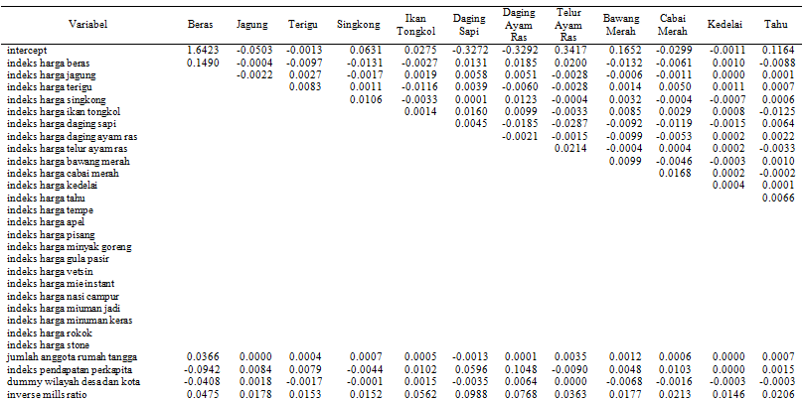

Lampiran 4 Parameter Dugaan di Kaltim

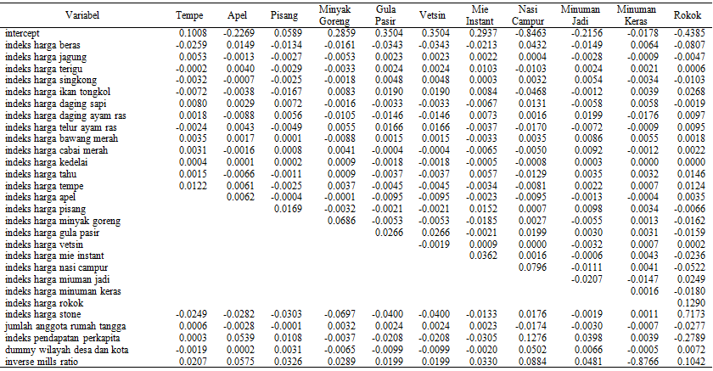

Parameter Dugaan di Kaltim (lanjutan)

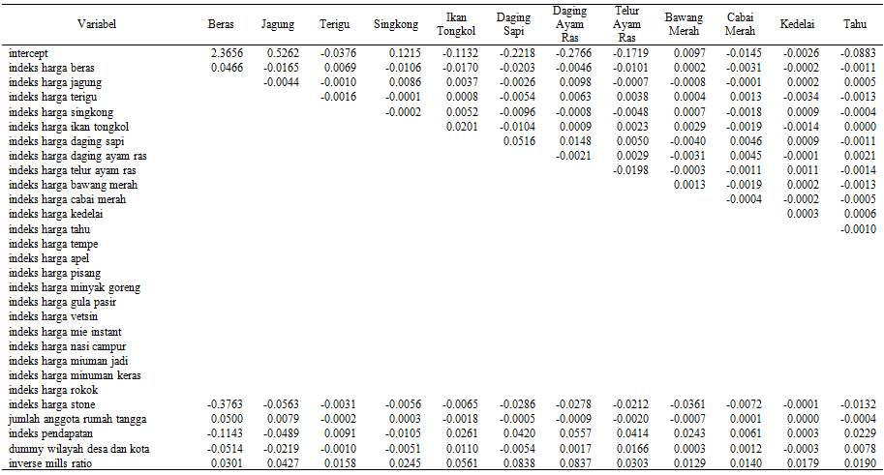

Lampiran 5 Parameter Dugaan di NTT

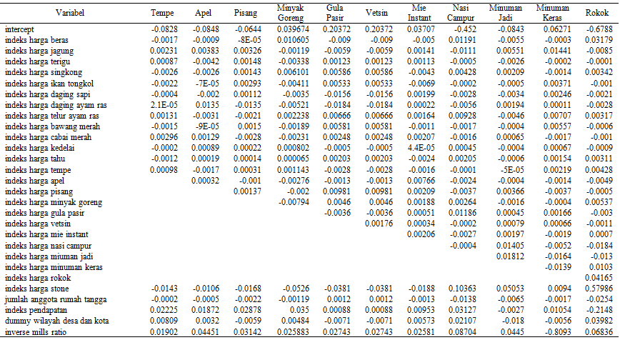

Parameter Dugaan di NTT (lanjutan)

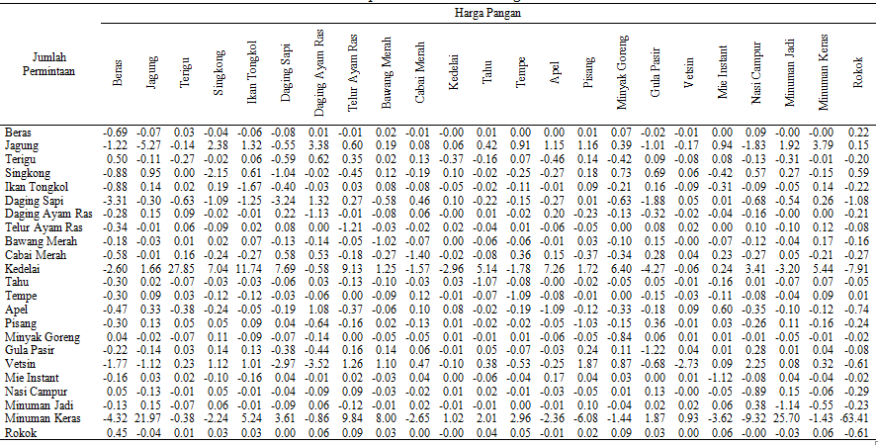

Lampiran 6 Elastisitas Harga di NTT

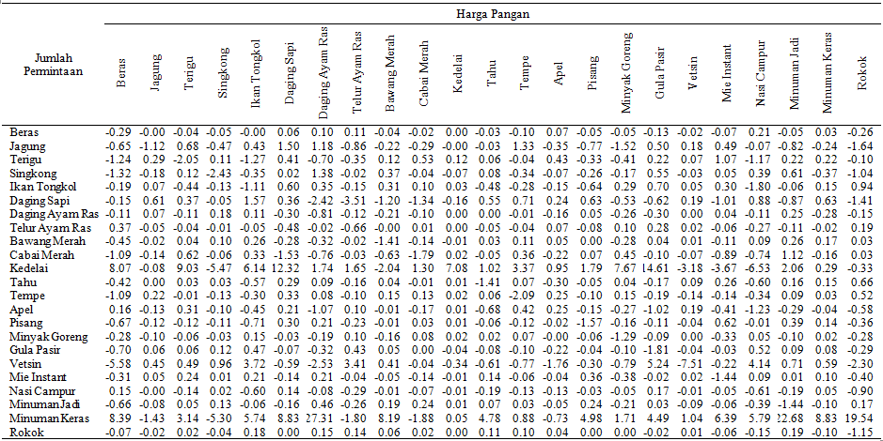

Lampiran 7 Elastisitas Harga di Kaltim

