**Lampiran 1 Data Perusahaan Sampel**

|  |  |  |
| --- | --- | --- |
| **No** | **Kode** | **Nama Perusahaan** |
| 1 | BACA | PT Bank Capital Indonesa Tbk |
| 2 | BBCA | PT Bank Central Asia Tbk |
| 3 | BBMD | PT Bank Mestika Dharma Tbk |
| 4 | BBNI | PT Bank Negara Indonesai Tbk |
| 5 | BBRI | PT Bank Rakyat Indonesia Tbk |
| 6 | BBTN | PT Bank Tabungan Negara Tbk |
| 7 | BDMN | PT Bank Danamon Tbk |
| 8 | BGTG | PT Bank Ganesha Tbk |
| 9 | BINA | PT Bank Ina Perdana Tbk |
| 10 | BJBR | PT Bank Pembangunan Daerah Jawa Barat |
| 11 | BJTM | PT Bank Pembangunan Daerah Jawa Timur Tbk |
| 12 | BMAS | PT Bank Maspion Indonesia Tbk |
| 13 | BMRI | PT Bank Mandiri Tbk |
| 14 | BNBA | PT Bank Bumi Arta Tbk |
| 15 | BNGA | PT Bank CIMB Niaga Tbk |
| 16 | BNII | PT Bank Maybank Indonesia Tbk |
| 17 | BNLI | PT Bank Permata Tbk |
| 18 | BSIM | PT Bank Sinarmas Tbk |
| 19 | BTPN | PT Bank BTPN Tbk |
| 20 | MAYA | PT Bank Mayapada Tbk |
| 21 | MCOR | PT Bank China Constr. Tbk |
| 22 | MEGA | PT Bank Mega Tbk |
| 23 | NISP | PT Bank OCBC NISP Tbk |
| 24 | NOBU | PT Bank Nationalnobu Tbk |
| 25 | PNBN | PT bank Pan Indonesia Tbk |
| 26 | SDRA | PT Bank Woori Saudara Indonesia 1906 Tbk |
| 27 | AMAR | PT Bank Amar Indonesia Tbk |
| 28 | MASB | PT bank Multiarta Sentosa Tbk |
| 29 | AGRO | PT Bank Raya Indonesia Tbk |
| 30 | BABP | PT Bank MNC Internasional Tbk |
| 31 | BBHI | PT. Allo Bank Indonesia Tbk |
| 32 | BBKP | PT Bank KB Bukopin Tbk |
| 33 | BBYB | PT Bank Neo Commerce Tbk |
| 34 | BCIC | PT Bank JTrust Indonesia Tbk |
| 35 | BKSW | PT Bank QNB Indonesia Tbk |
| 36 | DNAR | PT Bank Oke Indonesia Tbk |
| 37 | INPC | PT Bank Artha Graha Internasional Tbk |

**Lampiran 2 Data Penelitian**

|  |  |  |  |  |  |  |
| --- | --- | --- | --- | --- | --- | --- |
| **Tahun** | **No** | **Kode Emiten** | **Modal Intelektual** | **Kinerja Pasar** | **Efisiensi** | **Rasio Pinjaman** |
| 2017 | 1 | BACA | 2.432 | 0.049 | 0.634 | 0.506 |
| 2017 | 2 | BBCA | 4.599 | 0.411 | 1.000 | 0.782 |
| 2017 | 3 | BBMD | 3.623 | -0.113 | 0.646 | 0.810 |
| 2017 | 4 | BBRI | 4.449 | 0.559 | 1.000 | 0.873 |
| 2017 | 5 | BGTG | 2.633 | 0.064 | 0.595 | 0.856 |
| 2017 | 6 | BJBR | 2.220 | -0.292 | 0.600 | 0.814 |
| 2017 | 7 | BJTM | 3.522 | 0.246 | 0.809 | 0.769 |
| 2017 | 8 | BMAS | 2.375 | -0.067 | 0.672 | 0.971 |
| 2017 | 9 | BNBA | 2.796 | 0.340 | 0.541 | 0.821 |
| 2017 | 10 | BNGA | 3.794 | 0.598 | 0.965 | 0.978 |
| 2017 | 11 | BNII | 2.589 | -0.224 | 0.710 | 1.002 |
| 2017 | 12 | BNLI | 3.420 | 0.136 | 0.916 | 0.790 |
| 2017 | 13 | BSIM | 2.154 | 0.011 | 0.884 | 0.836 |
| 2017 | 14 | BTPN | 2.365 | -0.068 | 0.553 | 0.962 |
| 2017 | 15 | MAYA | 9.576 | 0.222 | 0.861 | 0.901 |
| 2017 | 16 | MCOR | 2.004 | 0.446 | 0.735 | 0.776 |
| 2017 | 17 | MEGA | 2.948 | 0.310 | 1.000 | 0.575 |
| 2017 | 18 | PNBN | 4.436 | 0.520 | 0.947 | 0.862 |
| 2017 | 19 | SDRA | 3.567 | -0.226 | 0.940 | 1.102 |
| 2017 | 20 | AGRO | 3.628 | 0.469 | 1.000 | 0.853 |
| 2017 | 21 | BBYB | 1.432 | -0.087 | 0.547 | 0.914 |
| 2017 | 22 | INPC | 1.434 | 0.096 | 0.485 | 0.805 |
| 2018 | 23 | BACA | 3.109 | 0.389 | 1.000 | 0.519 |
| 2018 | 24 | BBCA | 4.716 | 0.189 | 1.000 | 0.833 |
| 2018 | 25 | BBMD | 3.278 | 0.004 | 0.644 | 0.869 |
| 2018 | 26 | BBNI | 4.620 | -0.111 | 0.996 | 0.880 |
| 2018 | 27 | BBRI | 4.470 | 0.005 | 1.000 | 0.879 |
| 2018 | 28 | BDMN | 2.602 | 0.092 | 1.000 | 1.214 |
| 2018 | 29 | BGTG | 2.490 | -0.012 | 0.594 | 0.878 |
| 2018 | 30 | BINA | 1.534 | -0.326 | 0.419 | 0.693 |
| 2018 | 31 | BJBR | 2.476 | -0.146 | 0.638 | 0.872 |
| 2018 | 32 | BJTM | 2.805 | -0.028 | 0.514 | 0.656 |
| 2018 | 33 | BMAS | 1.990 | -0.061 | 0.679 | 1.009 |
| 2018 | 34 | BMRI | 4.703 | -0.078 | 1.000 | 0.981 |
| 2018 | 35 | BNBA | 2.563 | 0.037 | 0.497 | 0.843 |
| 2018 | 36 | BNII | 2.815 | -0.220 | 0.757 | 1.102 |
| 2018 | 37 | BNLI | 2.800 | -0.128 | 0.608 | 0.823 |
| 2018 | 38 | BTPN | 3.214 | 0.398 | 1.000 | 0.962 |
| **Tahun** | **No** | **Kode Emiten** | **Modal Intelektual** | **Kinerja Pasar** | **Efisiensi** | **Rasio Pinjaman** |
| 2018 | 39 | MEGA | 3.203 | 0.467 | 0.833 | 0.696 |
| 2018 | 40 | NISP | 3.689 | -0.090 | 0.918 | 0.903 |
| 2018 | 41 | NOBU | 1.411 | 0.099 | 0.613 | 0.753 |
| 2018 | 42 | PNBN | 4.777 | 0.004 | 0.850 | 0.994 |
| 2018 | 43 | SDRA | 4.606 | -0.034 | 1.000 | 1.449 |
| 2018 | 44 | BABP | 1.878 | 0.000 | 0.590 | 0.790 |
| 2018 | 45 | INPC | 1.395 | -0.225 | 0.451 | 0.726 |
| 2019 | 46 | BACA | 2.779 | 0.000 | 0.519 | 0.606 |
| 2019 | 47 | BBCA | 4.878 | 0.286 | 1.000 | 0.818 |
| 2019 | 48 | BBNI | 4.562 | -0.108 | 1.000 | 0.909 |
| 2019 | 49 | BBRI | 4.572 | 0.202 | 1.000 | 0.903 |
| 2019 | 50 | BBTN | 3.005 | -0.165 | 1.000 | 1.098 |
| 2019 | 51 | BGTG | 2.337 | -0.195 | 0.548 | 0.827 |
| 2019 | 52 | BINA | 1.277 | 0.284 | 0.467 | 0.629 |
| 2019 | 53 | BJTM | 2.825 | -0.007 | 0.563 | 0.605 |
| 2019 | 54 | BMAS | 2.155 | -0.027 | 0.811 | 0.941 |
| 2019 | 55 | BMRI | 4.548 | 0.041 | 1.000 | 0.968 |
| 2019 | 56 | BNGA | 3.546 | 0.055 | 0.946 | 0.993 |
| 2019 | 57 | BNII | 2.533 | 0.000 | 0.809 | 1.078 |
| 2019 | 58 | BSIM | 1.249 | 0.064 | 1.000 | 0.837 |
| 2019 | 59 | BTPN | 3.316 | -0.055 | 0.979 | 1.631 |
| 2019 | 60 | MAYA | 9.202 | 0.295 | 0.789 | 0.933 |
| 2019 | 61 | MCOR | 1.938 | -0.092 | 0.568 | 0.959 |
| 2019 | 62 | MEGA | 3.661 | 0.296 | 0.788 | 0.728 |
| 2019 | 63 | NISP | 3.771 | -0.012 | 1.000 | 0.906 |
| 2019 | 64 | NOBU | 1.458 | -0.110 | 0.540 | 0.791 |
| 2019 | 65 | PNBN | 4.629 | 0.166 | 0.869 | 0.520 |
| 2019 | 66 | SDRA | 4.568 | -0.035 | 1.000 | 1.386 |
| 2019 | 67 | BABP | 2.003 | 0.000 | 0.706 | 0.833 |
| 2019 | 68 | BBKP | 0.999 | 0.137 | 0.474 | 0.828 |
| 2019 | 69 | BBYB | 1.383 | 0.000 | 0.625 | 0.923 |
| 2019 | 70 | BCIC | 1.103 | 0.000 | 0.649 | 0.488 |
| 2019 | 71 | BKSW | 1.039 | -0.011 | 0.814 | 0.803 |
| 2020 | 72 | BACA | 0.750 | 0.253 | 0.730 | 0.393 |
| 2020 | 73 | BBCA | 5.212 | 0.013 | 0.923 | 0.656 |
| 2020 | 74 | BBRI | 3.689 | -0.052 | 0.904 | 0.891 |
| 2020 | 75 | BBTN | 3.170 | -0.186 | 1.000 | 0.907 |
| 2020 | 76 | BDMN | 1.798 | -0.205 | 0.905 | 1.063 |
| 2020 | 77 | BGTG | 2.156 | 0.061 | 0.576 | 0.640 |
| 2020 | 78 | BINA | 1.608 | -0.198 | 0.425 | 0.413 |
| **Tahun** | **No** | **Kode Emiten** | **Modal Intelektual** | **Kinerja Pasar** | **Efisiensi** | **Rasio Pinjaman** |
| 2020 | 79 | BJBR | 2.329 | 0.308 | 0.686 | 0.874 |
| 2020 | 80 | BJTM | 2.514 | -0.007 | 0.568 | 0.582 |
| 2020 | 81 | BMAS | 2.205 | -0.218 | 0.672 | 0.842 |
| 2020 | 82 | BMRI | 4.196 | -0.176 | 0.978 | 0.875 |
| 2020 | 83 | BNBA | 1.728 | 0.082 | 0.536 | 0.766 |
| 2020 | 84 | BNGA | 3.637 | 0.031 | 0.931 | 0.842 |
| 2020 | 85 | BNII | 2.177 | 0.680 | 0.862 | 0.854 |
| 2020 | 86 | BSIM | 1.306 | -0.137 | 0.664 | 0.612 |
| 2020 | 87 | BTPN | 3.366 | -0.043 | 1.000 | 1.351 |
| 2020 | 88 | MCOR | 1.759 | 0.078 | 0.725 | 0.796 |
| 2020 | 89 | MEGA | 4.735 | 0.134 | 0.770 | 0.612 |
| 2020 | 90 | NISP | 4.000 | -0.030 | 0.997 | 0.690 |
| 2020 | 91 | NOBU | 1.528 | -0.073 | 0.555 | 0.763 |
| 2020 | 92 | PNBN | 5.006 | -0.202 | 0.847 | 0.804 |
| 2020 | 93 | SDRA | 4.404 | -0.108 | 0.984 | 1.600 |
| 2020 | 94 | AMAR | 4.385 | 0.632 | 0.996 | 0.555 |
| 2020 | 95 | BBHI | -3.052 | 0.240 | 0.739 | 0.856 |
| 2020 | 96 | BBYB | 1.349 | 0.049 | 0.867 | 0.860 |
| 2020 | 97 | DNAR | 1.333 | -0.267 | 0.648 | 1.359 |
| 2020 | 98 | INPC | 1.266 | 0.131 | 0.535 | 0.468 |
| 2021 | 99 | BACA | 1.088 | -0.293 | 0.519 | 0.124 |
| 2021 | 100 | BBCA | 5.403 | 0.078 | 0.977 | 0.609 |
| 2021 | 101 | BBMD | 4.652 | 0.333 | 0.712 | 0.701 |
| 2021 | 102 | BBNI | 4.554 | 0.093 | 1.000 | 0.716 |
| 2021 | 103 | BBRI | 3.864 | -0.014 | 0.955 | 0.905 |
| 2021 | 104 | BBTN | 3.427 | 0.003 | 1.000 | 0.905 |
| 2021 | 105 | BDMN | 1.814 | -0.252 | 1.000 | 1.035 |
| 2021 | 106 | BJBR | 2.395 | -0.139 | 0.664 | 0.824 |
| 2021 | 107 | BJTM | 2.644 | 0.103 | 0.580 | 0.489 |
| 2021 | 108 | BMRI | 4.166 | 0.111 | 1.000 | 0.849 |
| 2021 | 109 | BNGA | 3.828 | -0.030 | 0.861 | 0.752 |
| 2021 | 110 | BNII | 2.339 | -0.040 | 0.788 | 0.848 |
| 2021 | 111 | BTPN | 3.514 | -0.158 | 0.654 | 1.240 |
| 2021 | 112 | MEGA | 5.573 | 0.177 | 0.995 | 0.613 |
| 2021 | 113 | NISP | 4.093 | -0.183 | 0.958 | 0.674 |
| 2021 | 114 | NOBU | 1.622 | -0.139 | 0.458 | 0.613 |
| 2021 | 115 | SDRA | 4.845 | -0.236 | 0.773 | 1.402 |
| 2021 | 116 | MASB | 4.172 | 0.057 | 0.846 | 0.378 |
| 2021 | 117 | BABP | 1.825 | 0.263 | 0.707 | 0.728 |

**Lampiran 3 Hasil Analisis Regresi**

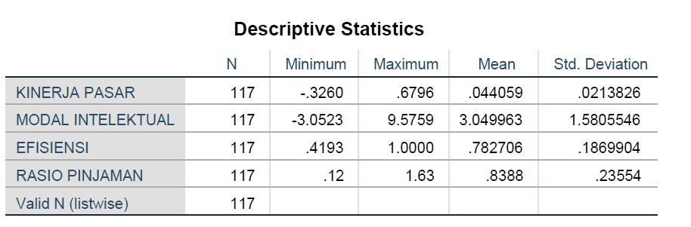

**Lampiran 3a Hasil Regresi Pengaruh Modal Intelektual terhadap Kinerja Pasar**

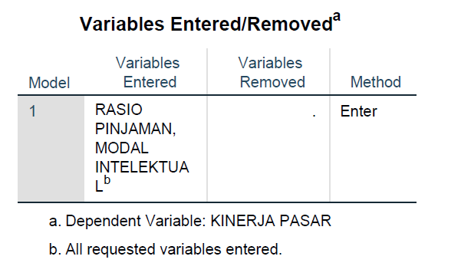

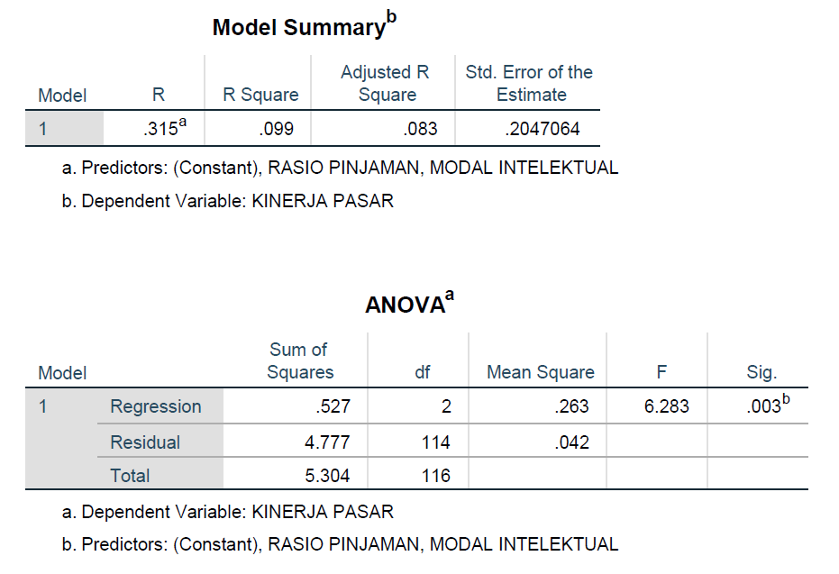

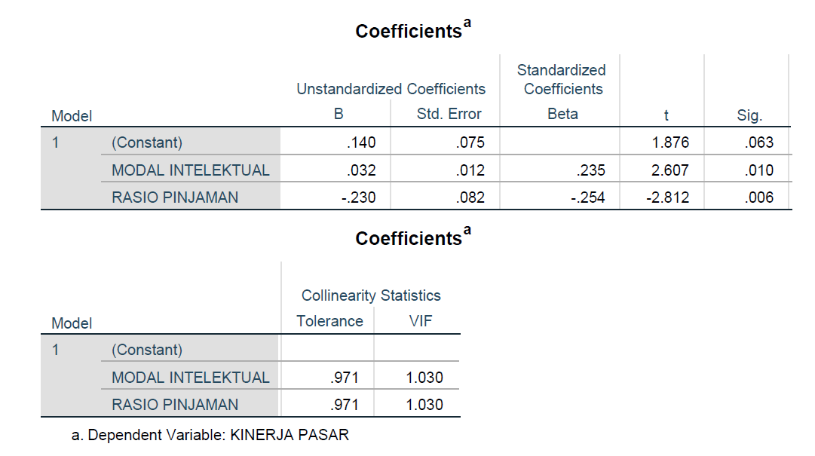

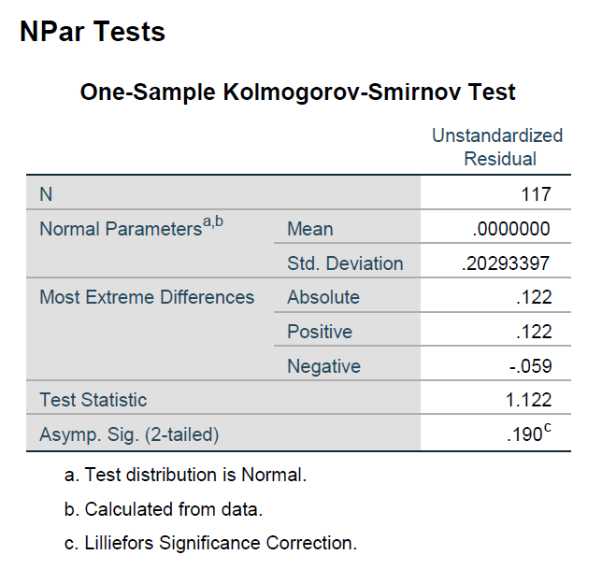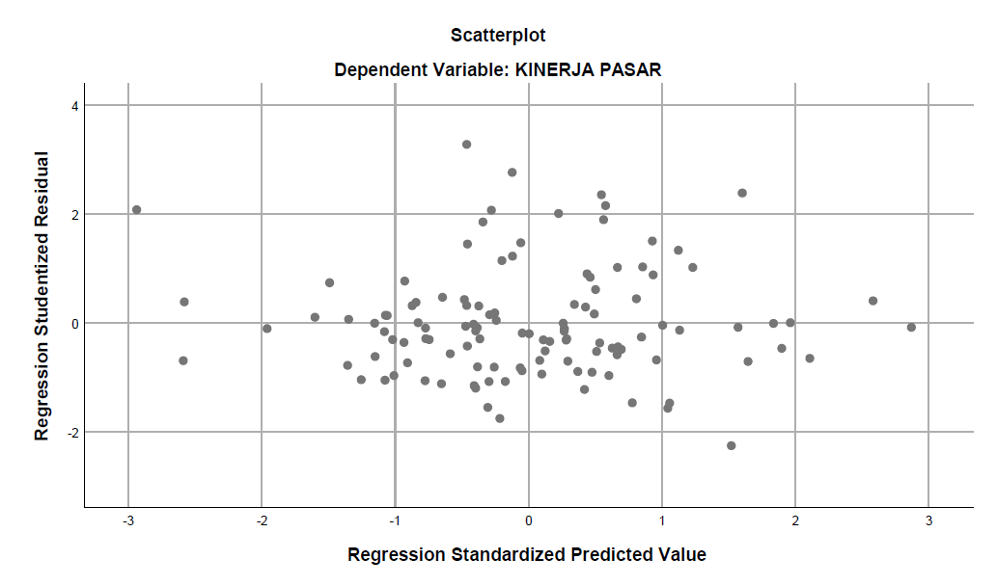

**Lampiran 3b Hasil Regresi Pengaruh Modal Intelektual terhadap Efisiensi Perbankan**

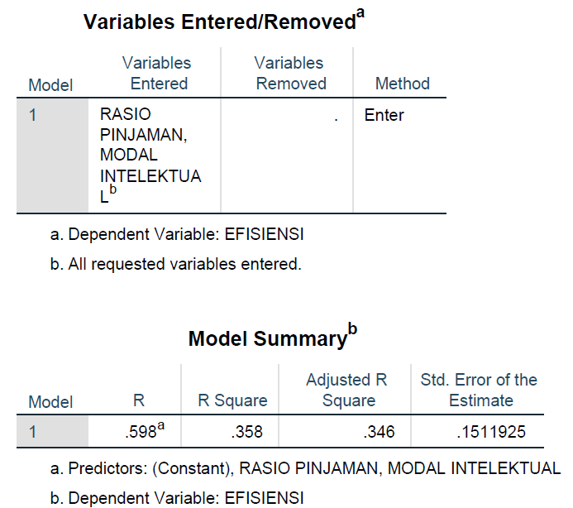

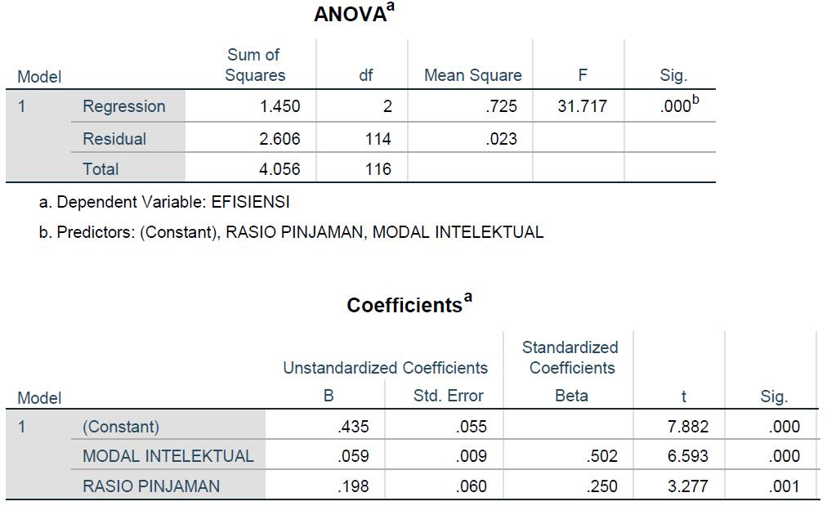

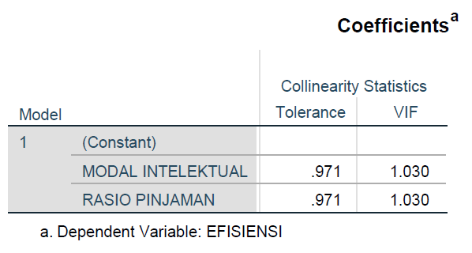

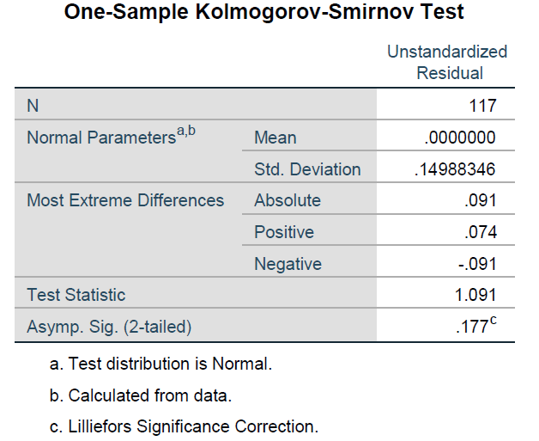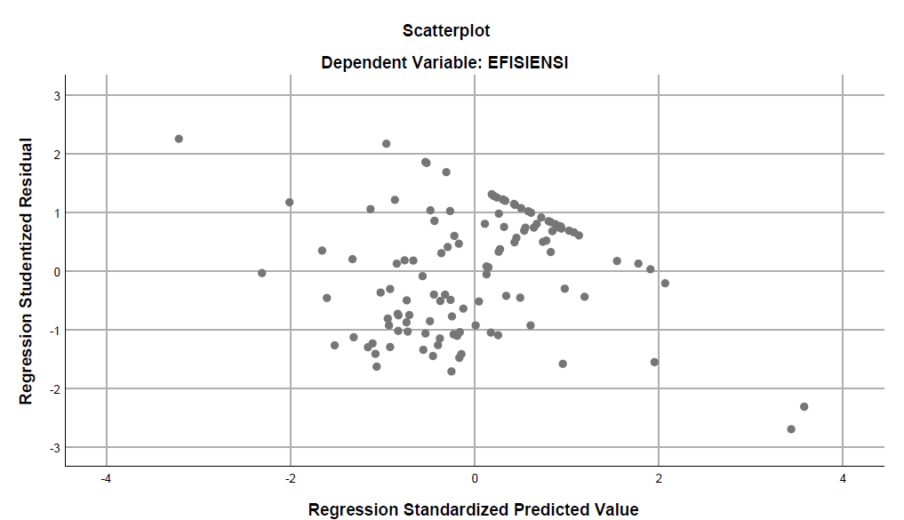

**Lampiran 3c Hasil Regresi Pengaruh Efisiensi Perbankan terhadap Kinerja Pasar**

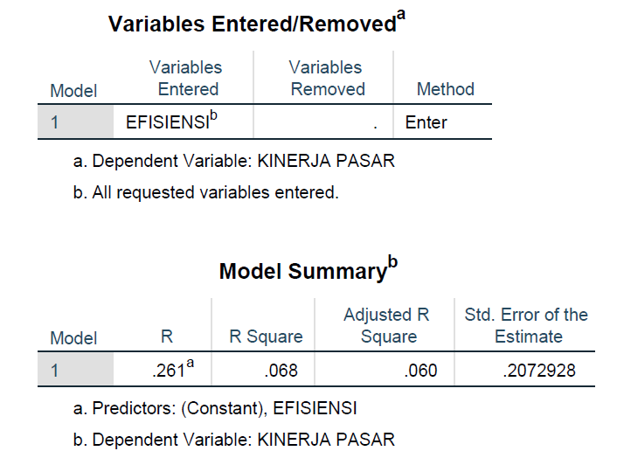

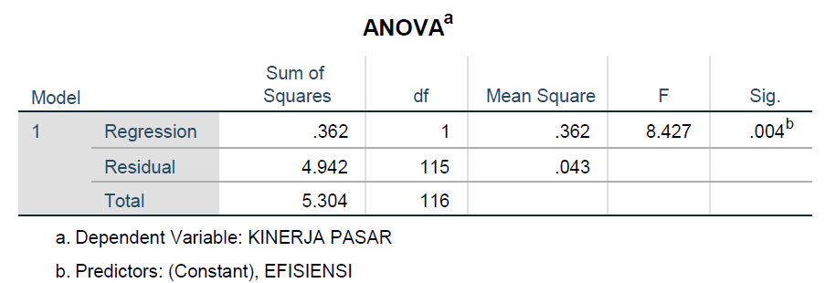

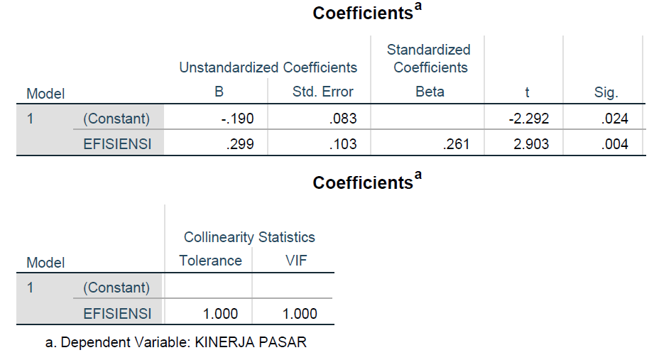

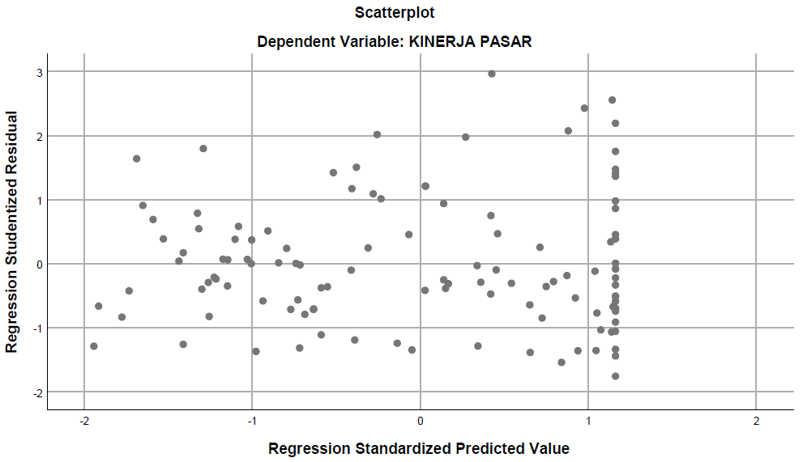

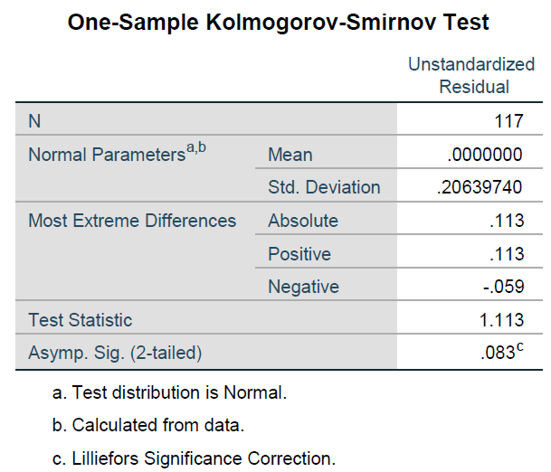

**Lampiran 3d Hasil Regresi Pengaruh Modal Intelektual terhadap Kinerja Pasar dengan Efisiensi Perbankan sebagai mediasi**

