

Research Article

**Comparison of Ricketts Method of Cephalometric Measurements Between Hand Tracing and Digital Tracing Based on Android OneCeph**

**Tita Ratya Utari1, Nur Izzatul Mujidah2**

1Department of Orthodontics, Faculty of Dentistry, Universitas Muhammadiyah Yogyakarta, Jalan Brawijaya, Tamantirto, Kasihan, Bantul, Indonesia.

2Dentistry Study Program, Faculty of Dentistry, Universitas Muhammadiyah Yogyakarta, Jalan Brawijaya, Tamantirto, Kasihan, Bantul, Indonesia.

**IDJ use only:** Received date here; revised date here; accepted date here

**DOI :**

*Abstract*

*Lateral cephalometric radiographic examination is one of the supporting examinations in orthodontic treatment. Cephalometric measurements can be performed using hand tracing (manual) and digital methods. The digital method is widely preferred today because of its faster measurement, easy and safe storage, and can be sent anywhere easily. One of the applications that can be utilized for digital analysis is OneCeph. This application’s accuracy for cephalometric analysis, therefore, needs to be evaluated. This study aims to determine the differences in cephalometric measurements using the Ricketts method between hand tracing and digital tracing based on the OneCeph Android application. This analytic observational study used a cross-sectional design conducted at the Dental Hospital of UMY. The samples were 30 lateral cephalometric radiographs of good quality and had film negatives and digital files. Then, the Ricketts method analysis was carried out manually and digitally utilizing the OneCeph application. The Shapiro Wilk test results obtained that the data were normally distributed for all components except for the convexity of point A, lower incisor to A Pog line, and e-line. Comparative test results with independent sample t-test and Mann-Whitney test got no significant difference in all components (p>0.05), except for the variable lower incisor to A Pog line (p<0.05). The multivariate analysis results also showed p>0.05, demonstrating no significant difference for all component (p>0.05). The OneCeph application is no different from the gold standard (hand tracing/manual method) that has been used so far, so it can be an alternative for cephalometric tracing.*

***Keywords:*** *Orthodontics; Cephalometry, Hand Tracing, Digital Tracing, Ricketts, OneCeph*

INTRODUCTION

Orthodontics is a treatment in the field of dentistry to treat craniofacial, dentofacial growth, dental occlusion relationships, and facial esthetics.1 Orthodontic treatment requires supporting examinations in the form of radiography as a diagnostic tool, in which one way to obtain radiographic images that function to make treatment plans and check the progress of patients undergoing orthodontic treatment is cephalometric radiography.2

Cephalometric studies quantitative head measurements to obtain information about craniofacial patterns. The benefits and uses of cephalometry are that it can be a diagnostic tool and an evaluation tool in the fields of pedodontics, prosthodontics, orthodontists, oral surgeons, and general dentists.3

Cephalometric measurements can be carried out in two versions, i.e., the hand tracing or manual method and the digital method. This manual method is extensively utilized in cephalometric measurements but is quite time-consuming and has several drawbacks, such as the risk of errors in tracking, measuring, and identifying landmarks. Meanwhile, digital cephalometric measurements are widely preferred nowadays because they have several advantages over those of using the hand tracing method, including faster measurements, easier treatment plans to determine, easy and safe image storage, and can be sent anywhere easily.4

Several analytical methods employed to perform cephalometric measurements encompass the Down, Wendel Wylie, Steiner, Ricketts, Tweed, and Holdaway methods5. Of the various cephalometric measurement methods, the researchers chose the Ricketts method since it is simple and easy to apply6. The hallmark of the Ricketts method is the aesthetic line created by a line drawn from the pogonion (Pog) to the tip of the nose (Pr). Ricketts also devised a method of facial convexity and height from within the facial skeleton7.

Moreover, several smartphone-based applications for measuring cephalometrics include OneCeph, CephNinja, EasyCeph, and OrthoCeph. In this case, the OneCeph utilized in this study was an Android-based application with programs for analyzing cephalometrics, such as Down, Steiner, Ricketts, Tweed, Holdaway, Jabarak, McNamara, Schwarz, Yen angle, Beta angle, and Wits Appraisal. OneCeph is also one easy-to-use mobile software since it is operated on mobile phones, especially Android, so it is easy to carry, lightweight, practical to operate anywhere, and measurements can be done automatically. However, this application’s accuracy for cephalometric analysis needs to be evaluated.

**MATERIALS AND METHOD**

This analytic observational study employed a cross-sectional design and was conducted at the Dental Hospital, Universitas Muhammadiyah Yogyakarta. The samples used in this study were 30 lateral cephalometric radiographs of patients from the Dental Hospital of UMY and lateral cephalometric radiographs of patients from private orthodontic practice, with good quality and negative films and digital files. The sampling technique utilized was purposive sampling.

Thirty lateral cephalometric radiographic films were analyzed using the Ricketts method using manual cephalometric analysis techniques and then digital techniques utilizing the OneCeph Android-based application (Figure 1). This study used 11 components in the Ricketts method: Facial axis angle, Mandibular plane angle, Facial taper, Lower facial height angle, Mandibular arc angle, Convexity of point A, Lower incisor to A-Pog line, Lower incisor inclination, Upper molar to PTV, Interincisal angle (IIA), Lower lip, and E-line (Figure 2).

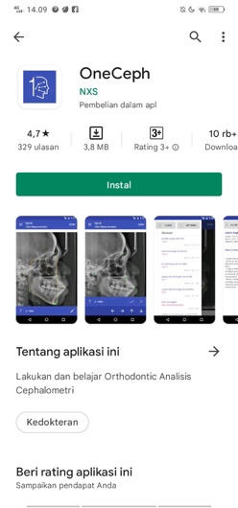

**Figure 1.** OneCeph application

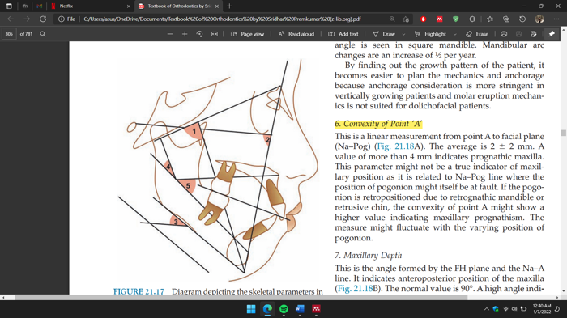

**Figure 2.** Ricketts analysis. (1) Facial axis, (2) Facial depth, (3) Mandibular plane angle, (4) Lower facial height, and (5) Mandibular arc (Premkumar, 2015)

The research data were then analyzed using SPSS, including the Shapiro-Wilk normality test, independent sample t-test/Mann-Whitney Test, and multivariate analysis.

**RESULT**

The results of the two analyzes are presented in Table 1.

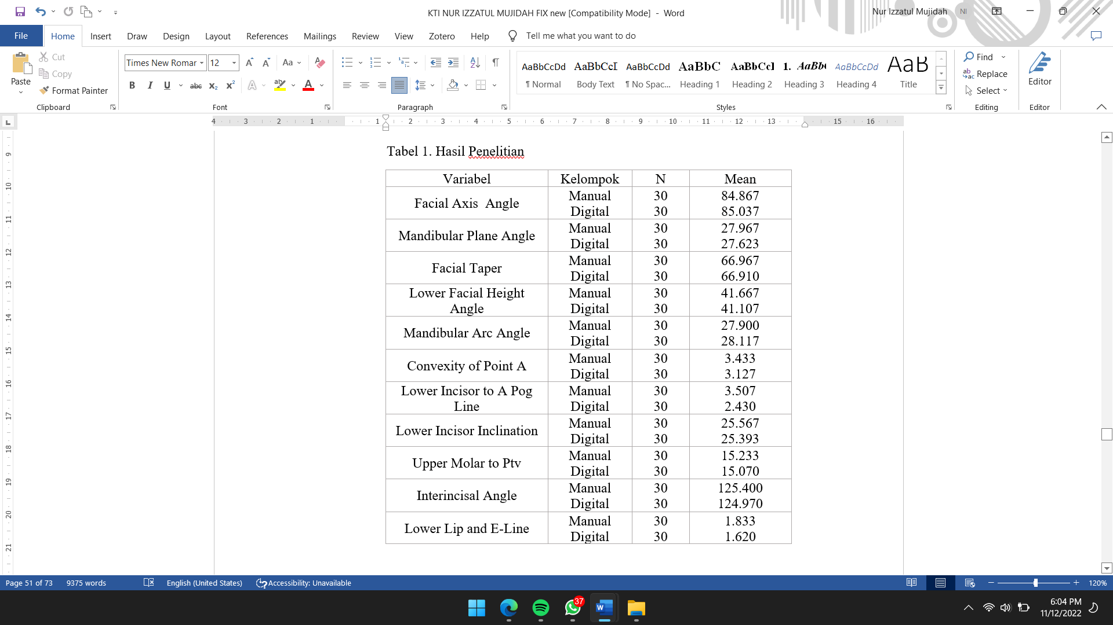

**Table 1**. Research Results Variable Group

The analysis results were then tested for normality using Shapiro-Wilk. The normality test results are in Table 2.

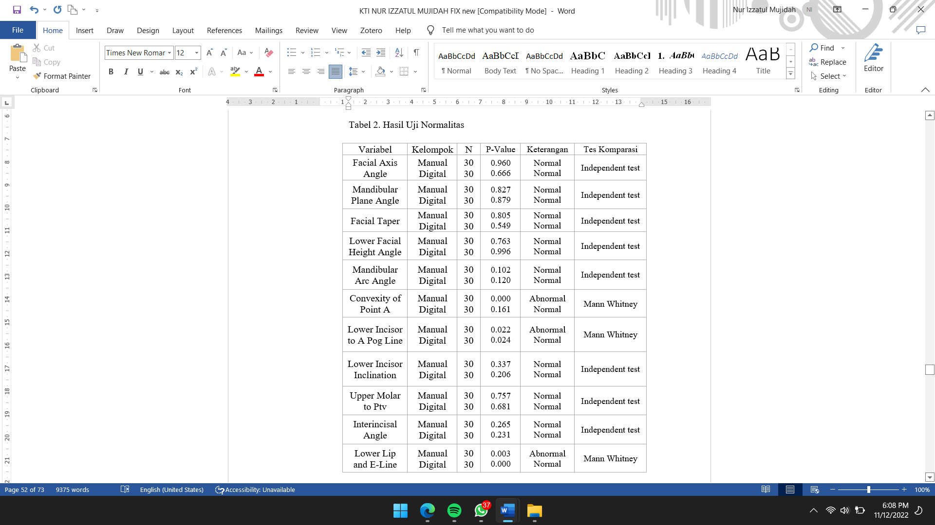

**Table 2**. Normality Test Results Variable Group Description Comparison Test

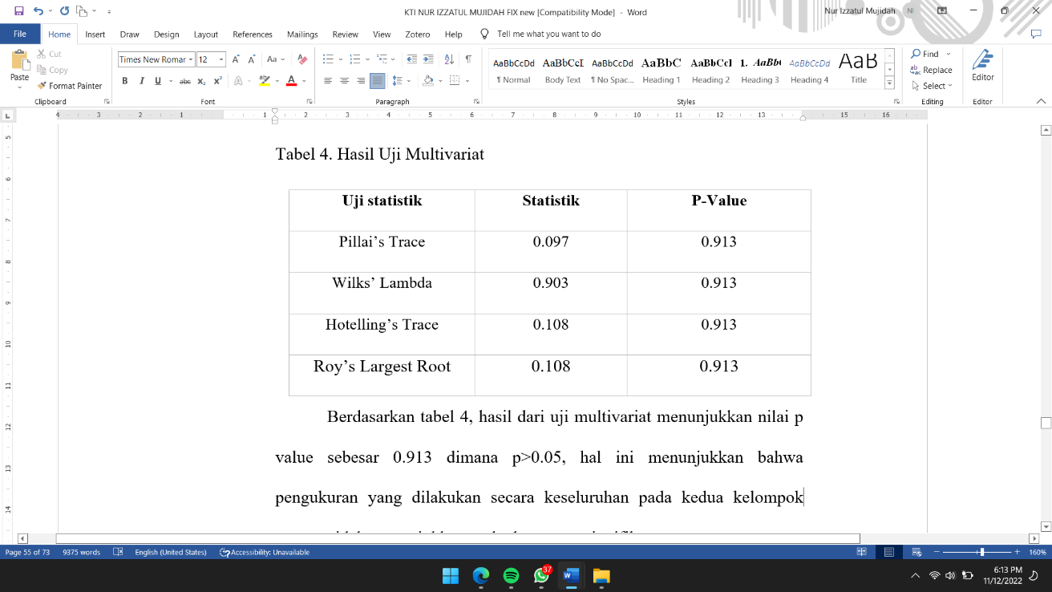Based on Table 2, the normality test results from cephalometric measurements of facial axis angle, mandibular plane angle, facial taper, lower incisal height angle, mandibular arc angle, lower incisor inclination, upper molar to PTV, and interincisal angle in manual cephalometric analysis and digital cephalometric analysis using OneCeph obtained a significance value of p>0.05. It means that the data were normally distributed. Meanwhile, in the convexity of point A, lower incisor to A Pog line, and e-line measurements in manual cephalometric analysis and digital cephalometric analysis using OneCeph, a significance value of p<0.05 was obtained, indicating that the data were not normally distributed. Therefore, the eight variables with normally distributed data were analyzed using the independent sample t-test to see the differences in the manual and digital cephalometric analysis measurement results utilizing Oneceph. Meanwhile, the convexity of point a, lower incisor to a Pog line, and e-line were analyzed using the Mann-Whitney Test. The comparative test results are shown in Table 3.

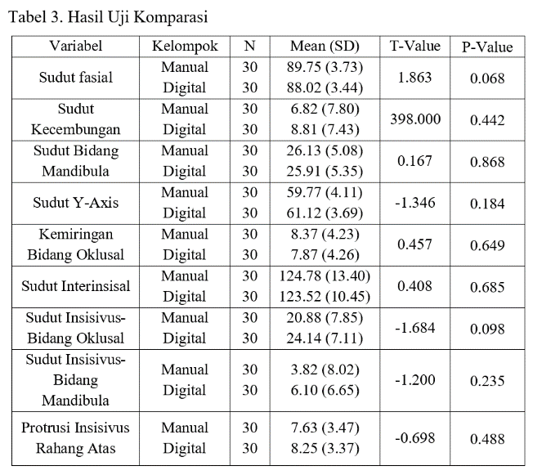

**Table 3.** Comparison Test Results Variable Group

Based on Table 3, all components of the cephalometric measurement showed a value of p>0.05. These results suggest that no significant difference existed between the manual cephalometric and the digital cephalometric analysis groups using OneCeph in all components. Furthermore, to compare the overall cephalometric analysis, data were tested using multivariate analysis. The multivariate analysis results are in Table 4.

Table 4. Multivariate Test Results Statistic test Statistics

Based on Table 4, the multivariate test results revealed a p-value of 0.913, i.e., p>0.05. It demonstrates that the measurements taken as a whole in the two tracing groups did not show a significant difference.

**DISCUSSION**

Based on Table 2, the independent sample t-test results uncovered no significant difference between manual cephalometric measurements and digital cephalometric analysis utilizing OneCeph for facial axis angle, mandibular plane angle, facial taper, lower facial height angle, mandibular arc angle, lower incisor inclination, upper molar to PTV, and interincisal angle, indicated by a p-value of >0.05. It aligns with a previous study by Faliya et al. (2021), who compared cephalometric measurements using digital and manual analysis.9 Their study results demonstrate no significant difference between the two analyses. The research also explains the advantage of OneCeph, i.e., having the same accuracy level as manual analysis. It is one of the reasons for the absence of a significant difference between digital and manual cephalometric measurements.

Moreover, the Mann-Whitney Test results showed no significant difference between manual cephalometric analysis and digital cephalometric analysis using OneCeph, showing p>0.05, except for the lower incisor to a Pog line. At the lower incisor to the A Pog line, p<0.05 means a significant difference between the two analyses. In this case, the lower incisor to a Pog line is formed by the incisal point on the mandibular incisor to the line connecting point A to the pogonion point. In a previous study by Shrestha & Kandel (2020), identifying landmarks from lower incisors had a statistically significant difference because the zoom-in function of OneCeph is very sensitive when identifying landmarks from mandibular incisors.10 According to prior research by Barbhuiya et al. (2021), identification of point A is also often in error since point A is adjacent to the soft tissue near the anterior nasal spine, which casts a shadow on X-rays, making identification in the OneCeph application more difficult.11 These two reasons could be why there was a significant difference in the variable lower incisor to a Pog line.

Based on Table 4, the four multivariate analysis methods, namely Pillai's Trace, Wilk's Lambda, Hotelling's Trace, and Roy's Largest Root, had p> 0.05. It denotes that the overall cephalometric variables in the manual and digital cephalometric analyses using OneCeph did not significantly differ. This study’s results agree with research by Faliya et al. (2021), who showed no significant difference between manual cephalometric analysis and digital cephalometric analysis using OneCeph on 40 radiographs using Tweed analysis.9 Thus, it was concluded that OneCeph is relatively accurate compared to manual cephalometric analysis.

It is also consistent with research by Shrestha & Kandel (2020), explaining no significant difference between manual cephalometric analysis and digital cephalometric analysis using OneCeph. Their research compared the duration of manual and digital cephalometric measurements using the OneCeph application.10 Analysis was performed on 35 cephalometric radiographs measuring eight skeletal, five dental, and three soft tissue measurements. Likewise, it also corroborates with a study by Akshay Mohan et al. (2021), who explained that there was no significant difference because all parameters had a p-value>0.05, both digital cephalometric measurements carried out using the OneCeph application and manual cephalometric measurements. The study also compared the reliability and accuracy of digital cephalometric measurements performed utilizing the OneCeph application with manual cephalometric measurements using 20 pre-treatment lateral cephalometric radiographs of subjects. They came to a postgraduate orthodontic clinic for orthodontic treatment for more than one month. Cephalometric measurements were performed using the OneCeph application to evaluate the nine parameters of Steiner's cephalometric analysis.11

Manual cephalometric analysis was carried out by manual measurement using a caliper and protractor. This analysis was one of the shortcomings since the operator had limitations in making measurements and was less accurate than digital cephalometric analysis. On the other hand, in digital cephalometric analysis, OneCeph was utilized. It is mobile software, which is easy to use, fast, saves time, and has other advantages. They included free of charge in conducting cephalometric analysis, carrying out unlimited measurements, and even performing cephalometric analysis on a smartphone without an internet connection. Thus, it can be used in conducting studies in rural centers with less internet access. Meanwhile, the weakness of OneCeph is that this application’s availability is only found on Android-based smartphones, and the measurement uses a semi-automatic method.12

Furthermore, manual tracing and OneCeph have similarities in the anatomical landmark points determined by the operator manually, while the measurement of angles and distances is done automatically in OneCeph with a faster time than manual tracing. It makes this application semi-automatic, so there is no significant difference between manual tracing and digital tracing utilizing OneCeph. Hence, the OneCeph application can make it easier for operators to obtain results from measurements taken and reduce measurement error rates.

**CONCLUSION**

Based on the research results, it can be concluded that there was no significant difference between manual cephalometric analysis and digital cephalometric analysis based on Android OneCeph. Thus, it can be an alternative to cephalometric tracing.

**ACKNOWLEDGMENTS**

This research was supported by funding from Universitas Muhammadiyah Yogyakarta. We thank our university for providing financial support, facilities, and infrastructure that greatly assisted this research.

**REFERENCES**

1. Kumar P, Londhe SM, Kotwal A, Mitra R. Prevalence of malocclusion and orthodontic treatment need in schoolchildren – An epidemiological study. *Med J Armed Forces India*. 2013;69(4):369-374.

2. Sandeep Goyal. *Textbook of Orthodontics*. Departemen. (Goyal Sonia, ed.). CBS Publishers & Distributors Pvt Ltd; 2017. pg. 510-532.

3. Brahmanta A. *Gambaran Sefalometri Skeletal, Dental Dan Jaringan Lunak*. (S. Revianti, ed.). Kartika Mulya; 2017. hal 9.

4. Mitra R, Chauhan A, Sardana S, Londhe SM, Jayan B, Maurya R. Determination of the comparative accuracy of manual, semi-digital, and fully digital cephalometric tracing methods in orthodontics. *J Dent Def Sect*. 2020;14(2):52.

5. Gayatri G, Harsanti A, Zenab Y, Sunaryo IR. Steiner cephalometric analysis discrepancies between conventional and digital methods using CephNinja application software. *Padjadjaran J Dent*. 2016;28(3):154-158.

6. Juma et al. The alternative use of a nonconventional orthopantomograms analysis technique for facial skeletal assessment. *Int J Orofac Res*. 2018;3(2):26.

7. Turley PK. Evolution of esthetic considerations in orthodontics. *Am J Orthod Dentofac Orthop*. 2015;148(3):374-379.

8. Zamrik OM, Iseri H. The reliability and reproducibility of an Android cephalometric smartphone application in comparison with the conventional method. *Angle Orthod*. 2021;91(2):236-242.

9. Faliya N, Doshi J, Gandhi P, Mathakiya L, Bind P. Comparing the Efficacy between OneCeph digital software versus Manual Cephalometric Tracing. *J Adv Heal Sci Res |Jan*. 2021;2(1).

10. Shrestha R, Kandel S. A Comparative Study on Use of Manual Versus Digital Method using Mobile Application for Cephalometric Measurements. *Orthod J Nepal*. 2020;10(1):11-16.

11. Mohan, A., Sivakumar, A. & Nalabothu, P. Evaluation of accuracy and reliability of OneCeph digital cephalometric analysis in comparison with manual cephalometric analysis—a cross-sectional study. *BDJ Open* **7**, 22 (2021). https://doi.org/10.1038/s41405-021-00077-2

12. Goutham, S N, HK V, Ramegowda S, AM S. Handy Gadget for Cephalometric Analysis: A Systematic Review. *J Indian Orthod Soc*. 2021;55(1):64-71.