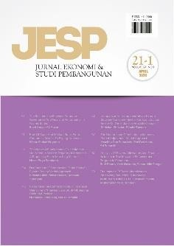Author Declaration Form

Jurnal Ekonomi & Studi Pembangunan

ISSN: 2541-5506 (Online) and 1411-9900 (Print)

https://journal.umy.ac.id/index.php/esp

Name of Principal/Corresponding Author\*

Indanazulfa Qurrota A’yun

Address of Principal/Corresponding Author\*

Jl. Tampungan No.98, Tampungan, Sendangtirto, Kec. Berbah, Kabupaten Sleman, Daerah Istimewa Yogyakarta 55573

Telephone\*

0857-4661-0873

Fax\*

-

All author(s) name\*

Indanazulfa Qurrota A’yun, Uswatun Khasanah

Date of submitted\*

2022-02-03

Manuscript title\*

THE EFFECT OF ECONOMIC GROWTH AND TRADE OPENNESS ON ENVIRONMENTAL QUALITY: EVIDENCE FROM 10 ASEAN MEMBER COUNTRIES

1. Declare that the article above is original. my own thoughts not translated, and has not been published elsewhere or currently not in the process of other journal publications. I am willing to be responsible if there are parties who feel disadvantaged privately and/or based on a lawsuit in the future by the publication of this article.
2. I also declare that the transfer of copyright for the first publication is granted to

Jurnal Ekonomi & Studi Pembangunan.



Indanazulfa Qurrota A’yun

2022-02-07

Editorial Office Jurnal Ekonomi & Studi Pembangunan:

Journal Room, E4 Building, 2nd Floor, Faculty of Economics and Business, Universitas Muhammadiyah Yogyakarta, Jalan Lingkar Selatan (Brawijaya), Tamantirto, Kasihan, Bantul, Daerah Istimewa Yogyakarta, Indonesia 55183.