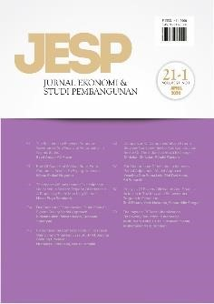 **Author Declaration Form**

**Jurnal Ekonomi & Studi Pembangunan**

ISSN: 2541-5506 (Online) and 1411-9900 (Print) https://journal.umy.ac.id/index.php/esp

Name of Principal/Corresponding Author*

Nadya Setiawati

Address of Principal/Corresponding Author*

Jln. Raya Manggar, Ds. Mentawak RT01/RW01, Kec. Kelapa Kampit, Belitung Timur, Bangka Belitung, 33571

Telephone*

082289559672

E-mail*

[Nadya19007@mail.unpad.ac.id](mailto:Nadya19007@mail.unpad.ac.id)

Fax*

-

All author(s) name*

Nadya Setiawati

Eksa Pamungkas

Date of submitted*

June, 27 2022

Manuscript title*

How Important is Environmentally Sustainable-Tourism? Evidence in Indonesia from 1974 – 2018 Using NARDL Cointegration

1. Declare that the article above is original. my own thoughts not translated, and has not been published elsewhere or currently not in the process of other journal publications. I am willing to be responsible if there are parties who feel disadvantaged privately and/or based on a lawsuit in the future by the publication of this article.
2. I also declare that the transfer of copyright for the first publication is granted to Jurnal Ekonomi & Studi Pembangunan.

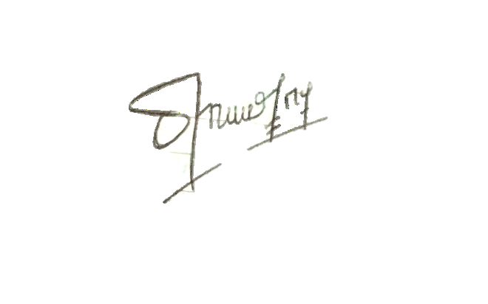Belitung Timur, June 27 2022

Nadya Setiawati

Editorial Office Jurnal Ekonomi & Studi Pembangunan:

Journal Room, E4 Building, 2nd Floor, Faculty of Economics and Business, Universitas Muhammadiyah Yogyakarta, Jalan Lingkar Selatan (Brawijaya), Tamantirto, Kasihan, Bantul, Daerah Istimewa Yogyakarta, Indonesia 55183.