**Money Demand in Indonesia: Does Economic Uncertainty Matter?**

**Abstract**

Research on economic uncertainty and its effect on money demand has increased since the 2008 global crisis. The money demand is vital in monetary policy, which has implications for the regional economy. This study aims to analyze the money demand in Indonesia in the middle of global economic uncertainty. The study used a structural vector autoregressive (SVAR) approach. The results show that the demand for money responds negatively to economic uncertainty. With the development of the financial sector, the impact of economic uncertainty and the uncertainty of US monetary policy causes people to be more careful so that people will shift their "wealth" to other instruments. The current study implies that the monetary policy in the form of interest rate as the response to the global condition should consider the monetary aggregates in terms of money demand as an anticipatory step in maintaining money demand.

**Keywords**: Economic Uncertainty, Money Demand, Monetary Policy, SVAR

**JEL Classification: D81, E41, E44**

**Introduction**

Control over the money demand development is important to achieve a safe and stable level. The money demand can affect many economic aspects, such as inflation, investment, savings, and demand for assets in other sectors. The money demand is the economy's liquidity and can determine the state of a country's economy. The monetary policy challenges, particularly in the money demand sector, were increasing along with the global uncertainty, given that the economy in developing countries, particularly Indonesia, was vulnerable to crisis.

There has been a long debate regarding the role of money demand in the monetary policy framework. Poole (1970) stated that the monetary authority can utilize money demand as a formula by applying monetary aggregates as a policy tool. In contrast, Friedman (1975) stated that monetary aggregates as a policy tool do not play a direct role in the policy process. Thus, Friedman emphasized the main target of monetary policy, namely actual output. The development of the literature shows that one of the targets of monetary policy is the level of price stability. That way, the inflation targeting policy can be applied to money targeting or monetary aggregates. Duca and VanHoose (2004) stated that the development of financial innovation would have a practical impact on implementing monetary policy. It implies that studies related to money demand are essential to provide policy alternatives to the monetary authorities.

Environment economics plays an essential role in the changing patterns of money demand. Economic uncertainty will increase output volatility, affecting people's decisions to allocate their wealth. This study emphasizes the economic uncertainty, which reflects people's behavior in holding money. If people expect high inflation rates due to conditions of economic uncertainty, they will hold more assets than cash. Furthermore, they will hold more money if people expect output and money volatility due to uncertain employment opportunities.

Previous researchers have widely developed research related to money demand. There are some studies regarding the money demand stability in Indonesia, such as Alamsyah et al. (2001), James (2005); Narayan (2007); and Kurniawan (2020). The result of the studies revealed different views of the monetary policy on whether to apply money targeting or inflation targeting. Studies related to money demand can be developed using the economic uncertainty variable in Indonesia. Limited studies have concerned the response to money demand by applying the variable of economic uncertainty and also analyzing the elasticity of demand for money against crisis shocks and economic uncertainty in the model.

Is the pattern of money demand in Indonesia stable? There are different views regarding the stability of money demand in Indonesia. The implication is related to the policies that the monetary authorities can take as a monetary policy strategy. Research by James (2005) analyzed the demand for money in Indonesia from 1983 to 2000 using a time-trend as a proxy for financial liberalization. The result shows cointegration between money demand and income and interest rates. The study employed the CUSUM and CUSUMQ approaches. The study revealed that the money demand model in Indonesia is stable. The study by James (2005) supports money targeting monetary aggregates as monetary policy. Another research by Kurniawan (2020) analyzed money demand in Indonesia using the CUSUM and CUSUMQ approaches on the autoregressive distributed lag model (ARDL) by utilizing quarterly data from 2000 to 2019. The research showed that the money demand model in Indonesia is unstable. It implied that Kurniawan (2020) supports inflation targeting as a monetary policy in Indonesia.

Narayan (2007) developed a different technique by employing the Johansen Cointegration approach shows that the model has cointegration in the long run between the money demand and its determinants in Indonesia. Meanwhile, the stability test using the Hansen Test approach showed that the money demand model in Indonesia is unstable. The results imply that Narayan (2007) supports inflation targeting as a monetary policy by Bank Indonesia. Alamsyah et al. (2001) argued that the inflation targeting policy implemented by the monetary authority would directly affect aggregate demand, which is consistent with maintaining the supply side and sustainable economic growth. Implementing inflation targeting is a logical monetary policy and is accepted by a broad audience.

Currently, money demand and growth are moving towards uncertain fluctuations, which leads to instability in money demand. Thus, the money targeting policy is "difficult" to apply. The innovation development in the financial sector creates the money velocity more volatile. Furthermore, the challenges to money demand become more severe coupled with the macroeconomic conditions of a country and conditions of economic uncertainty.

Ball (2012) argues that the money target policy can be applied if the money demand is stable. The stability of money demand is explained by velocity from M1 with GDP, where stable M1 growth will produce stable GDP growth. Currently, money demand growth moves towards uncertain fluctuations, leading to money demand instability. In that way, the money targeting policy is "difficult" to apply. The development of innovation in the financial sector creates the velocity of money to move more fluctuate. Furthermore, the challenges to the money demand become heavier with the uncertain condition of the economy.

The economist's attention to economic uncertainty increases with the global financial crisis (Baker, Bloom, and Davis, 2016). Coupled with a trade war and pandemic, uncertainty in the future must be anticipated. Pastor and Veronesesi (2013) argue that economic uncertainty causes a condition where there is no certainty of trends in the future and the movement of economic policy. The current condition of economic uncertainty gradually has an adverse impact on economic growth or macroeconomic variables, one of which is the demand for money.

In Indonesia, the economic uncertainty that occurred during the 1998 crisis increased again during the 2008 global crisis and has received attention since then. Setiastuti (2017) analyzes the effect of global uncertainty on macroeconomic conditions in Indonesia by using the time-varying Bayesian structural VAR (TVP-BVAR). The results showed that global uncertainty shocks cause declines in prices, interest rates, and the trade balance that impact output. The shock of global uncertainty can harm economic conditions in Indonesia. Aswicahyono and Hill (2014) analyze five countries: Brazil, India, Indonesia, South Africa, and Turkey, showing that these five countries face a double shock in capital and a declining trade trend. Capital outflows in Indonesia occurred after a shock, causing the Indonesia Stock Exchange (IDX) to decline and triggering exchange rate depreciation. Research by Choi and Seonghwan Oh (2003) analyzed the demand for M1 money in the US. The research argued that during specific episodes, it was mainly due to a misspecification of the money demand function compared to economic behavior. However, other events showed that output uncertainty negatively affected money demand. Moreover, the uncertainty of the monetary sector has a positive effect. Abid (2019) stated that economic uncertainty impacts decreasing levels of investment and consumption and increases financial costs.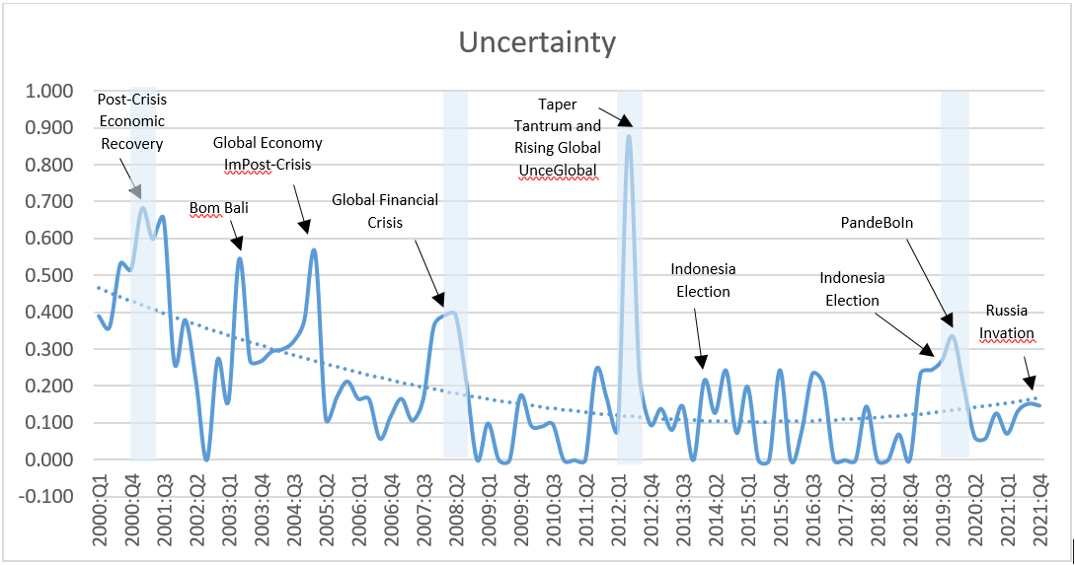

Bahmani-Oskooee and Satawatananon (2015) associate economic uncertainty with volatility in real GDP and monetary uncertainty with nominal monetary volatility such as M2. The research tested the hypothesis of output and monetary uncertainty on money demand in Thailand by employing a bound test approach. The result showed that both uncertainties affect short- and long-term money demand. Both uncertainties (economic and monetary) have a negative effect on money demand in Thailand in the short term, in contrast to the long term, where monetary uncertainty has a negative effect. However, economic uncertainty positively affects the long-term demand for money. The impact of economic uncertainty causes the public to be more careful so that the public will hold more cash.

In contrast, monetary uncertainty causes a substitution effect from cash into assets. Bahmani-Oskooee and Baek (2016) identified Korea's economic and monetary uncertainty. The ARDL approach shows that both uncertainties affect the short run, while only economic uncertainty affects the demand for money in the long term. Economic uncertainty causes Koreans to save less cash and replace it with assets.

A study by Bahmani-Oskooee and Nayeri (2018) approaches the uncertainty arising from policy and its effect on the money demand in Australia using the ARDL approach. Policy uncertainty has an effect in the short term but not in the long term. There is a significant asymmetric effect in the long run when a decrease in policy uncertainty will reduce the cash demand in Australia. Olawale et al. (2014) analyzed the demand for money in the UK using the VECM approach. The study revealed that money demand is elastic to the production index in the long run and is inelastic to short-term interest rates and exchange rates. The global financial crisis had a negative effect on the money demand in the UK.

There have been many studies on money demand in Indonesia. Previous studies only used standard variables to discuss the factors affecting money demand. However, few studies discuss the economic uncertainty in money demand, especially in Indonesia. This research also utilizes Global Economic Policy Uncertainty as a variable of economic uncertainty built by Baker et al. (2016) and US monetary policy uncertainty from Husted et al. (2017). The purpose of this study is to analyze the money demand in the global economic uncertainty that exists in Indonesia. This study also examines the transmission and effects of shocks on macroeconomic variables on money demand.

**Research Method**

This study examines quarterly data in the form of time-series data from 2000Q1-2021Q4. The data generated from several research sources, such as Indonesian Economic and Financial Statistics, Bank Indonesia (SEKI-BI), the Central Statistics Agency (BPS), and Global Economic Policy Uncertainty as a variable of economic uncertainty developed by Baker et al. (2016) and Davis ( 2016). This study examines the money demand in a narrow sense (M1) and a broad sense (M2) by utilizing two variables on money demand to describe in detail the characteristics of money demand in Indonesia. This study utilizes income variables to obtain an idea related to the pattern of income to the demand for money in Indonesia with an increase in income will increase the acceleration of transactions by itself will increase the money demand. CPI has an inverse relationship with income to money demand. The higher the CPI level, the public will prefer to hold more assets than cash. The interest rate variable is a variable as a proxy for the opportunity to hold money.

Exchange rates have an a priori relationship (Narayan, 2007). An increase in the real exchange rate, which implies a depreciation of the domestic currency, will lead to an increase in the value of foreign assets denominated in the domestic currency. Since this is considered an increase in wealth, depreciation should positively affect the money demand. However, if there is depreciation, it can trigger speculation that the demand for domestic money will decrease because the public prefers to hold foreign money. Therefore, depreciation will reduce the demand for money, which means that depreciation will have a negative effect on the demand for money. Using economic uncertainty and policy variables, utilize the calculations proposed by Baker et al. (2016) and Davis (2016) to see their effect on the demand for money in Indonesia. The details of the data are available in table 1 below:

|  |  |  |  |
| --- | --- | --- | --- |
| **Proxy Variables** | **Description** | **Symbol** | **Source** |
| Money Demand for Broad Money | Money demand at the broad definition | *BM* | Bank Indonesia |
| Real Income | As a transaction in demand for money using the variable GDP | *Inc* | Bank Indonesia |
| Inflation | Utilizing quarterly data | *Inf* | Bank Indonesia |
| Interest rate | A proxy from an opportunity to hold money | *r* | Bank Indonesia |
| Exchange rate | Nominal exchange rate of rupiah against US dollar | *Exc* | Bank Indonesia |
| Economic Uncertainty | Economic uncertainty | *EU* | Baker et al. (2016) |
| Monetary Policy  Uncertainty | The US monetary economic policy uncertainty | *MPU* | Husted et al. (2017) |

This study focuses on the *interrelationship* between macroeconomic variables such as GDP as a proxy for income, inflation, interest rates, exchange rates, economic uncertainty, and money demand with a *structural vector autoregressive* (SVAR) approach. This method examines the transmission and effects of shocks on macroeconomic variables on demand for money. Bacchiocchi and Fanelli (2015) stated that the SVAR method is used for policy analysis and the response of a variable to shocks, as it is known that structural shocks need to be identified for the simulation of a policy. Magnussion and Mavroeidis (2014) revealed that structural changes in macroeconomics could be used constructively to identify structural relationships with time *invariant*s.

This study focuses on the demand for money and its environment, such as a country's macroeconomic conditions. Given the importance of money demand as a transaction tool, macroeconomic variables, economic uncertainty, and shocks will impact the overall demand for money because it can affect people's purchasing power. The contribution of this research is to provide an overview of the importance of monetary policy with a quantitative approach (money demand) and the response to money demand based on macroeconomic variables and their shocks. The SVAR approach is employed for policy analysis. The SVAR *model was developed based on the theoretical basis and previous research. Impulse response* analysis and *forecast error variance decomposition* are applied to describe the empirical findings in the study. According to Arwatchanakarn (2017), the SVAR model is more exciting and profitable than the VAR model because it can use several economic theories and previous research and know the response of a variable when shocks occur in other variables.

Assume that $X_{1,t}$ is a vector of $η_{1}$, which is the money demand variable, and $X_{2,t}$ vector of $η_{2}$ is the macroeconomic variable and economic uncertainty (GDP as a proxy of Income, Inflation, interest rate, exchange rate, economic uncertainty and uncertainty of US monetary policy) at time t. We assume that X1, t is an exogenous variable to macroeconomic variables, both dynamic relationships and structural shocks in the vector that can affect the value of $X_{1, t+k}$ for every k > 0. The equation of the SVAR, as proposed by Carillo *et al*. ( 2020), is written as follows:

$A^{-1}X_{t}=C+\sum_{l=1}^{p}{B_{l}X_{t-l}+υ_{t}}$ (1)

Where C is n x 1, which is a constant vector.. $A^{-1}$ is n x n which is used as a matrix of contemporary structural relationships between variables in the model, $B_{l}$ is a persistent matrix, and $υ_{t}$ is a vector of structural innovations with an average equal to zero, not containing autocorrelation and the same variance-covariance matrix. With E{$υ_{t}$, $υ_{t}$}= $Ι_{n}$..

The model with the derivative will produce a version of the multiplication on system $A$, which becomes:

$X_{t}=\tilde{C}+\sum_{l=1}^{p}{{\tilde{B}}_{l}X_{t-l}+ξ_{t}}$ (2)

Where $\tilde{C}≡AC$, $\tilde{B}≡AB$ dan $ξ_{t}≡{Aυ}_{t}$, which are vector forms derived from the innovation form with the same variance-covariance matrix for E{$ξ_{t}$, $ξ_{t}$}= $Ω$. Therefore, matrix A follows $AA^{'}=Ω$.

To fulfill the exogenous block, the matrix $A$ and ${\tilde{B}}_{l}$ are matrices with blocks equal to zero, so they can be written as follows:

$A≡\left[\begin{matrix}A_{zz} & 0 \\ A_{zy} & A_{yy}\end{matrix}\right] and {\tilde{B}}_{l}≡\left[\begin{matrix}{\tilde{B}}_{zz,l} & 0 \\ {\tilde{B}}_{zy,l} & {\tilde{B}}_{yy,l}\end{matrix}\right]$ (3)

Where $A_{zz}$ represents the impact of shocks from variables on the system, $A_{zy}$ indicates the effects of macroeconomic variables, and $A_{yy}$ represents the impact of shocks on macroeconomic variables and economic uncertainty. Likewise, ${\tilde{B}}_{zz,l}$ is the effect of the *lagged $l$* variable on the variable when it occurs, ${\tilde{B}}_{zy,l}$ is the effect of the current macroeconomic variable, and ${\tilde{B}}_{yy,l}$ is the effect of the lagged $l$ macroeconomic variable and the current macroeconomic variable.

**Result and Discussion**

All variables have a more excellent mean value than the standard deviation, which means that all variables have high variability. The skewness value in the data indicates the slope of the data. The positive skewness value means the data has a slope to the right, while if the skewness value is negative, it indicates that the data has a slope to the left. Table 1 shows only broad money (BM) and income (Inc) variables with a negative skewness value. Both variables skew to the left, while the rest have a positive skewness value.

Table 1. Descriptive Analysis

|  |  |  |  |  |  |  |  |
| --- | --- | --- | --- | --- | --- | --- | --- |
|  | BM | Inc | Inf | r | Exc | Eu | Mpu |
| Mean | 14.828 | 14.440 | 5.797 | 6.959 | 9.306 | 0.163 | 4.704 |
| Maximum | 15.804 | 14.852 | 17.110 | 12.750 | 9.703 | 0.877 | 5.853 |
| Minimum | 13.685 | 13.942 | 1.330 | 3.500 | 9.022 | 0.000 | 3.854 |
| Std Dev | 0.663 | 0.285 | 3.351 | 2.103 | 0.203 | 0.153 | 0.414 |
| Skewness | -0.248 | -0.173 | 1.398 | 0.730 | 0.273 | 1.790 | 0.210 |
| Kurtosis | 1.722 | 1.713 | 5.171 | 3.653 | 1.444 | 8.354 | 2.956 |
| Obs | 75 | 75 | 75 | 75 | 75 | 75 | 75 |

The kurtosis value is utilized to identify whether the data is normally distributed or not. The data are typically distributed if the kurtosis value is at number 3 or around number 3. Furthermore, if the value is above three, the data distribution is at a high peak. Then, if the kurtosis is below three, it means that the data distribution is flat. The variables with a kurtosis value of more than three are inflation, interest rate, and exchange rate. It means that the data distribution is at a high peak. The other variables with a kurtosis value below 3 mean that the data distribution is flat. All variables have the same observation value, as many as 75.

This study applies the unit root test Phillips-Perron (PP) approach to test the presence of non-stationary stochastic in time-series data. The use of PP is also to eliminate the problem of heteroscedasticity in the data. The unit root test applies "trend and intercept" as a unit root test with "trend" and applies "intercept" as a unit root test with "no trend". Broad Money (BM), real income (Inc), Inflation (Inf), interest rate (r), exchange rate (Exc), Uncertainty Index (Eu), and monetary policy uncertainty (MPU) index are stationary at the first difference I( 1) based on the unit root test results of the PP approach. Only inflation (Inf), uncertainty index (Eu), and monetary policy uncertainty (Mpu) variables are stationary in the first difference. The unit root test does not apply second difference I(2) because it can produce false regressions.

The use of PP is also to eliminate the problem of heteroscedasticity in the data. The unit root test applies "trend and intercept" as a unit root test with "trend" and applies "intercept" as a unit root test with "no trend". Broad Money (BM), real income (Inc), Inflation (Inf), interest rate (r), exchange rate (Exc), Uncertainty Index (Eu), and monetary policy uncertainty (MPU) index are stationary at the first difference I(1) based on the unit root test results of the PP approach. Only inflation (Inf), uncertainty index (Eu), and monetary policy uncertainty (Mpu) are stationary in the first difference. The unit root test does not apply second difference I(2) because it can produce false regressions.

Table 2. Unit Root Test

|  |  |  |  |
| --- | --- | --- | --- |
| Variables | Philips-Perron | | |
| Intercept | Trend & Intercept | None |
| Level | | |
| BM | 6.137 | 0.813 | 11.893 |
| Inc | 1.198 | -3.081 | 7.604 |
| Inf | -2.636* | -3.679** | -1.485 |
| r | -1.490 | -3.020 | -1.188 |
| Exc | -1.270 | -2.417 | 1.086 |
| Eu | -5.450*** | -6.476*** | -3.167 |
| Mpu | -4.351 | -4.680*** | -0.896 |
|  | First Difference | | |
| BM | -9.902*** | -13.168*** | -5.648*** |
| Inc | -11.935*** | -13.610*** | -8.861*** |
| Inf | -7.988*** | -7.941*** | -8.033*** |
| r | -4.618*** | -4.519*** | -4.582*** |
| Exc | -11.713*** | -11.661*** | -11.493*** |
| Eu | -17.114*** | -17.067*** | -17.170*** |
| Mpu | -18.281*** | -18.300*** | -18.345*** |

Note: The ***, **, and * indicate the statistically significant level at 1%, 5%, and 10%, respectively.

Money demand response to shocks

Shocks to the income variable are responded negatively by money demand, in contrast to previous research conducted by Narayan (2007) and Kurniawan (2020) in Indonesia, income positively affects money demand. The difference occurs because there are different approaches to analyzing income's effect on money demand. The findings show the inconsistency of economies of scale in holding money. However, this does not happen by chance. Along with the development of financial innovation, the community faces many choices as an alternative to inventorying wealth other than in the form of money, such as assets and shares that can be used as an alternative storage portfolio by the public. This finding is in line with Baharumshah et al. (2009). This is not much different and is in line with expectations when there is a shock to exchange rate volatility. Shocks or an increase in the exchange rate will reduce the demand for money, which means that if the rupiah depreciates, the demand for holding money will decrease, and this is in line with research by Narayan (2007), the depreciation of the domestic currency will have a more significant impact on the demand for foreign currency than holding the domestic currency.

A negative response to the money demand

occurs when there is a shock to the inflation variable. The increase in the price of goods makes people hold back their consumption and secure their wealth in other assets or portfolios. Blejer (1979) emphasizes that using inflation as a variable and its relationship to money demand is prone to inaccurate forecasts because it can increase uncertainty about future prices. As uncertainty about future prices increases, it will affect the money demand. In addition to influencing the money demand, it will also increase prudence, thereby increasing the demand for portfolios or other assets. A positive response is shown in demand for money when there is a shock to the domestic interest rate. This is inversely proportional to the theory that interest rate policy aims to reduce the level of money demand. This finding is in line with research by Favara and Giordani (2009), which shows that monetary aggregate responds positively to the federal fund rate for a prolonged period. This reflects the endogenous response of a policy known as the Taylor rule that can increase inflation and output after a shock to the monetary aggregate.

Uncertainty as a shock effect

The attention of researchers is currently increasing on conditions of economic uncertainty. Economic uncertainty can reflect people's behavior in holding money. Uncertainty in the study consists of two indices: economic uncertainty, an index developed by Baker et al. (2016), and the US monetary uncertainty policy index developed by Husted et al. (2017). The use of the US monetary uncertainty policy cannot be separated from the fact that several monetary policies in Indonesia are closely related to US policy. Thus, the utilization of US MPU is an anticipatory measure of global monetary uncertainty.

The results of the IRF when Eu and Mpu as a shock effect show that money demand responds negatively to Eu and positively to Mpu. The impact of economic uncertainty causes people to be more careful so that people will shift their "wealth" to other instruments besides money, such as assets, etc. Meanwhile, monetary uncertainty has led to increased demand for money. The negative response to Eu turmoil is in line with research by Bahmani-Oskooee and Satawatananon (2015), Bahmani-Oskooee and Baek (2016), and Olawale et al. (2014).

The response of variable income, interest rates, and exchange rates tend to move negatively when there is a shock from Eu and Mpu. When the domestic exchange rate depreciates, it can increase demand for foreign exchange rates that are "more resistant" to shocks from economic uncertainty than the domestic currency. This condition can trigger a movement in the depreciation of the domestic exchange rate towards the worse. The results align with Narayan's (2007) related exchange rate depreciation. The response of the inflation variable related to the Eu and Mpu shocks shows a fluctuating response, where prices will increase. When the Eu and Mpu shock gradually get longer, people are "forced" to accept the new price (price increase).



**Figure 1. Impulse response function (with 95% error bands). The impulse responses are computed using lag 6 for VAR models.**

***Other findings***

The IRF method shows more comprehensive results, such as muted inflation fluctuations with an upward trend in interest rates. The increase in interest rates is still at the prudent level because, in the last two years, there has been a crisis due to the pandemic. Likewise, income is responded to in a negative direction by interest rates. Income fluctuation can cause people's purchasing power to fall, which is responded to by lowering interest rates to maintain people's purchasing power. This shows that monetary policy through interest rates can normalize and strengthen the domestic economy. It is more adaptive in its implementation, adapting to domestic economic conditions

considering the global economy.

Other results are shown in the negative income response when there is a shock to inflation and exchange rates. It shows that shocks to inflation and exchange rates can reduce people's purchasing power. Maintaining inflation and exchange rate stability can maintain people's purchasing power. Likewise, when there is a shock in the exchange rate, interest rates will respond positively. This aims to strengthen the rupiah exchange rate against foreign exchange rates.

***Forecast Error of Variance***

The Forecast Error of Variance (FEV) presented in the table illustrates the importance of a shock. FEV, apart from money demand, is dominated on average by income with a time horizon of 10th, 25th, and 50th, which is 6,817, 13,536, and 16,259. The difference in the effect of the income variable with a longer time horizon shows a significant increase from 6,817 on the 10th to 13,536 on the 25th. Next is inflation, which strongly influences income, with an average of 3,283 on the 10th, increasing over the 25th time horizon to 6,182 and 6,474 on the 50th time horizon.

Table 3. Forecast Error of Variance

|  |  |  |  |  |  |  |  |  |
| --- | --- | --- | --- | --- | --- | --- | --- | --- |
|  | Dynamic Horizon | BM | Inc | Inf | Exc | r | Eu | Mpu |
| Average Forecast | 10th | 79.549 | 6.817 | 3.283 | 2.087 | 3.674 | 2.972 | 1.618 |
| 25th | 64.412 | 13.536 | 6.182 | 5.350 | 3.552 | 5.604 | 1.364 |
| 50th | 61.092 | 16.259 | 6.474 | 6.577 | 2.651 | 5.957 | 0.989 |

Variable shock increases when a longer time horizon is utilized. However, there are several decreasing variables domination. For example, the interest rates on the 25th horizon, which is 3,552, decline to 2,651 on the 50th time horizon. The uncertainty of the US monetary economic policy shows a decrease in its dominance in the model from 1,618 on the ten-time horizon to 1.364 and 0.989. The difference in economic uncertainty has increased in dominance from 2,972 to 5,604 on the 25th and 5,957 on the 50th time horizon.

***Demand for money and the uncertainty***

This section presents a model with three variables in structural shocks. Each variable is a representation of a moving average vector. The equation in the model is ${∆z}_{t}=C\left(L\right)u_{t}$ where it is the endogenous vector ${∆z}_{t}$ variable, CL is the matrix of the polynomial lag and $u_{t}$ is the vector of the identified structural shocks. The three variables formed in the model are money demand (BM), economic uncertainty (Eu), and US monetary policy uncertainty (Mpu). This section aims to identify further the structural shocks of the effect of economic uncertainty (Eu and Mpu) on money demand in Indonesia.

The fundamental difference from the previous model is in the model with three variables using a lag order of 5. The results showed that there was no difference in the previous model and supported the results of research by Bahmani-Oskooee and Satawatananon (2015), Bahmani-Oskooee and Baek (2016), and Olawale *et al*. (2014). The negative response was shown by the demand for money when there was turmoil from economic uncertainty and uncertainty in US monetary policy. With the development of the financial sector, the impact of economic uncertainty and the uncertainty of US monetary policy causes people to be more careful so that people will shift their "wealth" to other instruments besides money, such as assets, etc. There is a substitution effect that occurs when there is a shock or increase in economic uncertainty (Eu and Mpu) from the role of holding money to other financial instruments such as assets, shares, etc. Figure 2 shows that economic uncertainty (Eu) is more dominant than US monetary policy uncertainty (Mpu) based on FEV results.

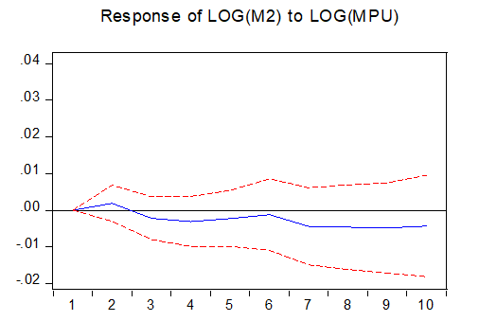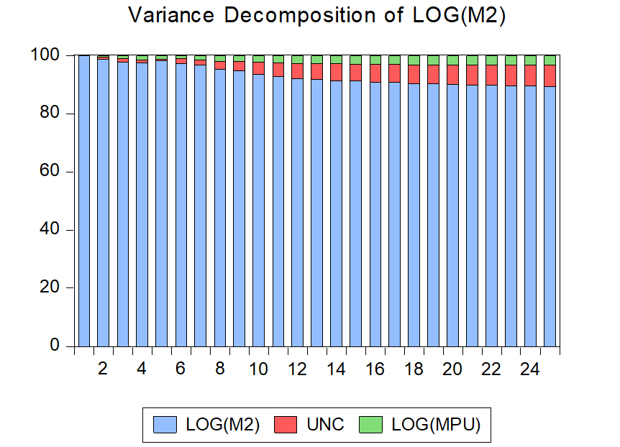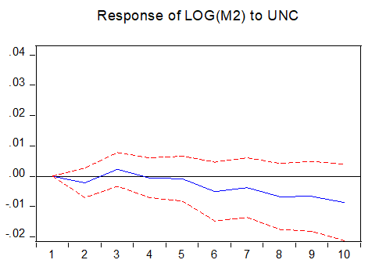

**Fig 2.** **Impulse response function (with 95% error bands). The impulse responses are computed using lag 5 for VAR models and forecast error of variance.**

**Conclusion**

This study aims to analyze money demand under economic uncertainty in Indonesia. This study focuses on the relationship between macroeconomic variables such as GDP as a proxy of income, inflation, interest rates, exchange rates, economic uncertainty, and money demand by employing the structural vector autoregressive (SVAR) approach. This method is used to examine the transmission and the effect of macroeconomics variable shock of money demand. This study utilizes quarterly data from time-series data from 2000Q1 to 2021Q4.

The results revealed the sensitivity of money demand to income changes, prices, and exchange rate volatility. The positive response to interest rate changes shows that the pattern of money demand in Indonesia is close to a Taylor rule policy. The Taylor rule can increase inflation and output after a shock to the monetary aggregate or money demand. The negative response showed by the money demand when there is economic uncertainty and uncertainty in the US monetary policy. The development of the financial sector changed people's behavior to be more concerned about diverting their assets due to the economic uncertainty and the US Monetary policy uncertainty. This study implies that the monetary policy in the form of interest rate as the response to the global condition should consider the monetary aggregates in terms of money demand as an anticipatory step in maintaining money demand.

**References**

Abid, A. (2019). Economic policy uncertainty and exchange rates in emerging markets: short and long runs evidence. *Finance Research Letters*, 50(4); https://doi.org/10.1016/j.frl.2019.101378

Alamsyah, H., Joseph, C., Agung, J., dan Zulverdy, D. (2001). Towards implementation of inflation targeting in Indonesia. *Bulletin of Indonesian Economic Studies*, 37, 309-324.

Arwatchanakarn, P. (2017). Structural vector autoregressive analysis of monetary policy in Thailand. *Sociology Study*, 7(3), 133-145.

Aswicahyono, H. dan H. Hill. (2014). Survey of recent developments. *Bulletin of Indonesian Economic Studies*, 50(3), 319-346.

Bacchiocchi., E. Fanelli, L. (2015). Identification in structural vector autoregressive models with structural changes, with an application to US monetary policy. *Oxford Bulletin of Economics and Statistics*, 77(6), 761-779.

Bahmani-Oskooee, M. dan Satawatananon, K. (2015). Economic uncertainty, monetary uncertainty, and the demand for money in Thailand. *Global Business and Economics Review*, 17(4), 467-476.

Bahmani-Oskooee, M. dan Baek, J. (2016). Economic uncertainty, monetary uncertainty and the Korean demand for money. Journal of Economic Policy Reform.

Bahmani-Oskooee, M. dan Nayeri, M, M. (2018). Policy uncertainty and the demand for money in Australia: An asymmetry analysis. *Australian Economic Papers*, 1-14.

Baker, S. Bloom, N. dan Davis, S, J. (2016). Measuring economic policy uncertainty. *The Quarterly Journal of Economics*, 131, 1593-1636.

Ball, L. (2012). Short-run money demand. *Journal of Monetary Economics*, 59, 622-633.

Blejer, M. I. (1979). Inflation, hedging and the demand for money. American Economic Review, 821-833.

Carrillo, J, A. Elizondo, R. dan Hernandez-Roman, L, G. (2020). Inquiry on the transmission of US aggregate shocks to Mexico: A SVAR approach. Journal of International Money and Finance, https://doi.org/10.1016/j.jimonfin.2020.102148

Choi, W, G. dan Seonghwan Oh. (2003). A money demand function with output uncertainty, monetary uncertainty, and financial innovations. *Journal of Money, Credit, and Banking*, 35(5), 685-709.

Davis, S, J. (2016). An index of global economic policy uncertainty. *NBER Working Paper No 22740*.

Duca, J, V. VanHoose, D, D. (2004). Recent developments in understanding the demand for money. *Journal of Economics and Business*, 56, 247-272.

Favara, G. & Giordani, P. (2009). Reconsidering the role of money for output, prices and interest rates. *Journal of Monetary Economics*, 56, 419-430.

Friedman, B. (1975). Targets, instruments and indicators of monetary policy. *Journal of Monetary Economics*, 1, 443-473.

Husted. Lucas. Rogers, J. & Bo Sun. (2017). Monetary policy uncertainty. International Finance Discussion Papers 1215. https://doi.org/10.17016/IFDP.2017.1215

James, G, A. (2005). Money demand and financial liberalization in Indonesia. *Journal of Asian Economics*, 16(5), 817-829.

Kurniawan, M, L, A. (2020). The stability of money demand in Indonesia: An ARDL Approach. *Optimum: Jurnal Ekonomi dan Pembangunan*, 10(2), 153-162.

Magnusson, L.M., Mavroeidis, S. (2014). Identification using stability restrictions. *Econometrica*, Vol. 82, 1799-1851.

Narayan, P, K. (2007). Is money targeting an option for Bank Indonesia?. *Journal of Asian Economics*, 18, 726-738.

Olawale, A, N. Taofik, A. Adekunle, A, dan Olusegun, A, S. (2014). Empirical analysis of the elasticity of real money demand to macroeconomic variables in the United Kingdom with 2008 financial crisis effects. *Journal of Economics and International Finance*, 6(8), 190-202.

Pastor, L. dan Veronesi, P. (2013). Political uncertainty and risk premium. *Journal of Financial Economics*, 110, 520-545.

Poole, W. (1970). Optimal choice of monetary policy instruments in a simple stochastic macro model. *Quarterly Journal of Economics*, 84, 197-216.

Setiastuti, S, U. (2017). Time-varying macroeconomic impacts of global economic policy uncertainty to a small open economy: evidence from Indonesia. *Buletin Ekonomi Moneter dan Perbankan*, 20(2), 129-148.

The composition of the bibliography used consists of 80% of the primary reference sources (journals, proceedings) and a maximum of 20% secondary reference sources (textbooks) published in the last 10 years. It is recommended to use a library management application (Mendeley, Zotero, Endnote, Reference Manager). Please follow the APA style. It's recommended for the author. [Garamond, 11, Justify, & Capitalize Each Word].