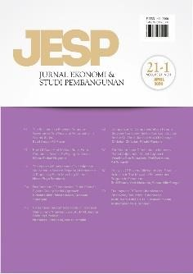 **Author Declaration Form**

**Jurnal Ekonomi & Studi Pembangunan**

ISSN: 2541-5506 (Online) and 1411-9900 (Print) https://journal.umy.ac.id/index.php/esp

Name of Principal/Corresponding Author*

Iqram Ramadhan Jamil

Address of Principal/Corresponding Author*

Jalan Kalimas RT21 RW06 Desa Mejayan Kecamatan Mejayan Kabupaten Madiun Provinsi Jawa Timur 63153

Telephone*

083121067608

E-mail*

[Iqramramadhanj@gmail.com](mailto:Iqramramadhanj@gmail.com)

Fax*

-

All author(s) name*

Iqram Ramadhan Jamil

Maman Setiawan

Date of submitted*

December, 9 2022

Manuscript title*

MARKET SHARE OR EFFICIENCY? CAUSALITY TEST IN INDONESIAN GENERAL INSURANCE INDUSTRY

1. Declare that the article above is original. my own thoughts not translated, and has not been published elsewhere or currently not in the process of other journal publications. I am willing to be responsible if there are parties who feel disadvantaged privately and/or based on a lawsuit in the future by the publication of this article.
2. I also declare that the transfer of copyright for the first publication is granted to Jurnal Ekonomi & Studi Pembangunan.

Sumedang, December 9 2022

Iqram Ramadhan Jamil

Editorial Office Jurnal Ekonomi & Studi Pembangunan:

Journal Room, E4 Building, 2nd Floor, Faculty of Economics and Business, Universitas Muhammadiyah Yogyakarta, Jalan Lingkar Selatan (Brawijaya), Tamantirto, Kasihan, Bantul, Daerah Istimewa Yogyakarta, Indonesia 55183.