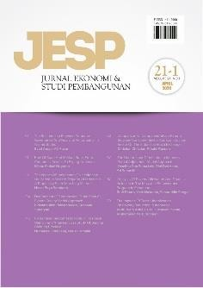Author Declaration Form

Jurnal Ekonomi & Studi Pembangunan

ISSN: 2541-5506 (Online) and 1411-9900 (Print)

https://journal.umy.ac.id/index.php/esp

Name of Principal/Corresponding Author\*

Siti Aminatul Ahadiyah……………………………………………………………………………………………………………

…………………………………………………………………………………………………………..

Address of Principal/Corresponding Author\*

Kudus, Jawa Tengah, Indonesia……………………………………………………………………………………………………………

…………………………………………………………………………………………………………..

Telephone\*

085742604319……………………………………………………………………………………………………………

…………………………………………………………………………………………………………..

E-mail\*

aminatulahadiyah44@students.unnes.ac.id……………………………………………………………………………………………………………

…………………………………………………………………………………………………………..

Fax\*

……………………………………………………………………………………………………………

…………………………………………………………………………………………………………..

All author(s) name\*

Siti Aminatul Ahadiyah dan Andryan Setyadharma……………………………………………………………………………………………………………

…………………………………………………………………………………………………………..

Date of submitted\*

18 January 2023……………………………………………………………………………………………………………

…………………………………………………………………………………………………………..

Manuscript title\*

The Impact of the Provincial Minimum Wage on Environmental Quality in Indonesia ……………………………………………………………………………………………………………

…………………………………………………………………………………………………………..

1. Declare that the article above is original. my own thoughts not translated, and has not been published elsewhere or currently not in the process of other journal publications. I am willing to be responsible if there are parties who feel disadvantaged privately and/or based on a lawsuit in the future by the publication of this article.
2. I also declare that the transfer of copyright for the first publication is granted to

Jurnal Ekonomi & Studi Pembangunan.

Siti Aminatul Ahadiyah

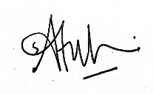

18 January 2023

Editorial Office Jurnal Ekonomi & Studi Pembangunan:

Journal Room, E4 Building, 2nd Floor, Faculty of Economics and Business, Universitas Muhammadiyah Yogyakarta, Jalan Lingkar Selatan (Brawijaya), Tamantirto, Kasihan, Bantul, Daerah Istimewa Yogyakarta, Indonesia 55183.