**“Digital Transformation and Its Impact on Inclusive Growth: A Four-Decade Experience in Indonesia”  
Hidsal Jamil, hidsaljamil@gmail.com, Department of Economics, Universitas Brawijaya & Pusat Kajian Ekonomi Pembangunan dan Kerakyatan (PKEPK)**

**Submission of a manuscript to the Jurnal Ekonomi & Studi Pembangunan**

(September 16, 2022)

Dear Editor of Jurnal Ekonomi & Studi Pembangunan,

I wish to submit an original research article entitled “Digital Transformation and Its Impact on Inclusive Growth: A Four-Decade Experience in Indonesia” for consideration by Jurnal Ekonomi & Studi Pembangunan. The identity of the author of the manuscript is as follows:

**First Author**

Name : Visi Saujaningati Kristyanto

Affiliation : Department of Management, Universitas Katolik Widya Mandala Surabaya, Indonesia

Email : visisau@ukwms.ac.id

**Second Author and Corresponding Author**

Name : Hidsal Jamil

Affiliation : Department of Economics, Universitas Brawijaya, Indonesia & Pusat Kajian Ekonomi Pembangunan dan Kerakyatan (PKEPK), Indonesia

Email : [hidsaljamil@gmail.com](mailto:hidsaljamil@gmail.com)

In our study, we examine the experience of digital transformation and inclusive growth in Indonesia over four decades from 1980 to 2021, with a focus on two main objectives. First, our study utilises Principal Component Analysis (PCA) to assess the key factors forming the progress of digital transformation and inclusive growth. Second, the Two-Stage Least Square (2SLS) estimation method is applied in this study to investigate the endogenous impact of digital transformation on inclusive growth. By dealing with these two research objectives, our study is poised to bridge existing gaps in the literature, which frequently originate in short term periods, subjective measurement challenges, and endogeneity issues. This will result in more robust findings than previous research efforts, increasing the credibility of the outcomes.

Thank you for your consideration of this manuscript to be published on Jurnal Ekonomi & Studi Pembangunan.

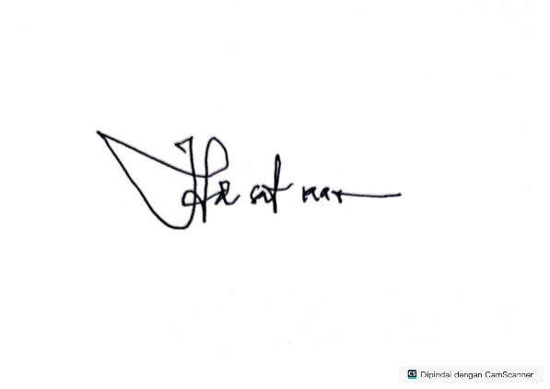Sincerely,

Hidsal Jamil