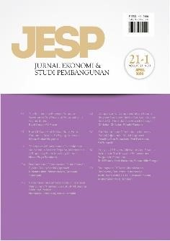 **Author Declaration Form**

**Jurnal Ekonomi & Studi Pembangunan**

ISSN: 2541-5506 (Online) and 1411-9900 (Print) https://journal.umy.ac.id/index.php/esp

Name of Principal/Corresponding Author*

Faisal Madjid Alyasa

Address of Principal/Corresponding Author*

Griya Batara Asri RT05 RW01 Desa Dayeuh, Kecamatan Cileungsi, Kabupaten Bogor Provinsi Jawa Barat 16820

Telephone*

082112302928

E-mail*

[faisal20005@mail.unpad.ac.id](mailto:Iqramramadhanj@gmail.com)

Fax*

-

All author(s) name*

Faisal Madjid Alyasa

Ahmad Komarulzaman

Harlan Dimas Isjwara

Date of submitted*

October 25 2023

Manuscript title*

Who Emits More Emission? The Association Between CO2 Emissions and Socio-economics Characteristics of Indonesian Household

1. Declare that the article above is original. my own thoughts not translated, and has not been published elsewhere or currently not in the process of other journal publications. I am willing to be responsible if there are parties who feel disadvantaged privately and/or based on a lawsuit in the future by the publication of this article.
2. I also declare that the transfer of copyright for the first publication is granted to Jurnal Ekonomi & Studi Pembangunan.

Sumedang, October 25 2022

Faisal Madjid Alyasa

Editorial Office Jurnal Ekonomi & Studi Pembangunan:

Journal Room, E4 Building, 2nd Floor, Faculty of Economics and Business, Universitas Muhammadiyah Yogyakarta, Jalan Lingkar Selatan (Brawijaya), Tamantirto, Kasihan, Bantul, Daerah Istimewa Yogyakarta, Indonesia 55183.