**Author Declaration Form**

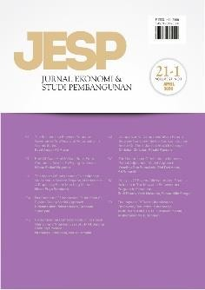

**Jurnal Ekonomi & Studi Pembangunan**

ISSN: 2541-5506 (Online) and 1411-9900 (Print)

https://journal.umy.ac.id/index.php/esp

Name of Principal/Corresponding Author*

Chairullah Amin

Address of Principal/Corresponding Author*

Economics department, School of Graduate, University of Khairun, Ternate

Telephone*

(0921) 3110901, 3110903

E-mail*

[Chairullah.amin@unkhair.ac.id](mailto:Chairullah.amin@unkhair.ac.id)

Fax*

(0921) 3110901

All author(s) name*

Chairullah Amin, Irfan Zam-Zam, Indraswati Tri Abdi Reviane, Firdaus Duko, MuhammadHasnin, Nurdin I Muhammad, Romi Bakti Hartarto, Cep Jandi Anwar

Date of submitted*

23 December 2023

Manuscript title*

Social Assistance Performance on Local Economic Development: Evidence from Island Regions in East Indonesia

(1) Declare that the article above is original. my own thoughts not translated, and has not been published elsewhere or currently not in the process of other journal publications. I am willing to be responsible if there are parties who feel disadvantaged privately and/or based on a lawsuit in the future by the publication of this article.

(2) I also declare that the transfer of copyright for the first publication is granted to

Jurnal Ekonomi & Studi Pembangunan.



Chairullah Amin

23 December 2023

Editorial Office Jurnal Ekonomi & Studi Pembangunan:

Journal Room, E4 Building, 2nd Floor, Faculty of Economics and Business, Universitas Muhammadiyah Yogyakarta,

Jalan Lingkar Selatan (Brawijaya), Tamantirto, Kasihan, Bantul, Daerah Istimewa Yogyakarta, Indonesia 55183.