1Article Meilita Arini.docx

*by* Turnitin

**Submission date:** 15-Jan-2024 12:56AM (UTC-0800)

**Submission ID:** 2183254019

**File name:** 1Article_Meilita_Arini.docx (100.09K)

**Word count:** 7729

**Character count:** 44170

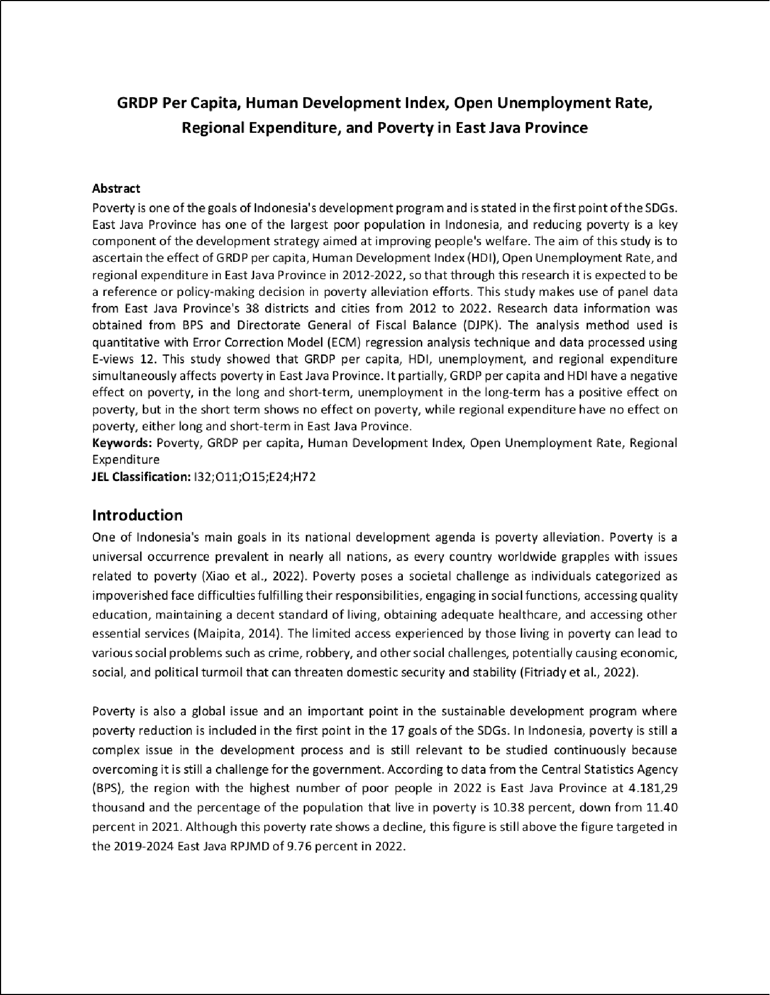

4

24

9

49 21

17

6

12

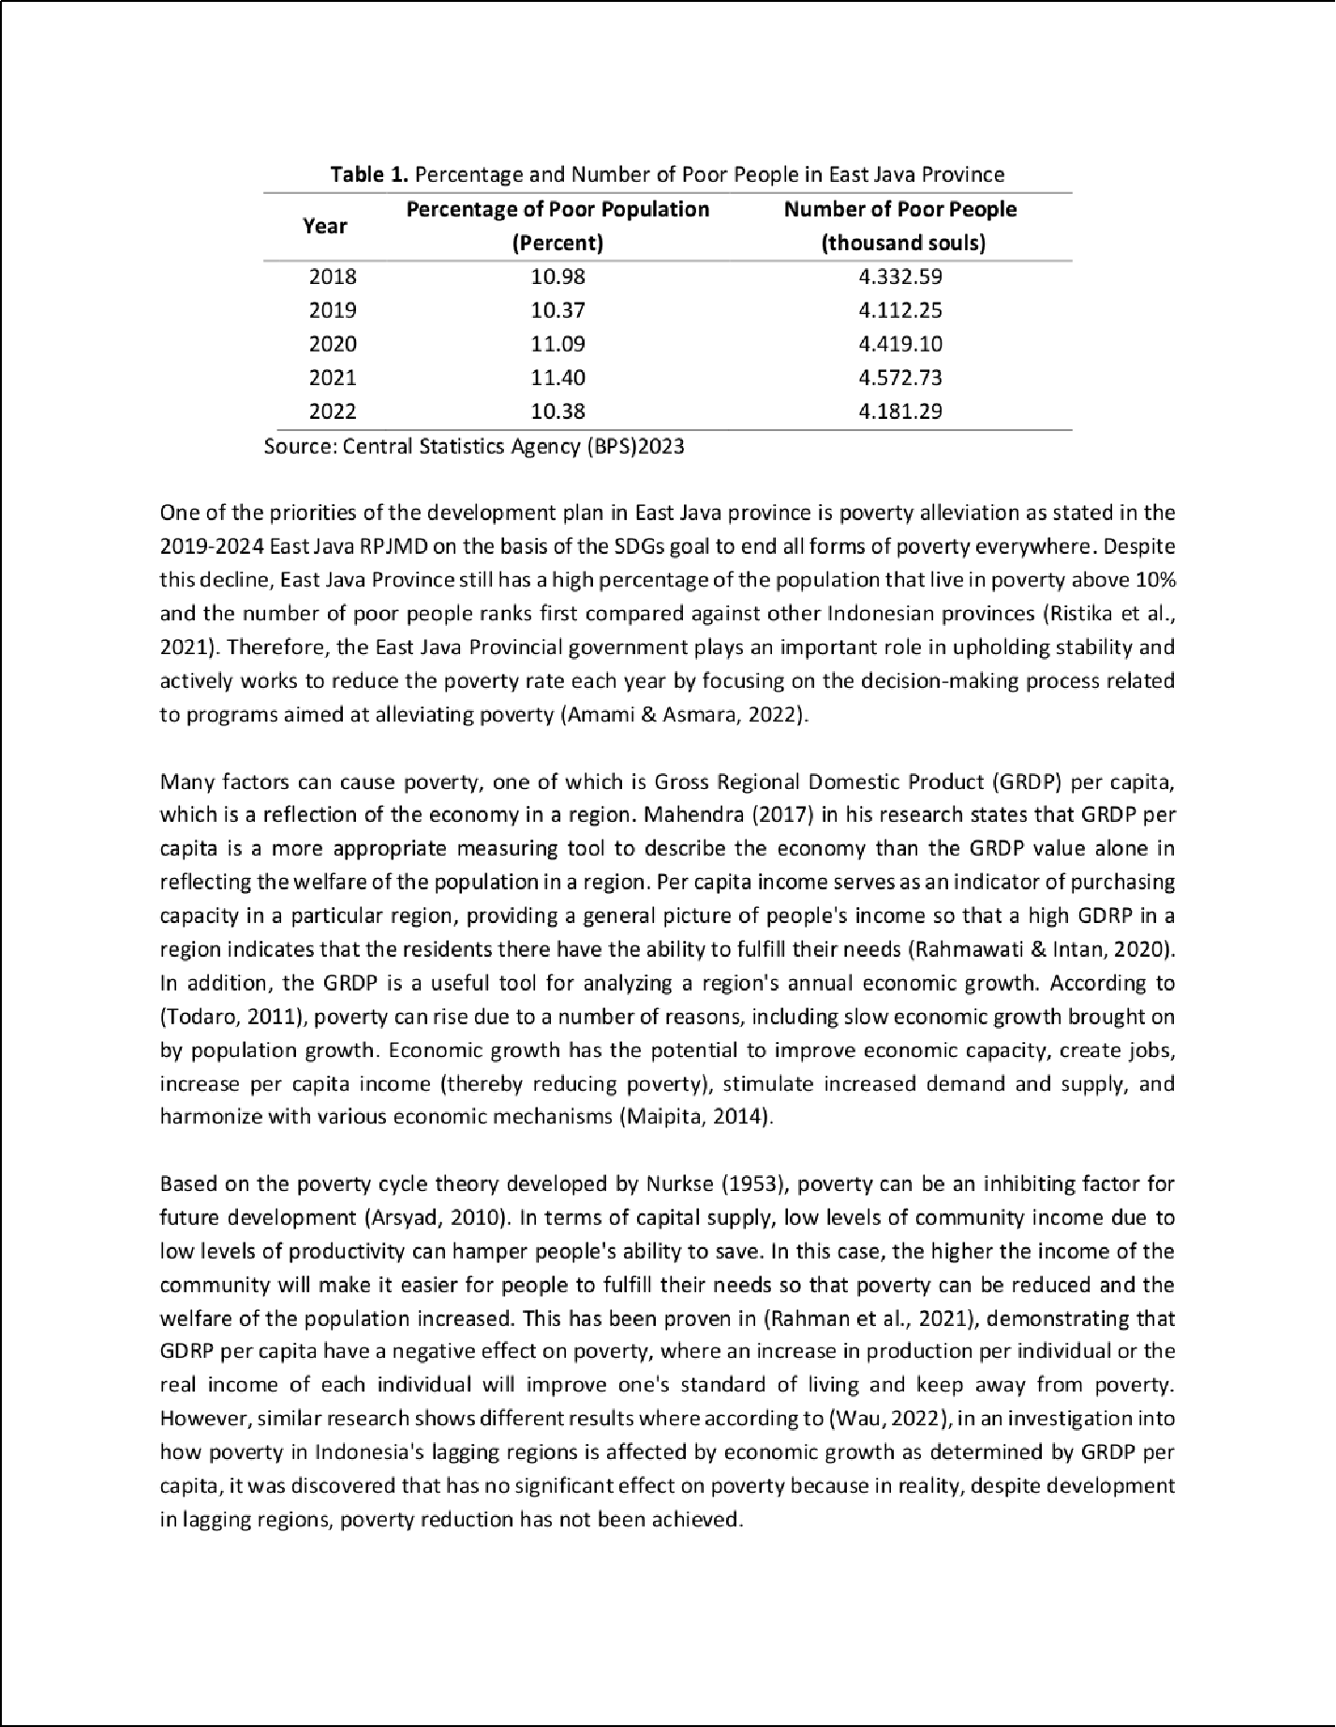

11

20

33

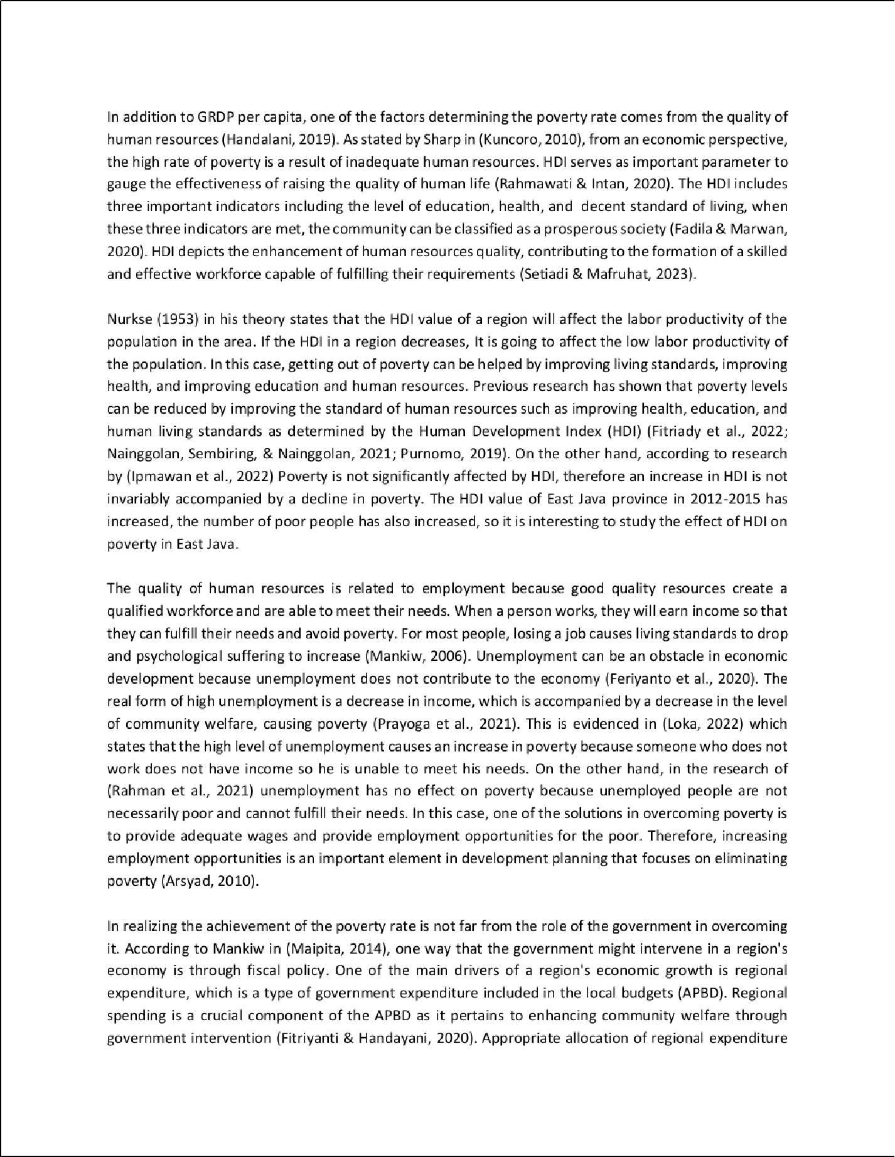

51

13 7

50

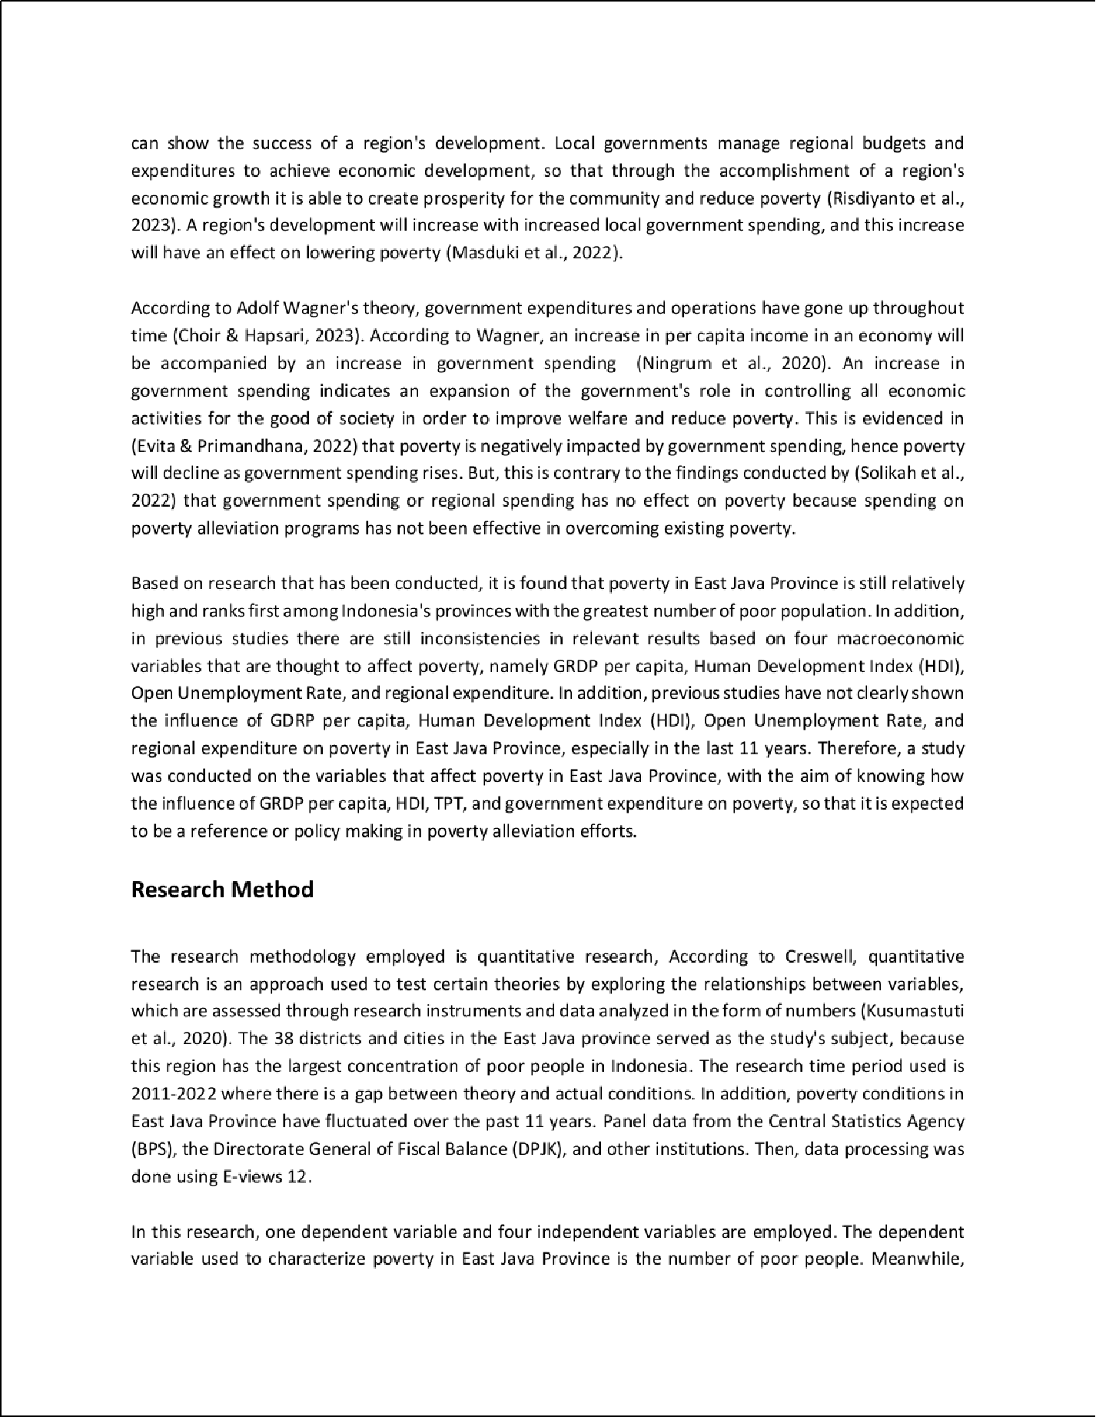

44

4

4

43

1

12

48

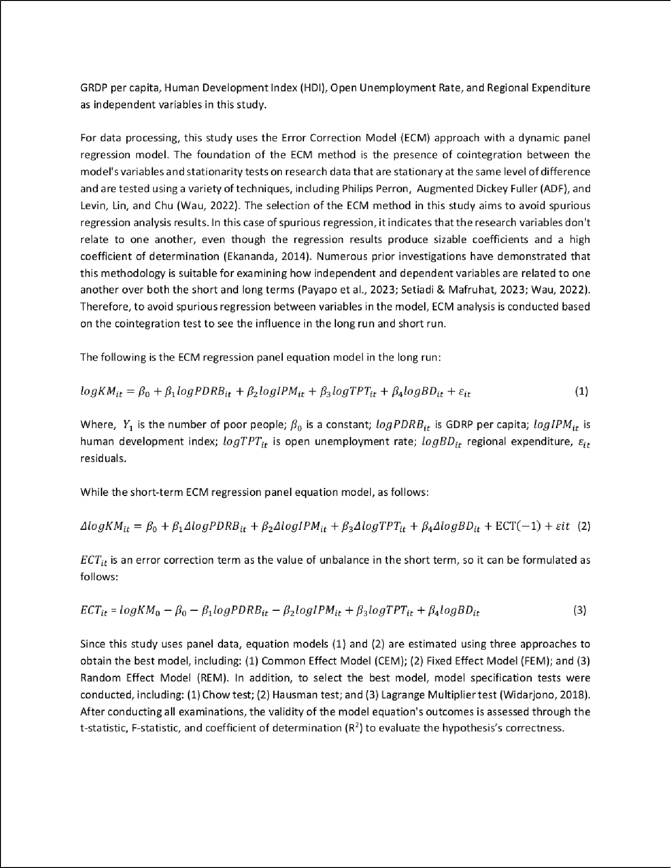

13

23

7

22

15

35

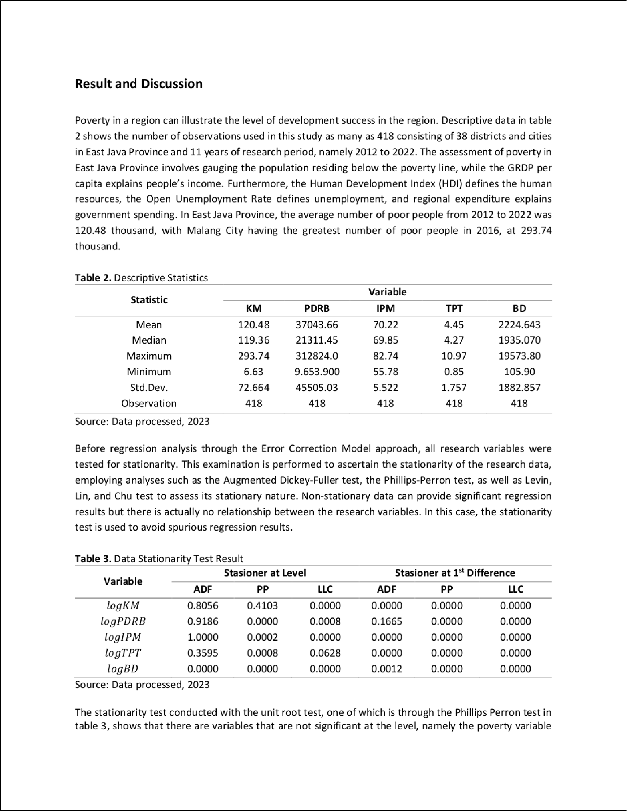

1

3

38

25

3

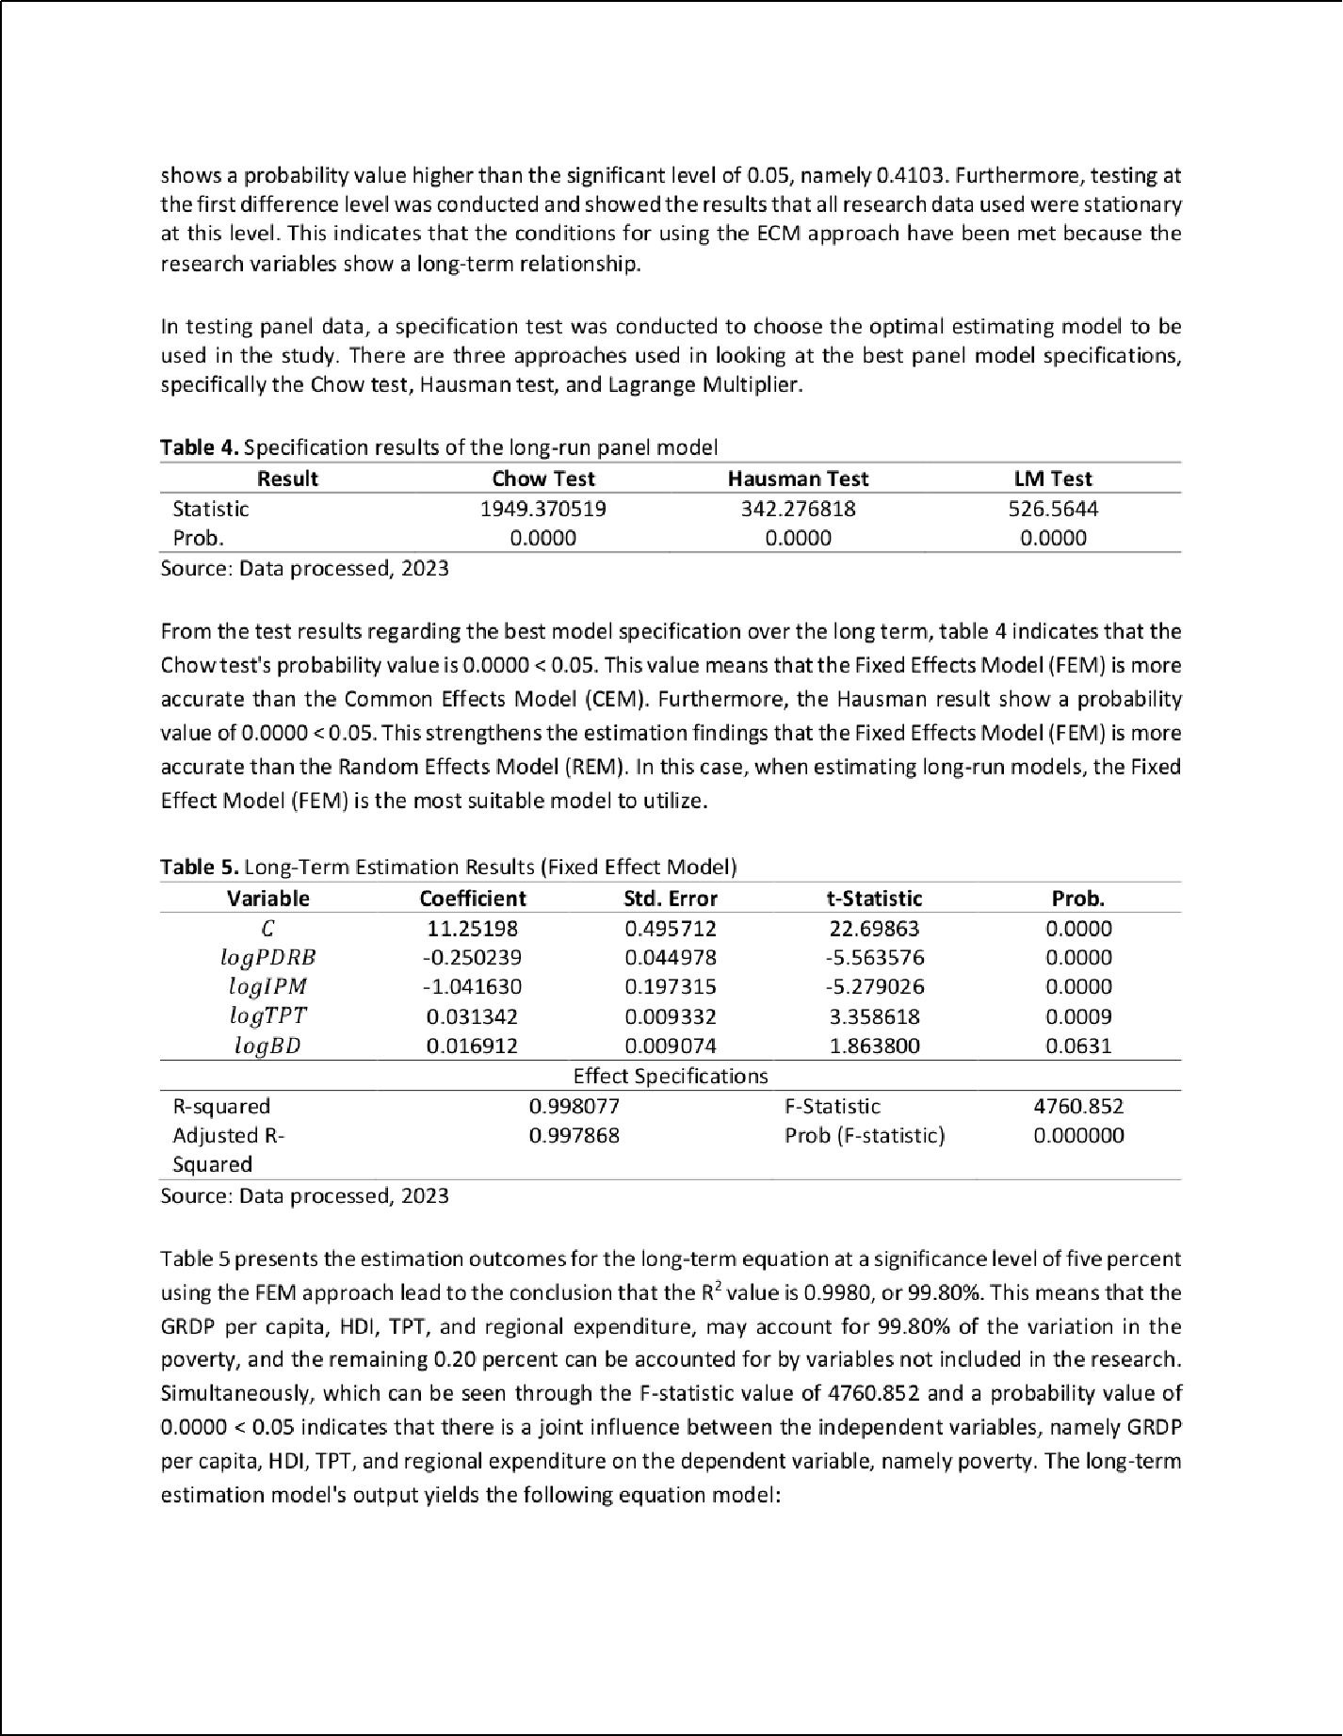

40

3

5 16

16

1

7

2

46

10

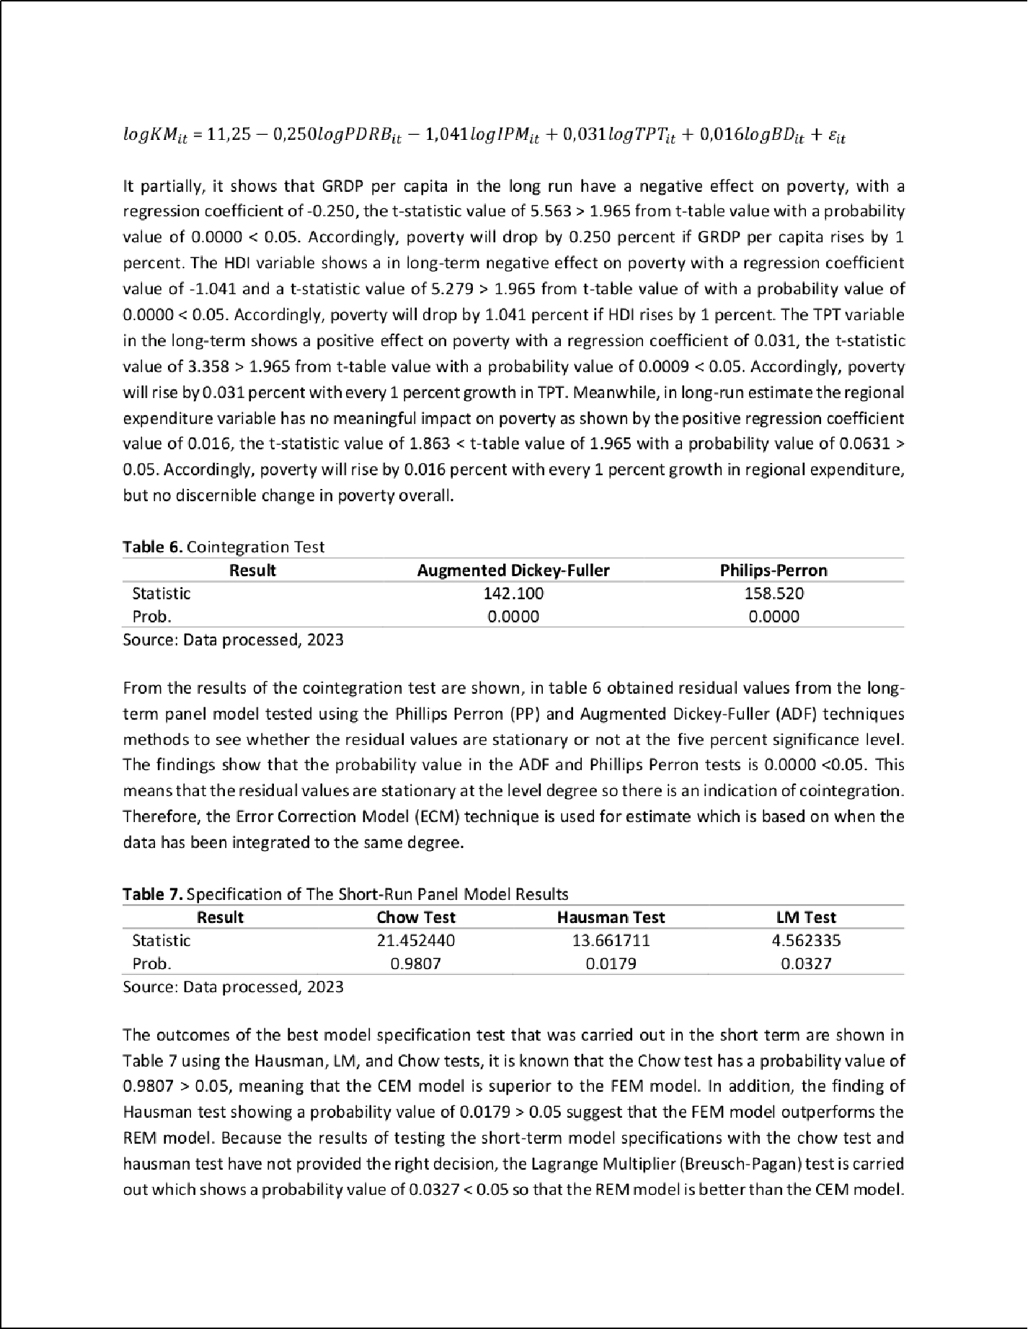

5

9

1

1

6 2

9

3

2

1

32

23

7

18

3

3

19

19

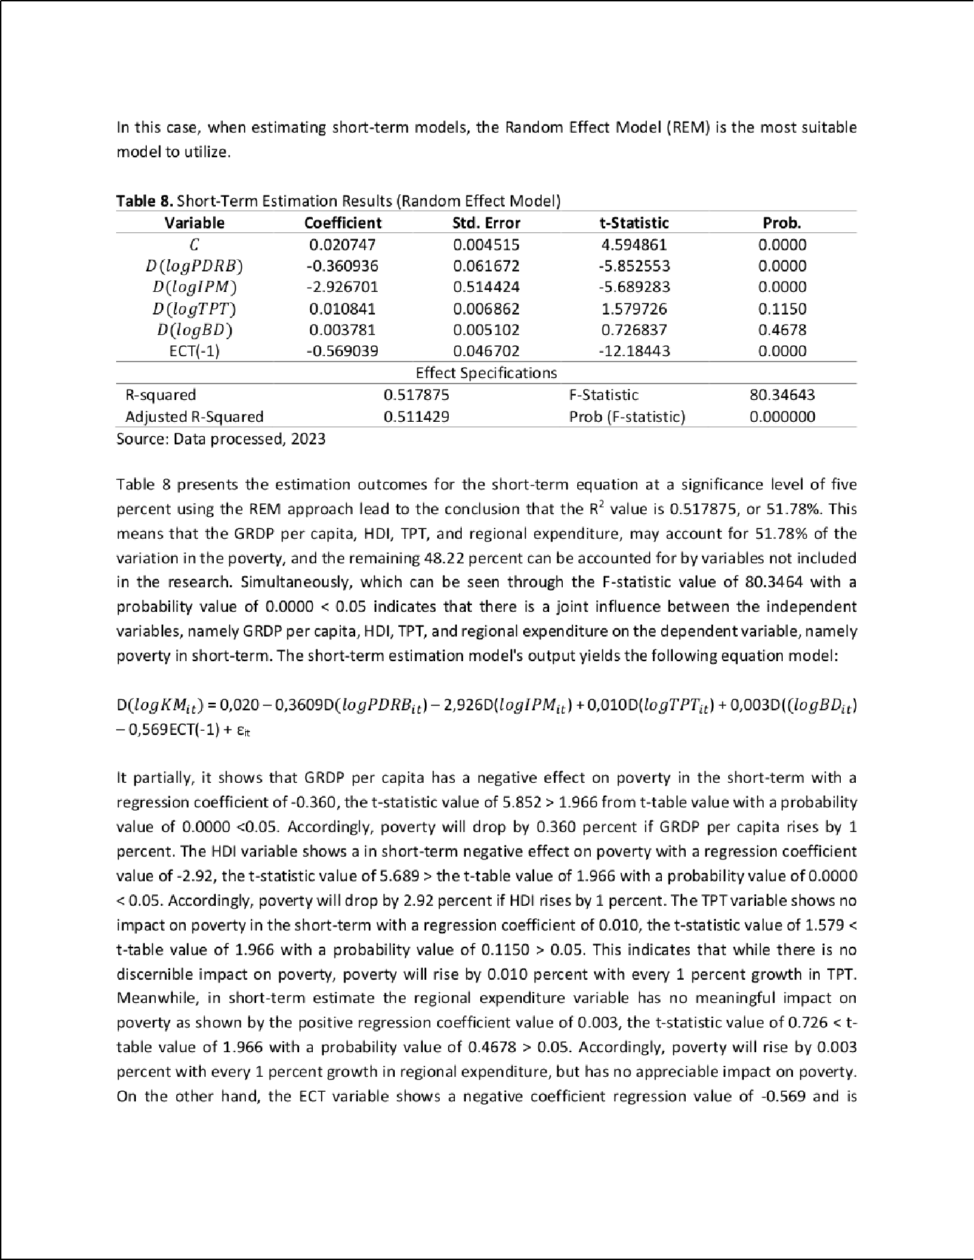

18

28

1

10

45

5

9

2

31

2

1

2

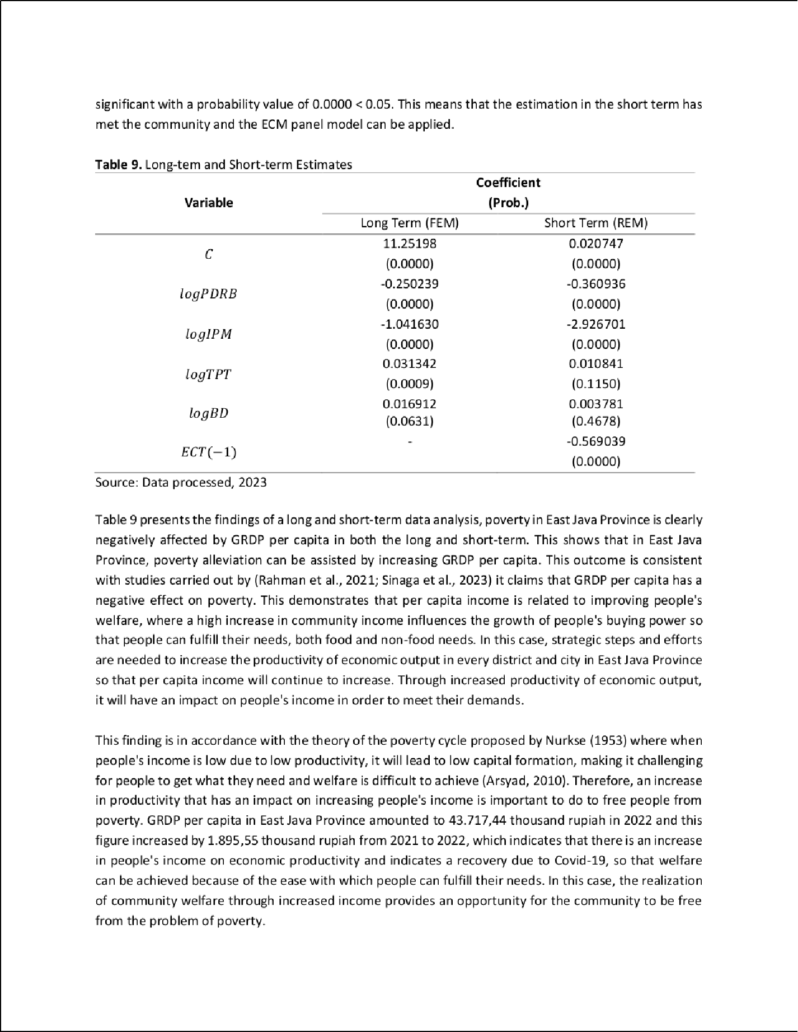

34

6

26

8

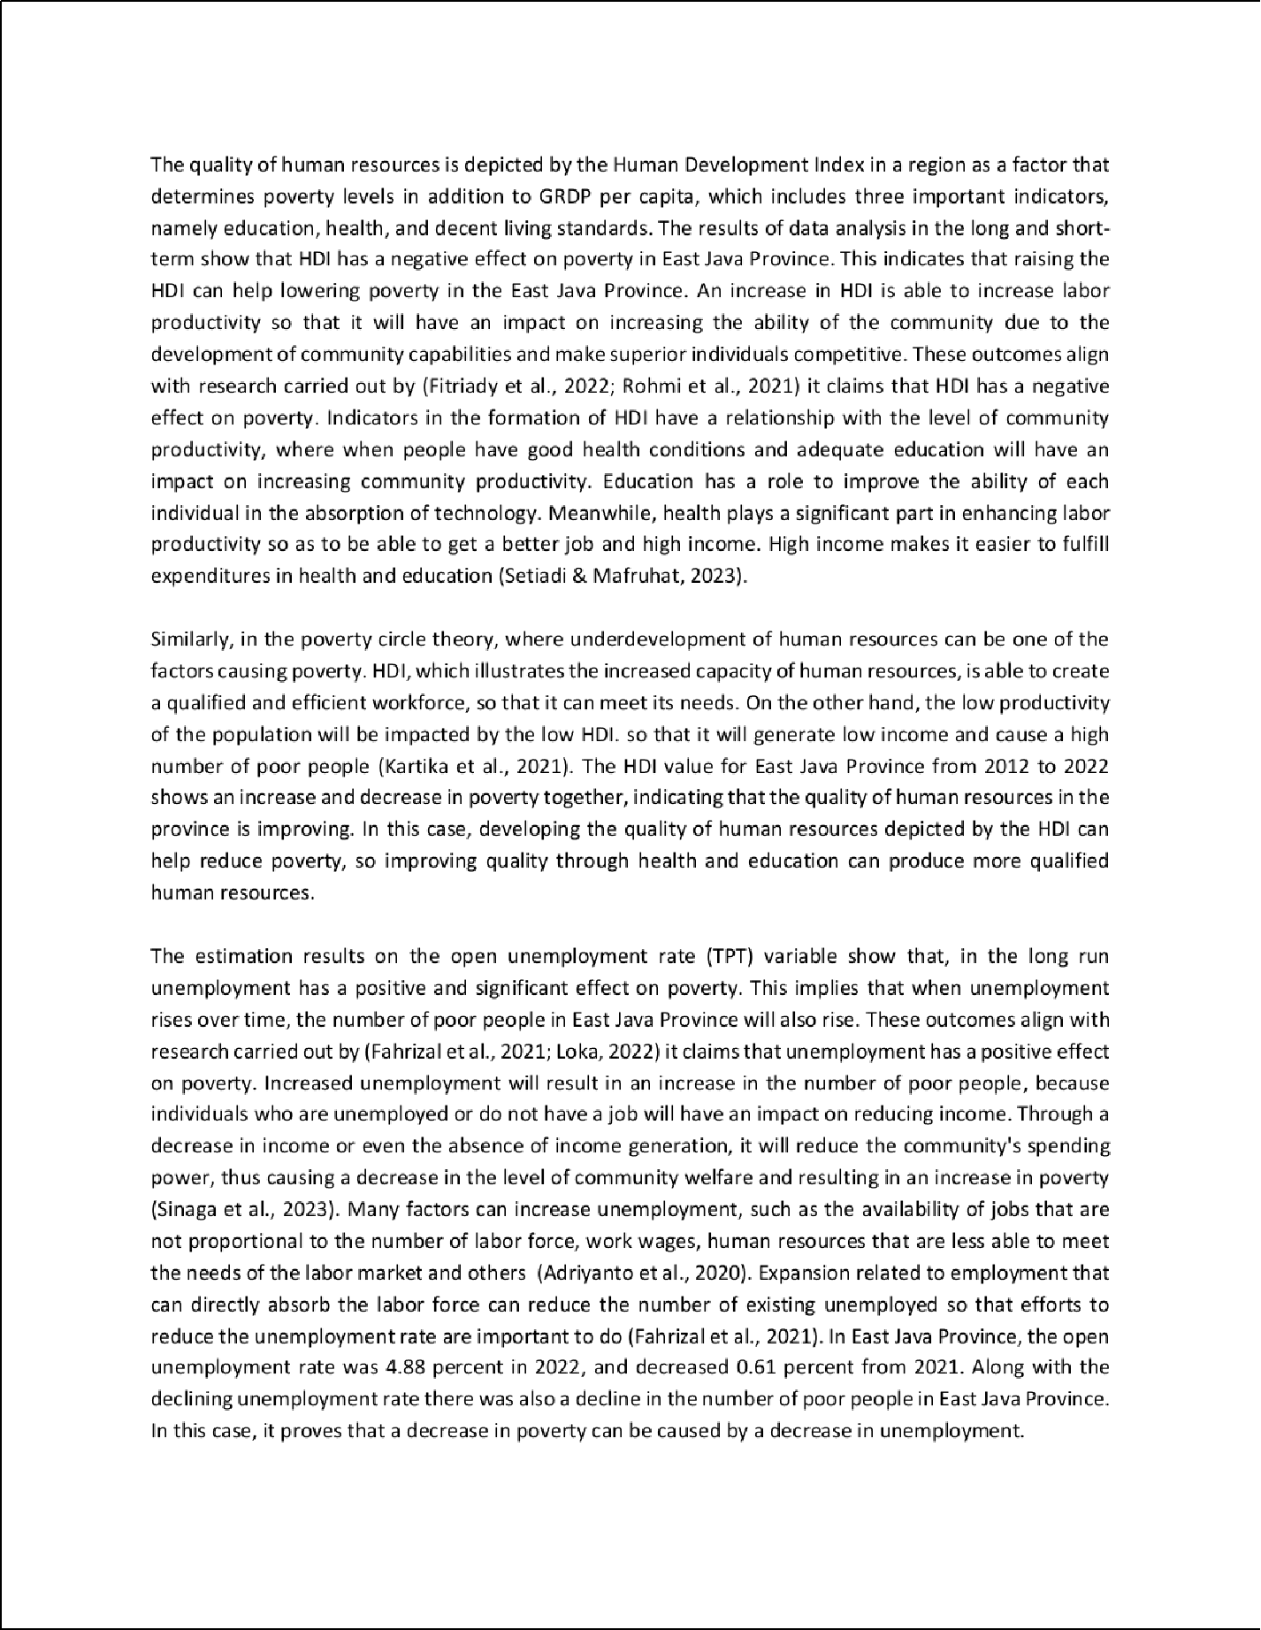

14

3

8

11

30

5

22

47

14

29

11

20

41

8

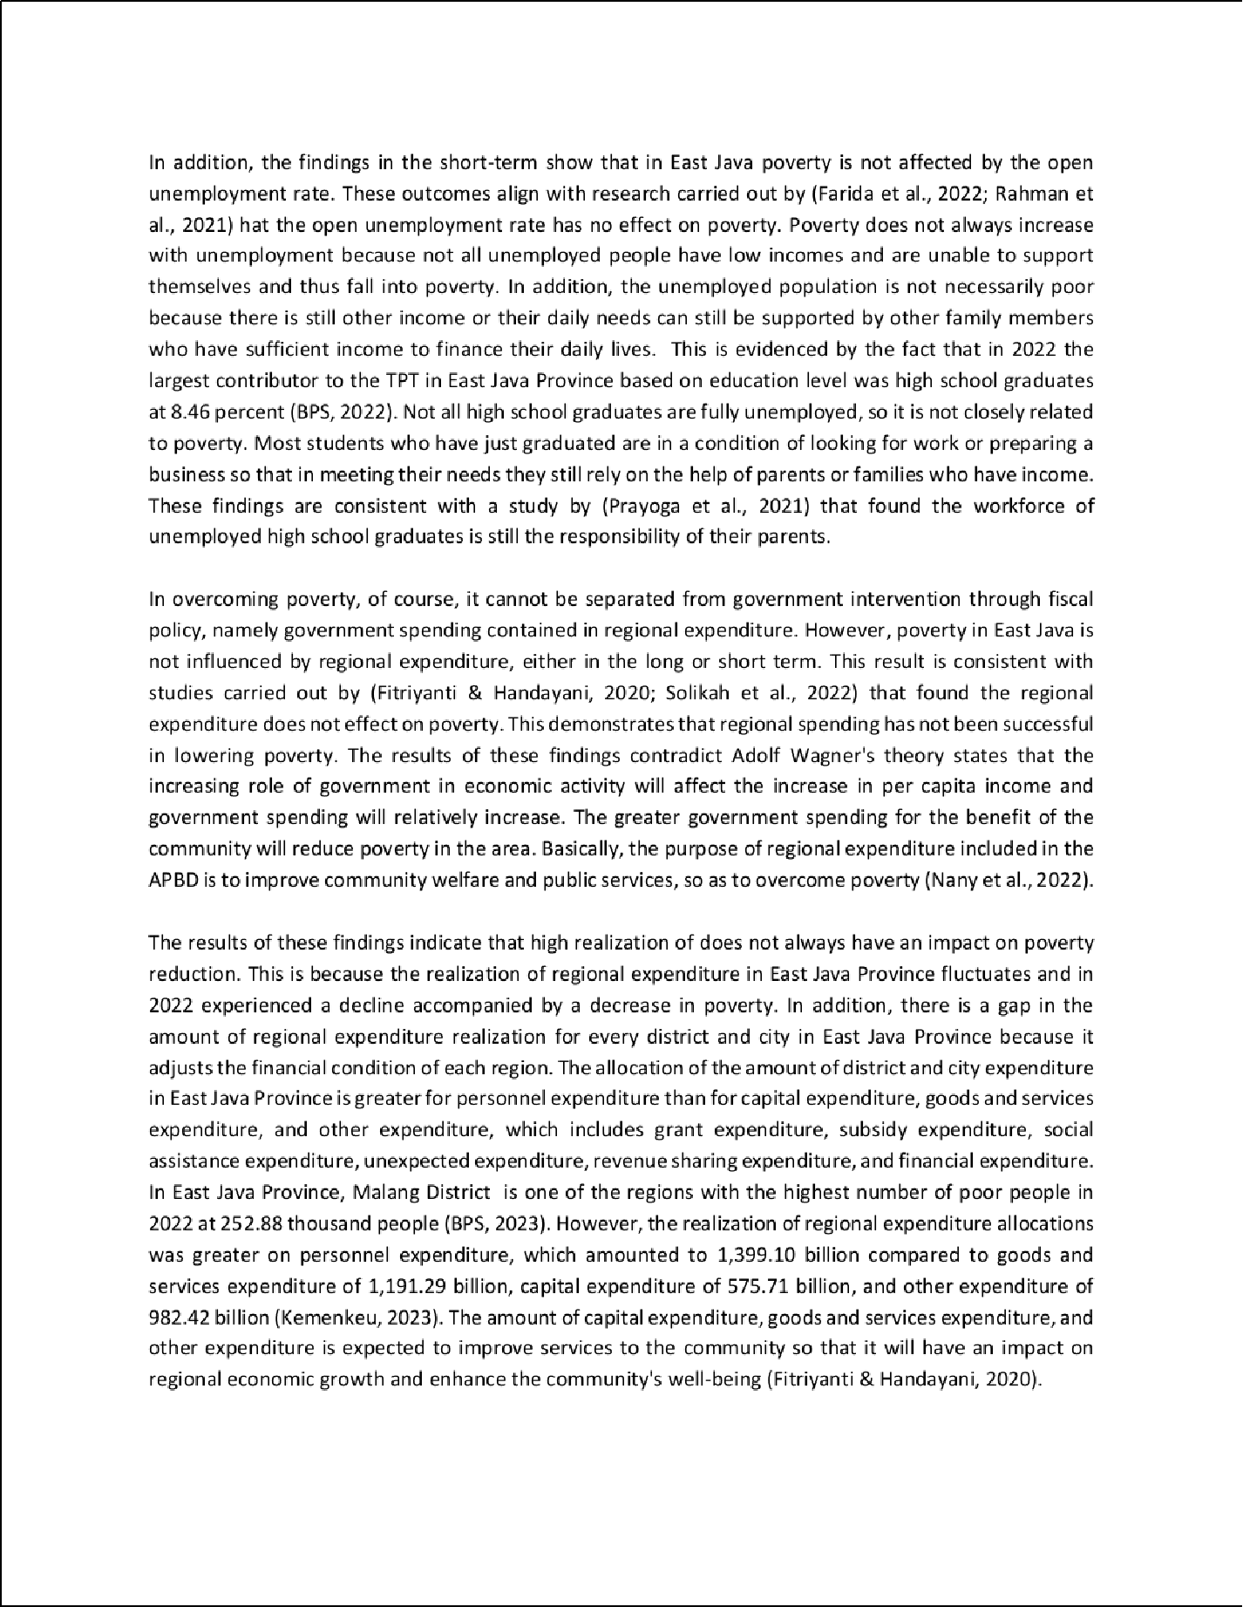

13

42

8

52

53

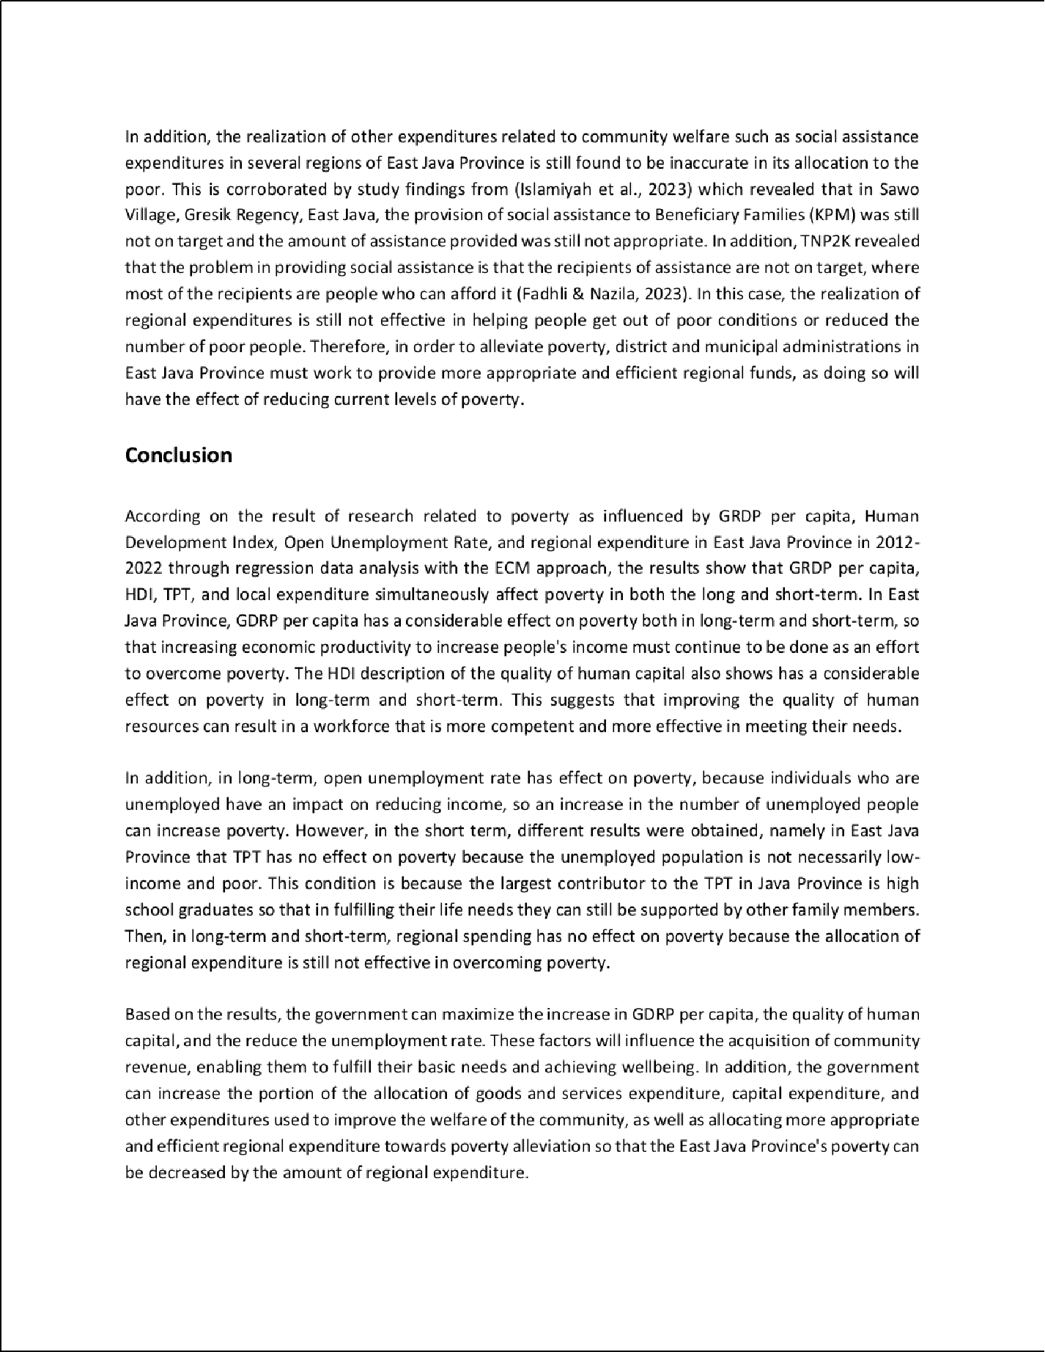

4

6

21

55

6 39

37

27

54

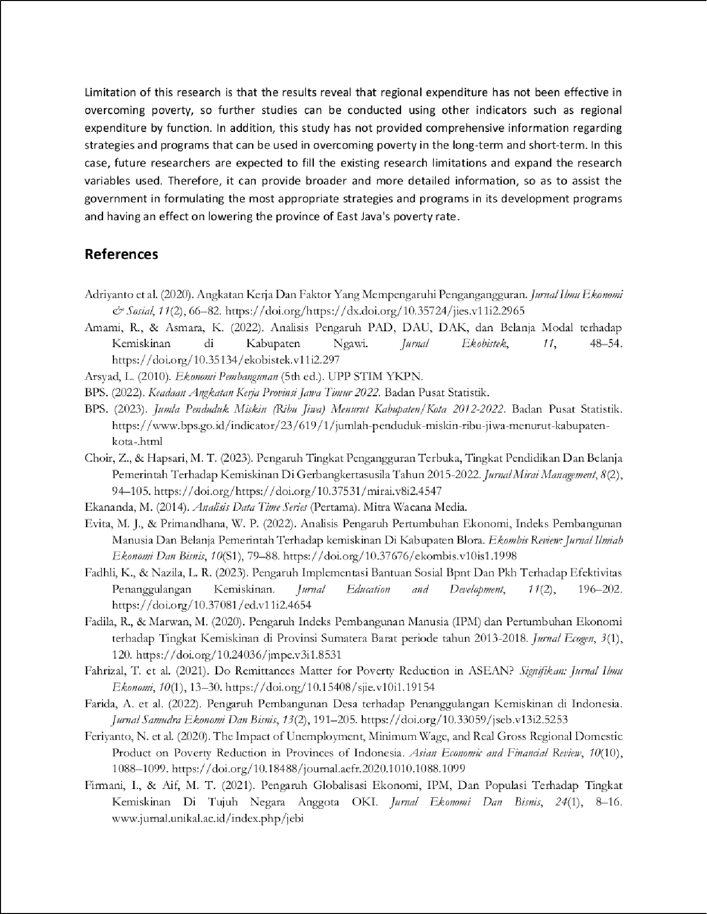

6

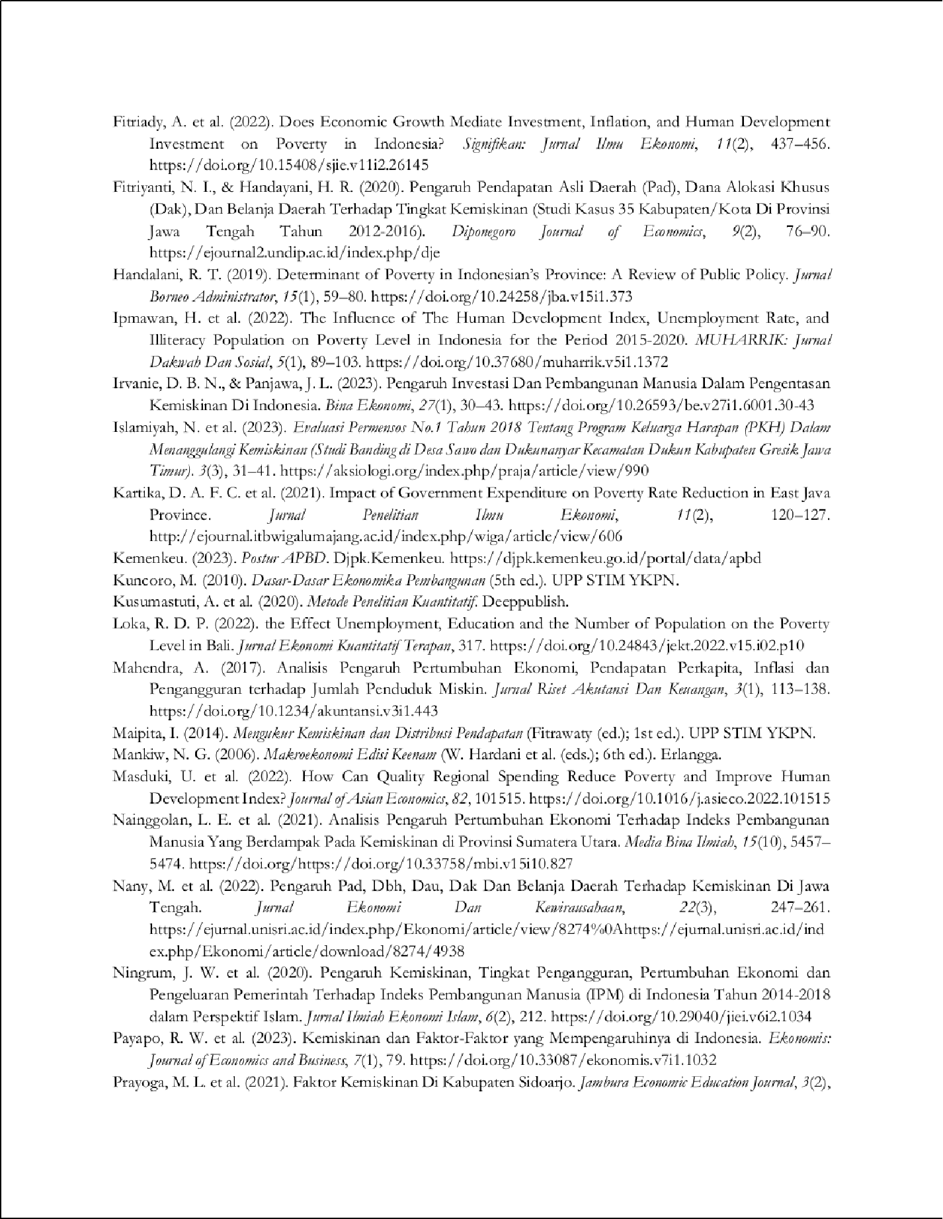

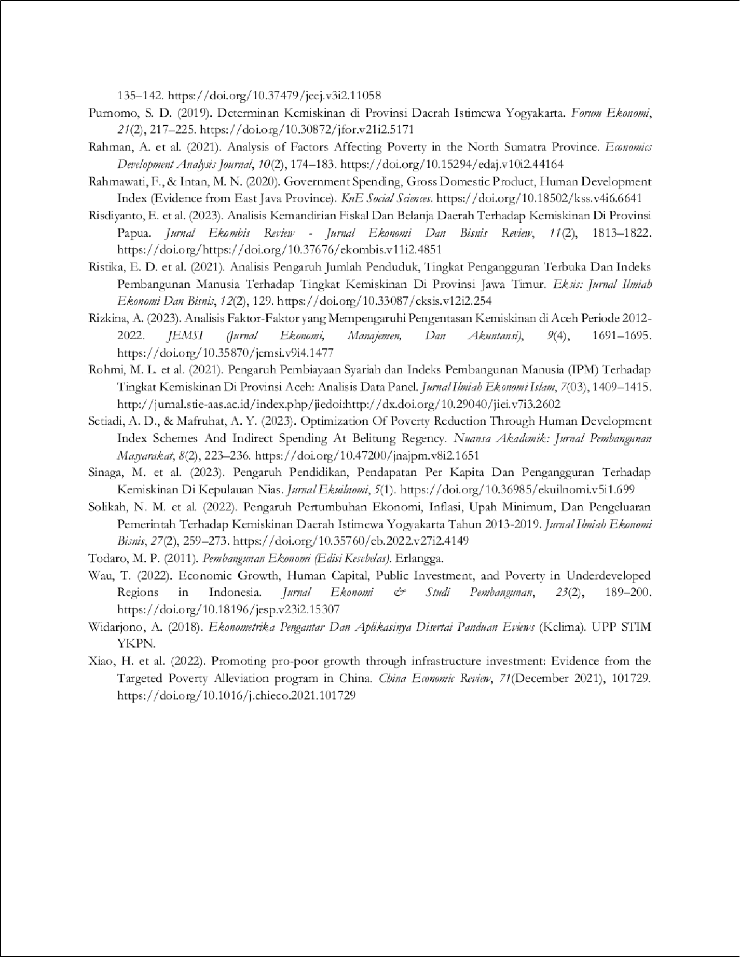

1Article Meilita Arini.docx

14

ORIGINALITY REPORT

%

SIMILARITY INDEX

13%

INTERNET SOURCES

9%

PUBLICATIONS

2%

STUDENT PAPERS

PRIMARY SOURCES

e-journal.unair.ac.id

Internet Source %

1

1

1

airjournal.org

Internet Source %

2

1

journal.umy.ac.id

Internet Source %

3

1

[www.saudijournals.com](http://www.saudijournals.com/)

Internet Source %

4

1%

5 Rifda Nabila. "The eﬀect of macroeconomic variables on the poverty rate in Indonesia", Journal of Economics Research and Policy Studies, 2021

Publication

1%

6 Maulidar Agustina, M. Shabri Abd. Majid, Said Musnadi, Faisal Faisal, Hafasnuddin Hafasnuddin, Suriani Suriani. "Islamic Banking, Economic Growth, and Poverty Reduction in Indonesia", 2022 International Conference on Decision Aid Sciences and Applications (DASA), 2022

Publication

7

8

9

10

11

12

13

14

15

16

17

journal.uinjkt.ac.id

Internet Source

repository.unej.ac.id

Internet Source

journal.formosapublisher.org

Internet Source

ejournal.unp.ac.id

Internet Source

Vika Annisa Qurrata, Nadiah Ramadhani. "The Impact of HDI, Minimum Wages, Investment and GRDP on Poverty in East Java in 2019", KnE Social Sciences, 2021

Publication

ejournal.seaninstitute.or.id

Internet Source

[www.openaccessojs.com](http://www.openaccessojs.com/)

Internet Source

jurnal.unimed.ac.id

Internet Source

dosen.perbanas.id

Internet Source

febi.radenfatah.ac.id

Internet Source

garuda.kemdikbud.go.id

Internet Source

1%

1%

1%

<1%

<1%

<1%

<1%

<1%

<1%

<1%

18

19

20

21

22

23

24

25

26

jurnal.umsu.ac.id

Internet Source

proceeding.umsu.ac.id

Internet Source

journal2.uad.ac.id

Internet Source

online-journal.unja.ac.id

Internet Source

journal.uin-alauddin.ac.id

Internet Source

jurnal.ar-raniry.ac.id

Internet Source

Siti Rohima, Junaidi Junaidi, Annada Nasyaya, Hamira Hamira. "Analysis of Human Development Index, Government Expenditure, Exports and Imports on Economic Growth in ASEAN-5", Jurnal Ekonomi Pembangunan, 2023

Publication

[www.haraldhau.com](http://www.haraldhau.com/)

Internet Source

Submitted to Universitas Jenderal Soedirman

Student Paper

<1%

<1%

<1%

<1%

<1%

<1%

<1%

<1%

<1%

<1%

27

28

29

30

31

32

33

Submitted to Universitas Tidar

Student Paper

journal.ipb.ac.id

Internet Source

Submitted to UNIVERSITY OF LUSAKA

Student Paper

Wiwin Indrayanti. "Analisis Faktor-Faktor Yang Mempengaruhi Kesejahteraan Masyarakat di Provinsi Riau Tahun 2008-2017", Jurnal Ecodemica: Jurnal Ekonomi, Manajemen, dan Bisnis, 2020

Publication

scholarsnetwork.org

Internet Source

Indira Ihnu Brilliant, Setiawan, Agus Suharsono. "Quasi-maximum likelihood estimation method on spatial autoregressive ﬁxed eﬀect for modeling the economic growth of ASEAN countries", AIP Publishing, 2019

Publication

Mochammad Yusuf, Avi Budi Setiawan. "The Nexus Between Health and Economic Growth: Empirical Evidence from Indonesia", Jurnal Ekonomi Pembangunan: Kajian Masalah Ekonomi dan Pembangunan, 2022

Publication

<1%

<1%

<1%

<1%

<1%

<1%

<1%

34

35

36

37

38

39

40

41

42

43

journal.perbanas.ac.id

Internet Source

publikasi.mercubuana.ac.id

Internet Source

digilib.uin-suka.ac.id

Internet Source

journal.uinmataram.ac.id

Internet Source

journal.unnes.ac.id

Internet Source

journal.walisongo.ac.id

Internet Source

jurnal.kemenkopmk.go.id

Internet Source

[www.researchgate.net](http://www.researchgate.net/)

Internet Source

A M Yolanda, K Yunitaningtyas, Indahwati. "Spatial Data Panel Analysis for Poverty in East Java Province 2012-2017", Journal of Physics: Conference Series, 2019

Publication

Asti Nuswantari, Anik Djuraidah, Utami Dyah Syaﬁtri. "The modeling of poverty in Java Island 2012 until 2018 using dynamic spatial panel", AIP Publishing, 2022

<1%

<1%

<1%

<1%

<1%

<1%

<1%

<1%

<1%

<1%

44

45

46

47

48

49

50

51

Publication

I Ketut Nama, Sri Suharsih, Rini Dwi Astuti. "Utilization of Regional Government Assets and Economic Growth in the Special Region of Yogyakarta", Proceeding of LPPM UPN “Veteran” Yogyakarta Conference Series 2020

– Economic and Business Series, 2020

Publication

Yessi Rahmawati, Andiga Kusuma Nur Ichsan, Annisaa Rizky Dwi Brintanti, Iqram Ramadhan Jamil. "Geo-spatial analysis: the impact of agriculture productivity, drought, and irrigation on poverty in East Java, Indonesia", Letters in Spatial and Resource Sciences, 2023

Publication

apjbet.com

Internet Source

bircu-journal.com

Internet Source

doaj.org

Internet Source

ekonomis.unbari.ac.id

Internet Source

ijemr.politeknikpratama.ac.id

Internet Source

jurnal.narotama.ac.id

Internet Source

<1%

<1%

<1%

<1%

<1%

<1%

<1%

52

53

54

55

jurnal.ucy.ac.id

Internet Source

jurnal.ugj.ac.id

Internet Source

Handaru Edit Sasongko, Puji Wibowo. "GOVERNMENT SPENDING AND REGIONAL ECONOMIC GROWTH: THE MEDIATING EFFECT OF HUMAN DEVELOPMENT INDEX",

Jurnal Ekonomi Bisnis dan Kewirausahaan,

2022

Publication

journal.trunojoyo.ac.id

Internet Source

<1%

<1%

<1%

<1%

<1%

Exclude quotes On Exclude bibliography On

Exclude matches Oﬀ