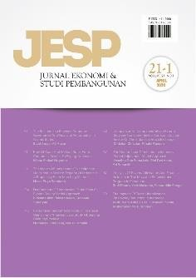Author Declaration Form

Jurnal Ekonomi & Studi Pembangunan

ISSN: 2541-5506 (Online) and 1411-9900 (Print)

https://journal.umy.ac.id/index.php/esp

Name of Principal/Corresponding Author\*

Ni Putu Sumartini

Address of Principal/Corresponding Author\*

Perum Puspa Raya Blok EF 30 Bogor Jawa Barat 16320

Telephone\*

085777492485

E-mail\*

[meyputu@gmail.com](mailto:meyputu@gmail.com)

Fax\*

-

All author(s) name\*

Ni Putu Sumartini, Rus’an Nasrudin

Date of submitted\*

4 March 2024

Manuscript title\*

Does Contract Farming Participation Promote Household’s Food Security for Smallholders? Empirical Evidence from Indonesia

1. Declare that the article above is original. my own thoughts not translated, and has not been published elsewhere or currently not in the process of other journal publications. I am willing to be responsible if there are parties who feel disadvantaged privately and/or based on a lawsuit in the future by the publication of this article.
2. I also declare that the transfer of copyright for the first publication is granted to

Jurnal Ekonomi & Studi Pembangunan.

Ni Putu Sumartini

4 March 2024

Editorial Office Jurnal Ekonomi & Studi Pembangunan:

Journal Room, E4 Building, 2nd Floor, Faculty of Economics and Business, Universitas Muhammadiyah Yogyakarta, Jalan Lingkar Selatan (Brawijaya), Tamantirto, Kasihan, Bantul, Daerah Istimewa Yogyakarta, Indonesia 55183.