**Does resource-rich provinces perform lower democratisation progress? Estimating oil impact on democracy indicators in Indonesia**

Rian Hilmawan1

1 Department of Economics, Faculty of Economics & Business, Mulawarman University, Samarinda, 75119, INDONESIA

Corresponding E-mail: rian.hilmawan@feb.unmul.ac.id

**ABSTRACT**

This study examines whether oil dependence affects democracy quality using provincial level data in Indonesia. While physical quantity production is used to measure oil *dependence*, democracy is measured based on Indonesia Democracy Index (IDI). I use static panel data analysis to control unobserved time-invariant characteristics of provinces, and use the Driscool and Kraay (D-K) standard error model which is robust to general forms of cross-sectional dependence when dealing with panel observations. The results show that provinces dependent to oil are positively correlated with democracy. The effects are also robust when democracy is separated into three main elements of IDI: *political rights*, *civil liberties*, and *democracy institutions*, or when alternative measure of dependence is used. Interestingly, this study finds that oil dependence has a strong effect on democracy in provinces with lack of oil rather than those in Sumatra and Kalimantan Islands, which are globally known as dominant resource locations.

**Key words** : *Oil, Democracy, Education, Province, Indonesia*

**JEL Classifications**: O13, D72

1. **INTRODUCTION**

Oil impact has long been understood can substantially penetrate a country’s economy. Regardless of whether oil extraction activities may hinder or help nation’s welfare, attentions have now moved to test whether country’s oil dependence has a link on democracy progress. This issue has initially emerged in countries primarily located in the Middle-East and North Africa for which oil wealth is seen as factor that stimulates authoritarianism (Anderson, 1987; Anderson, 1995). Study by Ross (2001) formally hypothesises this relationship focusing on country’s *dependence* on oil sector. Ross finds that oil-reliant nations, including mineral, tend to have lower quality in democracy. This paper thus aims to test this hypothesis by selecting Indonesia, a developing and young democratic country, as a special case study and incorporating data of provincial levels.

There are two reasons for why Indonesia should be particularly considered. First, Indonesia’s economy historically stems from oil-based income contributions. The production of oil has been commercially produced in the 1970’s following a succesfully oil reserves discovery in a number of locations in the Sumatra and Kalimantan Islands, which later these islands have become the forerunner of Indonesia’s giant oil fields.[1] The contribution of oil production on national income has still been overwhelmingly critical until the present time, though oil production experienced a gradual decrease over time. It has been provenly measured that the deposits of oil may still last approximately more than 50 years as efforts to invest in deep water explorations have been highly devoted.[2]

Secondly, Indonesia follows democracy system across national and sub-national (province and district) areas, for almost two decades. The direct presidential election was initially started in 2004 and rapidly echoed by the direct elections of local leaders at sub-national governments ran in 2005. These events were induced by a decentralization policy that allowed local governments in executing development planning, budgeting, and public service delivery to local citizens. Although democracy climate seems to blossom, no available data exist to monitor development progress on this aspect, making it hard to exercise causal effects of whether oil wealth improves practicality of democracy at decentralised area. Only from 2009, the Indonesian Democracy Index (IDI) has been officially released in a yearly basis, enabling researchers to verify the progress of local democracy across provinces.

The available time period from this exogenous event allows to test the extent to which democracy progress is affected by activities associated with hydrocarbon resources. As oil endowments are randomly spread across Indonesia’s province (where each province has several number of districts), some, whose their areas have rich oil endowments, have become dependent on resource-based economic sectors, while those which have less or no oil reserves will rely on sectors unrelated with non-renewable resources.

Following Ross’s study and foreshadowing it to Indonesia decentralisation movement, this research examines whether oil affects democracy, and checks does becoming reliant on oil result in a devastating effect on democracy at the provincial level. As the study using within-country analysis on this field is lacking, this paper contributes to the literature by providing empirical investigations.

Oil is often seen as a valuable resource capital that should, by default, help improving country’s economy or achieving better development progress. The positive effect of oil on national income has been found in a number of cross-country studies for example Alexeev & Conrad (2011), Brunnschweiler (2008), Brunnschweiler & Bulte (2008), and Libman (2013). Despite a blessing consequence that natural resources could contribute, researchers have found that nations that highly dependent on mining sector, in general, are more likely to have lower income and development outcomes (Sachs and Warner, 2001; Papyrakis & Gerlagh, 2004).

Another striking finding of a detrimental effect of oil is that oil wealth retards country’s democracy quality. A seminal article published by Ross (2001) initially provides the empirical evidence of why oil is bad for democratic development. Ross, using country-level data, measures democracy level using a scale ranging from 0 to 10, where the highest value indicates the most democractic contry.[3] Oil dependence is used as the key variable, measured as the share of the agregate export-value of mining-based fuels (petroleum, gas, and coal) in total GDP. Focusing the period between 1971 and 1977, with a pooled OLS using cross-sectional data set, Ross finds that increased oil dependence, including minerals, tends to worsen democracy quality.

One might reasonably argue that cross-country investigation could suffer from biasedness due to different development levels between developed and developing countries, or between Africa-Middle East versus non-Africa-Middle East countries. Ross also addresses this possibility by controlling the locational effects of nations in the Middle East and sub-Saharan Africa, or distiguishing them according to the country’s size (i.e. large and small states), both use binary variables. Again the point estimates for oil and minerals are still significantly negative, though have reduced when additional control variables are included.

Of why oil hinders democracy in a oil-rich nations, Ross (2001) argues that the rentier and repression effects have weakened processes towards better civil freedom and political rights. For example a higher prorportion of revenues from minerals causes government to build up its internal security, enabling them to reduce or block people’s demands towards democracy. This reasoning refers to the *repression effect*. The second cause is caused by the *rentier effect*. In oil-wealthy states, revenues have dominantly sourced from oil extraction than citizens taxation. This gives incentive for the country’s residents to get less effort in paying tax. As a result, citizens demand less accountability to government, making the government becomes less dependent to its citizens, weakening checks and balances processes between two actors, yet deteriorating democracy.

Some studies supporting Ross’s paper are Jensen & Wanthecekon (2004), Aslaksen (2010) and Anyanwu and Erhijakpor (2014). Jensen and Wanthecekon (2004), for example, focus on 46 countries in Sub-saharan Africa following 1960-1995 period. The authors use political regime as a proxy for democracy as Ross (2001) with some modifications of the scale. Using fixed-effects analysis, they find that oil and mineral exports, as a share in merchandise exports, negatively affect democracy in Africa, even after controlling dummies for historical colony.

Aslaksen (2010) regresses democracy on the share of oil in total GDP using pooled cross-sectional OLS regression, and finds that oil share has a negative effect on political rights. The negative impact persists whether democracy is regressed sparsely or whether income per capita, population and education are included, or even whether the fixed-effects and dynamic panel model are also applied. Anyanwu and Erhijakpor (2014) compare OLS and fixed-effects model, and find stable inverse relationship between oil wealth per capita, measured using log of oil per capita, and democracy. Here *polity2* is used as a measure of democracy, which reflects competitiveness and opennes representing political participations.

When adverse effects of oil on democracy have become widely accepted, some studies find a surprising contrast result against Ross (2001). Haber and Menaldo (2010), for instance, find insignificant results once country fixed-effects are controlled. Werger (2009) using fixed-effects regression between 1960 and 2004 finds that the negative impact of oil production on democracy decreases once the model incorporates income per capita and population. Arezki and Bruckner (2011) find that a change in oil rents raises civil liberties. Similarly, study by Bruckner, Ciccone and Tesei (2012) finds that an increase in the share in international oil price raises democratic institutions. Herb (2005) also initially argues that negative relationship between oil and democracy is just a matter of geographic samples as previous studies relied much on states in the Middle East and North Africa.

Oskarsson & Ottosen (2010) conduct a thorough study that criticises democracy variable used in previous studies (e.g. Jensen and Wanthecekon (2004), Smith (2004), Tsui (2010)). They argue that most studies in the past were focussed on political rights index (*Polity*), ignoring civil liberties components such as freedom to assembly, to form organisation and also not considering freedom of the press, that can better capture democracy dimensions. Studies that confirm Ross’s finding are also restricted by the time horizon, which is importantly needed for robustness. Oskarsson & Ottosen then empirically test the hypothesis by proposing alternative democracy scores from Freedoom House (FH) that includes civil freedoom aspect to complement traditional Polity index used in the past studies. For checking temporal stability, Oskarsson & Ottosen (2010) also use different time periods, comparing old periods in 1977-1999 and new periods within 2000-2006, according to panel data in 132 countries. They find that democracy quality becomes unaffected by oil when democracy is measured following FH-index, with some surprising positive evidence of oil dependence, or mineral (defined as percentage of GDP), when democracy scores refer to political rights and civil liberties, respectively.

In addition, Acemoglu, et al. (2005) also test whether democracy performance is actually determined by income per capita as pointed out other influential study of Barro (1999). The authors find that once countries unobserved effects are included, income per capita becomes insignificant, but education itself has a strong effect on democracy. This finding suggests that *education* should be added as important control to detect direct influence of oil on state’s democracy level.

Reviewing the highlighted literatures as above, it is clear that the causal effects between oil and its impact on democracy has still been a developing topic to be studied, and while existing literatures have shed some light, many of them are concentrated using cross-country dataset. This study offers a room to fill the gap by adopting within-country analysis. To the best of our knowledge, I cannot find similar studies which conduct causal links between oil or mining dependence and democracy in Asia, nor for Indonesia.

The structure of this paper is then organised as follows: Section 2 explains sources of my data, including measures of variables and the research method used in this study. Section 3 demonstrates the results and discusses relevant findings associated with the aim of the paper. Section 5 concludes.

1. **RESEARCH METHOD**

Since export data of oil are not available at province level in Indonesia, I use physical production (lifting) as it closely captures degree of exports across provinces in Indonesia. Data of physical quantity of oil production (in barrels) are obtained from the Indonesian Ministry of Energy and Mineral Resources (MoEMR). Oil production at province is the sum of oil produced in all districts of the related province, specifically calculating oil wells are operated onshore or offshore, or both, in the respective area. Following Ross (2001), I divide each province’s oil production with total national production to measure it as a share. Again for robustness check, I also devide province’s oil lifting by its population according to Indonesia’s census data in 2010, allowing me to measure it as per capita value.

Regarding the democracy variable, I use the Indonesia Democracy Index (IDI) released in 2009 by Indonesia Central Statistical Bureau (BPS). The IDI encompasses three fundamental aspects namely civil freedom, political rights, and democracy institutions. These aspects are then decomposed into 11 variables and 28 indicators to obtain single composite index of IDI. This demoracy index has a scale of 0 to 100, where the higher value means better improvement in democratic level. I then rescale this from 0 to 1 to match the scale of my key independent variable that uses the proportion value. I restrict the period only within 2009 – 2016 following the availaibility data of IDI. The IDI reflects dimensions similar to the well-known FH democracy indicators used by Aslaksen (2010) and Oskarsson & Ottosen (2010), which give more weights on political rights and civil liberties as the main components.

As in Ross (2001), Aslaksen (2010), and Oskarsson & Ottosen (2010), some control variables are also included. Income per capita is hypothesised can increase prosperity thereby improve demand on democracy. Better educated people are expected raising political representations and public awareness, improving quality of democracy (Acemoglu, et al. (2005); Barro (1999)). To measure this, I use human development index (HDI) as a proxy. I also interest to add variable that captures dynamics of women contributions at each province, believed to affect democracy sustainability (Gberevbie and Oviasogie, 2012). For this aim, I use the proportion of women involved in formal and professional jobs. I also include internet usage as our important control variable. Some recent studies have emphasized internet exposure as a driving factor to reinforce democracy practices (Pirannejad, 2017; Evans, 2018), or instead can reduce people satisfaction towards democracy (Chang, 2018). Thus, I collect information related to the percentage of “household” using internet in the last 3 months. I am also aware that past studies have controlled religion to capture proportion of people embracing Islam. However, based on Indonesia’s census in 2010, majority population across provinces in Indonesia was affiliated as “Muslim” whereas data related with it are unavailable over time, I exclude this as my control. All data used for these explanatory variables are collected from BPS.[4]

The estimation strategy consists of two parts. First, considering that my observation contains a number of provinces across different islands, estimates based on fixed-effects (FE) method to control factors caused by the unobserved heterogeneity in these provinces are prefered. My static model is then constructed as follows:

${DEMOC}_{i,t}={α+OIL}_{i,t}+{β'X}_{i,t}+μ_{i}+γ_{t}+ε_{i,t}$………………………….(1)

Here, I regress quality of democracy (${DEMOC}_{i,t}$), on our key variable, oil dependence or ${OIL}_{i,t}$. Democracy is measured by the IDI, and I also use each component of the IDI namely civil freedom (CV), political rights (PR) and democracy institutions (DI), as mentioned above as alternative dependent variables, following the strategy used by Oskarsson & Ottosen (2010). ${OIL}_{i,t}$ is a share of oil produced by each province in oil total production, and is a share per population as in Haber and Menaldo (2008) or Aslaksen (2010).[5]

The constant provincial fixed effects are indicated by $μ_{i}$, while $X_{i,t}$ is a set of vector indicating control variables. The subscript $i=1, 2, 3, ……, 33$ for the 33 provinces across Indonesian islands, and $t=1, 2, 3, …..8$, for the 8 years, making the time series are less than the number of cross-sectional identifier. Given to this fact, the more advanced static panel model such as a feasible general least square (FGLS) is not suitable to perform (Reed and Ye, 2011). Short period of time also gives a restriction to effectively perform lagged independent variables technique, or use more advanced dynamic panel model.

Estimation that relies on panel data may possibly suffer from a cross-sectional dependence problem which could result in biased estimates. I therefore complement fixed effects models by performing the Driscoll and Kraay (D-K) standard errors (1998) as it suits the specification of data set when $i>t$. The D-K method, as emphasized in Hoechle (2007), is robust in the case of heteroskedastic, autocorrelated with MA($q$), and the appearance of cross-sectionally dependent.[6] I therefore follow this procedure in all of my estimations. The Pesaran’s CD test is also first used to detect whether cross-sectional dependence in fact exists or does not (De Hoyos & Sarafidis, 2006).

Finally, I also test whether oil lowers democracy performance in provinces with higher oil dependence against with those less dependent or having no oil. To do so, I separate my sample into two categories. Provinces with less dependent on oil are grouped in Java and other regions, while oil-rich provinces are grouped in Sumatra and Kalimantan. I then repeat again our analysis as in Eq. (1) and see whether different results appear.

1. **RESULT AND DISCUSSION**
   1. **Descriptive Analysis**

I begin by showing descriptive figures regarding key variables used while the average comparison will also be shown later on. The descriptive statistics are shown in Appendix 1. Figure 1 presents scatterplots between the average of the share in oil production and aggregate index of democracy quality (IDI) over the period 2009-2016, including all three core aspects of IDI. For clarity, I also show the estimated lines in each graph. As shown, it shows positive correlations between oil dependence and IDI, and each index related with political rights and democracy institutions in 33 provinces observed. I also find a slight negative pattern on civil freedom index, though the predicted linear line is found to be not significant.

**Fig 1.** Relationship between share of oil production and IDI, (2009-2016).

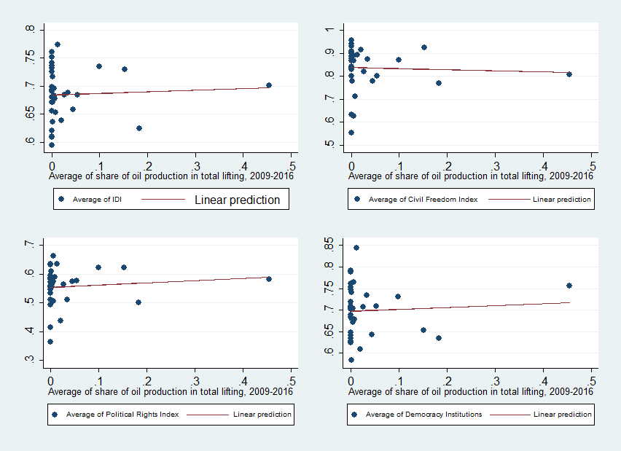

Source: *Author’s calculation*

Figure 2 compares the average oil production between 2009 and 2016, grouped into seven Indonesia’s largest Islands (Sumatra, Java, Kalimantan, Maluku and East Regions, Sulawesi, and Papua). As predicted, Sumatra’s region has been the highest contributor with production stood at 18.4 million barrels. Kalimantan and Java followed with 9.5 million barrels on average. The remainder regions have shown level of production under five million barrels, where Papua region has been the highest producer among the rest.

**Fig. 2.** Comparison of oil production across Indonesia’s Major Islands

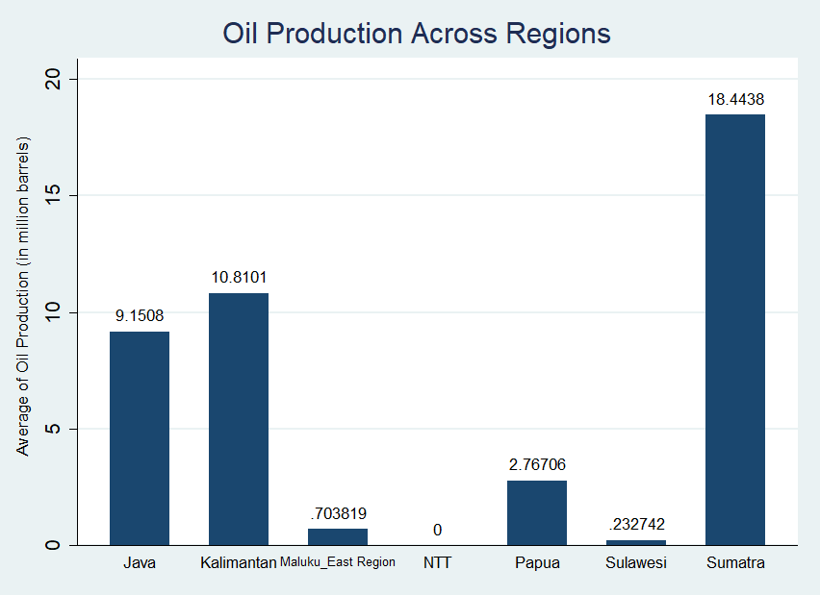

Source: *Author’s calculation*

**Fig. 3.** Comparison of democracy level across Indonesia’s Major Islands

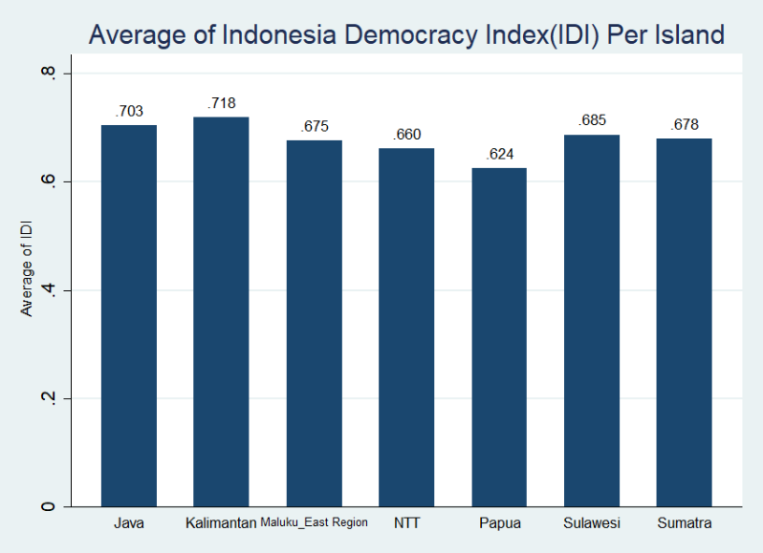

Source: *Author’s calculation*

Comparatively, as shown in Figure 3, Sumatra region which has produced the highest oil output does not automatically achieve higher democracy index, while Kalimantan and Java region have seen good performance compared to the rest. Interestingly, poor oil island, Sulawesi, has taken the fourth place with better IDI above the richest oil region Sumatra. Also from the graph, it is also clear that Papua’s region had the lowest democracy index over the period observed. To get a solid evidence for these revealed descriptive patterns, I next turn to run regression analysis to formally test the impact of oil dependence on local democracy indicators in Indonesia.

* 1. **Effects of Oil on Democracy**

Moving to results, Table 2 presents the effect of oil production’s share on aggregated index of democracy (IDI). All models control provincial fixed effects and perform Driscoll Kraay (D-K) standard errors as the Pesaran’s CD tests significantly reject the null hypothesis of no cross-sectional dependence.

In columns (1)-(4), Table 1, I interestingly find that local democracy is positively affected by the share of oil production, where all coefficients are statistically significant at 1 percent level. The point estimates are large in columns (3) and (4) when more determinants of democracy are included. Taking column (4) for example, a one percentage point increase in the share of oil in total production increases IDI by 0.005 (=0.462*0.01). If the average value of IDI is 0.685, the IDI will be 0.690 and the relative change will result in a (0.690 - 0.685 / 0.685 =) 0.71 percent increase. Alternatively, by standardizing the coefficient, an increase in the share of oil production in total oil production by one standard deviation would increase IDI by a ([0.088/0.066]*0.462 =) 0.607 standard deviations, holding all else constant.[7]

I also find that internet usage by households and share of women participation in profesional job are positively correlated with democracy level, though the magnitudes are small and the effects of gender are no longer significant as shown in columns (3)-(4). Gini ratio at urban districts also shows negative signs across all models as expected, but insignificant, while for income per capita I find positive sign but again not significant in majority model used. Education, in particular, has shown to be a strong determinant on democracy level in Indonesia, where the estimated coefficient is above 1. For example, HDI raises IDI by (1.460*0.01=) 0.015 points when HDI increases by one percentage point.

For robustness, I also use alternative measure of oil abundance based on its per capita value. All results are depicted in Table 2. Controlling other variables in the model as before, my results remain consistent with positive coefficients found for oil per capita, though only significant in columns (3) and (4) but at 1 percent level. In particular, again taking column (4) as an example to compare with the result in Table 1, democracy index improves by only (0.642*0.01 =) 0.006 points when oil per capita raises by one percentage point. This suggests that even both measures of oil dependence show a positive effect, I find that the share in oil production has a strong implication on democracy index at province. Regarding with other determinants, I again find similar effect of internet usage to be positively correlated with democracy, as predicted in the literature, whereas HDI remains to increase democracy.

**Table 1.** Effects of Oil Production on Democracy Quality

|  |  |  |  |  |
| --- | --- | --- | --- | --- |
| Dependent Variable: IDI | | | | |
|  | (1) | (2) | (3) | (4) |
| Share of Oil Production | 0.365*** | 0.444*** | 0.513*** | 0.462*** |
|  | (0.047) | (0.064) | (0.069) | (0.075) |
| Income per capita (in logs) | 0.037 | 0.034* | 0.009 | -0.002 |
|  | (0.020) | (0.015) | (0.014) | (0.012) |
| Gini Ratio |  | -0.009 | -0.175 | -0.229 |
|  |  | (0.157) | (0.153) | (0.155) |
| Woman Participation |  | 0.006*** | 0.001 | 0.000 |
|  |  | (0.001) | (0.001) | (0.001) |
| Internet Use |  |  | 0.003*** | 0.001** |
|  |  |  | (0.001) | (0.000) |
| HDI |  |  |  | 1.460*** |
|  |  |  |  | (0.340) |
| Constant | 0.595*** | 0.330** | 0.595*** | -0.267 |
|  | (0.030) | (0.089) | (0.065) | (0.249) |
| Fixed Effects | YES | YES | YES | YES |
| D-K Standard Errors | YES | YES | YES | YES |
| R-squared | 0.055 | 0.112 | 0.289 | 0.320 |
| Observations | 264 | 231 | 231 | 231 |
| Number of groups | 33 | 33 | 33 | 33 |

*Note*: *, ** and *** imply statistical significance at the 10, 5, and 1 percent level, respectively

**Table 2.** Effects of Oil Per Capita on Democracy

| Dependent Variable: IDI | | | | |
| --- | --- | --- | --- | --- |
|  | (1) | (2) | (3) | (4) |
| Oil Per Capita | 0.042 | 0.026 | 0.743*** | 0.642*** |
|  | (0.191) | (0.112) | (0.141) | (0.151) |
| Income per capita (in logs) | 0.004 | 0.004* | 0.001 | -0.000 |
|  | (0.002) | (0.002) | (0.001) | (0.001) |
| Gini Ratio |  | 0.003 | -0.012 | -0.018 |
|  |  | (0.016) | (0.016) | (0.016) |
| Woman Participation |  | 0.001*** | 0.000 | -0.000 |
|  |  | (0.000) | (0.000) | (0.000) |
| Internet Use |  |  | 0.0003*** | 0.0001** |
|  |  |  | (0.000) | (0.000) |
| HDI |  |  |  | 0.151*** |
|  |  |  |  | (0.033) |
| Constant | 0.060*** | 0.034** | 0.057*** | -0.031 |
|  | (0.003) | (0.010) | (0.007) | (0.024) |
| Fixed Effects | YES | YES | YES | YES |
| D-K Standard Errors | YES | YES | YES | YES |
| R-Squared | 0.035 | 0.085 | 0.272 | 0.305 |
| Observations | 264 | 231 | 231 | 231 |
| Number of groups | 33 | 33 | 33 | 33 |

*Note*: *, ** and *** imply statistical significance at the 10, 5, and 1 percent level, respectively

Moving to Table 3, I now replicate again my model in Tables 1 and 2 but now divide my provinces sample as two groups: *Java & others[8]* and *Sumatra & Kalimantan*. Emphasizes are focused here for Sumatra and Kalimantan as these islands are known as oil-rich areas. I again find that, despite sample separation is conducted, oil dependence is still positively correlated with democracy level. Interestingly, the estimated coefficients in the share in oil production in provinces located in the first group are larger than those situated in Sumatra and Kalimantan.

**Table 3.** Effects of Oil on Each Aspect of Democracy

|  |  |  |  |  |
| --- | --- | --- | --- | --- |
| Dependent Variable: IDI | | | | |
|  | (1) | (2) | (3) | (4) |
|  | Java & other regions | Java & other regions | Sumatra & Kalimantan | Sumatra & Kalimantan |
| Share of Oil Production | 0.426*** |  | 0.145* |  |
|  | (0.087) |  | (0.072) |  |
| Oil Per Capita |  | 6.016*** |  | 0.325** |
|  |  | (0.950) |  | (0.097) |
| Income per capita (in logs) | 0.009 | 0.001 | -0.004 | -0.000 |
|  | (0.012) | (0.001) | (0.026) | (0.003) |
| Gini Ratio | -0.017 | 0.005 | -0.494** | -0.047** |
|  | (0.174) | (0.016) | (0.194) | (0.019) |
| Woman Participation | 0.000 | -0.000 | -0.000 | 0.000 |
|  | (0.000) | (0.000) | (0.002) | (0.000) |
| Internet Use | 0.001 | 0.000 | 0.001** | 0.0001*** |
|  | (0.000) | (0.000) | (0.000) | (0.000) |
| HDI | 2.048*** | 0.202*** | 0.736 | 0.063 |
|  | (0.360) | (0.043) | (0.460) | (0.043) |
| Constant | -0.728** | -0.076** | 0.322 | 0.037 |
|  | (0.243) | (0.027) | (0.328) | (0.031) |
| Fixed Effects | YES | YES | YES | YES |
| D-K Standard Errors | YES | YES | YES | YES |
| R-Squared | 0.422 | 0.437 | 0.242 | 0.246 |
| Observations | 133 | 133 | 97 | 97 |
| Number of groups | 19 | 19 | 14 | 14 |

*Note*: *, ** and *** imply statistical significance at the 10, 5, and 1 percent level, respectively

The same finding is also found for oil per capita. In particular, for example, holding all other factors constant, democracy raises by (0.426*0.01 =) 0.004 points when share of oil production in Java’s provinces increases by one percentage point, significant at 1 percent level. Whereas it only raises democracy quality by (0.145*0.01 =) 0.001 points in provinces located in Sumatra and Kalimantan, with stastically significant at only 10 percent level. The point estimates differ substantially between these two groups. For example, I find difference by 0.281 for oil production, and 5.691 for oil per capita. These findings suggest that although oil dependence has helped raising democracy level overall, oil impact in provinces with lack or no oil endowments achieves better democracy quality than provinces for which oil resources have dominantly contributed.

* 1. **Oil Effects on Particular Aspects of Democracy**

Finally, if oil dependence generally helps Indonesia’s democracy environment, does it also affect particular aspect of democracy in Indonesia? Table 4 presents the results regarding this question comparing civil freedom, political rights, and democracy institutions where each is put as a dependent variable and I regress them separately on oil measures as before. To save space, attentions now are only focused on estimates associated with key independent variables.

**Table 4.** Effects of Oil on Each Aspect of Democracy

|  |  |  |  |  |  |  |
| --- | --- | --- | --- | --- | --- | --- |
|  | (1) | (2) | (3) | (4) | (5) | (6) |
| VARIABLES | CF | PR | DI | CF | PR | DI |
| Oil Production | 0.051*** | 0.030* | 0.066** |  |  |  |
|  | (0.007) | (0.013) | (0.026) |  |  |  |
| Oil Per Capita |  |  |  | 1.733*** | -0.267 | 0.727 |
|  |  |  |  | (0.271) | (0.382) | (0.375) |
| Constant | 0.204*** | -0.224*** | -0.005 | 0.204*** | -0.231*** | -0.012 |
|  | (0.026) | (0.040) | (0.045) | (0.017) | (0.042) | (0.044) |
| Controls | YES | YES | YES | YES | YES | YES |
| Fixed Effects | YES | YES | YES | YES | YES | YES |
| D-K Standard Errors | YES | YES | YES | YES | YES | YES |
| R-Squared | 0.078 | 0.058 | 0.098 | 0.113 | 0.589 | 0.083 |
| Observations | 231 | 231 | 231 | 231 | 231 | 231 |
| Number of groups | 33 | 33 | 33 | 33 | 33 | 33 |

*Note*: Civil Freedom (CF), Political Rights (PR) and Democracy Institutions (DI). *, ** and *** imply statistical significance at the 10, 5, and 1 percent level, respectively

As shown, I again find consistent results across all specifications in particular dimension in democracy. Again, oil as measured by its share in total production is positively correlated with each dimension, with indicator in democracy institutions is strongly affected. Despite this, different results appear when oil is measured based on its per capita value. I find no evidence that oil has improved political rights and democracy institutions, except for civil freedom. For example, in column (4), an increase in oil per capita by one percentage point raises civil freedom value by 0.017 points, whereas in column (1) using the share of oil production, civil freedom increases by only 0.001 points, *ceteris paribus*.

1. **DISCUSSION**

My findings in this research seem to oppose Ross’s study where it shows oil dependence positively affects democracy. As democracy measure(s) used reflects indicators according to FH dimensions, I closely find positive effect on democracy, or in particular on civil liberties. These results are in line with studies by Arezki and Bruckner (2011) and specifically Oskarsson and Ottosen (2010), who emphasized on FH scores. I follow arguments built by Oskarsson and Ottosen that the negative relationship between oil and democracy found in the previous studies may be caused by inadequate measurements to better measure democracy aspects. For example, once indicators capturing civil liberties are better weighted, oil effect became no longer exist or instead fostered democracy. Oskarsson and Ottosen also stressed issues with respect to temporal variations which may result in different consequences once more newly periods are added.

Another justification of why the findings in this research differ perhaps may be caused by different scopes observed. Previous studies have repeatedly used cross-national explorations which may not fully control effects led by countries heterogeneity. In contrast, our within-country approach removes country heterogeneity issue while regional differences across provinces can still be controlled by incorporating the fixed effects method.

I also find interesting results where oil impacts in provinces grouped in Java and other regions have shown better democracy performance than in provinces that have had highly oil track record. As provinces in Java, in general, have better institutional capacity and infrastructure factors, these may exogenously contribute in strengthening local democracy in such areas.

Furthermore, on why oil production entrenches Indonesia’s democracy, I argue that two factors might contribute. First, as oil generates revenues to provinces and districts, local governments may respond it in a form of better spending decisions which could strengthen particular aspects of democracy such as democracy institutions and civil awareness. Oil also generates income which promotes democracy through expansions of middle class in society (Leonard, 2019). I also find that in all regression models used, education has been a positive contributor to democracy level in Indonesia.

Second, I argue that testing the effects driven by oil wealth on “quality” of democracy should be more relevant in a country that has just transformed to practice democratisation values. Suppose country A and country B have both typically reliant on oil as state income source, but ‘country A’ has recently shifted to embrace democratic system, say one decade ago, while ‘country B’ keeps under their authoritarian political regime. The windfalls from oil across regions in ‘country A’ would have been more varied since in a young democratic country people tend to use this environment to express their political aspirations, yet raising freedom. In contrast, for ‘country B’, as the public participation is partly or entirely blocked by political regime, the magnitude of the oil windfalls seem to create a small or instead, a detrimental effect, which suggests that it seems unlikely that it can improve democracy.

1. **CONCLUSIONS**

This study assesses the causal links between oil abundance and democracy using Indonesia as a sample of developing countries in Asia. This study contributes over the lacking number of studies conducting this issue specific at within-country. In this research I control province fixed effects and use Driscoll-Kraay robust standard errors to deal with arbitrary forms of heteroskedasticity, serial correlation and cross-section dependence in my panel data model. I use two measures of oil dependence based on its production and per capita value, and test for locational effects by dividing our sample. I also scrutinise whether oil also matters on particular aspects of Indonesian democracy.

The main finding does not confirm hypothesis that says oil rents weaken democracy performance. I instead find that oil dependence does improve Indonesia’s democracy quality, either it is measured based on its aggregate index value or when democracy is divided based on the index of specific democracy aspects. I also find that oil has a strong influential effect on civil freedom in particular, rather than on political rights and democracy institutions. Finally, I find that oil impact on democracy quality in Java and other regions lacking with oil resources is stronger than in resource-rich provinces such as Sumatra and Kalimantan Islands. This may suggest that institutional capabilities matter as it has been widely understood that provinces in Java have owned better established government and bureaucracy system compared to the rest.

Lastly, I should recognize that this research has its limitations as it only conducted at provincial level given the fact that data on democracy quality are not available at district level. My study also does not provide wide time intervals due to the availability of data in Indonesia, making only a short observation duration can be analysed in my regression models and this suggests that tests of temporal stability have not been sufficiently investigated. Subsequent research that emphasises on such situations, still at within country, is thus worth pursuing.

**Acknowledgements**

I would like to thank Department of Economics, Faculty of Economics and Business, Mulawarman University, for financial supports that allow me to conduct this research and facility provided to do the data analysis process.

1. **REFERENCES**

Acemoglu, D., Johnson, S., Robinson, J. A., & Yared, P. (2005). From Education to Democracy? *The American Economic Review*, *January*(7–9), 44–49.

Alexeev, M., & Conrad, R. (2011). The natural resource curse and economic transition. *Economic Systems*, *35*(4), 445–461. https://doi.org/10.1016/j.ecosys.2010.10.003

Anderson, L. (1987). The State in the Middle East and North Africa. *Comparative Politics*, *20*(1), 1–18.

Anderson, L. (1995). Peace and Democracy in the Middle East: The Constraints of Soft Budgets. *Journal of International Affairs*, *49*(1), 25–44.

Anyanwu, J. C., & Erhijakpor, A. E. O. (2014). Does oil wealth affect democracy in Africa? *African Development Review*, *26*(1), 15–37. https://doi.org/10.1111/1467-8268.12061

Arezki, R., & Brückner, M. (2011). Oil rents, corruption, and state stability: Evidence from panel data regressions. *European Economic Review*, *55*(7), 955–963. https://doi.org/10.1016/j.euroecorev.2011.03.004

Aslaksen, S. (2010). Oil and democracy: More than a cross-country correlation? *Journal of Peace Research*, *47*(4), 421–431. https://doi.org/10.1177/0022343310368348

Barro, R. J. (1999). Determinants of Democracy. *Journal of Political Economy*, *107*(December 1999), S158–S183. https://doi.org/10.1017/CBO9781107415324.004

Brückner, M., Ciccone, A., & Tesei, A. (2012). Oil price shocks, income, and democracy. *The Review of Economics and Statistics*, *94(2)*(May), 389–399.

Brunnschweiler, C. N. (2008). Cursing the Blessings? Natural Resource Abundance, Institutions, and Economic Growth. *World Development*, *36*(3), 399–419. https://doi.org/10.1016/j.worlddev.2007.03.004

Brunnschweiler, C. N., & Bulte, E. H. (2008). The resource curse revisited and revised: A tale of paradoxes and red herrings. *Journal of Environmental Economics and Management*, *55*(3), 248–264. https://doi.org/10.1016/j.jeem.2007.08.004

Chang, W. C. (2018). Media Use and Satisfaction with Democracy: Testing the Role of Political Interest. *Social Indicators Research*, *140*(3), 999–1016. https://doi.org/10.1007/s11205-017-1806-y

Evans, O. (2019). Digital politics: internet and democracy in Africa. *Journal of Economic Studies*, *46*(1), 169–191. https://doi.org/10.1108/JES-08-2017-0234

Gberevbie, D. E., & Oviasogie, F. O. (2013). Women in Governance and Sustainable Democracy in Nigeria, 1999-2012. *Economics & Sociology*, *6*(1), 89–107.

Haber, S., & Menaldo, V. (2010). *Natural Resources in Latin America : Neither Curse Nor Blessing*.

Haber, S., & Menaldo, V. (2011). Do natural resources fuel authoritarianism? A reappraisal of the resource curse. *American Political Science Review*, *105*(1), 1–26. <https://doi.org/10.1017/S0003055410000584>

Herb, M. (2005). No representation without taxation? *Comparative Politics*, 37, 297-316.

Hoechle, D. (2007). Robust standard errors for panel regressions with cross-sectional dependence. *Stata Journal*, *7*(3), 281–312. https://doi.org/The Stata Journal

Jensen, N., & Wantchekon, L. (2004). Resource wealth and political regimes in Africa. *Comparative Political Studies*, *37*(7), 816–841. https://doi.org/10.1177/0010414004266867

Leonard, L. (2019). Oil, Democracy, and Development in Africa by John R. Heilbrunn (review). *African Studies Review*, *62*(1), E4–E6.

Libman, A. (2013). Natural resources and sub-national economic performance: Does sub-national democracy matter? *Energy Economics*, *37*, 82–99. https://doi.org/10.1016/j.eneco.2013.02.003

Oskarsson, S., & Ottosen, E. (2010). Does Oil Still Hinder Democracy? *Journal of Development Studies*, *46*(6), 1067–1083. https://doi.org/10.1080/00220380903151058

Papyrakis, E., & Gerlagh, R. (2004). The resource curse hypothesis and its transmission channels. *Journal of Comparative Economics*, *32*(1), 181–193. https://doi.org/10.1016/j.jce.2003.11.002

Pirannejad, A. (2017). Can the internet promote democracy? A cross-country study based on dynamic panel data models. *Information Technology for Development*, *23*(2), 281–295. https://doi.org/10.1080/02681102.2017.1289889

Reed, W. R., & Ye, H. (2011). Which panel data estimator should I use? *Applied Economics*, *43*(8), 985–1000. https://doi.org/10.1080/00036840802600087

Ross, M. L. (2001). Does Oil Hinder Democracy? *World Politics*, *53*(3), 325–361. https://doi.org/10.1353/wp.2001.0011

Sachs, J. D., & Warner, A. M. (2001). The curse of natural resources. *European Economic Review*, *45*(4–6), 827–838. https://doi.org/10.1016/S0014-2921(01)00125-8

Werger, C. (2009). The effect of oil and diamonds on democracy: is there really a resource curse? In *OxCarre Research Papers*.

Wooldridge, J. (2016). *Introductory Econometrics: 6th Edition*. Cengage Learning.

**Appendix 1:**

|  |  |  |  |  |  |
| --- | --- | --- | --- | --- | --- |
| Variable | Obs | Mean | Std. Dev. | Min | Max |
| IDI | 264 | 0.685353 | 0.066787 | 0.5261 | 0.8558 |
| Civil Freedom | 264 | 0.08367 | 0.011645 | 0.04721 | 0.1 |
| Political Rights | 264 | 0.055643 | 0.012406 | 0.02895 | 0.08577 |
| Democracy Institution | 264 | 0.069916 | 0.010159 | 0.0447 | 0.0935 |
| Share of Oil Production | 264 | 0.033667 | 0.088067 | 0 | 0.503516 |
| Oil Per Capita | 264 | 0.001891 | 0.00464 | 0 | 0.027594 |
| Income per capita (in logs) | 264 | 2.10745 | 0.758225 | 0.302138 | 4.747099 |
| Gini Ratio | 264 | 0.372144 | 0.044756 | 0.259 | 0.475 |
| Share of Woman Participation | 231 | 47.05931 | 5.326302 | 31.56 | 59.55 |
| Internet Use (%) | 264 | 28.87511 | 14.39659 | 4.15 | 76.96 |
| HDI | 231 | 0.673888 | 0.043982 | 0.5445 | 0.796 |

*Source*: Author’s calculation using Stata

1. Indonesia is an archipelago country with more than 17,000 islands in total. The six major islands, however, are Java, Sumatra, Kalimantan, Sulawesi, Maluku and East Regions, and Papua.
2. *Annual Report of Indonesian Oil and Gas, 2018*. Available from <https://migas.esdm.go.id/uploads/uploads/files/laporan-tahunan/Laptah-Migas-2018---FINAL.pdf>
3. This measure is modified from *Polity* scores published by Marshall and Jaggers (2005). This measure reflects dimensions of public participations in political aspects (political rights) including the openness and competitiveness of executive recruitment. The scores originally range between -10 to 10, where higher values indicate better quality of democratic institutions.
4. The year for HDI and woman participation starts from 2010 onwards.
5. As summarised in descriptive statistics (see Appendix 1), my oil dependence measure contains 0 value. This prevents me to transform it in a logarithmic form. Also, as it uses the share or proportions rather than level, it is infrequent to convert it as logs (see Wooldrige, 2016, p.194-195, for detailed explanations).
6. The PCSE (Panel Corrected Standard Errors) method is also a good alternative and can be done in Stata using *xtpcse* command, but again since the number of observation I use is greater than *T*, I prefer D-K method (Hoecle, 2007).
7. Standardized coefficients or *Beta* coefficients measure the standard deviation change in dependent variable caused by a standard deviation increase in an independent variable (Wooldridge, 2016:768). The calculation for Beta coefficient is obtained by multiplying the ${\hat{β}}_{1}$ with the ratio of standard deviation of $x_{1}$ to the standard deviation of dependent variable (see Wooldridge, 2016, p.169).
8. I combine provinces in Java, Maluku and East Regions, NTT, Papua and Sulawesi in this group.