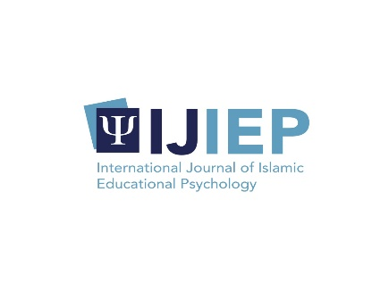_______________________________________________

*International Journal of Islamic Educational Psychology*

Vol. x, No. x, xxxxxxxxxx

DOI: *Filled by Journal Manager*

**Guidance Model to proactive coping skills.**

Asada Ploysopon*, Ratanaporn Loungkeaw, Nongyao Nuchanart,

Somyot Phaudjantuk

Faculty of Education, Suan Dusit University, Thailand

*Corresponding email: Asada_plo@dusit.ac.th

|  |  |  |  |
| --- | --- | --- | --- |
| **ARTICLE INFO** |  | **ABSTRACT** |  |
| **Article history**  Received, xxxxx  Revised, xxxxx  Accepted, xxxxx |  | Guidance systems are very important to students and the education system helps students maintain proactive coping skills. The research method the was Research and Development (R&D). The sample was used 250 undergraduate students at Suan Dusit University. The instruments in this study used the current conditions and needs questionnaire, structured interview form to study current conditions and needs, proactive coping strategies scale, and Opinion exam form. Analysis techniques were presented in the Priority Needs Index (PNIModified) and independent t-test. This research concludes (1) counseling services, administrative structure, activities that response to student needs, activities to support strengthen coping skills and promoteing positive attitudes towards self and the university have the highest need, respectively; (2) A guidance model for enhancing proactive coping skills with the following 5 components: Administrative, Staff, Activity, Deming Cycle and Assessment; (3) Guidance model could reinforce proactive coping skills that was statistically significant .05  This is an open access article under the [CC–BY-SA](http://creativecommons.org/licenses/by-sa/4.0/) license. |  |
| **Keywords**  *Guidance, Model, proactive coping, skills* |  |

**Citation:**

*Filled by Journal Manager*

**INTRODUCTION**

Higher education is different from High School in academics, psychology, and interpersonal relationships. As a result, some students who are unable to adjust themselves face problems in life such as study skills, time management, stress, anxiety, depression drug addiction, sexual-related problems, suicide, homesickness, lack of conflict management skills, violence handling (Getachew, 2020). Making learning performance worse, the study found that Students with the lowest entry grades were about 2.17 times more likely to drop out (Sosu and Pheunpha, 2019).

The guidance system in university is a process of helping and supporting students in academic, professional career, personal, and society. Encourage students to live happyly. guidance consists of 3 dimensions, including academic guidance. career guidance and psychological counseling (Ferreira, 2020). Guidance systems are important to students for themselves and understand society (Sun and Yuen, 2012) problem-management and proactive coping skills enable students lead themselves to achieve their goals by focusing on personal growth (Greenglass et al., 1999). It can also create positive attitudes and views of the university (Yüksel, 2006). A guidance system that will help students to know themselves, develop some skills and on able to choose the right way to solve problems. Develop and encourage students to have desirable behaviors that can adjust themselves to live in society happyly. Teachers and students are learning to resolve further problems. As well as helping students realize their values and be able to guide their own life wisely and carefully. Decision-making and problem solving make them grow up in the students and success in life (Hongjin and Yunfang, 2017).

The guidance system is a good working system that achieves the goal of guidance work. It is a management system that applies the concept of a system to coordinate with various work systems in educational institutions such as Deming Cycle. The continuous quality improvement model is used in the operation process for efficiency and effectiveness by the objectives focusing on the main components (1) Input (2) Process (3) Output (Vihokto, 2018; Jesadakultavee, 2020). It covers guidance and counseling services in higher education. The scope of the service includes the pre-admission service, the admission service, the orientation service, the student information service, the information service, the counselling service, the placement service, the remedial service, the follow-up service, the research service and the evaluation service (Kochhar, 1984). By focusing on promoting and developing proactive coping skills that can develop a person's behavior to use proactive persons to manage and cope with stress skills that related to proactive behavior include: 1) Proactive Coping 2) Reflective Coping 3) Strategic Planning 4) Preventive Coping 5) Instrumental Support Seeking 6) Emotional Support Seeking and 7) Avoidance Coping (Tatha et al., 2013).

Proactive Coping Inventory (PCI) is a psychometric tool with three major features: (a) planning and preventive tactics with proactive self-regulatory goal success (b) proactive goal success with identification and utilization of social resources, and (c) proactive emotional coping for self-regulatory goal success (Greenglass et al., 1999). Self-regulation significantly affected psychological well-being (Salleh et al., 2021).

Therefore, this research involved a guidance model for the proactive coping skill that its aims to (1) study the current state and needs of a guidance model that promotes proactive coping skills, (2) to develop a guidance model to strengthen proactive coping skills, and (3) to study the effect of using the development of a guidance model to enhance proactive coping skills.

**METHODS**

Research and development (R&D) were used in the study to develop a guidance model which was proactive coping skills had been effectively and systematically used to develop the Faculty of Education, Suan Dusit University.

The population is 500 undergraduate students of the Faculty of Education, Suan Dusit University. The sample group was (1) condition and needs for the development of a guidance model that promotes proactive coping skills the Faculty of Education, Suan Dusit University, of 250 undergraduate students and (2) To study the results of using the guidance model of 50 people. The target audience is to study the current situation and the need for the development of a form of guidance system. By interviewing 10 people: (1) 4 executives, consisting of Dean, Vice-Dean, Head of Campus; Head of department (2) Advisors 2 persons (3) Lecturers 2 persons (4) Students 2 persons.

Research Tools include (1) Current conditions and needs questionnaire, (2) Structured interview form to study current conditions and needs, (3) Proactive coping strategies scale (Tatha et al., 2013), and (4) Opinion exam form, which is implied in this research.

Data collection was divided into 4 phases as follows; Phase 1 (R1: Research) was to study the current situation and the need of a supportive guidance model for the Faculty of Education, Suan Dusit University. By using an opinion questionnaire, a form of guidance model of 250 students. The data were analyzed using the means, standard Deviation, Priority Needs Index (PNIModified) (Wongwanich, 2007) and an interview to study the current condition and needs of 10 people by analyzing the content.

Phase 2 (D1: Development) Develop a form of guidance model by focus group of 10 people.

Phase 3 (R2: Research) was to experiment with the guidance management model with 50 students in the Faculty of Education, Suan Dusit University by asking for their opinions on the guidance model.

Phase 4 (D2: Research) Optimize the prototype by focus group of 10 people.

**RESULT AND DISCUSSION**

**Part 1 Results showed the current situation and the need for the development of guidance following a model that promotes proactive coping skills.**

**Table 1.** Analysis of the modified priority needs index for guidance system (Input)

|  |  |  |  |  |
| --- | --- | --- | --- | --- |
| Input | Mean of actual condition (I) | Mean of desired condition (D) | PNIModified  (I-D)/D | Rank |
| Guidance administration structure | 4.080 | 3.952 | 0.032 | 1 |
| Guidance activities that respond to student needs | 4.057 | 3.952 | 0.026 | 2 |
| Parental roles | 3.947 | 3.852 | 0.024 | 3 |

Table 1 illustrated that the guidance system (Input) the necessary needs (PNIModified), Showed that the top three are the guidance administration structure, guidance activities that respond to student needs, and parental roles (0.032,0.026, and 0.024 respectively), respectively. Consistent with Ferreira (2020) noted that university guidance services: A case study of Finland found that the guidance system is an educational and work of an individual plan and needs. Moseover the objectives of the guidance system linked to practice and employment. Students who were able to adjust their time on campus. Howevre, this system promot student mental health care and prevent student stress, anxiety. TA. A (2011) conducted a study on the perception of the availability of guidance systems and counseling services to students in The Southwestern Institute of Higher Education in Nigeria and found that psychological guidance and counseling should provide some personnel intonation which clouds develop.

**Table 2.** Analysis of the modified priority needs index for guidance system (Process)

| Process | Mean of actual condition (I) | Mean of desired condition (D) | PNIModified  (I-D)/D | Rank |
| --- | --- | --- | --- | --- |
| information service | 4.038 | 3.895 | 0.036 | 1 |
| Student problem prevention targeting | 4.147 | 4.014 | 0.033 | 2 |
| career guidance | 4.038 | 3.947 | 0.022 | 3 |
| individual student data services | 3.966 | 3.880 | 0.022 | 3 |

Table 2 illustrated that the guidance system (process) the necessary needs (PNIModified), the top three are the information services, student problem prevention targeting, career guidance, and individual student data services (0.036,0.033,0.022, and 0.022 respectively). It seems to be the finding of Ferreira (2020) found that the guidance service arrangement consists of 3 dimensions, namely academic guidance. professional guidance and psychological counseling these dimensions to meet the needs of students. Both in the form of a face-to-face, service online guidance or groups covering academic, welfare, employment, or mental health. Additionally, Liang (2021) found that an accurate guidance system support developing university students that relies on collecting all available data within the organization (Big data) to motivate and promote the overall development of students.

**Table 3.** Analysis of the modified priority needs index for guidance system (Output)

| Output | Mean of actual condition (I) | Mean of desired condition (D) | PNIModified  (I-D)/D | Rank |
| --- | --- | --- | --- | --- |
| counseling services when students face stress | 4.057 | 3.914 | 0.036 | 1 |
| activities to strengthen coping skills | 4.028 | 3.938 | 0.022 | 2 |
| students had a positive attitude towards themselves and the school | 4.052 | 3.985 | 0.016 | 3 |

Table 3 illustrated that the guidance system (Output) the necessary needs (PNIModified), the top three are the counseling services when students face stress, activities to strengthen coping skills, and students had a positive attitude towards themselves and the school (0.036,0.022, and 0.016 respectively), respectively. Consistent with Maupa (2020) a study assessing the effectiveness of guidance and counseling services in universities of Zimbabwe found that students and counselors had Positive perceptions of the university's guidance and counseling services benefits that occur to students. In terms of personal and social, occupational, personalization, counseling, and service evaluation. As whom studied the effectiveness of counseling and counseling services at Cameroon State Universities, found that Guidance and counseling are critical to effective teaching and learning of students and psychological counseling services also help students to be aware of themselves and the environment. Able to adapt in terms of education, career, and society (Bobga, 2016).

**Part 2 The results of the development of a guidance management model to enhance students' proactive coping skills consisted of 5 components as follows:**

The results of the development of a guidance management model to enhance students' proactive coping skills. Phase 1 (R1: Research) is to study the current situation and the need for the development of a supportive guidance model. By using an opinion questionnaire (Online) and an interview with a structured target group. Phase 2 (D1: Development) Develop a form of guidance model by the focus group. The model is presented in figue.1

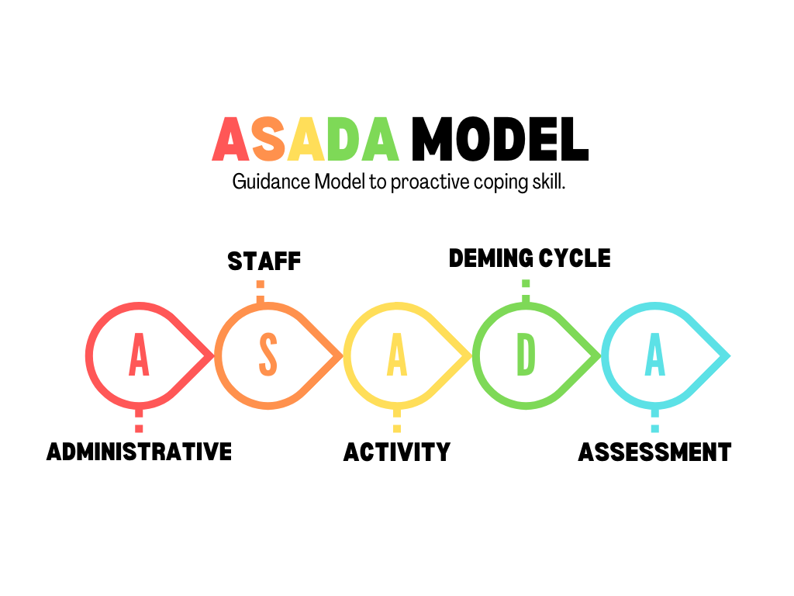

**Figure 1.** Asada Model

**Administrative** is the administration of guidance to enhance students proactive coping skills. By providing a guidance policy at the faculty level that is linked to the guidance program at the faculty level and establishing a guidance management structure by the committee as well as defining the roles and duties in driving and assessments are used to continuously improve and develop guidance (Mahahing and Thuraphun, 2018). Guidance administration system in educational institutions have equipment and technology which provide learner information. This system a network of cooperation and process component which consists of guidance on student achievement career guidance for the future inspiring your future career (Jesadakultavee, 2020).

**Staff** is those involved in carrying out the guidance work by the plan consisting of the guidance committee include advisors, differences in parental attachment and coping ability (Gallo, 2022), students, and support personnel in their work. Specific coping behaviours utilized included seeking of support from family and friends (Labrague et al., 2018). Parents and peers have more important influences on student decisions than teachers (Alexitch et al., 2004).

**Activity** is 5 activities which is guiding services (Mahahing and Thuraphun, 2018) include 1) individual student data services 2) information service and media in guidance and counseling services plays an important role in the implementation of guidance and counseling so that student can better understand, understand, and internalize the material guidance and counseling services to the student (Alhadi, S., Supriyanto, A., & Dina, D. A. M., 2016) 3) psychological counseling service by group counseling service is one of the efforts that can be made to enhance student engagement in learning at school (Bahiroh and Madjid, 2022) 4) personalization service by career guidance and 5) follow-up services by organizing projects or activities that meet the needs of students by surveying needs and opinions before organizing a project or activity for students to participate in the design of projects and activities. Guiding services should focus on career guidance (Hongjin and Yunfang, 2017).

**The Deming Cycle** which is the PDCA cycle is a management method that requires 4 activities: Step 1, Planning, Step 2, Implementation of the Plan (Do), and Step 3 Evaluation. Performing work (Check) Step 4 Adjusting the new operating method (Act) (Sulistiyana et al., 2019).

**Assessment** is the systematic collection of information to verify the effectiveness of the guidance service operations. This assessment will be used the information to make decisions about the activities or the guidance services program. The objectives of the project, activity is based on the evaluation of success. Prepared in a systematic, comprehensive, and consistent with the objectives of the assessment and evaluated at the beginning during operation and after the end of the organization of projects, activities, or services each year to continuously improve and develop and guidance services was also thoroughly evaluated (Bibi and Khan, 2018).

**Part 3 The results of the study on the effect of using the development of a guidance management model to enhance proactive coping skills.**

**Table 4.** Study results of the use of ASADA model

|  |  |  |  |  |  |  |
| --- | --- | --- | --- | --- | --- | --- |
| **major features** | **Score** | **N** | **X** | **S.D.** | **df** | **Sig** |
| goal setting and proactive management. | Pre | 36 | 40.14 | 34.98 | 35 | 0.00 |
| Post | 36 | 41.81 | 26.79 |
| problem reflection | Pre | 36 | 33.41 | 30.36 | 35 | 0.01 |
| Post | 36 | 35.22 | 21.32 |
| strategic planning seeking | Pre | 36 | 11.61 | 5.33 | 35 | 0.00 |
| Post | 36 | 12.58 | 6.25 |
| help seeking | Pre | 36 | 22.55 | 22.36 | 35 | 0.00 |
| Post | 36 | 24.13 | 27.95 |
| psychological support | Pre | 36 | 15.22 | 15.94 | 35 | 0.00 |
| Post | 36 | 16.13 | 15.09 |
| avoiding problems | Pre | 36 | 7.66 | 6.34 | 35 | 0.02 |
| Post | 36 | 8.47 | 6.59 |

The guidance management model can enhance students proactive coping skills in terms of goal setting and proactive management (Abdillah et al., 2022), problem reflection, strategic planning seeking, help seeking, psychological support and avoiding problems were statistically significant .05 Consistent with Chooseng et al. (2020), a study of the results of using a guidance activity package to improve their ability to manage stress found that the students who used the guidance activity package to improve their ability to manage stress management was more able to manage stress than the students who used regular guidance activities. Likewise, Sunee Putta (2014), studied the effect of using a guided activity package to improve emotional and stress management skills. It was found that students who used the activity package to improve emotional management skills and stress had higher emotional and stress management skills than students who used other guidance activities. statistically significant at the .05 level. Guidance service system helps to raise mental health awareness among the students at the university (Arcilla et al., 2021).

**CONCLUSIONS**

Based on the research results, analysis, and discussion described previously, it can be concluded that:

1. Counseling services when facing stress, administrative structure, activities that respond to student needs, activities to strengthen coping skills and promote positive attitudes towards self and university have the highest need, respectively;

2. ASADA model has been enhancing proactive coping skills with the following 5 components: Administrative, Staff, Activity, Deming Cycle, Assessment;

3. ASADA model is guidance management to enhance students' proactive coping skills, consisting of 5 components. It can effectively enhance students' proactive coping skills in the dimension of goal setting and proactive management. problem reflection strategic planning seeking help seeking psychological support and avoiding problems.

Suggestions that researchers can give based on the results of this study are:

1. The implementation of the guidance model to enhance proactive coping skills should consider the differences in the context of educational institutions and students.

2. Skills related to proactive coping behaviours in preventive preparation should be studied.

3. Long-term follow-up of the guidance management model is to strengthen proactive coping skills in the long-term study of learning persistence.

**REFERENCE**

Abdillah, H. Z., Rahman, F., Husna, M., Sitinjak, C., Hidayah, N., & Mujidin, M. (2022). School well-being in terms of self-determination and patience in vocational high school students. *International Journal of Islamic Educational Psychology*, *3*(1), 19-34. https://doi.org/10.18196/ijiep.v3i1.14476

Alhadi, S., Supriyanto, A., & Dina, D. A. M. (2016). Media in guidance and counseling services: a tool and innovation for school counselor. *SCHOULID: Indonesian Journal of School Counseling*, *1*(1), 6-11. https://doi.org/10.23916/schoulid.v1i1.35.6-11

Arcilla, P. S., Domingo, K. L. D., Joaquin, A. Y. O., Ungos, A. N. O., & Jamis, M. N. (2021). Framework for the mobile and web development of NU Guidance Service System (NUGSS). *In 2021 1st International Conference in Information and Computing Research (iCORE),* 157-162. https://doi.org/10.1109/iCORE54267.2021.00047

Bahiroh, S. and A. Madjid (2022). "Group Guidance Model to Improve Students’ Resilience in the Covid-19 Era." *Jurnal Basicedu, 6*(3): 5435-5446. https://doi.org/10.31004/basicedu.v6i3.3268

Bibi, N., & Khan, W. (2018). A Survey of Quality of Guidance Services at Allama Iqbal Open University. *Pakistan Journal of Distance and Online Learning, 4*(1), 171-184.

Villa, C. F. (2020). University guidance service at universities: the case of Finland. *In Innovación Docente e Investigación en Educación y Ciencias Sociales. Avanzando en el proceso de enseñanza-aprendizaje*, 97-104. Dykinson.

Gallo, C. A. (2022). *Parental attachment and coping skills of first-year college students* [Doctoral dissertation]. Rutgers University-Graduate School of Education.

Getachew, A. (2020). Assessment of Guidance and Counselling Service Centre in Higher Education Institutions: *A Qualitative Research. Int J Sch Cogn Psychol*. 7: 223. https://doi.org/10.35248/2469-9837.19.6.223

Greenglass, E., Schwarzer, R., Jakubiec, D., Fiksenbaum, L., & Taubert, S. (1999). The proactive coping inventory (PCI): *A multidimensional research instrument. In 20th international conference of the stress and anxiety research society (STAR), Cracow, Poland*, *12*(14).

Hongjin Fu, Yunfang Li. (2017). Strategies on Promoting Vocational Guidance

in Universities. *Proceedings of the 2017 3rd International Conference*

*on Humanities and Social Science Research* (ICHSSR 2017).

https://doi.org/10.2991/ichssr-17.2017.47

Jesadakultavee S. (2020). The Future - Oriented Guidance Administration System in School Under the Secondary Education Service Area Office*. Journal of Social Science and Buddhistic Anthropology,* *5*(2), 269–288.

Kochhar, S. K. (1984). *Guidance and counselling in colleges and universities*. Sterling Publishers Pvt. Ltd.

Labrague, L. J., McEnroe‐Petitte, D. M., Al Amri, M., Fronda, D. C., & Obeidat, A. A. (2018). An integrative review on coping skills in nursing students: implications for policymaking*. International nursing review, 65*(2), 279- 291. https://doi.org/10.1111/inr.12393

Liang, Z. (2021). Research on the path of precise guidance system for student development in universities based on big data analysis. *2nd International Conference on Big Data and Informatization Education (ICBDIE)*, 39-42. https://doi.org/10.1109/ICBDIE52740.2021.00017.

Mahahing, S., & Thuraphun, K. (2018). The Guidance Administration at the Basic Educational Institutes under KhonKaen Primary Educational Service Area Office 4. *Dhammathas Academic Journal, 18*(3), 79-90.

Salleh, R. R., Ismail, N. A. H., & Idrus, F. (2021). The relationship between self-regulation, self-efficacy, and psychological well-being among the Salahaddin University undergraduate students in Kurdistan. *International Journal of Islamic Educational Psychology, 2*(2), 105-126. https://doi.org/10.18196/ijiep.v2i2.12572

Sosu EM and Pheunpha P. (2019). Trajectory of University Dropout: Investigating the Cumulative Effect of Academic Vulnerability and Proximity to Family Support. *Frontiers in Education, 4*(6). https://doi.org/10.3389/feduc.2019.00006

Sulistiyana, S., Wiyono, B. B., Imron, A., & Suriansyah, A. (2019). Total Quality Management Program Specific Guidance and Counselling Services in the State High School. *International Journal of Innovation, 5*(4).

Sun, V.J., Yuen, M. (2012). Career Guidance and Counseling for University Students in China. *International journal for the advancement of counselling, 34*(3), 202–210. https://doi.org/10.1007/s10447-012-9151-y

TA, A. (2011). Perceived availability of guidance and counselling services among tertiary institutions students in selected south-west universities in Nigeria. *Ife PsychologIA, 19*(1). https://doi.org/10.4314/ifep.v19i1.64608

Tatha O, Laurujisawat P, Greenglass E. (2013). The validity and reliability of the Proactive CopingInventory (PCI): *Thai version. Chula Med J, 57*(6), 765 – 78*.*

Vihokto, P. (2018). *Principles and System of School Guidance*. Sukhothai Thammathirat University.

Wongwanich, S. (2007). *Needs Assessment Research*. Bangkok, Chulalongkorn University.

Yüksel, S. (2006). The role of hidden curricula on the resistance behavior of undergraduate students in psychological counseling and guidance at a Turkish University. *Asia Pacific Educ. Rev*. 7, 94–107. https://doi.org/10.1007/BF03036788