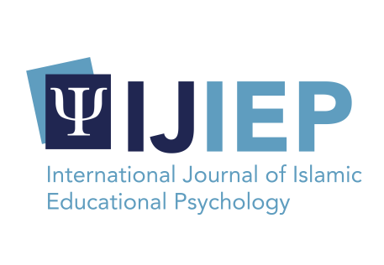

**Author Statement Form:**

**Manuscript Originality and Copyright Transfer Agreement**

**International Journal of Islamic Educational Psychology (IJIEP)**

ISSN: 2723-1402 (Online) and 2745-5289 (Print)

<https://journal.umy.ac.id/index.php/ijiep/>

Name of Principal/Corresponding Author*

Retno Mangestuti

Address of Principal/Corresponding Author*

JL. Griyashanta J 323 Malang

Telephone*

08155517943

E-mail*

mangestuti@uin-malang.ac.id

All author(s) name*

-

Date of submitted*

20-10-2023

Manuscript title*

Enhancing Students Religiosity In Educational Context: A Mixed Method Study In Islamic High School

1. Declare that the article above is original. my own thoughts not translated, and has not been published elsewhere or currently not in the process of other journal publications. I am willing to be responsible if there are parties who feel disadvantaged privately and/or based on a lawsuit in the future by the publication of this article.
2. I also declare that any and all rights in and to the article including, without limitation, all copyrights are transferred to International Journal of Islamic Educational Psychology. Therefore, the copyright transfer hands it the power and authority to edit, reproduce, distribute copies, and to publish the article partly or fully.

Retno Mangestuti

20 Oktober 2023