**IJNP (Indonesian Journal of Nursing Practices)**



Secretariat: School of Nursing

Universitas Muhammadiyah Yogyakarta

Faculty of Medicine and Health Sciences Siti Walidah Building F3 4th

floor

Campus Terpadu UMY

JL. Brawijaya/ Lingkar Selatan, Kasihan, Bantul, Yogyakarta 55183

Email: [IJNP@umy.ac.i](mailto:IJNP@umy.ac.id)d

Web: [http://journal.umy.ac.id/index.php](http://journal.umy.ac.id/index.php/)/ijnp

AUTHOR STATEMENT

|  |  |
| --- | --- |
| I, the undersigned below: |  |
| 1. Name of author correspondency : | Lina Ema Purwanti |
| 1. Paper Title : | Diabetes Mellitus, Hypertension and Heart Disease as Main Comorbid Factors in COVID-19 Patient Mortality |
| 1. Author Affiliation : | Universitas Muhammadiyah Ponorogo |
| 1. Mailing Address : | emapurwantilina@umpo.ac.id |
| 1. Phone Number : | 085330338231 |
| 1. email : | emapurwantilina@umpo.ac.id |

I hereby declare that the below statements are true:

1. The manuscript is originally written by the author and contains no plagiarism.
2. It contains no material previously published or currently not in the process of other journal publications.
3. Mentioning other author names along with the first author (If the research involves more than one author).
4. The manuscript has received all authors’ consent to be published (If the manuscript involves more than one author).
5. No conflict of interest.
6. The manuscript has received the consent of the research protocol ethics committees.

If any statement specified above is found to be incorrect, I am disposed to be given legal sanctions in a later time.

Ponorogo, 27th December 2022

Authorised Signatory

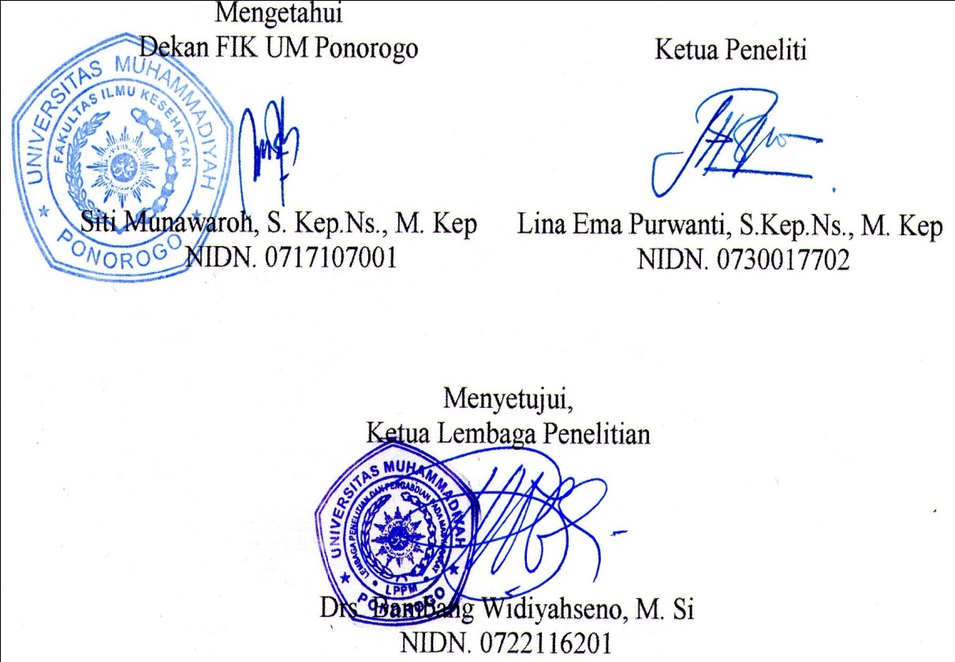

(Lina Ema Purwanti)