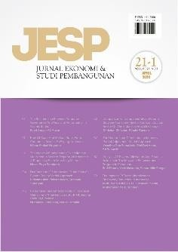Author Declaration Form

Jurnal Ekonomi & Studi Pembangunan

ISSN: 2541-5506 (Online) and 1411-9900 (Print)

https://journal.umy.ac.id/index.php/esp

Name of Principal/Corresponding Author*

**Ivan Rahmat Santoso**

…………………………………………………………………………………………………………..

Address of Principal/Corresponding Author*

**Faculty of Economics, Universitas Negeri Gorontalo, Indonesia**

…………………………………………………………………………………………………………..

Telephone*

**0811432884**

…………………………………………………………………………………………………………..

E-mail*

**ivan_santoso@ung.ac.id**

…………………………………………………………………………………………………………..

Fax*

……………………………………………………………………………………………………………

…………………………………………………………………………………………………………..

All author(s) name*

1. **Aissyah Dien Akadri**
2. **Sri Indriyani S. Dai**
3. **Ivan Rahmat Santoso**

…………………………………………………………………………………………………………..

Date of submitted*

**1/0/2023**

…………………………………………………………………………………………………………..

Manuscript title*

**The Impact of Cigarette Consumption on Poverty in Pohuwato District**

…………………………………………………………………………………………………………..

1. Declare that the article above is original. my own thoughts not translated, and has not been published elsewhere or currently not in the process of other journal publications. I am willing to be responsible if there are parties who feel disadvantaged privately and/or based on a lawsuit in the future by the publication of this article.
2. I also declare that the transfer of copyright for the first publication is granted to

Jurnal Ekonomi & Studi Pembangunan.



Ivan Rahmat Santoso

1/9/2023

Editorial Office Jurnal Ekonomi & Studi Pembangunan:

Journal Room, E4 Building, 2nd Floor, Faculty of Economics and Business, Universitas Muhammadiyah Yogyakarta, Jalan Lingkar Selatan (Brawijaya), Tamantirto, Kasihan, Bantul, Daerah Istimewa Yogyakarta, Indonesia 55183.