PRACTICUM REPORT RECEIVING TOOL AT MUHAMMADIYAH UNIVERSITY OF SIDOARJO WITH ESPCAM32 AND UV STERILIZER BASED ON INTERNET OF THINGS (IoT)

Shinta Carolin Stevi Yanti*1 , Indah Sulistiyowati, S.T., M.T.2

Departement Of Electrical Engineering, Faculty of Science and Technology

Universitas Muhammadiyah Sidoarjo, East Java, Indonesia

*Corresponding author, email : shintacarolin4@gmail.com

***Abstract*** – *S**ome of the problems that currently exist in the electrical engineering laboratory of muhammadiyah university of Sidoarjo are the presence of crowds when students collect reports of practicum results, which certainly have their own dangers during the Covid-19 pandemic and other problems related to practicum report collection are when students will collect reports but laboratory assistant are not in the laboratory. From these problems, a tool is made that can receive practicum reports and can be monitored remotely by laboratory assistants . By put an RFID card to the RFID sensor on the box so that the solenoid can open the box door and the student can put the report into the box. at the same time espcam32 took pictures of students collecting reports. then notifications in the form of photos and student information will be sent to laboratory assistant through the telegram application. after the report is put into the box, the UV lamp will turn on to disinfect the report. The hope of making this tool can facilitate the process of collecting reports of practicum results and reduce the crowd in the laboratory.*

***Keyword*** *:* *Covid-19; Espcam32; RFID tag ; Telegram; Uv Lamp*

# **Introduction**

Since March 2020 until now, positive cases of Covid-19 in indonesia have reached more than 4 million people [1] [2]. Easy transmission makes the spread of this virus very fast[3]*.*  To break the chain of transmission, the government limits many communities to do activities outside the home, crowding, doing social distancing and disinfecting goods periodically [4]*.* The electrical engineering laboratory of muhammadiyah Sidoarjo University is one of the parties affected by the Covid-19 virus, which makes students have to do lectures online, even though practice cannot be done optimally online. Lack of student discipline in the application of social distancing when collecting practicum reports create own dangers. Another problem related to the collection of practicum reports is when students collect the results of practicum reports, but the laboratory assistant concerned is not in the electrical laboratory So, students leave the report to another laboratory assistant or put the results of the practicum report in any place that causes the practicum report to be damaged or lost. From these problems we create a tool to receive practicum reports that can be monitored remotely. This tool is equipped with ESP 32 Camera and UV Lamp. This tool can receive practicum reports by put an RFID card on the RFID sensor,then the camera ESP32 will send photos and student group information through the Telegram and Google Sheets applications. After the report is put into the box, the report will be sterilized with a UV Lamp. So, practicum reports are spared from viruses.

# **Theoritical Review**

* 1. *NodeMCU ESP8266*

NodeMCU ESP8266 is a microcontroller module that contains ESP8266 inside. NodeMCU ESP8266 can connect to WiFi networks. NodeMCU can be programmed using the Arduino IDE programming language [5].

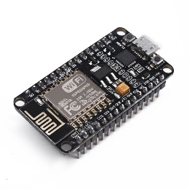

Figure 1. NodeMCU ESP8266 [6]

* 1. *RFID*

Radio Frequency Identification (RFID) is a method that uses radio waves used to track, store, and identify information using a device called an RFID tag. [7] [8].

# *Selenoid Door Lock*

Selenoid door lock is an electronic component that uses electromagnetic working principles and can be used when given a voltage of 12 Volts [9].

# *LCD 16x2*

LCD (Liquid Crystal Display) is a tool that can display the value of a sensor, display writing, and display menus on the microcontroller.[10]

# *Lampu UV*

Ultraviolet light (UV light) is a type of electromagnetic radiation with wavelengths ranging from 4nm - 400Nm. UV light technology is an easy and simple non-chemical disinfection method [11]–[13].

# *Telegram*

Telegram is a messaging service app with a focus on speed and security. We can use Telegram on all work devices at the same time. Your Messages can sync seamlessly across any phone, tablet, or computer (Windows, Mac, and Linux) [14].

# *Camera ESP32*

Camera ESP32 is a camera module used for indoor and outdoor monitoring. this module is also equipped with bluetooth and wifi which is designed like a microcontroller [15]

# **Research Methodology**

* 1. *Blok diagram system*

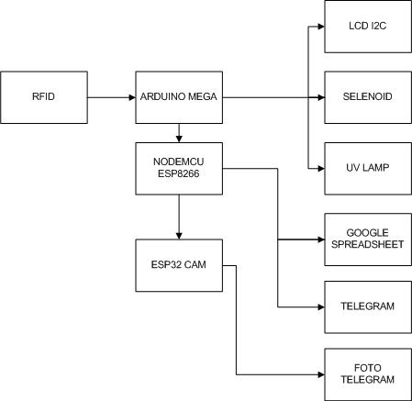

Figure 2. Tool Block Diagram

There are 3 parts of this box: input, process, and output. In the input section there is RFID as an input to open the box. In the process section there are Arduino Mega microkotrollers, NodeMCU ESP8266 and Camera ESP 32. Arduino mega is used to verify RFID inputs and control Selenoid door lock relays, and UV lamps. NodeMCU ESP8266 is used to send notifications to telegram and Google Sheets. The ESP32 camera is used to send photos to Telegram. In the output section there is a 20x4 LCD to display the commands and conditions of the tool, Selenoid door lock as a tool door safety, UV Lamp as a sterilizer when the report is entered into the box, Telegram and Google Spreadsheet as a recapitulation of incoming data.

* 1. *Flowchart Program*

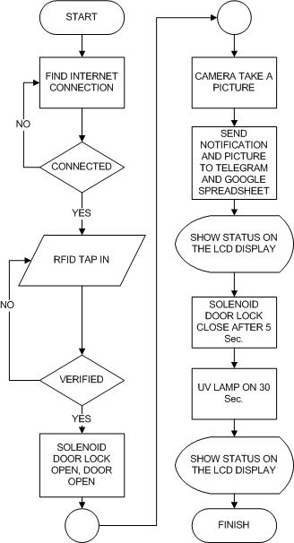

Figure 3. Flowchart program

The program begins with a Wifi connection, if the WiFi is connected, then put the RFID card to the RFID sensor, after the RFID card is verified, the Selenoid door lock will open. After the door is opened and the report is entered Camera ESP32 will take pictures of students collecting reports, after that nodeMCU ESP8266 will send a message in the form of group information and photos of students who have collected reports through the Telegram application and the data will also be stored on Google Spreedshet. Selenoid door lock will automatically close after 30 seconds. after the door of the box is closed the UV Lamp will be active to sterilize the practicum report. last, the LCD will display the text that the collection of reports has been successful.

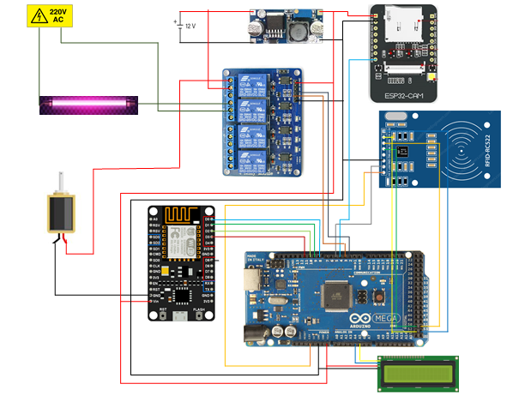

Figure 4. wiring design alat

Table I

NodeMCU ESP8266 Port Usage

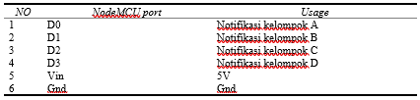

Table II

Arduino Port Usage

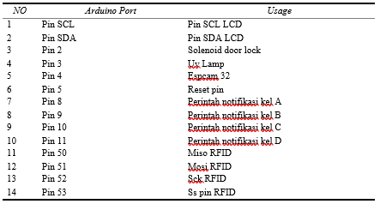

Tabel III

Camera ESP32 Port Usage



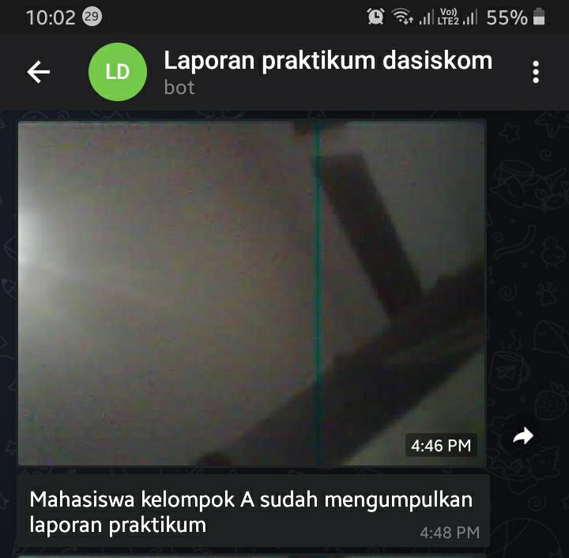

Figure 5. Telegram Display

In Figure 5 there is a display of telegram on the mobile screen when the report has been entered.

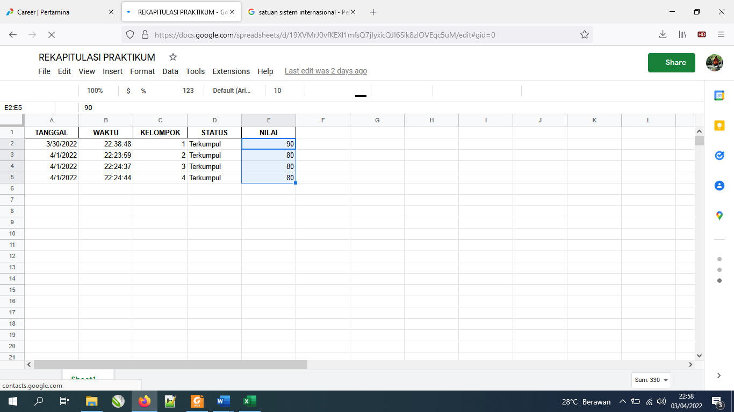

Figure 6. Google Spreadsheet Display

In Figure 6 there is a display of Google spreadsheets when the report has been entered.

# **RESULT AND DISCUSSION**

* 1. *Result Of Tool Realization*

Below are the results of the realization of the tool

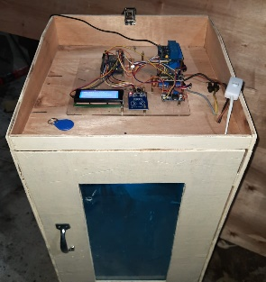 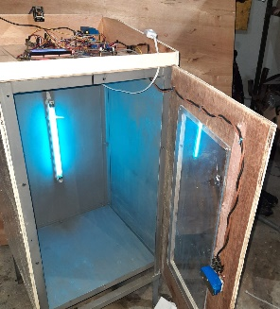

Figure 7. result of tool realization

Figure 7 is the result of realization of practicum report receiver box with uv sterilizer and esp32 camera based on IoT. How to use this tool is as follows:

1. Students put RFID Tags to RFID Sensors..
2. Next, the tool will verify the RFID TAG.
3. Selenoid on the tool door will open if the RFID is verified correctly. While the Camera ESP32 takes photos of students to send to telegram and google spreedshet belonging laboratory assistants along with group information and report collection time.
4. Students put the report into the tool.
5. Selenoid on the door will close after students enter the report with a period of 30s.
6. Uv lamp will light up to sterilize report.
7. The tool can be re-used.
   1. *Tool Testing*

Testing is done by comparing the measurement results of tools that have been made with standard tools that are commonly used. In addition, there is testing by taking the results of real conditions and real time.

Calculations are done using several formulas, including;

$Deviation=(nSensor-nMeasure)$*(1)*

which is the deviation formula [16];

$Average Value=µ=\frac{x_{1}+x_{2}+x_{3}+x_{4}+x_{5}}{n}$ (2)

which is the average value formula [17]; standard deviation formula [16][18]

$σ=\sqrt{\frac{\sum_{i-1}^{x}{(x_{i}-μ)^{2}}}{n}}$ (3);

and Formula percentage accuracy and percentage error,

(4) (5)

* + 1. *12 volt power supply testing*

Table IV

12 volt power supply testing

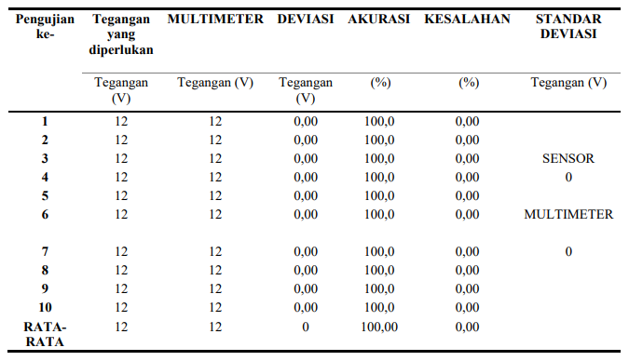

Table 4 shows the results of 10x 12 volt power supply testing using a multitester. From this Test obtained a deviation of 0.00 and 100% accuracy and implemented that the voltage of 12 volts used in this tool is accurate. This 12 volt voltage will be used to activate the solenoid and become a stepdown source to provide supply to the control circuit.

* + 1. *5V power supply testing*

Table V

5V Power Supply Testing

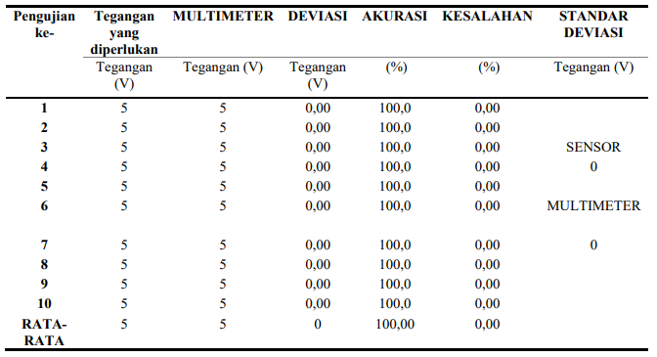

Table 5 shows the testing of 5volt power supply using multitester as much as 10x and obtained the results of deviation as much as 0 volts and 100% accuracy. It can be concluded that the 5volt voltage used in this tool is accurate.

* + 1. *Testing WiFi connection to NodeMCU ESP8266*

Table VI

Testing WiFi connection to NodeMCU ESP8266

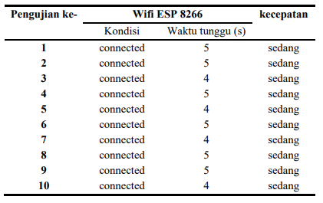

In table 6, the test results obtained from 10x trial wifi connection to NodeMCU ESP8266 with a waiting time of 4s and 5s. conclusion of the experiment NodeMCU ESP8266 can be connected to wifi in medium speed.

* + 1. *Testing Wifi connection to ESP32 camera*

Table VII

Testing Wifi connection to Camera ESP32

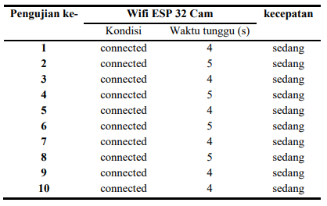

Table 7 showed testing wifi connection to ESP32 camera as much as 10x experiments, from the results of the experiment obtained the results of connection waiting time for 4s and 5s. conclusion of this experiment the speed of wifi connection to esp32cam is medium.

* + 1. *Solenoid Door Lock Testing*

Tabel VIII

Solenoid Door Lock Testing

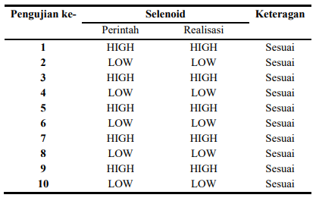

Table 8 shows the results of solenoid testing as much as 10x the experiment. From the results of the experiment, it was concluded that the instruction with realization was appropriate.

* + 1. *RFID Testing*

Table IX

RFID Testing

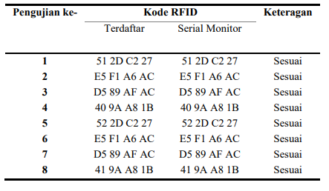

From the RFID testing table above, the results of 10x RFID card experiments registered with serial monitors are appropriate.

* + 1. *UV Lamp Testing*

Table X

UV Lamp Testing

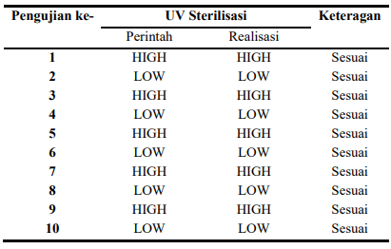

In table 10 has been tested from 10x UV lamp experiment with test results in accordance with the command with the realization of UV Lamp.

* + 1. *Camera ESP32 Testing*

Table XI

Camera ESP32 Testing

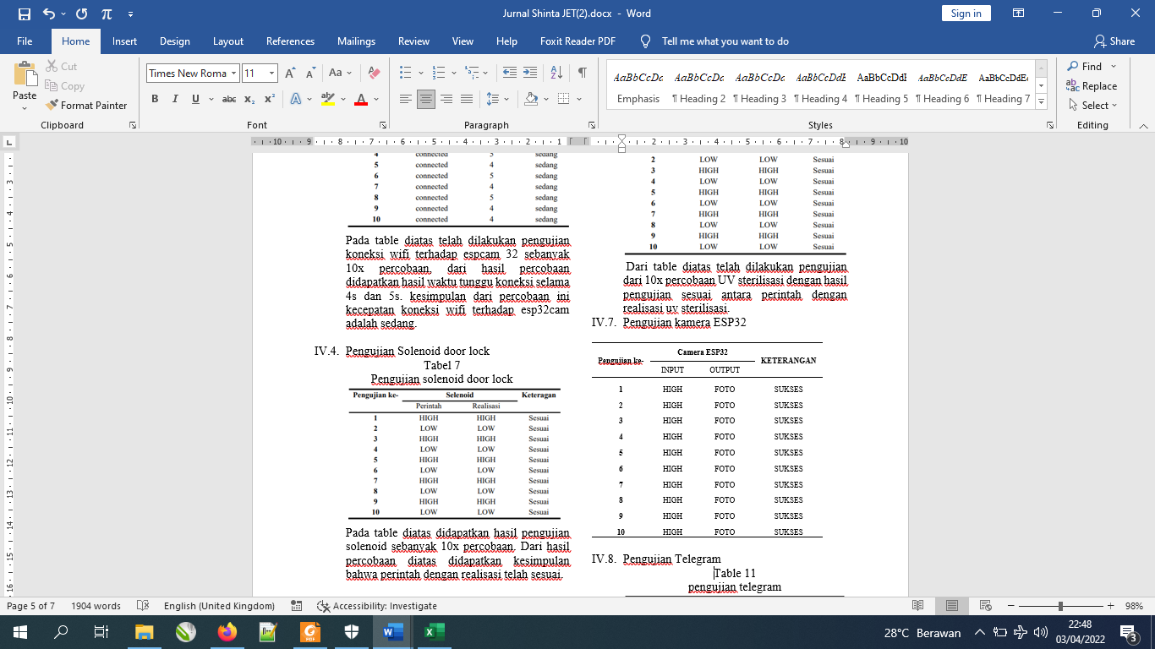

Table 11 shows, 10 times tests on esp 32 cameras and obtained results Camera ESP 32 can carry out photo commands well.

* + 1. *Telegram Testing*

Table XII

Telegram Testing

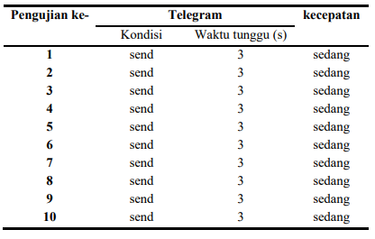

In table 12, the results of 10x the telegram application experiment with a 3s waiting time to send notifications. From the experiment, the conclusion that the speed to send notifications is medium.

* + 1. *Google spreedshet Testing*

Table XIII

google spreedshet Testing

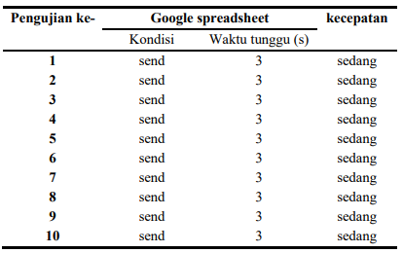

In table 13, the results of 10x google spreedshet experiments with a waiting time of 3s. From the experiment, the conclusion that the speed to send notifications is medium.

# **Conclusion**

Based on the results of the tests that have been done, it can be concluded as follows:

1. Normal power supply testing and no voltage drop either when the device is standby or when the device is operating.
2. RFID testing takes place optimally, RFID card code can be read well.
3. Internet connection testing runs optimally and the tool is able to connect so that telegram notifications and google spreadsheets can be sent.
4. Relay testing runs optimally, indicated from the relay that functions in accordance with the command logic of the microcontroller.

# **Acknowledge**

I would like to thank my parents, my lecturers and friends who have helped in the study.

**References**

[1] R. Satria Rinaldi, P. Sistem Disinfektan UV-C, and I. Novia Anggraini, “Perancangan Sistem Disinfektan UV-C Sterilisasi Paket sebagai Pencegahan Penyebaran Covid-19 (Design of Package Sterilization UV-C Disinfectant Systems to Prevent the Spread of Covid-19),” 2021.

[2] R. N. Putri, “Indonesia dalam Menghadapi Pandemi Covid-19,” *J. Ilm. Univ. Batanghari Jambi*, vol. 20, no. 2, p. 705, Jul. 2020, doi: 10.33087/jiubj.v20i2.1010.

[3] N. R. Yunus and A. Rezki, “Kebijakan Pemberlakuan Lock Down Sebagai Antisipasi Penyebaran Corona Virus Covid-19,” *SALAM J. Sos. dan Budaya Syar-i*, vol. 7, no. 3, Mar. 2020, doi: 10.15408/sjsbs.v7i3.15083.

[4] A. Athena, E. Laelasari, and T. Puspita, “PELAKSANAAN DISINFEKSI DALAM PENCEGAHAN PENULARAN COVID-19 DAN POTENSI RISIKO TERHADAP KESEHATAN DI INDONESIA,” *J. Ekol. Kesehat.*, vol. 19, no. 1, pp. 1–20, Jun. 2020, doi: 10.22435/jek.v19i1.3146.

[5] I. I. Setiawan, A. Jaenul, and D. Priyokusumo, *P-75 PROTOTIPE SISTEM KEAMANAN RUMAH MENGGUNAKAN FACE RECOGNITION BERBASIS RASPBERRY PI 4 PROTOTYPE OF HOME SECURITY SYSTEM USING FACE RECOGNITION BASED ON RASPBERRY PI 4*.

[6] L. Devy, Y. Antonisfia, M. Febrina, J. Teknik Elektro Politeknik Negeri Padang Jurusan Teknik Elektro Politeknik Negeri Padang, J. Limau Manih Padang, and C. Author, “Sistem Pengendalian dan Monitoring Distribusi Air Berbasis Nodemcu 8266,” *Elektron J. Ilm.*, vol. 12, 2020, [Online]. Available: https://www.mikirbae.com/2015/04/pemanfaatan-

[7] F. Zahro Aska, D. Satria, and I. Kasoep, “IMPLEMENTASI RADIO FREQUENCY IDENTIFICATION (RFID) SEBAGAI OTOMASI PADA SMART HOME.”

[8] H. Djamal, “Radio Frequency Identification (RFID) Dan Aplikasinya.”

[9] T. Adiono, S. Fuada, S. F. Anindya, I. G. Purwanda, and M. Y. Fathany, “IoT-enabled door lock system,” *Int. J. Adv. Comput. Sci. Appl.*, vol. 10, no. 5, pp. 445–449, 2019, doi: 10.14569/ijacsa.2019.0100556.

[10] S. T. Yuliza, U. N. Kholifah, J. M. Selatan, and J. Barat, “ROBOT PEMBERSIH LANTAI BERBASIS ARDUINO UNO DENGAN SENSOR ULTRASONIK”.

[11] “EFEKTIVITAS STERILISASI SINAR ULTRAVIOLET TERHADAP KONTAMINASI BAKTERI PADA BRAKET METAL (In Vitro).”

[12] A. U. Rahayu *et al.*, “PENERAPAN TEKNOLOGI SINAR UVC SEBAGAI MEDIA STERILISASI DOKUMEN DALAM UPAYA PENCEGAHAN PENULARAN COVID-19”, doi: 10.31604/jpm.v4i2.402-408.

[13] P. Yen, “Perancangan Alat Sterilisasi Paket dan Surat Menggunakan Sinar UV-C pada PT Pos Indonesia.”

[14] N. Fernando and E. Asri, “Ervan Asri 121 Monitoring Jaringan dan Notifikasi dengan Telegram pada Dinas Komunikasi dan Informatika Kota Padang Jurnal Ilmiah Teknologi Sistem Informasi,” 2020. [Online]. Available: http://jurnal-itsi.org

[15] R. RAGIL FANNY SETIYA AJI and I. Sulistiyowati, “Mesin Penetas Telur Burung Murai Batu Dengan Monitoring Camera ESP32 Berbasis IoT,” *JASEE J. Appl. Sci. Electr. Eng.*, vol. 2, no. 02, pp. 87–99, Sep. 2021, doi: 10.31328/jasee.v2i02.173.

[16] “JURNAL ILMIAH VOLUME 4.pdf.”

[17] A. about chemistry and Environmental, “Akurasi,” *Kimia Analitik, Statistik*.

[18] “27313-Article Text-84870-1-10-20190829”.

**Author’s Information**

**Indah Sulistiyowati** is a lecturer at the Department of Electrical Engineering, Faculty of Science and Technology, Universitas Muhammadiyah Sidoarjo. She received the M. Eng degree in Electrical Engineering from Institut Teknologi Sepuluh November Surabaya, Indonesia.

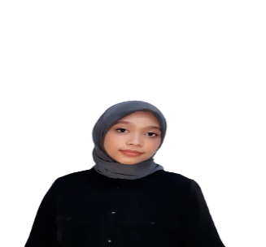

**Shinta Carolin S.Y** is a student at muhammadiyah university of sidoarjo majoring electrical engineering. she is a treasure of elctrical car team at UMSIDA (IMEI TEAM). His team won second place in indonesia energiefficient car competition (KMHE).