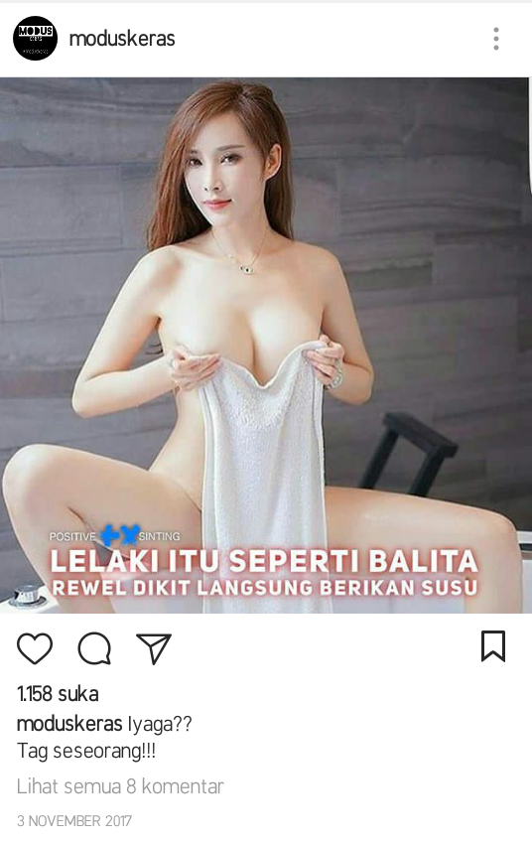 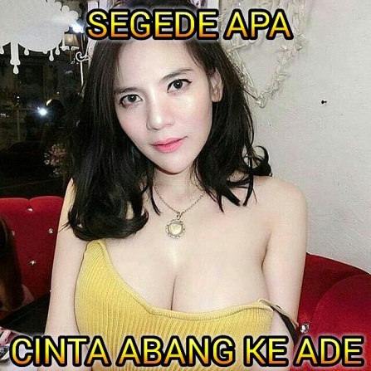

Figure 3 Figure 4

|  |  |  |  |  |
| --- | --- | --- | --- | --- |
| **No** | **Title** | **Kind of Sign** | **Data** | **Type** |
| 1 | Figure 3 | Visual | Woman | Icon |
| 2 | Figure 3 | Visual | Place, Gaze | Index |
| 3 | Figure 3 | Textual | Lelaki, Balita, Rewel Dikit | Symbol |
| 4 | Figure 3 | Visual and textual | Hands position, Berikan Susu | Index |
| 5 | Figure 4 | Visual | Woman | Icon |
| 6 | Figure 4 | Visual | Place, Gaze | Index |
| 7 | Figure 4 | Textual | Abang, Ade | Symbol |
| 8 | Figure 4 | Visual | Breast | Symbol, Icon |
| 9 | Figure 4 | Textual | Segede Apa | Symbol |

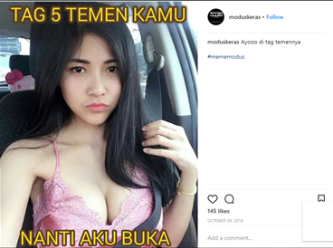 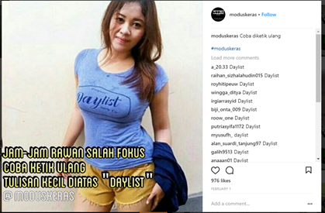

Figure 5 Figure 6

|  |  |  |  |  |
| --- | --- | --- | --- | --- |
| **No** | **Title** | **Kind of Sign** | **Data** | **Type** |
| 1 | Figure 5 | Visual | Woman | Icon |
| 2 | Figure 5 | Visual | Hand position | Index |
| 3 | Figure 5 | Textual | Tag 5 Temen Nanti Aku Buka | Index |
| 4 | Figure 5 | Visual | Lips “duckface” | Symbol |
| 5 | Figure 5 | Visual | Pink outfit | Symbol |
| 6 | Figure 6 | Visual | Woman | Icon |
| 7 | Figure 6 | Textual | Jam Rawan Fokus Coba Ketik…. | Index |
| 8 | Figure 6 | Textual | Daylist | Symbol |
| 9 | Figure 6 | Visual | Blue tight shirt | Symbol |
| 10 | Figure 6 | Visual | Camera possition | Index |

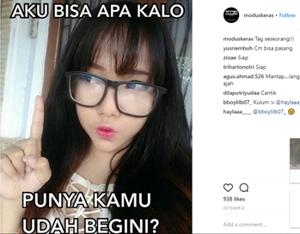 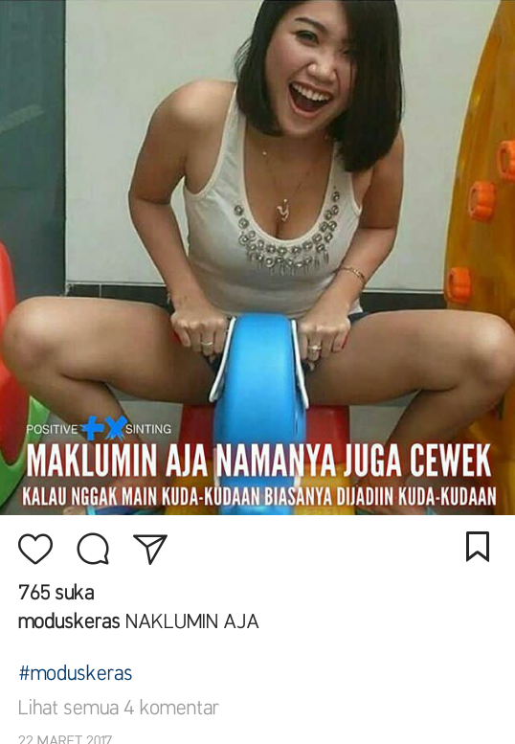

Figure 7 Figure 9

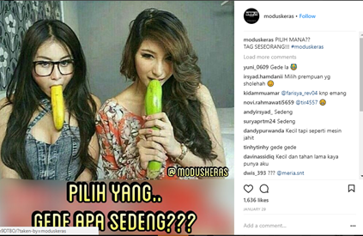

Figure 8

|  |  |  |  |  |
| --- | --- | --- | --- | --- |
| **No** | **Title** | **Kind of Sign** | **Data** | **Type** |
| 1 | Figure 7 | Visual | Woman | Icon |
| 2 | Figure 7 | Visual | Forefinger | Icon  Symbol  Index |
| 3 | Figure 7 | Visual | Gaze, Lips “duckface” | Index  Symbol |
| 4 | Figure 7 | Visual | Eye Glasses | Symbol |
| 5 | Figure 7 | Textual | Aku Bisa Apa | Index |
| 6 | Figure 7 | Textual | Udah Begini | Index  Symbol |
| 7 | Figure 8 | Visual | Women | Icon |
| 8 | Figure 8 | Visual | Banana, Cucumber | Icon  Symbol |
| 9 | Figure 8 | Visual | Gaze, Background | Index |
| 10 | Figure 8 | Textual | Gede atau Sedeng | Index |
| 11 | Figure 9 | Visual | Woman | Icon |
| 12 | Figure 9 | Textual | Maklumi Saja.. | Index |
| 13 | Figure 9 | Textual | Cewek | Symbol |
| 14 | Figure 9 | Visual | Horse Toy | Icon  Symbol |
| 15 | Figure 9 | Textual | Kuda-kudaan | Symbol |

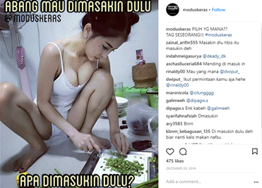 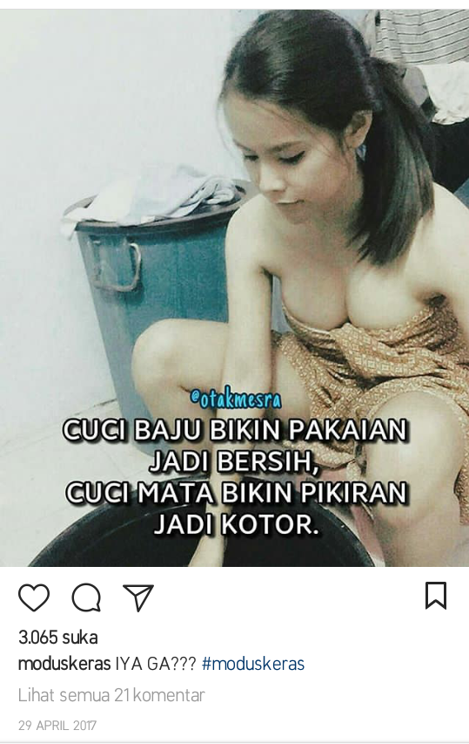 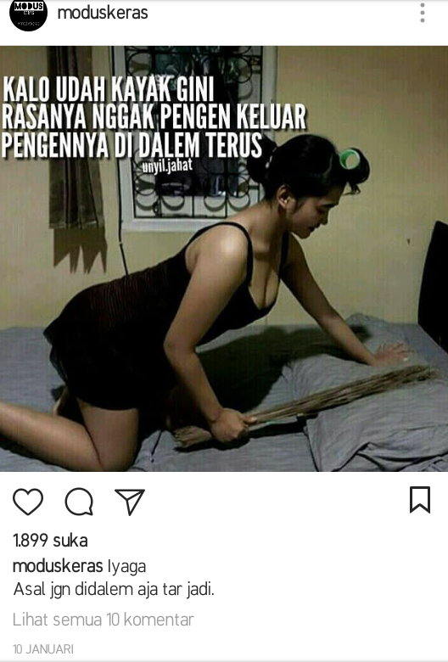

Figure 10 Figure 11 Figure 12

|  |  |  |  |  |
| --- | --- | --- | --- | --- |
| **No** | **Title** | **Kind of Sign** | **Data** | **Type** |
| 1 | Figure 10 | Visual | Woman | Icon |
| 2 | Figure 10 | Visual | Background, Outfit, Hair Tied, Pose, Gaze | Index |
| 3 | Figure 10 | Visual | Cutting vegetables | Symbol |
| 4 | Figure 10 | Textual | Abang, Dimasakin, Dimasukin | Symbol |
| 5 | Figure 11 | Visual | Woman | Icon |
| 6 | Figure 11 | Visual | Background, Outfit, Hair Tied, Pose, Gaze | Index |
| 7 | Figure 11 | Textual | Cuci Baju, Cuci Mata | Symbol |
| 8 | Figure 11 | Textual | Pikiran Jadi Kotor | Index |
| 9 | Figure 12 | Visual | Woman | Icon |
| 10 | Figure 12 | Visual | Background, Outfit, Hair Tied, Pose, Gaze | Index |
| 11 | Figure 12 | Textual | Kalo Udah Kayak Gini… | Index |

*Type adalah hubungan tanda dengan objeknya