**TOWARDS THE INDEPENDENCE OF THE PROPELLANT INDUSTRY**

**FOR MUNITIONS AND ROCKET**

**(MENUJU KEMANDIRIAN INDUSTRI PROPELAN UNTUK ISIAN MUNISI DAN ROKET)**

**Akhmad Rifaia**

aResearch Center for Sustainable Production System and Life Cycle Assessment of National Research and Innovation Agency, South Tangerang.

Hp.: 081211639918

E-mail: [rifaiakhmad@yahoo.com](mailto:rifaiakhmad@yahoo.com), akhm001@brin.go.id

**Era Restu Finalisb**

bResearch Center for Process and Manufacturing Industry Technology of National Research and Innovation Agency, South Tangerang.

Hp. 0813-82849442

E-mail: [erarestufinalis@yahoo.com](mailto:erarestufinalis@yahoo.com), erar001@brin.go.id

**ABSTRACT**

Indonesia has not yet been able to generate propellants, which are crucial components of the country's defense system. Long-term reliance on imports for ammunition and rocket components can compromise the TNI's operational readiness. These issues and weaknesses include being susceptible to political pressure and having less independence and deterrence factor readiness. Because it affects national pride in national defense, the installation of a propellant factory should not be postponed. Nitrocellulose, the primary raw material of cellulose and nitroglycerin, whose primary raw material is glycerine, is used as the primary raw material in the production of propellants. Domestic industries have generated the two primary raw materials.

Keywords: Industrial Propellant, Nitrocellulose, Nitroglycerin, Single Base, Double Base Propellant

1. **INTRODUCTION**

It is crucial to have the ability to make items in order to advance technological capabilities. The presence of rich natural resources (raw materials) does not translate into assets that can be possessed without evolving technological capabilities. Natural resources, meantime, have become increasingly useful materials thanks to the advancement of science and technology, particularly in the fields of security and defense. The following diagram illustrates the potential for the propellant and explosives industry. The propellant is a propulsion material used in the light, medium, and heavy munitions as well as for rocket filling. The majority of the raw ingredients may be purchased/have been produced domestically as shown in Figure 1.

Propellants can be divided according to the general raw material, namely (a) single base propellant (nitrocellulose) used in pistol munitions, (b) double base propellant (nitrocellulose & nitroglycerine) used in small and large caliber munitions and in rockets, (c) triple base propellant (nitrocellulose, nitroglycerine& nitroguanidine) used in large caliber munitions and howitzers, The integrated propellant plant consists of (a) ball powder plant, (d) nitroglycerine plant, (c) nitroglycerine powder plant, (d) nitrocellulose plant, (e) plant rocket propellant. The discussion in this paper is limited to the process of making Nitroglycerin, Nitrocellulose, and Double Base Propellant.

1. **MATERIALS AND METHOD**
   1. **Materials**

To determine the extent to which the quantity and quality of propellant raw materials have been carried out surveys and data collection of industries that have produced materials related to the process of making nitrocellulose and nitroglycerin. The following data sources of raw materials as shown in Table 1



**Figure 1.** Diagram illustrates the potential for the propellant and explosives industry

**: the raw materials are already produced and available domestically.**

..

**Table 1. Propellant Raw Material Source**

|  |  |  |  |  |
| --- | --- | --- | --- | --- |
| NO | Factory Name | Types of Product | Production Capacity/Year | Location |
| 1 | PT. Inti Cellulose Utama Indonesia | Cellulose, 99.99% | 2.700 tons | Banten,  Leces Probolinggo, Mojokerto, Padalarang, Blabak. |
| 2 | PT. Aribhawana Utama  PT. Budi Aneka Cemerlang  PT. Cisadane Raya Chem  PT. Para Sawita  PT. Sayap Mas Utama  PT. Sumi Asih  PT. Wing Surya | Glycerin | 20.000 tons  1.500 tons  25.500 tons  5.400 tons  3.000 tons  9.000 tons  4.000 tons | Medan  Tangerang  Tangerang  Medan  Bekasi  Bekasi  Gresik |
| 3 | Pabrik Asam Sulfat | Sulfuric Acid |  | Jakarta |
| 4 | Pabrik Asam Nitrat | Nitric Acid |  | Jakarta, Surabaya, Cikampek |
| 5 | Pupuk Kaltim I & II | Ammonia (NH3) | 330.000 Tons | Kalimantan Timur |
| 6 | Aceh Fertilizer | Ammonia (NH3) | 330.000 Tons | Aceh |
| 7 | PT. Pupuk kujang | Ammonia (NH3) | 330.000 Tons | Cikampek |
| 8 | Pupuk Sriwijaya | Ammonia (NH3) | 927.200Tons | Palembang |
| 9 | Industrial Gases | Oxygen (O2) | 4.802.476 M3 | Jakarta |
| 10 | PT. Nila Alam | Oxygen (O2) | 829.080 M3 | Jakarta |

* 1. **Nitroglycerin (NG) Manufacturing Process**

Nitroglycerin is made from the reaction of glycerin with nitric acid with a sulfuric acid catalyst. The reaction is as follows :



Due to the significant risk and potential hazards of this research, extreme vigilance is essential. This is due to Nitroglycerin's nature, which is extremely sensitive, poisonous, and explosive and will decompose into:

$$4 C_{3}H_{5}N_{3}O_{9}→ 12 {CO}_{2}+ {6N}_{2} +10 H_{2}O+panas$$

Nitroglycerin based on a chemical reaction is produced by reacting glycerin (glycerol) with nitric acid. However, there are several kinds of processes for making nitroglycerin.

1. **Schmid-Meissner** *continuous process*
2. **Nitro Nobel** *injector proses*
3. **Biazzi** *continous process*
4. **Schmid-Meissner** *continous process*

Schmid-Meissner was the first process in the manufacture of nitroglycerin. The process includes nitration, separation, and purification of nitrogen by neutralization and washing. The nitrator is in the form of a stirred tank, equipped with vertical cooling pipes. As a cooling medium, brine is used which enters at a temperature of -5oC. The mixed acid enters from the bottom of the nitrator and glycerin enters from the top while the result exits by overflow to the separator (stainless steel). The nitrator temperature is maintained at not more than 18 oC and atmospheric pressure. The separated nitroglycerin is mixed with a hot mixing solution, in the form of soda and ammonia and then emulsified with air. The separation of nitroglycerin and residual acid is based on the formation of two layers and differences in density. The remaining acid with a lower density is in the upper layer and nitroglycerin in the lower layer. The remaining acid coming out of the separator will be recovered, while the nitroglycerin is washed in a tower or washing column containing baffles. In the washing column, the mixture is emulsified using cold water and injecting compressed air. The emulsion flows from the top of the column to the intermediate separator, then flows to the bottom of the washing column II. The emulsion flows from the top of the washing column II to the separator II, then the liquid is flowed again. to washing column III and separator III until the desired stability has been achieved (Vuono, 1984).

1. **Nitro nobel** *injector proses*

The apparatus in this process is an injector which is used to mix glycerol with pre-cooled nitration acid. The flow of acid through the injector will create a vacuum so that the glycerin will be drawn in. The mixing of these two substances is very fast and will form an emulsion. Glycerin is sucked into the injector at a temperature of 48 oC and immediately reacts with acid. The reaction takes place at a temperature of 45-50 oC. The emulsion obtained is immediately cooled to 15 oC and then exits by gravity to the centrifuge, where nitroglycerin will be separated from the waste acid, then the used acid can be recycled or denitrified. The mixture containing nitroglycerin was emulsified with a water jet to form a non-explosive mixture, then neutralized with Na2CO3, and washed. The stabilized nitroglycerin is passed through the injector to form a non-explosive water emulsion for safe storage.

1. **Biazzi** *continous process*

Biazzi continuous is the newest process in the production of nitroglycerin. The equipment consists of a nitrator, separator, and stirred washer. Some of the appliance units are made of stainless steel, to prevent nitroglycerin build-up. The process includes nitration, separation, and purification of nitroglycerin by washing. The nitritor is a small cylindrical vessel equipped with a stainless steel vessel with a cooling coil, where brine at a temperature of (-2) – (-5) oC is circulated during nitration to maintain the reaction at 15oC and atmospheric pressure (1 atm). Then the nitrator product enters separator I to separate nitroglycerin from residual acid based on specific gravity and solubility, then the remaining acid is neutralized with a 2% sodium carbonate solution. In the washing tank the nitroglycerin is emulsified with water and washed to dissolve the neutralized salts, then flowed to separator II to separate the salts from the neutralization with nitroglycerin until the stability standard (safety factor) was reached. Furthermore, the nitroglycerin produced is stored in a storage tank (Kirk and Othmer, 1996), the complete process diagram is shown in Figure 2.

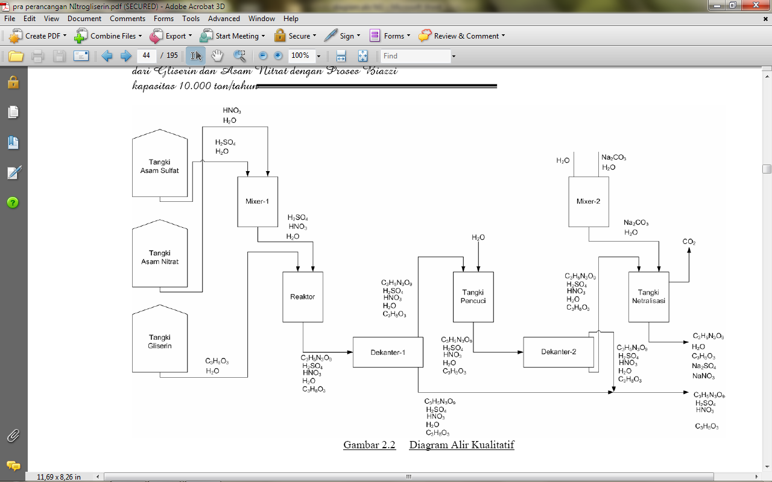

**Figure 2. Nitroglycerin process production**

* 1. **Nitrocellulose Manufacturing Process**

As the name implies, nitrocellulose is composed of cellulose compounds and nitric acid, an ester formed from the alcohol group of cellulose with nitric acid. The process of combining these two compounds is through a nitration process where there is an electrophilic substitution by nitrile ions, NO2+ which comes from a mixture of nitric acid and sulfuric acid with hydrogen atom groups in the cellulose.

The basis of the reaction is as follows:

[C6H7O2(OH)3]n + 3HONO2 + H2SO4🡪 [C6H7O2(ONO2)3 ]n + 3H2O + H2SO4

Materials and tools used:

* 1. Materials:
* α - cellulose
* Nitric Acid
* Sulfuric acid
* Natrium carbonate
* Aqua Dest
  1. Tool
* Nitrator
* Centrifugal / evaporator

Manufacturing process:

This nitration reaction takes place exothermic where heat is generated during the reaction (as opposed to endothermic, requiring heat). For this reason, cold water is needed. And the nitrator used is equipped with a cooling jacket to absorb the heat generated during the reaction. In addition, stirring in this reaction is necessary because it allows collisions between reactants to be greater in frequency so that there will be more opportunities to react. In addition, stirring serves to prevent explosions due to the unstirred part of the reactor which causes uncontrolled heat accumulation. The operating conditions for the nitration process are as follows:

**Table 2. Operating conditions for the cellulose nitration process**

|  |  |
| --- | --- |
| Temperatur, ˚ C | 30 |
| Lama Reaksi, menit | 25 |
| Konversi, % | 96-97 |

In this reaction, water is formed which directly reacts with sulfuric acid (in addition to functioning as a catalyst, it also functions to absorb water). The products of this reaction are nitrocellulose and spent acid. The results of the nitration reaction are centrifuged to separate nitrocellulose and spent acid. Spent acid that is formed is partly strengthened for reuse and partly formed by denitration and concentration of sulfuric acid. The nitrocellulose from the reaction is purified to remove residual acid by washing it twice with water and once with sodium carbonate. Then in the centrifuge separate the water with nitrocellulose. The complete process diagram is shown in Figure 3.

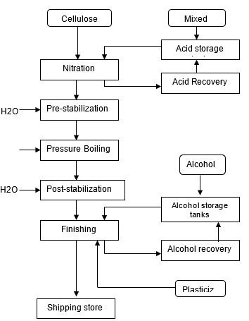

**Figure 3. Nitrocellulose process production**

Double Base Propellant Manufacturing Process:

The double base propellant is a mixture of nitrocellulose and nitroglycerin. Its composition is 50-60% NC and 30-49% NG.

Manufacturing Process:

Similar to the manufacture of nitrocellulose, nitroglycerin also undergoes an esterification reaction. This reaction takes place at a temperature of 30 C. This reaction is an exothermic reaction (producing heat) so that the nitrator (vessel) used is equipped with a cooling jacket. The reaction process is carried out very carefully and all mixed. After the reaction is complete, the reaction product is centrifuged then the nitroglycerin produced is washed with water and sodium carbonate (to remove residual acid) until neutral.

Materials and tools used;

a. Material:

* + - * Nitrocellulose
      * Nitroglycerin
      * Stabilizer
      * Organic Solvent/water

b. Tool:

* + - * Reactor with agitator
      * Printing
      * Cutting machine

Manufacturing Process:

Composition of double base propellant: 50-60% NC and 30-49% NG. The manufacture of DB can be done by mixing nitroglycerin into nitrocellulose. The process can be carried out by 2 methods. The first method uses an organic solvent, and the other uses water as a solvent. For the first method of mixing nitrocellulose and nitroglycerin with a solvent and an additive (stabilizer) to form a dough (Meyer 1987; National Research Council 1998; Radford Army Ammunition Plant 1987), the mixture is then shaped into blocks by feeding it into an extrusion press and cutting machine. The result in the form of granules is screened first to remove the solvent. Dried, screened again, and then in a blender until homogeneous. The second method is to add nitroglycerin to a nitrocellulose-water suspension to form a paste (Meyer 1987; Radford Army Ammunition Plant 1987). The water is separated by evaporation on hot rollers. Then formed by extrusion and cutting.

Stages of making DB Propellant:

* + - Paste Preparation

At this stage, enter the nitroglycerin solution into the nitrocellulose suspension slowly accompanied by stirring.

* + - Slurry Mixing

At this stage, the paste is pumped into the lead-lines centrifuge to reduce the water to reach 18% humidity.

* + - Equipment
    - Drying and Blending
    - Finishing

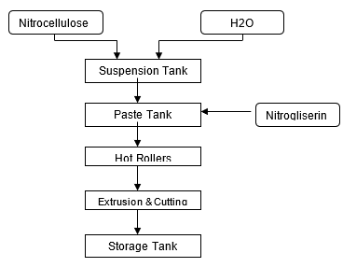

**Figure 4. Process Diagram of Double Base Propellant**

**Table 3: Typical properties of DB propellants**

|  |  |  |  |  |  |
| --- | --- | --- | --- | --- | --- |
| Propellant  (mass %) | Mass density  [kg/m3] | Flame temperature  [K] | Molar mass  [kg/kmol] | Specific heat ratio [-] | Regression rate [mm/s] |
| Nitrocellulose  (50-60%)  Nitroglycerine  (30-40%) | ~ 1600 | 2100-3125 | 22-28 | 1.21-1.25 | 15-25 |

The complete process diagram is shown in Figure 4.

**RESULT AND DISCUSSION**

1) If the observation and analysis of the 3 (three) processes of making nitroglycerin are carried out, it can be summarized in Table 4. From table 4. it can be concluded that the Biazzi process is a better result when compared to the others because the Biazzi process is more efficient than other processes (for the same capacity, the tool size is smaller). Compared to the Schmid-Meissner process, the Biazzi process is simpler, especially in the washing and separation units. The Biazzi process is the newest process. Domestic raw materials are sufficient to support the manufacture of Nitrocellulose (single base propellant), Nitroglycerin, and Double Base Propellant factories.

**Table 4. Comparison of NG Manufacturing Process**

|  |  |  |  |  |
| --- | --- | --- | --- | --- |
| **No** | **Comparison** | **Schmid-Meissner** | **Nitro Nobel**  **Injector** | **Biazzi**  **Continuous** |
| 1 | Raw Materials | Glycerol and nitric acid | Glycerol and nitric acid | Glycerol and nitric acid |
| 2 | Conversion | 93% | 90 % - 93% | 95 % |
| 3 | Operational Process | 1 atm, 18 oC | 1 atm, 45-50 oC | 1 atm, 15oC |
| 4 | Catalyst | H2SO4 | H2SO4 | H2SO4 |
| 5 | NG accumulated in system (safety factor) | Much accumulated | Much accumulated | A little accumulated |

**CONCLUSION**

1) When viewed from the national demand for a single base propellant of 100 tons/year*), then the Nitrocellulose plant can be built domestically.

2) When viewed from the national demand for double base propellant of 938 tons/year*), the Nitroglycerin plant can also be built domestically, although the technology for the manufacturing process of the two raw materials still has to be purchased/licensed from abroad.

**REFERENCES**

M. Ross, Donal & G.P. Sutton, *Rocket Propulsion Elements*, 4th ed. John Wiley & Sons, New York : 1976.

Meyer, Rudolf. *Explosive* 6nd Completely revised edition, Wiley-VCH Verlag GmBH, Weinheim, 2007.

<http://pdf.aiaa.org/preview/1980/PV1980_1169.pdf>

<http://solidpropelanproperties.htm>

Noris Shreve, R & Joseph A. Brink, Jr., *Chemical Process Industries*, 4th ed., Mc.Graw-Hill Kogakusha,ltd., 1977

Groggins, PH., *Unit Processes in Organic Synthesis*, 5th ed., International Student Edition, Mc.Graw Hill Kogakusha Ltd.