*Design and Manufacture of Post Stroke Therapy Equipment (PSTE) Using Electro Pneumatic System*

**Bambang Riyantaa, Rahma Caturb, Fitroh Anugrah Kusuma Yudhac**

a Department of Mechanical and Industrial Engineering, Faculty of Engineering, Universitas Muhammadiyah Yogyakarta

Jalan Brawijaya, Kasihan, Bantul, Daerah Istimewa Yogyakarta, Indonesia

e-mail: [bambangriyanta@umy.ac.id](mailto:bambangriyanta@umy.ac.id), rahma.catur2016@ft.umy.ac.id , fitroh.anugrah@umy.ac.id

|  |  |  |
| --- | --- | --- |
| **ARTICLE INFO** |  | **ABSTRAK** |
| Article History  Received  Revised  Accepted  Available online | Terapi konvensional pada penyakit Stroke mengharuskan pasien datang ke rumah sakit yang kurang efisien dari segi waktu dan biaya. Oleh karena itu, untuk mengatasi masalah tersebut perlu adanya alat terapi untuk memudahkan pasien dalam melakukan terapi secara mandiri. Rancangan alat terapi ini berdasarkan terapi gerakan yang direkomendasikan, yaitu *Stroke Glove* ini. Perangkat lunak yang digunakan ntuk *adalah Solidworks 2016*, dan *FluidSIM Pneumatic*. Perancangan juga melakukan simulasi uji struktur rangka servo dan melakukan simulasi pneumatik. Material yang digunakan adalah plat nilon. Komponen utama yang digunakan untuk sistem kelistrikan adalah *Wireless RF Module*, dan untuk sistem elektropneumatik antara lain *solenoid valves*, *control flow*, dan *Air Muscle Pneumatics*. Simulasi desain pada software *SolidWorks* didapatkan beberapa hasil yaitu tegangan Analisa, tegangan maksimum 9.613e + 05 N/mm^2/MPa, perpindahan maksimum 5.664e + 01 mm dan faktor keamanan minimum 6.242e + 00 atau 7 ul. Komponen otot udara dapat mengangkat beban rangka instrumen serta tangan pasien. Sedangkan hasil pembuatan alat terapi pasca stroke dengan dimensi tinggi 246 mm, lebar 110 mm dan panjang 220 mm. Alat ini menghasilkan 3 mode gerak rehabilitasi, yaitu mode satu; gerakan siku ke atas, mode dua; gerakan siku ke bawah, mode tiga; kombinasi dari semua mode. Hasil rancang bangun dan pembuatan alat ini mampu memberikan kemudahan bagi pasien stroke dalam melakukan rehabilitasi tangan dan pada dasarnya bermanfaat bagi pasien stroke.  ***ABSTRACT***  Conventional therapy requires patients to come to the hospital, which is less efficient in terms of time and cost. Therefore, to overcome this problem, therapy tools must be used to facilitate patients in doing therapy independently. The design of this therapeutic device is based on the recommended movement therapy, *Stroke Glove*. The software used to design this therapy device are Solidworks 2016 and FluidSIM Pneumatic. In addition to the design of the frame, the method also performs a simulation of the servo frame structure test and a pneumatic simulation. At the stage of making the prototype, the material used for manufacture is nylon plate, while the primary components used for the electrical system are Wireless RF Module, and for the electro-pneumatic system include solenoid valves, control flow, and Air Muscle Pneumatics. Several results are obtained from the design simulation, the maximum stress analysis stress is 9.613e + 05 N/mm^2/MPa, the maximum displacement is 5.664e + 01 mm, and the minimum safety factor is 6.242e + 00 or 7 ul. The air muscle component can lift the weight of the instrument frame and the patient's hands. While the results of the manufacture of post-stroke therapy tools with a height dimension of 246 mm, 110 mm wide, and 220 mm long. This tool produces three modes of rehabilitation movement: mode one; elbow movement up, mode two; downward elbow movement, mode three; a combination of all modes. The results of the design and manufacture of this tool can provide convenience for stroke patients in carrying out hand rehabilitation and are fundamentally beneficial for stroke patients. |
| **Kata kunci:** Stroke, electro-pneumatic, air muscle pneumatic, Solidworks, stress analysis  **Keyword:**  Stroke, electro-pneumatic, air muscle pneumatic, Solidworks, stress analysis |

**1. INTRODUCTION**

Stroke is one of the biggest causes of death in developed and developing countries. Worldwide, in the year 2000, the prevalence of stroke was 7.1 million and will continue to increase [1]. In developing countries such as Indonesia, data show an incidence of 234 per 100,000 population as the result of a survey in Bogor by Misbach [2]. According to RISKESDAS data from the Ministry of Health of the Republic of Indonesia [3], in its 2007 national report, it turns out that the leading causes of death for all ages were stroke (15.4%), TB (7.5%), hypertension (6.8%). Based on several studies, the patient's disability rate caused by stroke reached 65%. The level of disability caused by stroke, one of which is due to impaired cognitive function [1]. One of the cognitive functions includes the ability to move physical activities such as swinging hands, holding something, bathing, or eating.

Based on interviews conducted with six subjects who are stroke patients and stroke nurses, several obstacles have no solution yet, one of which is the high cost of rehabilitation and the discomfort experienced by the patients at the hospital [4], which results in a non-optimal rehabilitation. Therefore, an Independent Post-Stroke Therapy Tool (IPSTT) was made using an electro-pneumatic system designed to help stroke sufferers in early mobilization independently at home without needing to go to the hospital for medical rehabilitation [5,6,7].

**2. DESIGN METHOD**

The method used in the design of post-stroke therapy is the development of problems that occur in public, especially in post-stroke patients [5,6,7,8]. This study uses several stages, namely the planning stage, the concept development stage, the design stage, and the testing stage. The planning stage consists of identifying opportunities, setting goals, determining boundaries, and determining the machine technology platform used. This stage has been described in the introductory sub-heading.

The concept development stage is the stage to determine the machine concept, including the form, function, features, and required technological solutions. The design stage is the stage to produce the design plan, the constituent sub-systems, and process flow diagrams. Then the design stage also consists of determining the components’ technical specifications, the design of control panels, and electricity. In the design and manufacture of post-stroke therapy tools, several tools and materials are needed as follows; Tools: CNC, cutters and saws, rulers, screwdrivers (-) and (+), pliers, sandpaper, laptops, and Solidwork software, which are used as containers for making parts, assembly parts, and simulating design results; Materials: Nylon plate, Transmitter Receiver Module RF DC 12V 1CH Relay 433MHz Wireless, Remote, Cable, Stainless steel ties, 3/2 solenoid valve, Flow speed control, Y slip lock fittings, Slincer, 6mm pneumatic elbow fittings 4x6mm PE hose, Braided expandable sleeving PET, Latex tube 6x9mm, Hose clam 3/5, Bolts, Bolts, Nuts, Rings, and Bearings.

The testing stage conducted several tests, and the level of ergonomics using the appropriate motion in motion therapy also found out whether the IPSTT product worked well. Failure analysis and corrective action will be carried out on the IPSTT product and reprocessed to the IPSTT design and tooling process. If it works well, the next stage is ready to be processed. The analysis is carried out in the form of motion that works on the device according to the therapeutic needs of stroke patients [9,10,11].

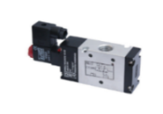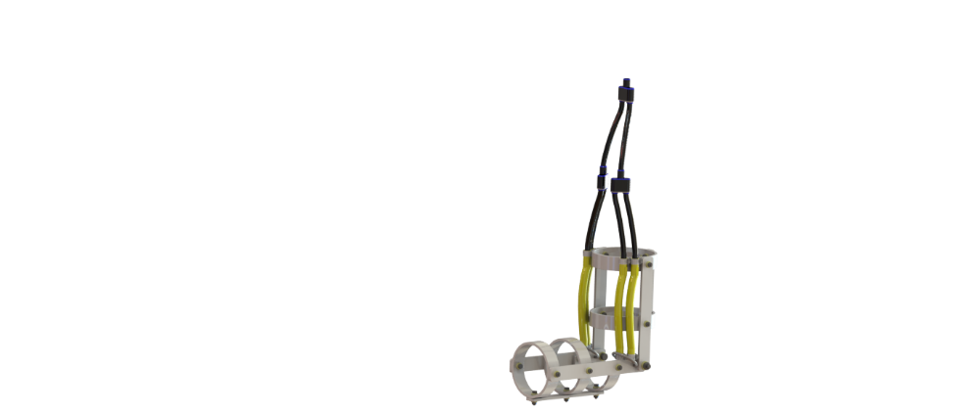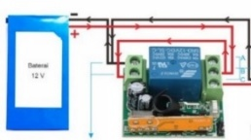

Figure 2.1 Circuit schematic Post Stroke Elbow Therapy Devices (PSETD)

Figure 2.1 shows a series of Post Stroke Elbow Therapy Devices (PSETD). There are several components shown in the figure, namely:

1. Pneumatic fittings, 2. Hose clamp, 3. Air muscle, 4. IPSTT frame, 5. Slincer, 6. Hoses, 7. Air filter compressor, 8. Compressor, 9. Minus cable (-), 10. Plus cable (+), 11. Module Transmitter Receiver RF DC 12V 1CH Relay 433MHz Wireless Remote, 12. 12V battery

The movement mechanism for the tool is based on strengthening the muscles and tightening the elbow, as shown below.

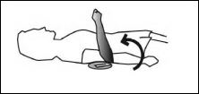

Figure 2.2 Elbow tightening movement

With that illustration, it can be concluded that the movement only requires lifting the lower arm to form an angle of 90° [12], with the motion mechanism schematic illustrations as follows.

90 $°$

90

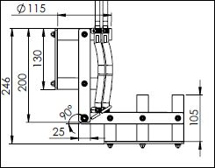

Figure 2.3 Motion mechanism schematic

**Figure 4.4.** skema mekanisme gerak

The specification shows that the pneumatic components should not exceed the load figures contained in the specifications. In the process of working steps, pneumatic functions with the following illustration [13,14]:

*Table1.1. Air muscle specification [14].*

|  |  |
| --- | --- |
| *Weight*: | 10 ~ 80 g (0.022 ~ 0.18 lb) |
| *Diameter inner*: | 9 ~ 30 mm |
| *Output (Pull force)*: | 30 ~ 350 N (6.6 ~ 77 lbf), normal 70 ~ 700 N (15 ~ 150 lbf), Max. |
| *Max. inflated pressure*: | 2 bar (30 psi), unloaded 4 bar (60 psi), loaded |

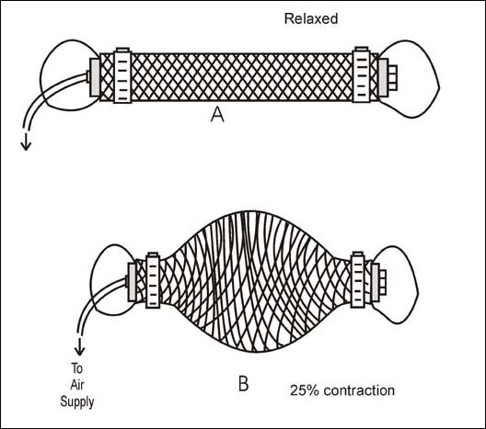

Figure 2.4. The working system of the pneumatic air muscle

**Figure 4.4.** skema mekanisme gerak

The electro-pneumatic design can be simulated first using the FluidSIM pneumatic software to determine whether the system is working properly. The electro-pneumatic system can be seen in Figure 2.5.

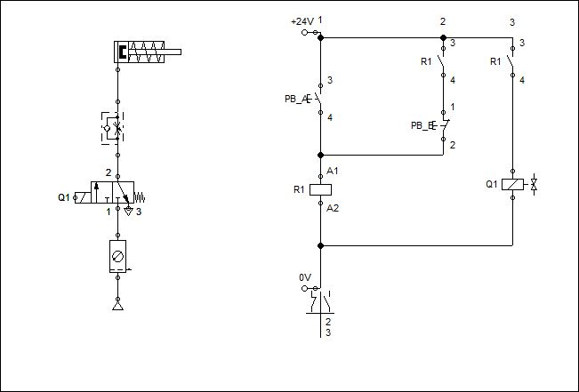

Figure 2.5. Electrical Pneumatic System Circuit Schematic

The electrical system uses 1CH RF Relay 433MHz wireless remote transmitter-receiver module to control the device [15]. When the remote button ‘’A’’ is pressed, the coil on the solenoid gets a voltage supply, and the coil will turn into a magnetic field so that it moves the plunger on the inside and changes position. The output hole of the pneumatic solenoid valve will release compressed air from the supply (Service units). When the remote button ‘’B’’ button is pressed, the coil will move the plunger to the air exhaust hole so that air can come out of the latex pipe in the air muscle.

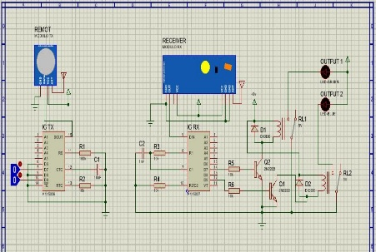

(a)

(a)

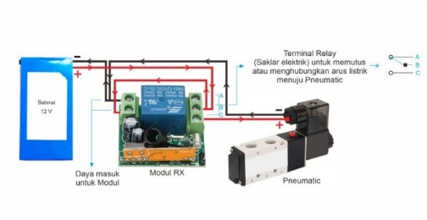

(b)

(b)

Figure 2.6. Circuit schematic (a) Electrical circuit schematic on the RF Transmitter Receiver Module component 1CH Relay 433MHz (proteous) (b) electrical circuit schematic on the post stroke therapy device

**3. RESULT AND DISCUSSION**

Determine the maximum designed load on the tool by determining the constraint or support regarding the position of the design made [16]. This Post Stroke, Hand Therapy Tool, uses a nylon material frame. The load on the frame is supported by the bottom three cylinders [16]. In this analysis, the weight of the load (Kg) is converted into Newtons (N). The frame load analyzed in this study simulation, whether 1-3 kg is x gravity = 3Kg x 10m/s2 = 30 N. The maximum load that the tool will accept is shown in Figure 3.1.

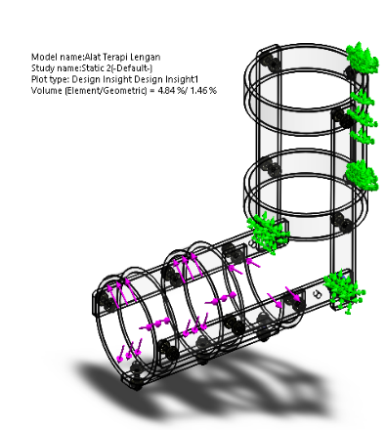

Figure 3.1 Loading in design

The simulation process is carried out with Solidwork software which analyses the structure of the conveyor by applying the machine element method of the object system process to be simulated so that elements will be connected in its structure. The analysis uses the Finite Element Method (FEA) [16]. After the simulation, several analysis results will be obtained, including von misses stress, displacement, and the factor of safety. Von Misses Stress shows the calculation results between the equivalent stress and strain used in the von Misses stress in the tool’s design shown in the orientation of the colors and numbers listed in the figure. 8.. The maximum stress that occurs is 9.613e + 05 N/mm^2 or (MPa), and the minimum stress that occurs is 1.925e + 03 N/mm^2 (MPa).

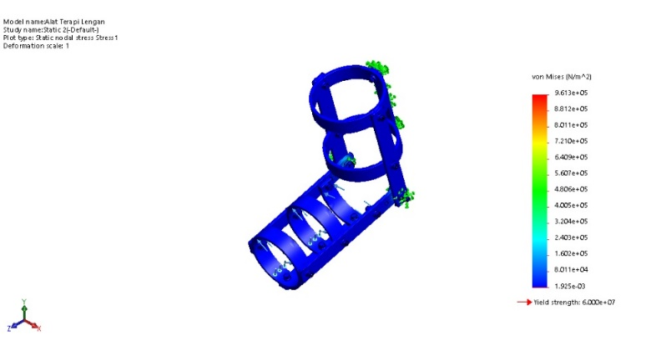

Figure 3.2 Von Misses Stress

The safety factor is one of the parameters to determine the feasibility of a construction design. The factor of safety is the ratio of the allowable stress to the stress that occurs. A design construction is declared to have passed the factor of safety or declared safe if the FOS value is greater than 1 [16]. The design simulation results comparing the allowable stress with the actual stress that occurs are obtained at a minimum of 78886.242e + 00 or 7 so that it can be concluded that this design construction is feasible and got a good level of security.

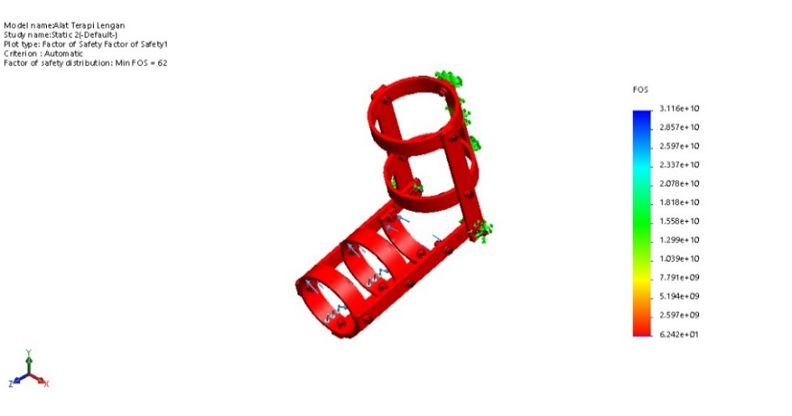

Figure 3.3 factor of safety

After the design stage is obtained, the next stage is manufacturing the Post Stroke Therapy Tool (IPSTT). In making the IPSTT, the reference used is the design stage that has been made. At the stage of making IPSTT, it is only sometimes following the design stage because the manufacturer of IPSTT looks at the conditions as shown in Figure 3.3.

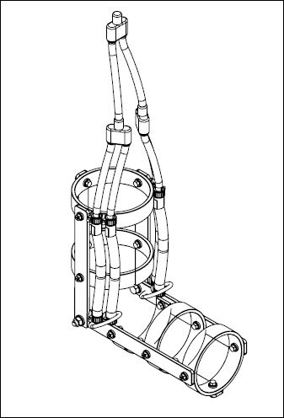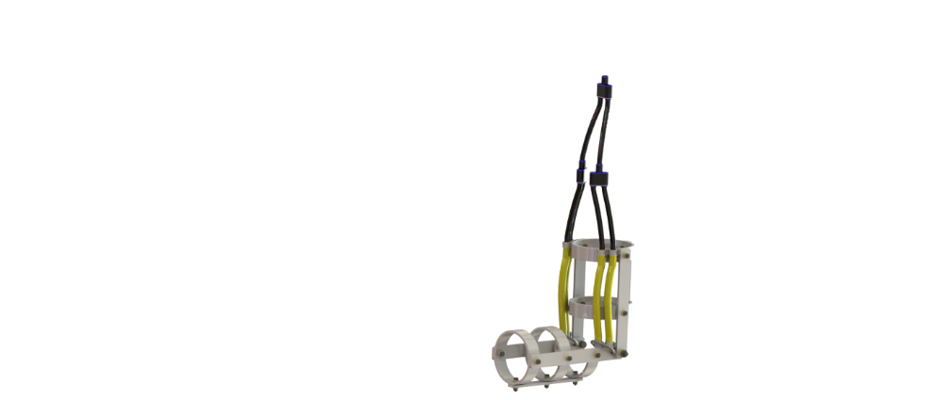

Figure 3.4 Tool Design

The tools were made in high accordance with the design. Knowledge of machining tools and the possibility of every production process that can be carried out is required in the manufacturing process. This production process requires the most efficient place of manufacture of tools. The selection of tools and materials in manufacturing products will determine the products’ results.

In forming the skeleton, several parts must be formed. The first component was the straight bone section. There are two different sizes the upper arm consisting of 3 parts and the lower arm consisting of 3 parts and the holder. The steps for making the seat are as follows:

a) Straight bone design

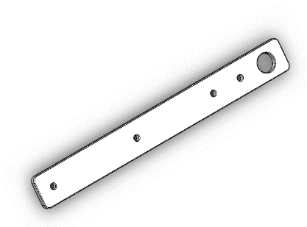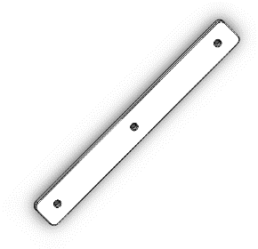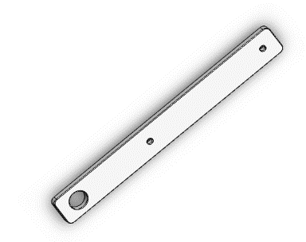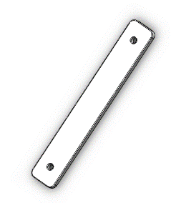

(a)

(a)

(b)

(b)

(c)

(c)

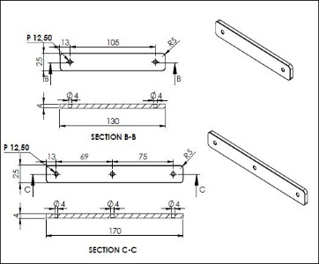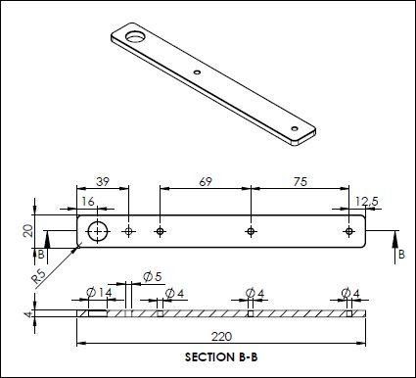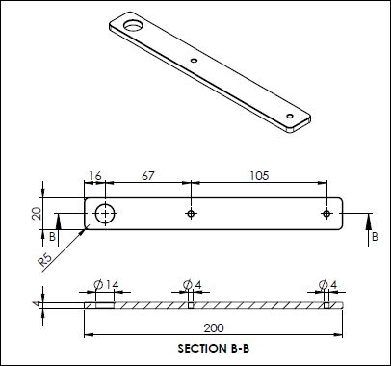

(a)

(a)

(b)

(b)

(c)

(c)

Figure 3.5. Working figure a) Lower bone figure (b) upper bone (c) middle bone

b) Cutting result

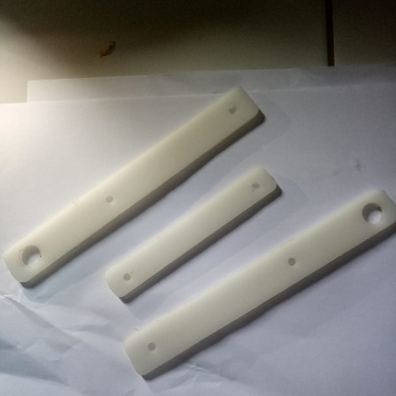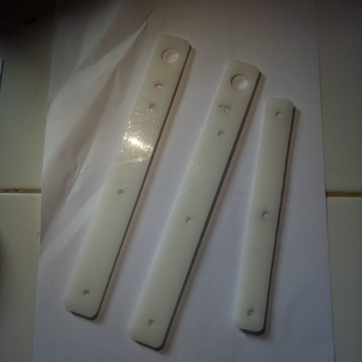

(a)

(a)

(b)

(b)

Figure 3.5. cutting results (a) bottom cutting results (b) top cutting results

In forming the skeleton process, several parts must be shaped in the circle section, and in this section, there are three different ones as well as in the straight bones in the upper arm, under the arm, and the bottom half circle. In this section, the initial concept of making arm circles is made first. The manufacturing steps are as follows.

a) arm circle design.

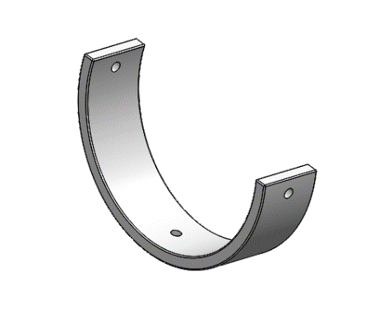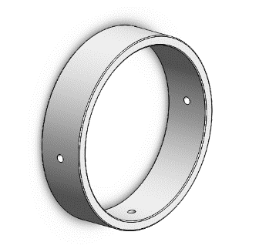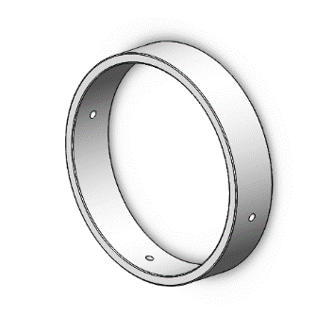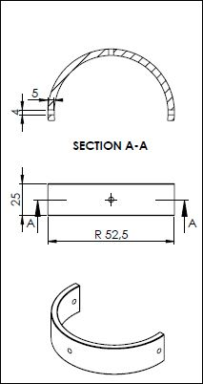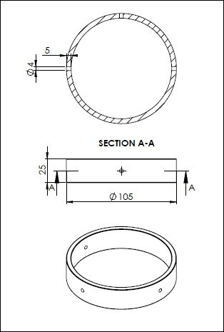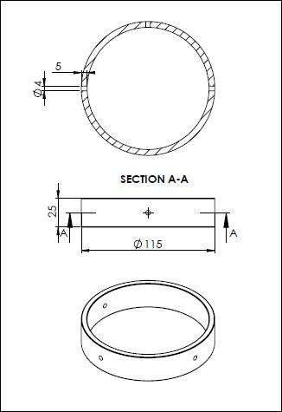

(a)

(a)

(b)

(b)

(c)

(c)

Figure 3.6 Working figure (a) bottom circle figure (b) the top circle (c) the bottom half circle

b) Cutting result

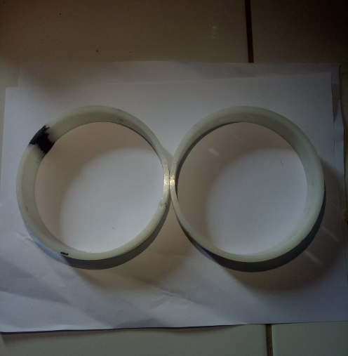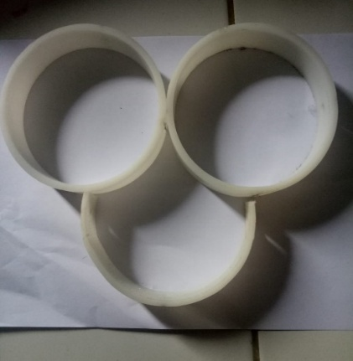

(a)

(a)

(b)

(b)

Figure 3.7 Cutting results (a) Figure bottom circle (b) top and bottom circle.

An electro-pneumatic system can be made after obtaining a small box available on the market with a 132 mm x 70 mm size. After getting the box, the next step is to arrange the Solenoid valve components, elbow fittings, silencers, batteries, and the RF Transmitter Receiver Module will be interconnected with the wind pressure source using 6” and 4” hoses due to different fitting diameters. In addition, in the structuring process, the comfort and convenience factors must be considered during later maintenance. The arrangement process is complete, and the following process is to perforate the box plate one by one to get the hoses and cables out. The component installation process can be seen in Figure 3.8.

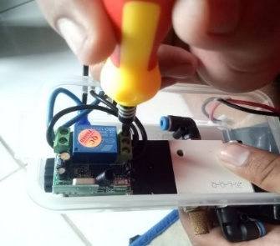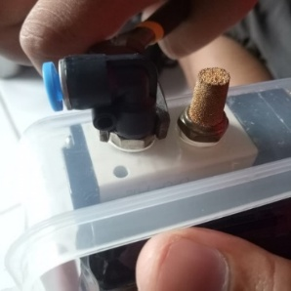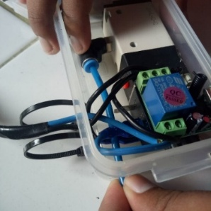

(a)

(a)

(b)

(b)

(c)

(c)

Figure 3.8. Electro Pneumatic installation (a) wiring (b) installation of fitting components (c) installation of pneumatic hoses

The unification of components is carried out by inserting a latex tube with an inner diameter of 6mm and an outer diameter of 9mm into a braided expandable sleeving PET net developer with a diameter of 12mm herring. The size is increased from the latex pipe so that when inserting it into the developer net, it can be more accessible, and it also makes it easier for the rubber pipe to expand first. The process of assembling the components can be seen in Figure 3.9

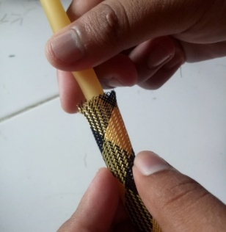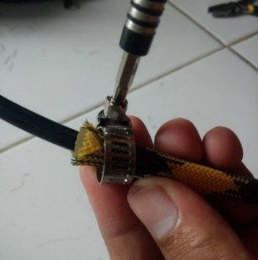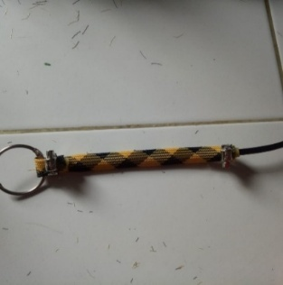

(a)

(a)

(b)

(b)

(c)

(c)

Figure 3.9 Installation of air muscle components (a) installation of latex hoses (b) installation of hose clams (c) air muscle penumatic

The finished component is then installed, and test whether each component's performance works perfectly. If components are less than optimal, a repair process must be conducted before the testing and finishing stages. The method of assembling the design frame by combining all the results of manufacture using bolts, rings, and nuts according to the size of the circle of bolts that have been made and installing bearings so that the movement of the elbows can be more easily pulled with air muscles and also installing air muscles on. It can be seen in Figure 3.10.

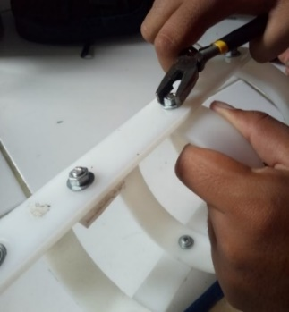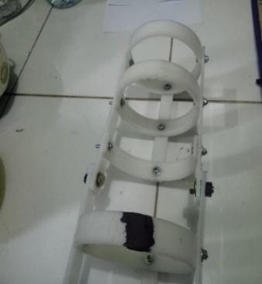

(a)

(a)

(b)

(b)

Figure 3.10 frame assembly (a) frame assembly process (b) PSTT frame

Assembly of this tool is the last step in the manufacture, where the frame that has been paired will be put together again with the electro-pneumatic system so that it can work. This step can be seen in Figure 3.11. Combining all the frames, the post-stroke therapy tool can already be used. Can be seen in Figure 3.20 b.

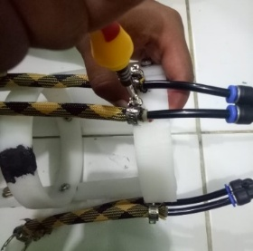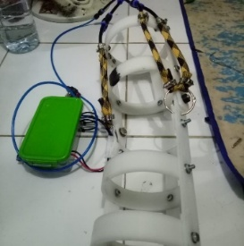

(a)

(a)

(b)

(b)

Figure 3.11. Tool assembly (a) Installation of skeletal air muscle (b) Post stroke therapy tool

The elbow trap was carried out with the recommended therapy movement for the testing experiment. The prototype test was to check the expected function of the prototype. Then the test is carried out by pairing the tool to the user, and consideration of this tool takes 2.48 (Seconds). To calibrate, adjust the airflow speed to develop the air muscles to regulate the user.

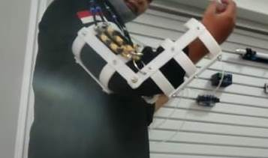

Figure 3.12. Results of post-stroke therapy

**4. CONCLUSION**

The conclusions that can be drawn from the design and manufacture of this post-stroke therapy device using an electro-pneumatic system namely:

The design and prototype of this post-stroke therapy tool have been produced using an electro-pneumatic system that delivers the therapeutic movement needed by the patient, thus providing convenience in the independent therapy process wherever it is located. The material used to manufacture the post-stroke elbow trap is nylon PE, while the primary components used for the system are a 12V DC 1CH Relay 433MHz RF Transmitter Receiver Module and a Wireless Remote. The Electro Pneumatic system includes one solenoid valve unit, two air muscle units, and one flow control unit. This Post Stroke Appliance Tool measures 220 mm in length, 110 mm in width, and 246 mm in height.

This device uses two artificial [17,18] air muscle units to lift the patient's hand weight. And also, the analysis of the strength of the frame or frame on this post-stroke therapy device concluded that it is feasible and safe at a maximum load of 30 N for each loading point with a von misses stress value of 9.613e + 05 N/mm^2 or (MPa) and minimum stress that occurs of 1.925e + 03 N/mm^2 (MPa), the maximum displacement value is 5.664e + 01 mm, and the minimum factor of safety value is 6.242e + 00 or 7.

In designing this tool, it produces 3 (three) modes of rehabilitation movement, namely mode one; elbow movement up, mode two; downward elbow movement, mode three; a combination of all modes with speed settings that are safe for stroke sufferers because the tool has a speed setting according to its capacity. This tool provides convenience and reduces the risk for people with disabilities.

**DAFTAR PUSAKA**

[1] American Stroke Association. "The Stroke Recovery Guide stroke. org." (2020).

[2] Y. Kusuima, N. Venketasubramanian, L. S. Kiemas, and J. Misbach, “Burden of Stroke in Indonesia,” International Journal of Stroke, vol. 4, no. 5, pp. 379–380, Oct. 2009, DOI: 10.1111/j.1747-4949.2009.00326.x.

[3] “Kemkes.go.id.” [Online]. Available: https://kesmas.kemkes.go.id/assets/upload/dir_519d41d8cd98f00/files/Hasil-riskesdas-2018_1274.pdf. [Accessed: 05-Dec-2022].

[4] Annisa, M.N., Matondang, A.R., Ginting, R., Penerapan Metode Kano Peningkatan Mutu, 2014

[5] Suyadi, Sunarto, 2012. Lengan Robot Sistem Pneumatik Untuk Alat Pembelajaran Aplikasi. Jurnal Teknik Mesin Politeknik Negeri Semarang. Volume 6 (2), pp. 99-105.

[6] P. Madona, “Alat Bantu Terapi Pasca Stroke untuk Tangan,” JURNAL ELEMENTER, vol. 4, no. 1, pp. 27–36, May 2018, doi: 10.35143/elementer.v4i1.1422.

[7] A. Yani and J. Kasmara, “RANCANG BANGUN MEKANIK ROBOT PHYSIO TERAPY UNTUK PENDERITA KELUMPUHAN PADA LENGAN,” Turbo : Jurnal Program Studi Teknik Mesin, vol. 1, no. 2, Dec. 2012, doi: 10.24127/trb.v1i2.648.

[8] Z. F. Rosyada, D. Nurkertamanda, and A. Dewangga, "PERANCANGAN ALAT PERMAINAN UNTUK PASIEN PASCA STROKE," J@ti Undip: Jurnal Teknik Industri, vol. 5, no. 3, pp. 151-158, Feb. 2012. https://doi.org/10.12777/jati.5.3.151-158

[9] F. Setiawan Daldiri, W. N. Khotimah, and D. Herumurti, “Rancang Bangun Aplikasi Terapi Pascastroke untuk Latihan Pergerakan Jari Tangan dengan Menggunakan Leap Motion Controller,” Jurnal Teknik ITS, vol. 6, no. 2, Sep. 2017, doi: 10.12962/j23373539.v6i2.23753.

[10] Hariandja JR, Maitimo R. Perancangan Alat Bantu Interaktif Penunjang Aktivitas Pendamping Insan Pasca Stroke. Research Report-Engineering Science. 2014;2.

[11] H. Mastrisiswadi and H. Herianto, “IDENTIFIKASI KEPENTINGAN RELATIF KONSUMEN TERHADAP ROBOT REHABILITASI PASIEN PASCA STROKE DENGAN MENGGUNAKAN CONJOINT ANALYSIS,” J@ti Undip : Jurnal Teknik Industri, vol. 12, no. 1, p. 35, Mar. 2017, doi: 10.14710/jati.12.1.35-42.

[12] L. Sherwood, Human physiology: From cells to systems. Cengage Learning, 2016.

[13] “Rangkaian Dasar Pneumatik - jatengprov.go.id.” [Online]. Available: http://pintar.jatengprov.go.id/uploads/users/trimaryono/materi/SMK_Pneumtaik_2014-10-06/Pneumtaik.pdf. [Accessed: 26-Nov-2022].

[14] Sitepu, T. (n.d.). Kajian Penggunaan Kompresor Aksial. Jurnal Dinamis. Retrieved December 5, 2022, from https://jurnal.usu.ac.id/index.php/jddtm/article/view/40

[15] I. G. Nurhayata, “PERANCANGAN KENDALI WIRELESS ROBOT BERODA DENGAN REMOTE CONTROL MP3 PLAYER BERBASIS MIKROKONTROLER AT89S52,” Jurnal Pendidikan Teknologi dan Kejuruan, vol. 10, no. 1, Jan. 2013, doi: 10.23887/jptk-undiksha.v10i1.2864.

[16] Goni, Hiskia, Jan Soukotta, and Rudy Poeng. "Perencanaan Alat Angkat Kendaraan Niaga Kapasitas 2 Ton." JURNAL POROS TEKNIK MESIN UNSRAT 2.2 (2013).

[17] K. K. Ahn and H. T. C. Nguyen, “Intelligent switching control of a pneumatic muscle robot arm using learning vector quantization neural network,” Mechatronics, vol. 17, no. 4–5, pp. 255–262, May 2007, doi: 10.1016/j.mechatronics.2006.12.002.

[18] H. Tomori and T. Nakamura, “Theoretical Comparison of McKibben-Type Artificial Muscle and Novel Straight-Fiber-Type Artificial Muscle,” International Journal of Automation Technology, vol. 5, no. 4, pp. 544–550, Jul. 2011, doi: 10.20965/ijat.2011.p0544.