Design Of An Automatic Bell Warning System For Prayer Times In A Net Centric Computing Lab
Juhariansyah¹, Ritzkal², Ade Hendri Hendrawan³
^{1, 2, 3} Net Centric Computing Laboratory, Informatics Engineering Study Program, Faculty of Engineering & Science, Ibn Khaldun University, Bogor. Indonesia
Email: juhariansyah13@gmail.com¹ , ritzkal@ft.uika-bogor.ac.id² , hendri@uika-bogor.ac.id³

Abstract—The development of science and technology is now increasingly providing convenience in everyday life. Various household appliances to office work tools use electronic devices so that human work is much lighter and easier. As an example of the use of an Arduino microcontroller which is used as an automatic bell time warning bell control. This research wants to provide a solution to these problems by giving automatic prayer times. The formulation of the problem in research is. (i) How do you design and implement a set of prayer time warning bell system tools? (ii) How do you test the series of prayer bell alert system tools? There are several research objectives including the following. (i) Can design and implement a series of prayer time warning bell system tools. (ii) Can produce a test time series of prayer time bell alarm system tools. The method in this study includes (i) analysis consisting of needs analysis, and analysis of work methods, (ii) Design consisting of Hardware Design, and Network Design (iii) Implementation consists of Hardware Implementation, Software Implementation , (iv) Testing Consists of Real Time Clock (RTC) Testing, Dfplayer Testing, i2c LCD Testing, System Testing Results, Telegram Testing. This prayer time automatic alarm bell is equipped with a dfplayer module that can play mp3, or wav, sound file formats. So the call to prayer information can play well. And this warning bell system will provide a notification to the telegram when the call to prayer time has arrived.
Keywords— Rtc, Dfplayer, Telegram

Introduction
The development of science and technology is now increasingly providing convenience in everyday life. Where all the things that are widely applied by science and technology with machines or electronics, so that human work can be done easily without having to waste energy and can shorten time. Various household appliances to office work tools use electronic devices so that human work is much lighter and easier [1]. one of them from the development of knowledge and technology is a warning system, warning system is a series of systems or tools that function to collect information that is useful to be used as a surveillance system. This warning is generally an act of providing information in an easily digestible language. For example manifested in the form of alarm or siren. Alarm or siren is only a form of information delivery because it is the fastest way.
prayer time warning systems in various places have not used many warning systems automatically, but there are still not many systems that lack the application of internet technology such as social media. Information technology has developed rapidly at this time, especially with the existence of internet networks that can facilitate communication with other parties. The last two decades, computer networks have become a revolutionary field for improvisation [2], information and data moving through cables or wirelessly, allowing computer network users to exchange documents and data [3]. Problems that occur in the campus environment of the University of Ibn Khaldun Bogor (UIKA), especially in the Net Centric Computing Labolatorium still do not use an automatic bell system. Sometimes it makes students difficult with the busy life of the campus or work and habits with behavior, confused to find out whether there is a call to prayer or not. This assumption occurs, due to lack of information on the automatic prayer bell warning time that can be given to students and lecturers at the Laboratory of the Centric Computing Net.
From these problems, to develop an automatic prayer time warning bell tool that can send notifications, it has entered prayer time using internet technology through social media telegram. Because social media telegram for now among the people most often used to communicate with others. With the development of information using telegraph social media technology, you can see when the call to prayer has arrived. Based on this background, it provides a solution by designing and implementing the tool for the final project entitled "Design Of An Automatic Bell Warning System For Prayer Times In A Net Centric Computing Lab". the purpose of this research is (i) Can design and implement a series of prayer time warning bell system tools and (ii) Can produce shipments of prayer time warning system bell notification units.

Method
This research method is a stage of the research flow in compiling a directed idea and related to the goal. The method used in this study is as follows.

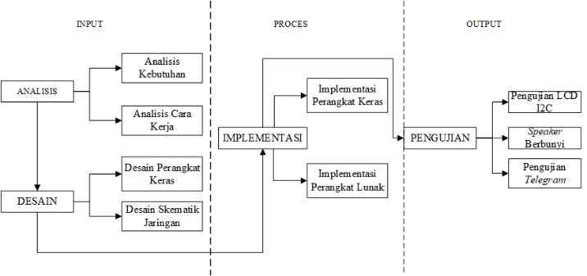
Figure. 1. Stages of the Research Flow

  - Movement system design

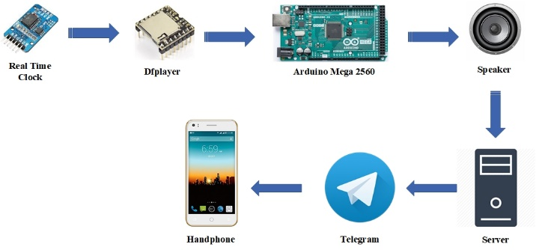

Figure. 2. How the System Works
Figure 2 explains how the system works in this study starting from the hours or hours that have been set using Rtc, Dfplayer to enter sound and audio files, then Arduino Mega receives data and will process it from Dfplayer. The speaker will sound according to the source code that has been created. Placed next the set of tools will send a notification to a private telegram whose source code or php has been stored on the server.

  - System Schematic Design

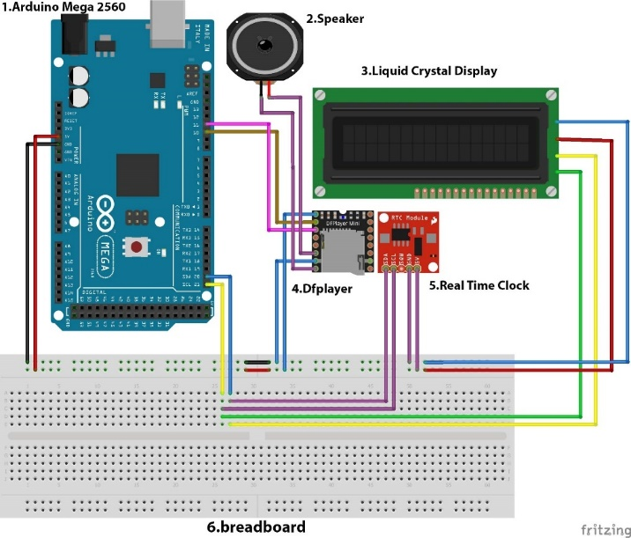
Figure. 3. Hardware Schematic Series

In Figure 3 the circuit is divided into several stages namely, the first stage of the dfplayer schematic circuit is connected to Arduino at pin 7.8, GND, 5V which consists of pin 7 to Tx (transmitter), pin 8 to Rx (receiver), GND pin and pin 5V, the two Arduino schematic circuits are connected with RTC (real time clock) on the SDA 20 pin (serial data), SCL 21 (serial clock), GND, 5V consisting of SDA 20 SDA, SCL 21 SCL GND, 5V, all three schematic circuits Arduino is connected with LCD (liquid crystal display), the output pins of Arduino Mega that will be used are GND, VCC, SDA, SCL pins which consist of GND, VCC, SDA, SCL.

III IMPLEMENTATION
- System Flow
There are several explanations on how the motion systemworks based on their respective functions on each device and material that has been run. The system workflow is shown in Figure 4.

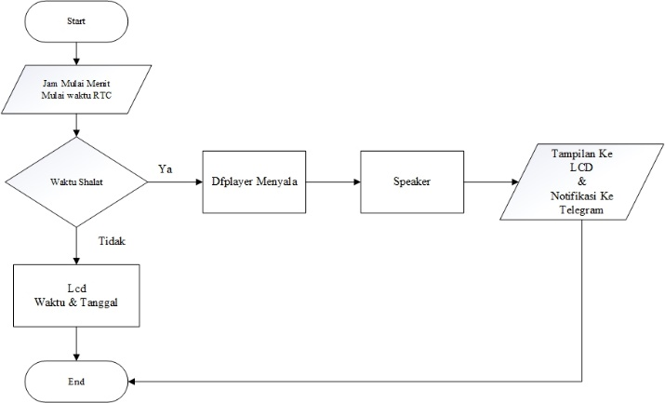
Figure. 4. System workflow
- Software Implementation
So that both devices can communicate in C language, which is the Arduino programming language, it needs an RTC library, the library is the library of RTC used in this study. namely by connecting between Arduino Mega 2560 with RTC using a jumper cable as for the Arduino source code program is as follows.
#include <DS3231.h>
DS3231 rtc(SDA, SCL);
void setup() {
// Setup Serial connection
Serial.begin(9600);
// Initialize the rtc object
Input pins used in real time clock (RTC) on Arduino are GND / GND pin, 5V / VCC, SDA20 / SDA, and SCL21 / SCL.

Testing
At this stage that is testing the automatic alarm bell alert system. This test is done so that the tools are made in accordance with the expected objectives.
- Rtc (Real Time Clock)

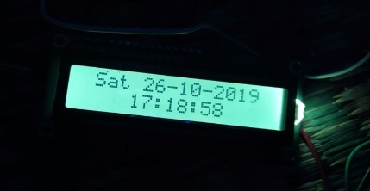

Figure. 5. Testing Before prayer time

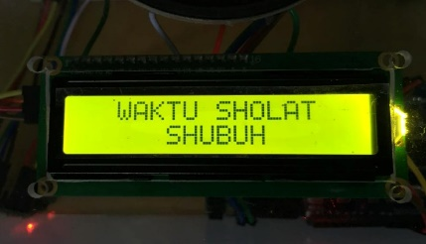
- LCD (Liquid Crystal Display)
Figure. 6. LCD testing

- Telegram
This stage is testing the telegram. This test is done only to send a notification message automatically to the telegram if the prayer hour has arrived.
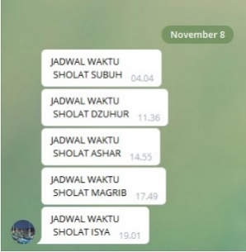

Figure.7. Telegram Testing

Figure. 7. is a telegram test when the hours are according to the automatic schedule system that has been created, the tool will send notifications via telegram.

IV. CONCLUSION
based on the research conducted, the result and discussion in the previous chapter can be concluded as follows:
1. Utilization of Arduino microcontroller as a core data processing tool in the design of the prayer time warning bell system.
2. Automatic prayer bell alert system will send a notification to the telegram when the prayer time has arrived.
REFERENCES
- Handaya Tri Utomo1, Slamet Winardi2, Wiwin Agus Kristiana3 “Rancang BangunBel Sekolah Otomatis BerbasisArduinoUno” Universitas Narotama Surabaya
- Ade Hendri Hendrawan, “Remote Iptables dan intrusion detection system (IDS) dengan Snort berbantuan sms gateway pada jaringan fakultas Teknik Universitas Ibn Khaldun Bogor,” 2017
- Ritzkal,”Manajemen Jaringan Untuk Pemula”, 1st,ed Bogor,UIKA Press,2018
- Syaiful Akmal 2018 "Implementation of Availability System for Automatic PARKING Slot Assisted Microcontroller USING Arduino Uno R3
- Hasanuddin Muhamad 2017 "Infusion Monitoring System Using Arduino Mega 2560"
- Arie Linarta1, Nurhadi 2018 "Automatic School Bell Application Based on Arduino Equipped with Sound Output"
- Nida Nabilah, Hannif Izzatul Islam, Dendy Handy Saputra, Gagut Mughni Pradipta, Sofyan Said, Ade Kurniawan, Heriyanto Syafutra, Ridwan Siskandar, Irzaman "Making Automatic Prototype Lights for Energy Savings Based on Undu Arduino in the Physics Department of Fmipa Ipb"
- I Gusti Agung Putu Raka Agung, I Gusti Ngurah Janardana Ferry, Ardiansyah 2011 "Design of Automatic School Bell Based on AVR Microcontroller Based Atmega8"
- Indri Neforawati, Dinabilah Adani, Eka Rahmawati, Ayu Fitriana, 2016 "The Use of Android-Based Notifications to Monitor Treatment on Automatic Aquaponic Systems Using the ATmega 2560 Microcontroller"
- Diki Rahsidin "Baby Incubator Temperature and Humidity Monitoring System with Whatsapp Technology"
- Bayu Ramadhan "Warning System Notification Model of a Microcontroller-Based Railway Crossing"

