Monitoring the Environmental Temperature of the Arduino Assistance Engineering Faculty Using Telegram

M Wujut Hariyanto¹, Ade Hendri Hendrawan², Ritzkal³
^{1, 2, 3,} Laboratorium Net Centric Computing, Program Studi Teknik Informatika, Universitas Ibn Khaldun Bogor, Indonesia
Email: ariagijuliano@gmail.com, ²hendri@uika-bogor.ac.id, ³ritzkal@ft.uika-bogor.ac.id³

Abstract— The temperature of the air is the state of hot air caused by the heat of the sun. Factors that affect the amount of solar heat received by the earth are the state of the cloud, the state of the surface plane, the angle of the sun, and the length of the sun's exposure. The heat of the earth's surface by solar radiation affects the heat of the air. Earth's surface air temperature varies because sunlight spreads unevenly on the surface of the earth. The formulation of the problem in research is. (i) How do you design a system that can measure the temperature of the engineering faculties? (ii) How do you get the temperature information from the Faculty of Engineering's environmental temperature? There are several research objectives including the following. (i) Design and implement a series of tools that can measure the ambient temperature of the engineering faculty. (ii) Can provide information about the environmental temperature of the engineering faculty via telegram. The methods in this study include (i) Analysis consisting of needs analysis, and analysis of how it works, (ii) Implementation consists of hardware implementation, software implementation, (iv) Testing consists of testing the DHT11 sensor, Testing of LED lights, Testing of LCD i2c, Ethernet Shield Test, Telegram Test, Integration Test of LED components when the temperature is below <= 25˚C the green LED will ON the red LED is OFF which states it is below cold temperature and if the temperature is above> = 30˚C Then the red LED will be ON the green LED OFF states that the temperature is hot. The second test is to compare digital and analog sensors. Value comparison of digital and analog temperatures 1.1˚C and humidity 23.1% RH. And testing the system per day in which the value produced the highest temperature reaches 34˚C and the lowest temperature reaches 23˚C.

Keywords: Monitoring, Temperature, Environment, Telegram

Introduction
The temperature of the air is the state of hot air caused by the heat of the sun. Factors that influence the amount of solar heat received by the earth are the state of the cloud, the state of the surface plane, the angle of the incident ray, and the length of the sun's irradiation. The surface heat of the earth by solar radiation affects the heat of the air. Air temperatures on the surface of the earth vary because sunlight spreads unevenly on the surface of the earth. [1]
The campus environment is also called the ‘Learning society‘ environment. During their studies, students generally spend their days in the campus environment. Various forms of activities carried out by students in the campus environment, so the existence of off-campus space becomes important meaning for students. In the off-campus space, students can be seen actively communicating among themselves, sharing information, holding group discussions, just holding hands, or doing independent individual tasks. After the recovery, which is mostly carried out in closed lecture halls, students are in dire need of outdoor spaces that are open and informal, to eliminate boredom and invigorate the body and mind, so that they can resume their lecture activities with better conditions. [2]
Based on this background the implementation of Arduino Uno ATMega 328 assisted temperature monitoring system is implemented. In this study, we want to provide information on the temperature of the engineering faculties in which the system uses telegram so that the series of devices can be connected to the network using LAN cables. LAN must not only be able to function in its own operational area but also must be able to interact with LAN networks, for example with other corporate networks, the Internet and others. [3] For the time being the solution that can be provided is the LCD (Liquid Crystal Display) sensor that has been configured using a microcontroller when the sensor detects the ambient temperature of the engineering faculty will send temperature information to the telegram. The purpose of this study is (i) Designing and implementing a series of tools that can measure the temperature of the environment of the engineering faculty, (ii) Can provide information on the environmental temperature of the engineering faculty via telegram.

II. METHOD
This research method is a framework for carrying out an action or thinking framework to arrange an idea that is directed and related to the aims and objectives. The method used in this study uses a framework.

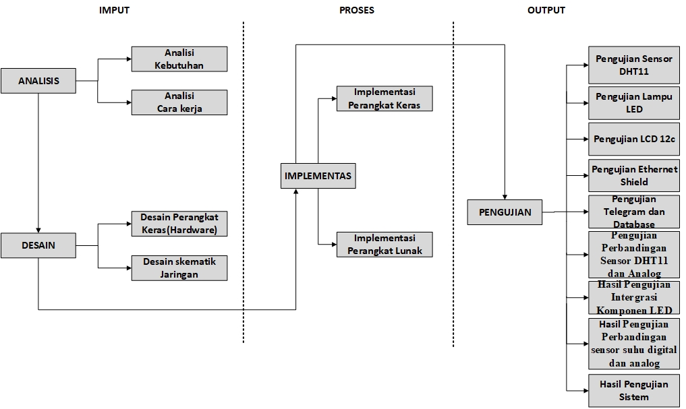
Figure 1 Framework for Thinking

Analysis
In this initial stage, an analysis of the requirements needed to build the system is carried out. At this stage what is done is to analyze why this research was conducted. The analysis phase is divided into two things, namely the needs analysis and how to work analysis.
- Requirements Analysis
In the needs analysis phase to be carried out, there are several hardware devices to support research into the implementation of environmental temperature monitoring techniques.

Table 1 Hardware Requirements
No | Nama Hardware
1 | Arduino UNO
2 | Ethernet Shiled
3 | Sensor DHT11
4 | Breadboard
5 | LCD 16x2
6 | Kabel Jumper
7 | Leptop/PC
8 | Kabel power

- Analysis of How the System Works
In the process of analyzing the workings will be explained the workings of the system that runs in this study. explain how the system works in this study starting with the DHT11 sensor detecting the ambient temperature, then the DHT11 sensor will send a signal to Arduino and then display the temperature on the LCD in the form of text. Then when the ambient temperature is not in accordance with the provisions, the system will continue the information to the telegram via the ethernet shield network then send the information to the server, from the server will be forwarded to the telegram bot that has been set, will automatically give notification to the cellphone via the telegram messeger.

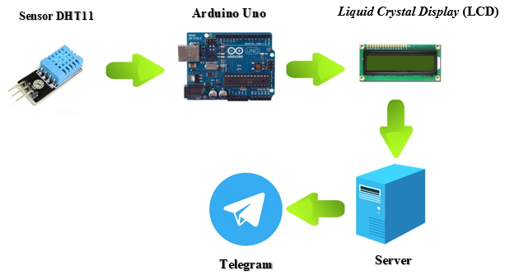
Figure 2: How the System Works

  - Design
This stage of design is carried out to provide a structured description of the planning in hardware and in the network needed. The design process in hardware design uses block diagrams and schematic circuits. The design is divided into several stages, namely:
- Hardware Design
The hardware design used in the study was carried out, the design was made in the form of block diagrams and schematic circuits to illustrate connected devices.
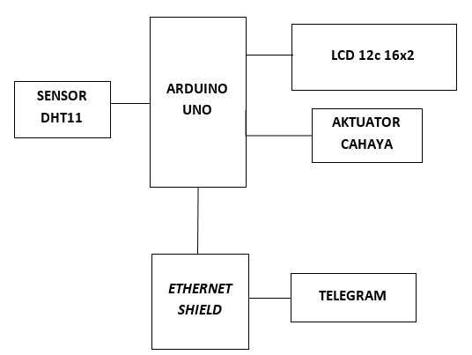
Figure 3 Overall System Block Diagram

- Schematic Diagram
In the stages of designing schematic diagrams related to research, ranging from schematic diagrams of whole systems, schematic diagrams of DHT11 sensors with Arduino Uno, Arduino Uno with LCD, Arduino Uno with Ethernet Shield.

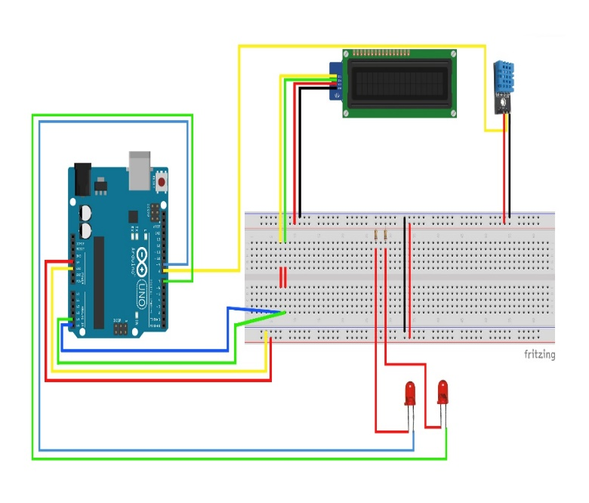
Figure 4 How the System Works
- Network Design
Network design is used in research, network design aims to provide an overview of network processes and data communication in research.
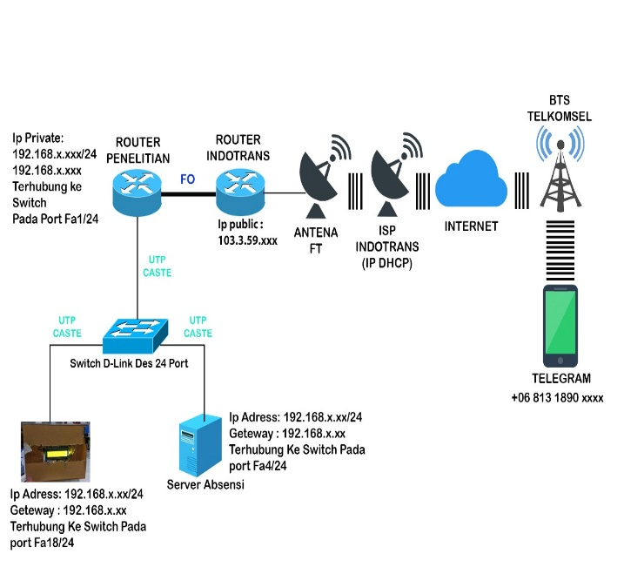
Figure 5 Schematic Design of Networks

III. IMPLEMENTATION
  - Implementation
The implementation phase implements everything that has been designed in both hardware design and network design. The stages are divided into two stages, namely the implementation of tools and the implementation of Telegram notifications.
- System Flow
At the implementation stage, namely the assembly or installation of all components that were carried out previously implemented on the system in full. Implementation of the program aims to ensure that the system that was designed before is running well or not. This research is generally described using the following Flowchart.

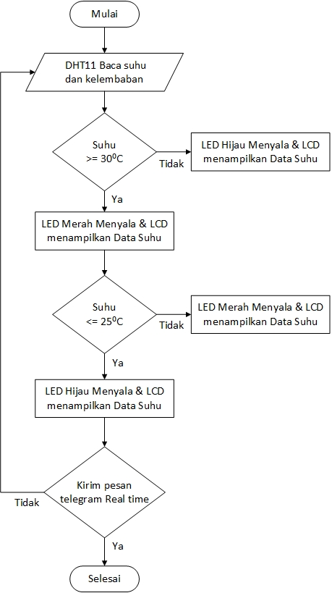
Figure 6 System Flowchart
Figure 6 is the overall flowchart that will be applied. flowchart consists of several parts, each part is divided based on work processes. Following are the flowchart system parts

- Software Implementation
In order for the two devices to communicate in C language which is the Arduino programming language Required Library <DHT11>, the Library is the Library of DHT11 used in this study. Namely by connecting between Arduino with predetermined, connect other parts of the Jumper cable to DHT11. The Arduino source code program is as follows

void setup() {
Serial.begin(9600);
lcd.begin(16, 2);
pinMode(LEDmerah, OUTPUT);
pinMode(LEDhijau, OUTPUT);
Ethernet.begin(mac, ip, server, gateway);
}

void loop() {
int kelembaban = dht.readHumidity();
int suhu = dht.readTemperature();
// set the cursor to (0,0):
lcd.setCursor(0, 0);
lcd.print("Suhu: ");
lcd.print(suhu);
lcd.print(" C");
lcd.setCursor(0,1);
lcd.print("Kelembaban: ");
lcd.print(kelembaban);
lcd.print("%");
Serial.print("Suhu: ");
Serial.print(suhu);
delay(1000);

if (suhu >= 30) {
digitalWrite(LEDhijau, LOW);
digitalWrite(LEDmerah, HIGH);
} else if ( suhu <= 25) {
digitalWrite(LEDhijau, HIGH);
digitalWrite(LEDmerah, LOW);
}
}

  - Testing
After designing and installing each component, then testing or testing each hardware contained in the temperature monitoring in this test is explained in the following sub-chapter
- DHT sensor
In this temperature monitoring system. DHT11 sensor is an input sensor. This sensor is the only input sensor. In testing the sensor is placed next to the box and reads the temperature and humidity in the environment of the engineering faculty. The results of this test are DHT11 sensor reading temperature with a value of 21 nilaiC and humidity of 65%. For the results of testing the DHT11 sensor can be seen in Figure.

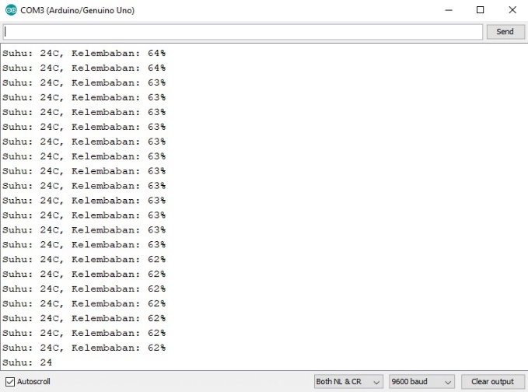

Figure 10 Shiled Ethernet testing
- LED light testing
The testing of these LEDs aims to find out the output produced by the LED when the system is running. When the green LED lights up it indicates cold temperatures and while the red LED turns on it indicates heat conditions. For the results of testing the LEDs can be seen in the picture.
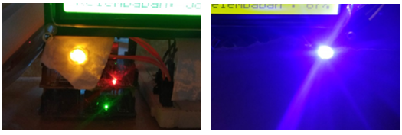
Figure 8 LED Testing

- Testing i2C LCD
This LCD test is to find out how the temperature and humidity of the engineering faculties displayed by the LCD. In this test the LCD can display the results of the DHT11 sensor with a temperature value of 26 ° C and humidity of 54% RH. For test results can be seen in Figure 9 LCD Testing.

Figure 9 LCD testing

- Shiled Internet Testing
In this Shiled ethernet test is conducted to find out whether ethernet Shiled is connected or not on the internet network so that it can send temperature and humidity data. To see it by looking at the serial monitor.

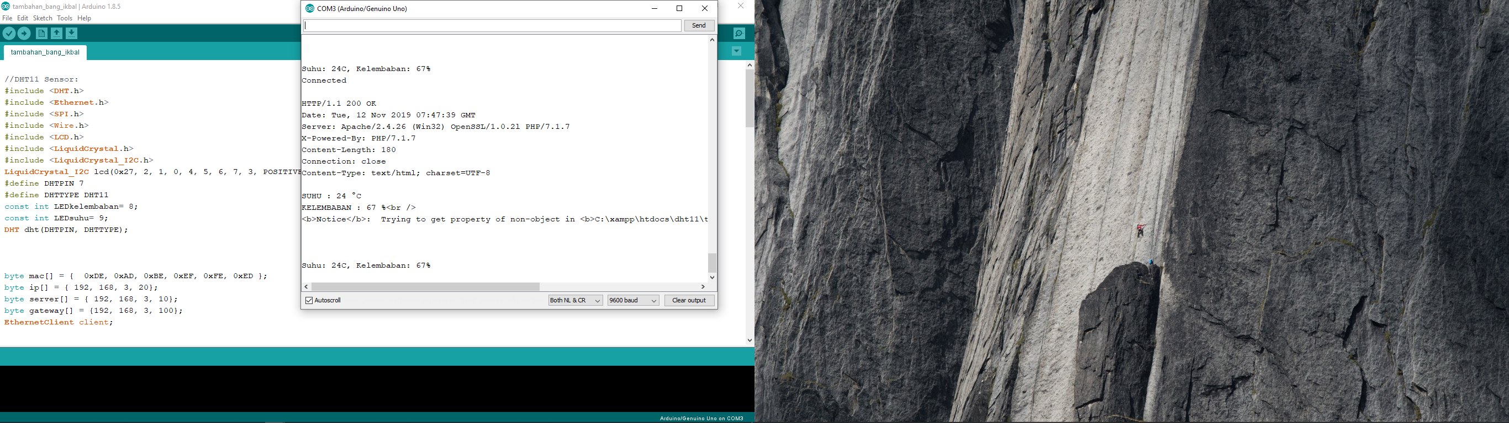
Figure 10 Shiled Ethernet testing

- Telegram and Database Testing
This stage is testing the telegram. This test is carried out as a notification. The system will send a telegram message in the form of temperature text that is obtained and will be saved in a database that has been made can be seen in the picture.

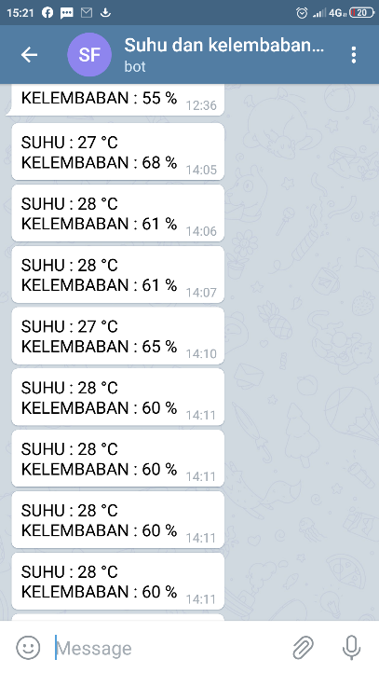
Figure 11 Telegram Testing
The following is a localhost interface test results from monitoring the temperature of the Arduino Assistance Engineering Faculty using telegram stored in MySQL.

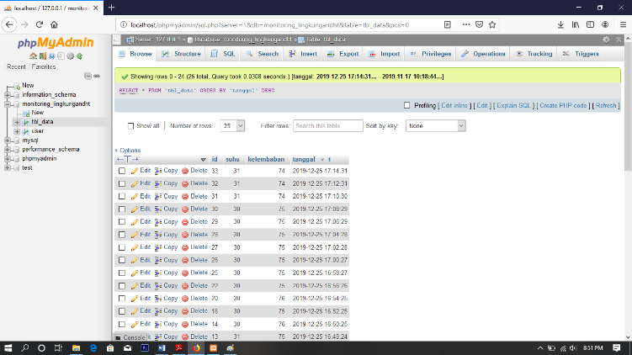
Figure 12 MySQL Database Interface

- LED Component Integration Test Results
Table Describes the integration between LED components consisting of DHT11 green leds, red leds. When the temperature is below <= 25˚C the green LED will ON the red LED is OFF and if the temperature is above> = 30˚C the red LED will ON the green LED is OFF. To see the results of the system testing can be seen in Table 2 results of the notification system integration test components.

Table 2 Test Results for LED Component Integration
Suhu | LED Hijau | LED Merah
<=25˚C | ON | OFF
>=30˚C | OFF | ON
- System test results
During the testing phase of the DHT11 Sensor, which was conducted in December in one week, starting from Sunday to Saturday in the Faculty of Engineering environment, the results of the tests carried out at the highest temperature reached 34 ° C and the lowest temperature reached 23 ° C.
Table 3 System Testing Results
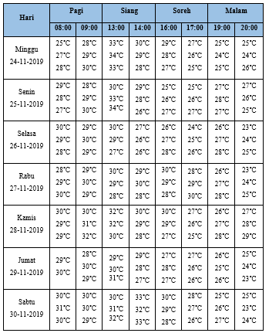

IV. CONCLUSION
Based on the research conducted, the results and discussion in the previous chapter can be concluded as follows:
- The physical design of the Faculty of Engineering's environmental temperature monitoring has been carried out. The series of tools can be used to determine the ambient temperature of the engineering faculty.
- Obtaining the results of information using telegrams that can help determine the temperature in the engineering faculty environment.

REFERENCES

- Jockie Zudhy Fibrianto, Mochamad Hilmy, 2018 Efektifitas
Pembayangan yang Dihasilkan Pohon dan Bangunan di Koridor Jalan
Perkotaan Untuk Mencapai Kenyamanan Termal,Politeknik Negeri
Pontianak, Pontianak, Indonesia.
- Mira Dewi Pangestu,2009, Pengaruh Penataan Tapak Terhadap
Kenyamanan Termal di Ruang Luar bangunan Rektorat Universitas
Katolik Parahyangan Bandung.
- Ritzkal, 2018. MANAJEMEN JARINGAN UNTUK PEMULA.
Bogor: UIKA PRESS
- Ferdy Erwan,Abdul Muid,Irma Nirmala,2018, Rancang Bangun
Sistem Pengukur Cuaca Otomatis Menggunakan Arduino Dan
Terintegrasi Dengan Website, Universitas Tanjungpura.
- Universitas Ibn Khaldun Bogor,2019,Sistem Monitoring Suhu dan
Kelembaban Inkubator Bayi dengan Teknologi Whatsapp, Universitas
Ibn Khaldun Bogor.
- Ferdy Erwan,Abdul Muid,Irma Nirmala,2018, Rancang Bangun
Sistem Pengukur Cuaca Otomatis Menggunakan Arduino Dan
Terintegrasi Dengan Website, Universitas Tanjungpura.

