VEHICLE SECURITY SYSTEM USING SMS (Short Message Service) AS A DANGER WARNING IN MOTORCYCLE VEHICLES

Nuraeni Puji Astuti^{1,*}, Ritzkal², Ade Hendri Hendrawan^{3,} ,Bayu Adhi Prakosa⁴
^{1,2,3,4}Laboratorium Net Centric Computing, Program Studi Teknik Informatika, Universitas Ibn Khaldun Bogor, Indonesia
Email: nuraenipujiastuti@gmail.com

ABSTRACT
Currently the security system is widely used even more so on motorcycle vehicles to prevent theft, because today there are so many modes of motorcycle theft, especially in crowded places, public parking or on the home page. Therefore research conducted in this field about vehicle safety systems uses SMS as a hazard warning

on motorcycle vehicles. This security system uses Module Sim 800L function to send warning messages to the owner of a motorcycle vehicle, and use Module GPS neo 6 to find out the position of a motorcycle vehicle use google maps, and using the C programming language.

Keywords: Module Sim 800L, Module GPS neo 6, Motorcycle, google maps

- INTRODUKTION
Private vehicles are valuable assets for everyone. Each vehicle owner usually has a way, each to protect the vehicle from damage or loss, with many cases of motor vehicle theft in Indonesia making the vehicle owner to always be vigilant. Moreover, the missing vehicle will be difficult to find, one reason is the difficulty to track the whereabouts of the vehicle during the theft.
Various vehicle owner's efforts to improve the safety of motorbike vehicles that are being parked, both in the public parking area and on the home page, so as not to easily trigger theft. Then the author will discuss the results of a vehicle safety system research that can send a warning to the owner of a motorcycle vehicle if the motorcycle is stolen. Besides that the device is equipped with GPS so the owner can see or know the position of the motorcycle vehicle.
Referring to the background of the problem, the formulation of the problem of this research is how to implement a security system on a motorcycle? How do you get the results of testing on a motorcycle security system? The purpose of this study is to produce a tool that is able to track the location of a lost vehicle with a GPS module neo 6 and can produce a software design of a tool that can display the location of the vehicle in the form of a map on the google maps application on the smartphone of the vehicle owner (user).
Referring to the problem formulation and research objectives, this study aims to create a vehicle safety system using SMS as a hazard warning on motorcycle vehicles.

- METHODS
The making of this security system was carried out in the Net Centric Computing laboratory in the Informatics Engineering Study Program at UIKA Bogor and the testing was carried out at the UIKA Campus in Bogor.
The initial stage of this research is to make it easier for vehicle owners to track down stolen or lost vehicles. The diagram below explains the workflow of analysis, design, implementation, and testing.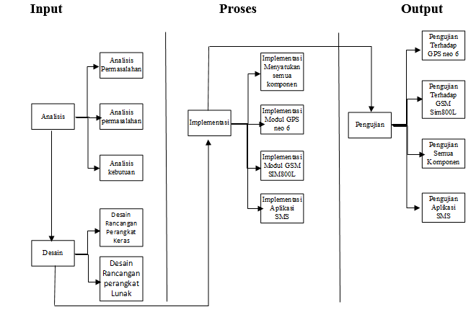
Figure 1. Research Methods
- Analysis
- Problem Analysis
In this stage, an analysis of the problems at the beginning and proposed updates on this research.
- Requirements Analysis
This needs analysis will require a tool allowance that will make it easy to resolve existing problems.
- Design
- Hardware Design
Make a series of tools that will be used on each device in accordance with the design that will be built in the vehicle safety system.
- Software Design
This stage makes C programming language which will be used to input the sim 800L module The GPS neo 6 to produce output on the vehicle security system.
- Implementation
The process of implementing everything that has been designed both software and hardware design.

- IMPLEMENTATION
The test results are divided into several sections including:
- Testing Module Sim 800L
- Testing Module GPS neo 6
- Testing configuration the GPS
- Testing The SMS application using the app inventor.
- Testing the entire tool.

- Test Results Module Sim 800L
- Testing module Sim 800L
In this test carried out aiming to test whether the module sim 800L work in accordance with the specifications that have been applies. As shown in the picture below.
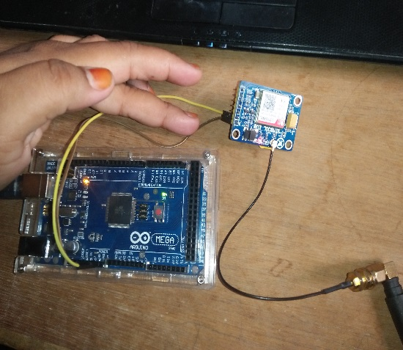
Figure 2. Test Conditions Sim 800L
In the picture above is a test of the module sim 800L aims to send a hazard warning message when the vehicle is on.
- Module Sim 800L voltage test results
This system is run requires a voltage from the microcontroller to function properly, her is a table of module sim 800L test results.
Table 1. Module Sim 800L voltage test results
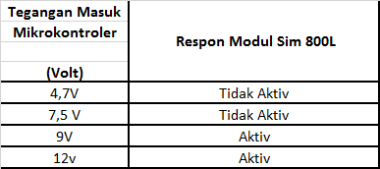
From the test results in the above table, it can be analyzed that the module sim 800L will be active when the voltage of the microcontroller.
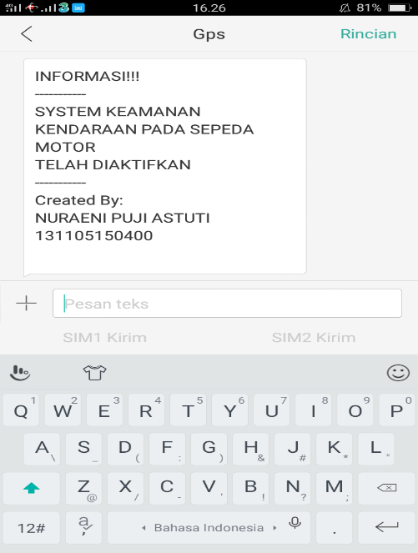
Figure 3. Test Results Sim 800L

- Testing Module GPS neo 6
This stage is to find out whether the GPS neo 6 is functioning properly or not and can receive GPS signals or not, like the picture below.
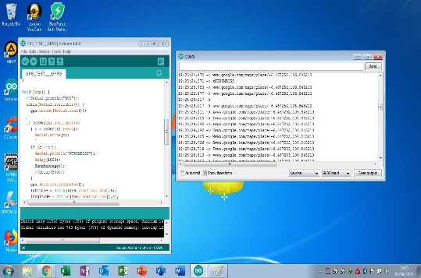
Figure 4. Testing GPS
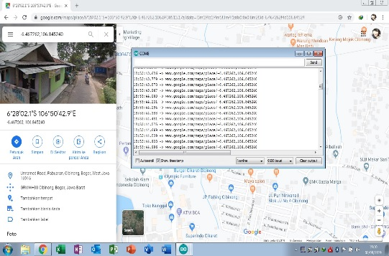
Figure 5. Test Result GPS
In Figure 5 this is the result of testing the Module GPS neo 6 aims at whether the coordinates are accurate or nit, and therefore requires this test.

- Testing GPS Configuration
This test is conducted to determine whether GPS after being installed on a motorcycle vehicle can function optimally, with the voltage through the accu ,otorcycle.
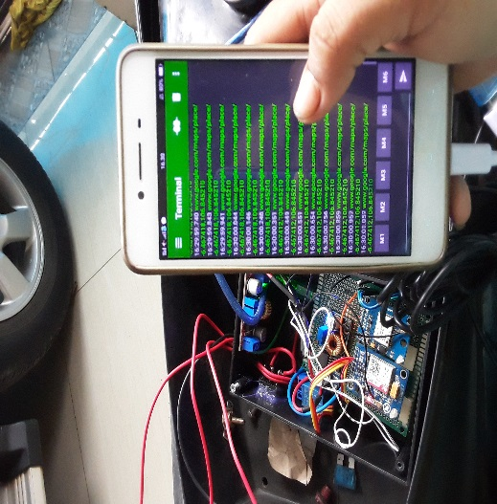
Figure 6. Configuration Check

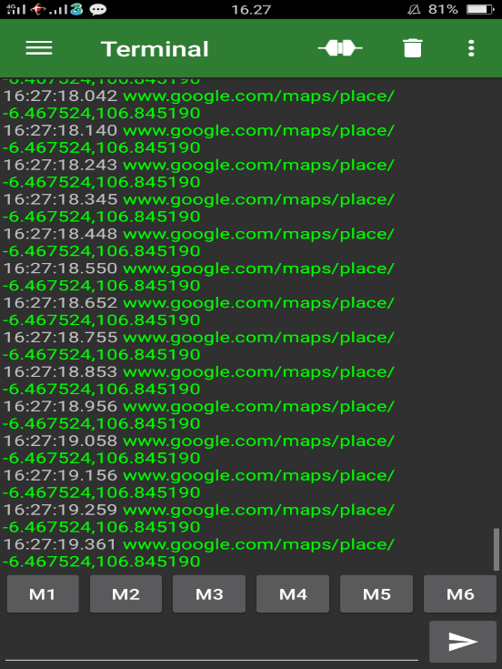
Figure 7. Testing GPS Configuration

- Testing the SMS application using the app inventor
Inventor application is a tool to create fun applications from this tool, because it is based on visual block programming, so we can create applications without any source code.
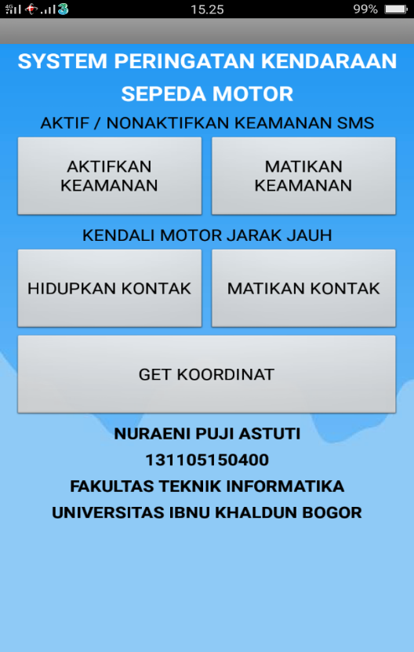
Figure 8. Application SMS
The above application is an sms application that is connected to arduino, Module Sim 800L and Module GPS neo 6.
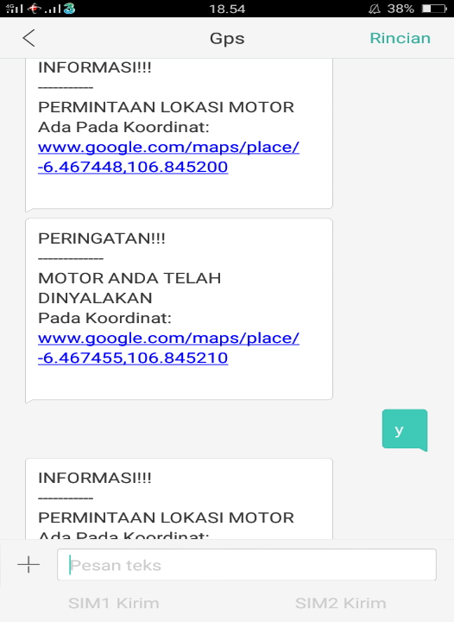
Figure 9. app inventor test results
In the picture above is the result of using the Inventor app that is connected to the module sim 800L and GPS neo 6.
5. Overall tool testing
Test results for the entire tool. The results of testing the delay time, the farther the distance between applications with propeder will result in greater delay time, this is because the distance traveled by the data sent from the server to the SMS application or from the SMS application to the server is getting longer and affects the operator signal strength received by the smartphone, where the operator signal power is getting smaller when the distance between the smartphone and the ISP is getting further away.
Table 2. The results of calculating the delay distance
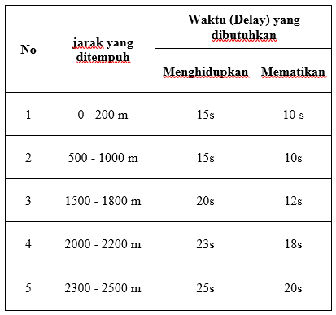
- The 40 m distance requires a delay of about 10s when turning off the motorcycle and 15s when turning on the motorcycle, in the picture below.
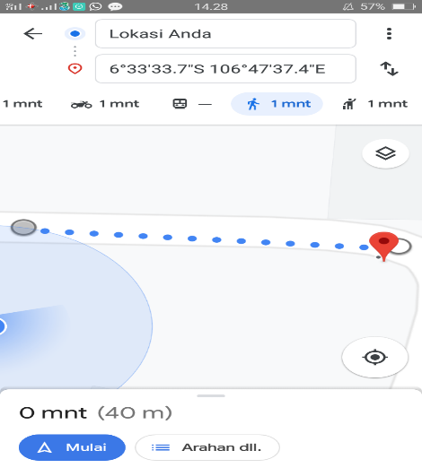
Figure10. Testing the measurement of the displacement distance of 40m
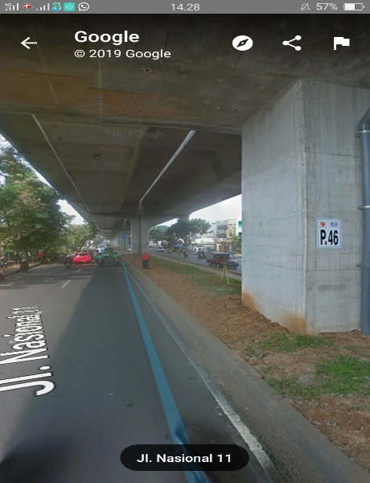
Figure 11. GPS testing at a distance of 40m
- The 1,200 m distance requires a longer delay than the 40 m distance. Delay time taken when turning off the engine 20 s and when starting the engine 25 s.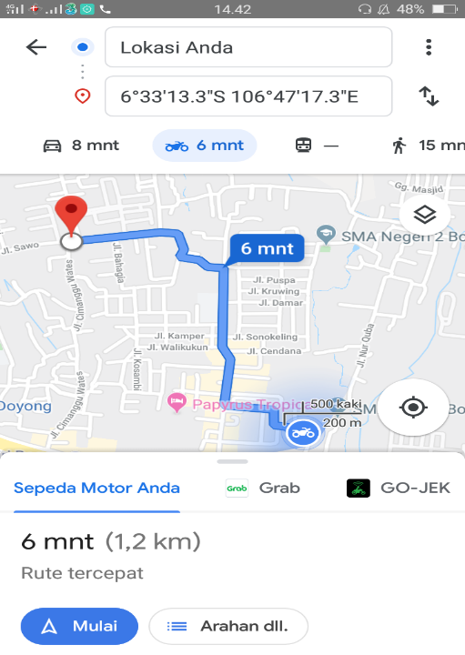
Figure 11. Testing the measurement of the distance of 1200m
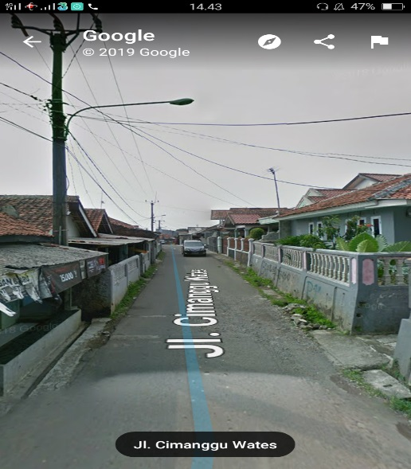
Figure 12. Testing GPS at a distance of 1200m

- CONCLUSION
Based on the results and discussion, the following conclusions can be drawn:
- The hardware manufacturing of the vehicle security system using SMS as a hazard warning on motorcycle vehicles was successfully made with arduino uno supported by the software inside and combined with several series of mutual support.
- The making of this software uses a programming language C system that is made to work well..

REFERENCES
- Maxmanroe. (2019, september 1). Pengertian Sistem: Definisi, Unsur-Unsur, dan Jenis-Jenis Sistem. Diambil kembali dari pengertian sistem: https://www.maxmanroe.com/vid/manajemen/pengertian-sistem.html. diakses tanggal 15 september 2019
- Kurniadi, M. R. (2019, 12). Arti Peringatan Menurut KBBI. Diambil kembali dari lektur.id: https://lektur.id/arti-peringatan/
- wikipedia. (2019, sepetember 1). pengertian sepeda motor. Diambil kembali dari sepeda motor: https://id.wikipedia.org/wiki/Sepeda_motor. diakses tanggal 15 september 2019
[4] Advernesia. (2019, november 9). Pengertian Perangkat Keras Komputer dan Fungsinya. Diambil kembali dari advernesia.com: https://www.advernesia.com/blog/komputer/pengertian-perangkat-keras-komputer-dan-fungsinya/
- Sulistiyanto, N. (2008). PEMROGRAMAN MIKROKONTROLER R8C/13. Jakarta: PT Elek Media Komputindo.
- Arduino. (2019, september 1). Arduino Uno: Arduino Uno Robot Line Follower Berbasiskan Sensor Infra Merah. Diambil kembali dari book: https://books.google.co.id/books?id=I_VvDwAAQBAJ&printsec=frontcover&hl=id#v=onepage&q&f=false
- robot, k. (2019). Belajar Pemrograman Dasar Arduino! https://kelasrobot.com/belajar-pemrograman-dasar-arduino/.
- kho, d. (2019). https://teknikelektronika.com/pengertian-relay-fungsi-relay/. Pengertian Relay dan fungsinya, 1.
- FADILASARI, R. (2019, agustus 31). Tinjauan Pustaka 2.1 Mikrokontroller. Diambil kembali dari Arduino Development Environment: http://webcache.googleusercontent.com/search?q=cache:IFUaZ_GXW0MJ:eprints.polsri.ac.id/4405/2/File%2520III.pdf+&cd=1&hl=id&ct=clnk&gl=id
- ANISA, O. (2017). RANCANG BANGUN PENGUKUR KADAR GAS METANA PADA LAHAN GAMBUT MENGGUNAKAN SMS GATEWAY DAN SENSOR MQ4 berbasis Arduino. eprints.polsri.ac.id, 5. Diakses 20 september 2019

