Synthesis of LQR controller based on BAT algorithm for Furuta pendulum stabilization
Nguyen Xuan Chiem¹, Le Tran Thang^{2*}
¹Department of Automation and Computing Techniques, Le Quy Don Technical University, Hanoi, Vietnam,
²Controls, Automation in Production and Improvement of Technology Institute, Hanoi, Vietnam
Email: ¹ chiemnx@mta.edu.vn, ² ltranthang@gmail.com
*Corresponding Author

Abstract—In this study, a controller design method based on the LQR method and BAT algorithm is presented for the Furuta pendulum stabilization system. Determine the LQR controller, it is often based on the designer's experience or using trial and error to find the Q, R matrices. The BAT search algorithm is based on the characteristics of the bat population in the wild. However, there are advantages to finding multivariate objective functions. The BAT algorithm has an improvement for the LQR controller to optimize the linear square function with fast response time, low energy consumption, overshoot, and a small number of oscillations. From there, we can find the matrices Q, R and these matrices still satisfy the Rickety equation. The controller with optimal parameters is verified through simulation results with different scenarios. The performance of the proposed controller is compared with a conventional LQR controller and implemented on a real system.
Keywords— LQR method; BAT algorithm; Furuta pendulum; Riccati equation; Controller

Introduction
The Furuta pendulum, or inverted pendulum, consists of a control arm that rotates in the horizontal plane and a pendulum attached to that arm that rotates freely in the vertical plane. It was invented in 1992 at the Tokyo Institute of Technology by Katsuhisa Furuta and his colleagues [1] – [4]. This system is typical of unstable and nonlinear systems of interest in classical and modern control theory. The large instability and nonlinearities are due to gravity and the coherence arising from the Coriolis force and the centripetal force. Furuta pendulum is a popular object in laboratories, used to test and prove linear and non-linear control laws.
The inverted pendulum system has been studied to simulate the dynamics of many processes when designing the controller [5] such as: balancing rockets when launching vertically, stabilizing oil rigs at sea, stabilizing aircraft take-off and landing, and ship cabin stability... The inverted pendulum model is a mechanical system that lacks actuators with fewer actuators than the number of degrees of freedom of the system. There have been many domestic and foreign studies to design control laws and control methods for the inverted pendulum system. In the study [7], [8] the traditional PID controller and its variants are used. But the nature of this controller is an error controller, so when designing, it will separate the system into 2 subsystems with separate control signals. In the studies [9], [10], a fast-acting sub-optimal control law has been presented to satisfy the system, but the control law is quite complicated. In the study [11] – [29] presenting the method of synthesizing the SMC sliding controller, linear feedback, and Backstepping for this system, the simulation results show the effectiveness of the designed control rules. The control rule design method based on fuzzy control theory and neuron network is presented in the works [30] – [34].
The LQR method is a classic method in linear controller design based on square function optimization. Studies [35] – [48] have presented the results of this controller for an inverted pendulum system. The optimal LQR controller is designed based on modeling the system structure; The accuracy and efficiency of the LQR controller have been verified, but it is difficult to determine the weight matrix 𝑄 and 𝑅. Many studies [49] – [53] have presented the option of choosing these matrices, but it is very difficult to simultaneously ensure the satisfaction of the objective function and satisfy some more criteria. This paper uses the BAT algorithm, which is one of the PSO algorithms, but it has advantages for multivariate problems [54] – [61]. The BAT algorithm learns from the movement of bats in searching for prey and avoiding obstacles to build a method to find the extrema for the objective function [62] – [64]. In terms of the mathematical model of the system, the LQR controller is designed based on swarm optimization and takes advantage of the searchability of the swarm algorithm (BAT) to optimize the matrices. 𝑅 of the LQR controller. In addition, in the way of updating matrix parameter values, we use weighting techniques, to incorporate the designer's experience in the algorithm's search. The purpose is to obtain the globally optimal solution of the matrices and for the LQR controller to design the optimal state feedback control matrix and overcome the disadvantages based on experience, trial, and error in selecting the matrix 𝑄 and 𝑅 of the controller. Controller results are illustrated by simulation on software and experimental results on real systems. The effectiveness of the optimized control law is shown when compared with some conventional LQR control rules and realized on embedded systems.

MATHEMATICAL MODEL OF FURUTA PENDULUM
The Furuta pendulum is composed of a rotating arm attached to a DC motor and a pendulum mounted on the top of the arm, having the structure shown in Figure 1. The pendulum moves as an inverted pendulum in a plane perpendicular to the rotating arm. Angle α is the angle of rotation of the arm, angle β is the angle of deflection of the pendulum, these two variables are used as generalized coordinates to describe the rotating inverted pendulum system. Parameters of the inverted pendulum model used when simulating and investigating the system are approximated from the experimental model, including: L = 0.1 (m) - Length of Pendulum center of mass; m = 0.1(kg) - a mass of Pendulum; β -pendulum angle in (rad), - pendulum velocity (rad/s); J = m(2L)²/3 - a moment of inertia of pendulum link about its center of mass; θ - motor shaft position (rad); J₀= 0.001(kgm²) - Swing arm moment of inertia.
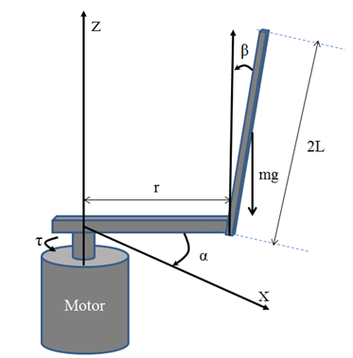
Fig. 1. Furuta pendulum system
Assuming that the friction at the joints is negligible, using the Euler-Lagrange method to get a Lagrange function of the form (1):
(1)
Lagrange's Equation (2):
(2)
where τ - moment generated by the motor. Substituting equation (1) into (2) we get the system of equations of the inverted pendulum (3):
(3)
Convert the system of equations (3) to the form of an equation of state with get the system of equations (4):
(4)
With ; d₁(x) and d₂(x) as the effect of external noise or model uncertainty, these components are limited |d_{i}|<D.
Linearization at the equilibrium point when there is no noise gets the system of equations (5):
(5)

SYNTHESIS CONTROLLER FOR FURUTA INVERTED PENDULUM

3.1. LQR method
The LQR method is the most classic optimal controller design method in the development of modern control theory [49]-[53]. LQR control is determining a control rule for a given system that minimizes one or more quality parameters. The optimal control LQR is to find the amount of control 𝑢*(𝑡) so that the system reaches a steady state and ensures that the efficiency index 𝐽 reaches the minimum value:
(6)
In which, and 𝑃 are solutions of the Riccati algebraic equation [7], [19] . In a study (13), the matrix 𝑄 and the matrix 𝑅 are mutual restrictions, and the matrix value 𝑄 is proportional to the anti-interference ability of the system; increasing the value of 𝑄, the anti-interference ability of the system is enhanced, shortening the adjustment time of the system. However, at the same time, system oscillations are enhanced and energy consumption increases. An increase in 𝑅 makes the system power consumption less but the adjustment time increases. Therefore, the key to the design is to find the correct weight matrix 𝑄 and matrix 𝑅. As long as we are certain about the matrix 𝑄 and the matrix 𝑅, the state feedback matrix 𝐾 is the only confirmation. However, the choice of matrix, matrix completely depends on experience and trial and error method in the design process of the LQR controller, so the greater the subjectivity, leading to the design of the controller is not perfect and affects the control efficiency.

3.2. Basics of bat algorithm
The standard BAT algorithm was developed by Xin-She Yang [54]. The main features of BAT are based on the echolocation behavior of microbats. Since BAT uses frequency tuning, it is the first algorithm of its kind to combine optimization and computational intelligence. Each bat is coded with a velocity and a position , at iteration t, in the d-dimensional search space. The position can be thought of as a solution vector with a given objective function. Among the n bats of the population, the current best solution x* found can be stored during an iterative search. In the algorithm use the following approximation or idealization rules [54], [55]:
- All bats use the echolocation of sound waves to sense distance, and they also know the difference between food, prey, and obstacles.
- The bat flies at random with speed at position . It can automatically adjust the Q frequency (or wavelength) of the emitted pulses and adjust the pulse width rate r ∈ [0, 1], depending on the target's proximity.
- Although the magnitude of the echo can vary in many ways, it is assumed that the magnitude of the echo varies from the large A₀ to the minimum value A_{min}.
For the sake of simplicity, many studies do not use ray tracing in this algorithm, but use variation in frequency f or wavelength λ to suit different applications, depending on ease of implementation and other factors. The algorithm flowchart is presented in studies [54].

Synthesis of LQR control law based on BAT algorithm for pendulum system Furuta
The objective function of the LQR method for the Furuta pendulum system with the matrices Q and R selected as a positive definite diagonal has the following form:
, (7)
where T is the time to survey when using the algorithm BAT; q₁, q₂, q₃, q₄ – matrix diagonal element Q. The problem of finding values q₁, q₂, q₃, q_{4,} and r_{lqr} make sure that the J value is less than a given value and that the Q, R matrices still satisfy the Riacti equation. At the same time, in the optimization process when updating the search values, the authors propose several techniques to update the optimal parameter values for the values to be searched based on the desired quality criteria of the system. output system. Such as fast response time, small overshoot, and low power consumption. Such update techniques are modeled through the update factor of each value in the algorithm in the direction of prioritizing the importance of the control goal of each output state.
The main parts of the bat algorithm can be summarized as follows:
Algorithm 1 Original BAT algorithm
Input : Bat population q =( q_{i1}, … q_{i4}, r_{lqr}) for i=1…Np MAX_FE
Output: The best solution is q_{best}, solve the Riccati equation (K_{best}) and its corresponding value J_{min}=min(J(K_{best})).
Line 1: init_bat() ;
Line 2: eval=evaluate_the_new_population ;
Line 3: J_{min}=find_the_best_solution(K_{best}) ; {initialization}
Line 4: While termination_condition_not_meet do
Line 5: for i=0 to N_{p} do
Line 6: y= improve_the_best_solution(q_{best}) ;
Line 7: if rand(0,1)>r then
Line 8: y = improve_the_best_solution(q_{best}) ;
Line 9: K = solve_the_Riccati_equation (y)
Line 10: end if {local search step}
Line 11: J_{new}=evaluate_the_new_solution(q) ;
Line 12: eval=eval+1 ;
Line 13: if J_{new}≤J_{i} and N(0,1)<A_{i} then
Line 14: q_{i}=y; K_best_{i} = K; J_{i}=J_{new} ;
Line 15: end if {save the best solution conditionally}
Line 16: J_{min}=find_the_best_solution(K_{best}) ;
Line 17: end for
Line 18: end while
- The first step is initialization (lines 1-3). In this step, we initialize the parameters of the algorithm, generate and evaluate the initial population, and then determine the best solution for the population.
-The second step is: to generate a new solution (line 6). Here, virtual bats are moved in the search space according to updating rules of the bat algorithm.
- The third step is a local search step (lines 7-10). The best solution is being improved using random walks. In this step, the values to be searched for are updated with a weight with different priorities according to the control objective . In addition, the parameters are limited to ensure that the matrices Q, R are always positive, to ensure the existence of solutions of the Riccati equation.
- In the fourth step evaluate the new solution (line 11), and the evaluation of the new solution is carried out.
- In the fifth step save the best solution conditionally (lines 13-15), conditional archiving of the best solution takes place.
- In the last step: find the best solution (line 16), the current best solution is updated.

RESULTS AND DISCUSSION

4.1. Numerical simulation results
To synthesize the LQR controller, the authors first choose the parameter determination scenario as follows: bring the pendulum from the initial position X₀= [π 0 0 0]^{T} to the original equilibrium position [0 0 0 0]^{T} in time 10 (s) so that the objective function J value is less than 25 (J_{min}=25) with the control goal priority orientation is the stabilization time less than 2(s) without overshoot of the arm, the control torque is less than 5(N.m). The initial parameter value of the matrix Q, R is q₁=5.0; q₂= 5. 0; q₃= 5.0; q₄= 5. 0; r_{lqr}= 5.0. The controller parameter found based on the traditional LQR method is as follows:
(8)
weights γ_{1,3}=0.2, γ_{2,4}=1, γ₅=0.1. Initial data for the BAT algorithm include the number of bats: N_{p}=28 (bats), the loudness A = 0.33, and pulse emission rates r = 0.28. After performing the algorithm with the parameters, we get the diagonal matrix values Q and R found in 14 search steps. The value of the calculation steps is shown in Figure 2, at the results found that the coefficients related to the position of the pendulum angle q₃, and the lever q₁ initially have a rapid increase in value, ensuring a fast effect for these variables, after that is slightly reduced. The coefficients related to the angular velocity q₂, and q₄ decrease rapidly to the value 0.1, showing that the change in the values of these variables has little effect on the objective function J. For the parameter r_{lqr}, the value increases compared to that of the objective function. The initial value then decreases slightly, which shows that the amplitude of the control signal value will be smaller during the transition when compared to the control law value found from the initial Q, R matrix. Figure 2 shows the values of the Q, R matrix parameters step by step, the search process to the minimum value takes 14 steps. The final value when satisfying the requirements of the objective function in this algorithm is as follows: q₁=5.6247; q₂= 0.10; q₃= 8.8897; q₄= 0.10; r_{lqr}= 5.8040;
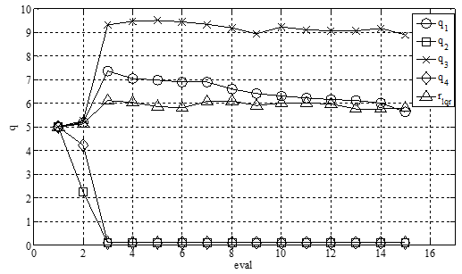
Fig. 2. Values of matrix parameters Q, R through search steps by BAT algorithm
With the obtained values, solving Riccati’s equation, we get the controller parameter as follows:
(9)
In the first scenario with the same initial condition as above, the response of the system (4) to two control laws (8) and (9) is shown in Figure (3). Figure (3a) shows the response of the arm deflection angle, at the results show that the system moves to the desired position without overshooting, with a fast response time. To achieve the goal system quickly stabilizes to the desired point with the goal of stability. The Pendulum will oscillate and have a larger amplitude in the transient mode but stabilize faster at the equilibrium point. This has been achieved because in the optimal function with the technique of adding weights to the variables α, β will create an impact moment considering the response time. This is also shown by the value of controller (9), where the sign of this controller is the same as that of a regular LQR controller, but its value gives preference to the variables x₁, x₂. The comparison of control quality is shown in Table 1. The control signals of the two rules are shown in Figure 4. In the initial time, the signal amplitude of the normal LQR rule is larger, but the control law is larger. The proposed LQR control will be large during the transition period. This indicates that the objective function J with the BAT algorithm and the techniques using weights only guarantee fast performance.
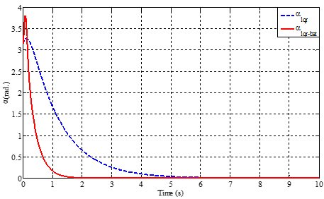
a)
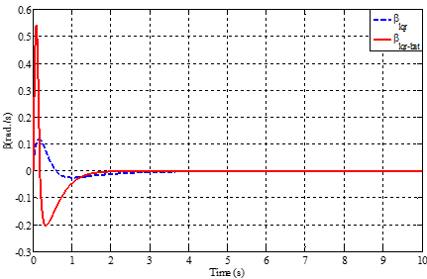
b)
Fig. 3. Angular response of arms a) and pendulum b)
- Comparison table of control quality indicators
Variable | LQR |  | LQR-BAT
Variable | Arm | Pendulum | Arm | Pendulum
Settling Time (s) | 3.55 | 2.9 | 1.04 | 1.72
Overshoot (%) | 0 | 15.7 | 0 | 54.4
Undershoot  (%) | 5.0 | 2.6 | 21.3 | 20.2
J | 22.7 |  | 66.8
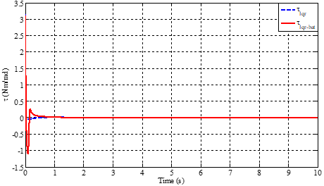
Fig. 4. Control signal.
In the second scenario when bad at the external noise component or model error with d_{1,2}(x) are random values in the range [-4; 4], the x_{ref} set value changes the form of the ladder. The response results of the system are shown in Figures 5 a, and b, from the graph we see that with the proposed control law the response of the lever arm (Figure 4a) gives better results when the response time better yet, the static error is within ±0.05 (rad) with the LQR in the ±0.1 (rad) cavity and remains stable at the set value. With a pendulum, when the influence of noise on both control laws ensures the pendulum is stable under the influence of random noise, the control law is designed to ensure a stable system within ±0.01 (rads). However, in transient mode, the overshoot will be larger than when using the LQR controller.
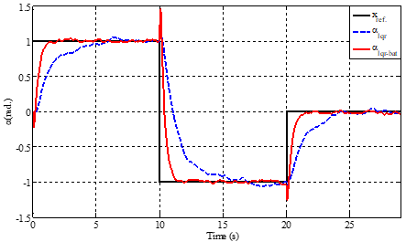
a)
b)
Fig. 5. Angular response of arm a) and pendulum b) when there is a noise component and the set value changes

Experimental results
The real-time implementation of the controller was performed using the STM32F4 Discovery and the STM32Cube IDE embedded programming software (Figure 6). The STM32F4 microcontrollers are powerful real-time controllers with fast processing and low cost. Embedded control system model for Furuta pendulum system at Control System Design Laboratory, Department of Automation Engineering, Le Quy Don University of Technology. The embedded control system is divided into data acquisition, signal processing, and output control, and includes relative encoder sensors, step-less rheostats, power amplifiers, and electrical circuits. In addition, the system is also connected to a computer via an RS232 port to monitor system parameters through software. The purpose of the system is to stabilize the vertical shakes at the positions where the arm angles overlap, and the sampling time is 2ms. Figure 7 shows the connection of blocks of the Furuta pendulum real system. Experimental scenario with two control rules LQR and LQR_BAT with x_{ref} set value change 1 (rad.) and -1 (rad.) respectively. Experimental results of angles α, β of the swing arm and pendulum are shown in Figure (8a,b). The experimental results show that the LQR control law with the designed BAT algorithm responds well to the real system. Compared with the conventional LQR control law, the stabilization time is faster, the oscillation frequency is smaller, and the deviation margin from the supply value is smaller. However, while designing the control law only using a mathematical model without calculating all the properties of the real system such as position accuracy of the engine gearbox, and friction between joints ... Therefore, the real system is not as good as the simulation.
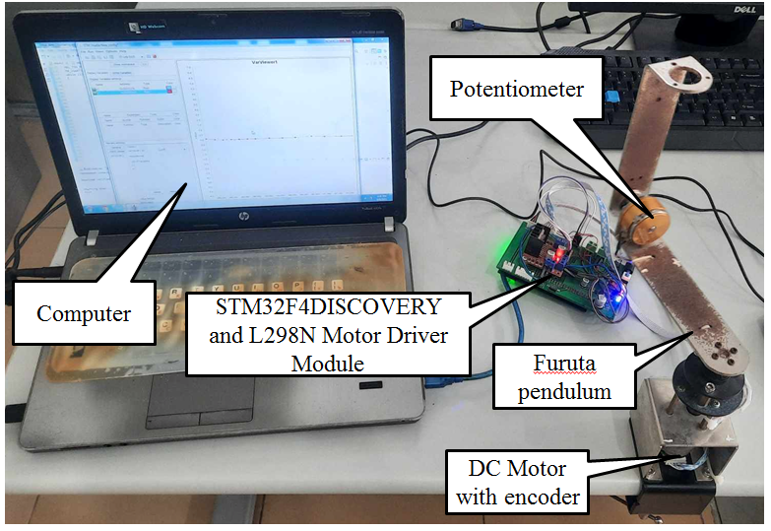
Fig. 6. Experimental model of the Furuta pendulum system
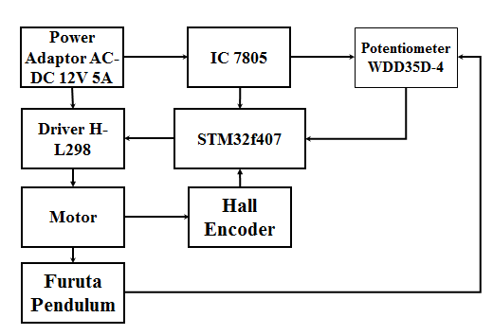
Fig. 7. Block diagram of embedded control system
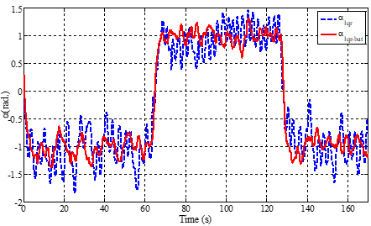
a)
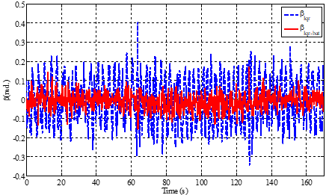
b)
Fig. 8. Swing arm angle response (a) and pendulum deflection angle (b) on an experimental model

CONCLUSION
Based on the theory of the LQR controller combined with the bat swarm algorithm (BAT algorithm), the authors have synthesized an LQR controller with parameters Q, R matrices that are optimized to control the balance of the Furuta pendulum system. From the simulation and experimental results, a method of building an optimal LQR controller with matrix parameters Q, R combined with weighting techniques will ensure that the objective function meets the requirements and gives priority to some indicator's desired quality. The results compared with the classic LQR controller show the advantages of the proposed method. In addition, the controller is realized on a real system that has proven effective. From the simulation and experimental results, it has been demonstrated that the method's ability in designing a feedback controller satisfies the least squares criterion function, but has better control quality due to the ability to find global solutions of the algorithm BAT. For future studies, we will conduct an online search for Q and R matrices on real models.

References
- M. Iwase, K. J. Åström, K. Furuta, and J. Åkesson, “Analysis of safe manual control by using Furuta pendulum,” Proceedings of the IEEE International Conference on Control Applications (CCA '06), pp. 568–572, October 2006
- Furuta, K., Yamakita, M., and Kobayashi. “Swing up control of inverted pendulum using pseudo-state feedback”, Proceedings of the Institution of Mechanical Engineers, Part I: Journal of Systems and Control Engineering, 206(4), 263–269, Sep. 1992.
- Furuta, K., Yamakita, M., and Kobayashi. “Swing up control of inverted pendulum. In Industrial Electronics”, Control and Instrumentation, 1991. Proceedings. IECON’91, 1991 International Conference on, 2193–2198. IEEE, Sep. 1991.
- K.J. Astrom, K. Furuta, Swining up a pendulum by energy control. Automatica 36, 287–295 (2000). https://doi.org/10.1016/S0005-1098(99)00140-5.
- B. S. Cazzolato and Z. Prime. “On the Dynamics of the Furuta Pendulum”, Hindawi Publishing Corporation, Journal of Control Science and Engineering, Volume 2011, Article ID 528341, 8 pages
- Sunil Kumar Mishra, Dinesh Chandra. “Stabilization and Tracking Control of Inverted Pendulum Using Fractional Order PID Controllers”. Journal of Engineering, Volume 2014, Article ID 752918, 9 pages.
- S. Howimanporn, S. Chookaew and C. Silawatchananai, “Comparison between PID and Sliding Mode Controllers for Rotary Inverted Pendulum Using PLC,” 2020 4th International Conference on Automation, Control and Robots (ICACR), Rome, Italy, 2020, pp. 122-126, doi:10.1109/ICACR51161.2020.9265510.
- E. S. Varghese, A. K. Vincent, and V. Bagyaveereswaran, “Optimal control of inverted pendulum system using PID controller, LQR and MPC,” IOP Conference Series: Materials Science and Engineering, vol. 263, no. 5, 2017.
- Hai N. Phan, Chiem X. Nguyen. Building embedded quasi-time-optimal controller for two-wheeled self-balancing robot MATEC Web Conf. Volume 132, 2017 XIII International ScientiÒc-Technical Conference “Dynamic of Technical Systems” (DTS-2017). DOI https://doi.org/10.1051/matecconf/201713202005
- Nguyen Xuan Chiem, Hai Nguyen Phan. Design controller of the quasi-time optimization approach for stabilizing and trajectory tracking of inverted pendulum. MATEC Web Conf. Volume 226, 2018. XIV International ScientiÒc-Technical Conference “Dynamic of Technical Systems” (DTS-2018). DOI https://doi.org/10.1051/matecconf/201822602007
- Md Akhtaruzzaman, A.A. Shafie A.A. “Modeling and control of a rotary inverted pendulum using various methods, comparative assessment and result analysis”, 2010 IEEE International Conference on Mechatronics and Automation. DOI: 10.1109/ICMA.2010.5589450.
- C X Nguyen, Th. Tr. Tran, Th X Pham, K M Le. “Design of control laws for rotary inverted pendulum based on LQR and Lyapunov function”. Dynamics of Technical Systems (DTS 2020) IOP Conf. Series, Materials Science and Engineering 1029 (2021) 012020 IOP Publishing doi:10.1088/1757-899X/1029/1/012020.
- Jie Wen, Yuanhao Shi, Xiaonong Lu. “Stabilizing a Rotary Inverted Pendulum Based on Lyapunov Stability Theorem”, 2017 29th Chinese Control And Decision Conference (CCDC).
- Saqib Irfan, Adeel Mehmood, Muhammad Tayyab Razzaq, Jamshed Iqbal. “Advanced sliding mode control techniques for Inverted Pendulum: Modelling and simulation”, Engineering Science and Technology, International Journal (2018).
- Dianwei Qian, Jianqiang Yi, and Dongbin Zhao. “Hierarchical sliding mode control for a class of SIMO under-actuated systems”, Control and Cybernetics, vol. 37 (2008) No. 1.
- Fatih Adıgüzel, Yaprak YalçınFirst. “Discrete-time backstepping control with nonlinear adaptive disturbance attenuation for the inverted-pendulum system”. Vol 43, Issue 5, 2021.
- Alfian Ma’arif , Marco Antonio Márquez Vera , Magdi Sadek Mahmoud , Samir Ladaci , Abdullah Çakan , Jonattan Niño Parada. Backstepping Sliding Mode Control for InvertedPendulum System with Disturbance and Parameter Uncertainty. Journal of Robotics and Control (JRC) Volume 3, Issue 1, January 2022 ISSN: 2715-5072 DOI: 10.18196/JRC.v3i1.12739
- . Xiaodong Miao, Hongjie Zhu , Shishou Li , Xiang Xu , Huimin Ouyang , Huan Xi. Adaptive-back-stepping-based controller design for double-pendulum rotary cranes. ISA Transactions. Volume 136, May 2023, Pages 676-686. https://doi.org/10.1016/j.isatra.2022.11.011
- Chunrong Xiaa, Irfan Qaisarb, Muhammad Shamrooz Aslam. Design of Hybrid Controller using Qualitative SimulationInternal Modeling for Inverted PendulumInternational Journal of Robotics and Control SystemsVol. 2, No. 4, 2022, pp. 638-651ISSN 2775-2658
- Magdi S. Mahmouda; Radhwan A. A. Salehb;2, Alfian Ma’arifc. Stabilizing of Inverted Pendulum System Using Robust SlidingMode Control International Journal of Robotics and Control SystemsVol. 2, No. 2, 2022, pp. 230-239ISSN 2775-2658
- N. Gupta and L. Dewan, “Trajectory Tracking And Balancing Control Of Rotary Inverted Pendulum System Using Quasi-Sliding Mode Control, 1-8.,” Mechatronic Systems and Control, vol. 50, no. 1, Jan. 2022, doi:10.2316/j.2022.201-0231.
- C. Eilers, J. Eschmann, R. Menzenbach, B. Belousov, F. Muratore and J. Peters, “Underactuated Waypoint Trajectory Optimization for Light Painting Photography,” 2020 IEEE International Conference on Robotics and Automation (ICRA), Paris, France, 2020, pp. 1505-1510, doi: 10.1109/ICRA40945.2020.9196516.
- K. Albert, K. S. Phogat, F. Anhalt, R. N. Banavar, D. Chatterjee and B. Lohmann, “Structure-Preserving Constrained Optimal Trajectory Planning of a Wheeled Inverted Pendulum,” in IEEE Transactions on Robotics, vol. 36, no. 3, pp. 910-923, June 2020, doi:10.1109/TRO.2020.2985579.
- G. Demirkıran, O. Erdener, ¨ O. Akpınar, P. Demirtas¸, M. Y. Arık and ¨ E. Guler, “Control of an Inverted Pendulum by Reinforcement Learning ¨ Method in PLC Environment,” 2020 Innovations in Intelligent Systems and Applications Conference (ASYU), Istanbul, Turkey, 2020, pp. 1-5, doi: 10.1109/ASYU50717.2020.9259890.
- L. Ronai and T. Szab ´ o, “Application of Rexroth Controlling for Inverted Pendulum,” International Journal of Engineering and Management Sciences, vol. 4, no. 1, pp. 174–179, https://doi.org/10.21791/IJEMS.2019.
- M. T. Vo, “Back-stepping control for rotary inverted pendulum,” Journal
of Technical Education Science, no. 59, pp. 93–101, Aug. 2020, doi:
https://jte.edu.vn/index.php/jte/article/view/110.
- Xuebo Yang, Xiaolong Zheng. Swing-Up and Stabilization Control Design for an Underactuated Rotary Inverted Pendulum System: Theory and Experiments. IEEE Transactions on Industrial Electronics. Volume65(Issue9)Pages, p.7229To - 7238. DOI:https://doi.org/10.1109/TIE.2018.2793214.
- A. De Carvalho, B. A. Angelico, J. F. Justo, A. M. De Oliveira, and J. I. Da Silva Filho, “Model reference control by recurrent neural network built with paraconsistent neurons for trajectory tracking of a rotary inverted pendulum,” Applied Soft Computing, vol. 133, p. 109927, Jan. 2023, doi:10.1016/j.asoc.2022.109927.
- Automation in Construction. Huimin Ouyang, Xiang Xu, Guangming Zhang. Energy-shaping-based nonlinear controller design for rotary cranes with double-pendulum effect considering actuator saturation. Volume 111, March 2020, 103054. https://doi.org/10.1016/j.autcon.2019.1030549
- Arnaldo de Carvalho Junior , Bruno Augusto Angelico , João Francisco Justo , Alexandre Maniçoba de Oliveira , João Inacio da Silva Filho . Model reference control by recurrent neural network built with paraconsistent neurons for trajectory tracking of a rotary inverted pendulum. Applied Soft Computing Volume 133, January 2023, 109927.
- Anthony Gutarra, Styven Palomino, Elvis J. Alegria, Jose Cisneros. Fuzzy Controller Design for Rotary Inverted Pendulum System Using Genetic Algorithms. 2022 IEEE ANDESCON. DOI: 10.1109/ANDESCON56260.2022.9989988
- Mohd Fairus Abdollah, Zaharuddin Mohamed, mohamad noh Ahmad. Fuzzy modeling and control of rotary inverted pendulum system using LQR technique. IOP Conference Series Materials Science and Engineering. DOI: 10.1088/1757-899X/53/1/012009
- Ul Hassan, M., Kadri, M.B., Amin, I. (2013). Proficiency of Fuzzy Logic Controller for Stabilization of Rotary Inverted Pendulum based on LQR Mapping. In: Masulli, F., Pasi, G., Yager, R. (eds) Fuzzy Logic and Applications. WILF 2013. Lecture Notes in Computer Science(), vol 8256. Springer, Cham. https://doi.org/10.1007/978-3-319-03200-9_21.
- J. Wu and W. Zhang, “Design of fuzzy logic controller for two-wheeled self-balancing robot”, Proceedings of the 6th International Forum on Strategic Technology (IFOST ’11), pp. 1266–1270, August 2011.
- Y. Qin, Y. Liu, X. Zang, and J. Liu, “Balance control of two-wheeled self-balancing mobile robots based on TS fuzzy model,” Proceedings of the 6th International Forum on Strategic Technology (IFOST ’11), pp. 406–409, August 2011.
- M. Park, Y.-J. Kim and J.-J. Lee, "Swing-up and LQR stabilization of a rotary inverted pendulum", Artificial Life and Robotics, vol. 16, no. 1, pp. 94-97, 2011.
- X. Ruan, J. Liu, H. Di, and X. Li, “Design and LQ control of a two-wheeled self-balancing robot,” Proceedings of the 27th Chinese Control Conference (CCC ’08), pp. 275–279, July 2008.
- Minh-Tai Vo , Van-Dong-Hai Nguyen , Hoai-Nghia Duong , Vinh-Hao Nguyen. Combining Passivity-Based Control and Linear Quadratic Regulator to Control a Rotary Inverted Pendulum. Journal of Robotics and Control (JRC) Volume 4, Issue 4, 2023. ISSN: 2715-5072, DOI: 10.18196/jrc.v4i4.18498
- Devi Handaya1, Resti Fauziah. Proportional-Integral-Derivative and Linear Quadratic Regulator Control of Direct Current Motor Position using Multi-TurnBased on LabView. Journal of Robotics and Control (JRC)Volume 2, Issue 4, July 2021ISSN: 2715-5072 DOI: 10.18196/jrc.24102
- Muhammad Auzan1*, Danang Lelono2, Andi Dharmawan. Humanoid Walking Control Using LQR and ANFIS. Journal of Robotics and Control (JRC)Volume 3, Issue 4, 2023ISSN: 2715-5072, DOI: 10.18196/JRC.v4i4.16444
- Ümit Önena, Abdullah Çakan. Multibody Modeling and Balance Control of a Reaction Wheel InvertedPendulumUsing LQR Controller. International Journal of Robotics and Control Systems84Vol. 1, No. 1, March 2021, pp. 84-89ISSN 2775-2658. DOI: 10.31763/ijrcs.v1i1.296
- Guilherme P. Dos Santosa, Adriano Kossoskib, Jose M. Balthazarb,Angelo M. Tusse. SDRE and LQR Controls Comparison Applied in High-Performance Aircraft in a Longitudinal Flight. International Journal of Robotics and Control SystemsVol.1, No. 2, 2021, pp. 131-144ISSN 2775-2658 . DOI: 10.31763/ijrcs.v1i2.329
- Ümit Önena,1, Abdullah Çakan. Multibody Modeling and Balance Control of a Reaction Wheel Inverted Pendulum Using LQR Controller. International Journal of Robotics and Control Systems. 84Vol. 1, No. 1, March2021, pp. 84-89ISSN 2775-2658
- Chawla and A. Singla, “Real-Time Stabilization Control of a Rotary Inverted Pendulum Using LQR-Based Sliding Mode Controller,” Arabian Journal for Science and Engineering, vol. 46, no. 3, pp. 2589–2596, Mar. 2021, doi: 10.1007/s13369-020-05161-7.
- P. Duan, L. He, Z. Duan, and L. Shi, “Distributed Cooperative LQR Design for Multi-Input Linear Systems,” IEEE Transactions on Control of Network Systems, pp. 1–12, 2022.
- S. Savin, S. Jatsun, and L. Vorochaeva, “Modification of constrained LQR for control of walking in-pipe robots,” in 2017 Dynamics of Systems, Mechanisms and Machines (Dynamics), 2017, pp. 1–6.
- P. Duan, L. He, Z. Duan, and L. Shi, “Distributed Cooperative LQR Design for Multi-Input Linear Systems,” IEEE Transactions on Control of Network Systems, pp. 1–12, 2022.
- J. Yu, R. Li, D. Gong, Y. Liu, and P. Liu, “Research on Disturbance of Upright Balance of Biped Humanoid Robot Based on AWPSO-LQR,” in 2021 IEEE International Conference on Robotics and Biomimetics (ROBIO), 2021, pp. 907–912.
- N. Kawasaki, E. Shimemura, “Determining quadratic weighting matrices to locate poles in a specified region", Automatica, vol. 19, pp. 557-560, 1983.
- N. Kawasaki, E. Shimemura, J.W. Shin. “On the quadratic weights of an LQ-problem shifting only the specified poles”, Proceedings of the Society of Instrument and Control Engineers, vol. 25(11), pp. 1248–1250, 1989.
- F. Kraus, V. Kucera. “Linear quadratic and pole placement iterative design”, Proc. of European Control Conference, 1999.
- J. Cigler, V. Kucera, “Pole-by-pole shifting via a linear quadratic regulation”, Proc. of the 17th International Conference on Process Control, 2009.
- B. D. O. Anderson, J. B. Moore. “Optimal Control: Linear Quadratic Methods”, Englewood Cliffs, NJ: Prentice Hall, 1990.
- X.S. Yang, “Nature-inspired Metaheuristic Algorithms”, Luniver Press, 2008.
- X.S. Yang, “A New Metaheuristic Bat-Inspired Algorithm”, Nature Inspired Cooperative Strategies for Optimization (NISCO 2010).
- Mahmoud Zadehbagheri,Alfian Ma'arif, Rahim Ildarabadi, MehdiAnsarifard, Iswanto Suwarno . Design of Multivariate PID Controller for Power Networks Using GEAand PSO. Journal of Robotics and Control (JRC)Volume 4, Issue 1, January2023ISSN: 2715-5072,DOI: 10.18196/jrc.v4i1.15682
- MotorEka Suci Rahayua, Alfian Ma’arifa,1,*, Abdullah Cakanb. Particle Swarm Optimization (PSO) Tuning of PID Control on DC. International Journal of Robotics and Control Systems Vol. 2, No. 2, 2022, pp. 435-447.ISSN 2775-2658. DOI: http://pubs2.ascee.org/index.php/ijrcs.
- E. S. Varghese, A. K. Vincent, and V. Bagyaveereswaran, “Optimal control of inverted pendulum system using PID controller, LQR and MPC,” IOP Conference Series: Materials Science and Engineering, vol. 263, no. 5, 2017.
- A. Saleem, B. Taha, T. Tutunji, and A. Al-Qaisia, "Identification and cascade control of the servo-pneumatic system using Particle Swarm Optimization," Simulation Modelling Practice and Theory, vol. 52, pp. 164-179, 2015, https://doi.org/10.1016/j.simpat.2015.01.007.
- M. Chavoshian, M. Taghizadeh, and M. Mazare, "Hybrid Dynamic Neural Network and PID Control of Pneumatic Artificial Muscle Using the PSO Algorithm," International Journal of Automation and Computing, vol. 17, no. 3, pp. 428-438, 2020, https://doi.org/10.1007/s11633-019-1196-5.
- N. Ali, Y. Ayaz, and J. Iqbal, "Collaborative Position Control of Pantograph Robot Using Particle Swarm Optimization," International Journal of Control, Automation and Systems, vol.. 20, no. 1, pp. 198-207, 2022, https://doi.org/10.1007/s12555-019-0931-6.
- Chiem Nguyen Xuan, Thang Le Tran. Design of State Feedback Controller with Optimal Parameters Using Bat Algorithm for Reaction Wheel Pendulum. 2021 International Conference on Advanced Technologies for Communications (ATC). 14-16 October 2021. DOI: 10.1109/ATC52653.2021.9598306.
- N. X. Chiem, N. D. Anh, A. D. Lukianov, P. D. Tung, H. D. Long, and N. D. Linh. Design real-time embedded optimal PD fuzzy controller by PSO algorithm for the autonomous vehicle-mounted camera. AIP Conference Proceedings 2188, 030008 (2019); ttps://doi.org/10.1063/1.5138401.
- Nguyen, X. C., Hoang, D. L., Pham, X. T., Nguyen, T. H., Le, M. K., & Nguyen, V. X. (2021). Synthesis of feedback linearization controller with parameters optimization based on bat algorithm for a magnetic levitation system. Journal of Science and Technique, 16(03), 123 - 139. https://doi.org/10.56651/lqdtu.jst.v16.n03.283.

