**Robust Adaptive Trajectory Tracking Sliding Mode Control for Industrial Robot Manipulator using Fuzzy Neural Network**

Quynh Nguyen Xuan 1,2, Cuong Nguyen Cong 2*, Nghiễn Bá Nghiễn3

1, College of Electrical and information engineering, Hunan University, Hunan Changsha, China.

2. Department of Electrical Engineering, Hanoi University of Industry, Hanoi, Vietnam.

3. Department of Information technology, Hanoi university of Industry, Vietnam.

Email: 2 nguyencongcuong@haui.edu.vn,

*Corresponding Author

***Abstract*— This paper presents a control method for a two-link industrial robot manipulator system that uses Fuzzy Neural Networks (FNNs) based on Sliding Mode Control (SMC) to investigate joint position control for periodic motion and predefined trajectory tracking control. The proposed control scheme addresses the challenges of designing a suitable control system that can achieve the required approximation errors while ensuring the stability and robustness of the control system in the face of joint friction forces, parameter variations, and external disturbances. The control scheme uses four layers of FNNs to approximate nonlinear robot dynamics and remove chattering control efforts in the SMC system. The adaptive turning algorithms of network parameters are derived using a projection algorithm and the Lyapunov stability theorem. The proposed control scheme guarantees global stability and robustness of the control system, and position is proven. Simulation and experiment results from a two-link IRM in an electric power substation are presented in comparison to PID and AF control to demonstrate the superior tracking precision and robustness of the proposed intelligent control scheme.**

*Keywords*— robot manipulators; fuzzy neural network; sliding mode control; robust adaptive control

# Introduction

Robot manipulators are complex systems that are prone to uncertainties in their dynamics, such as external disturbance, nonlinear friction, highly time-varying, and payload variation, which can deteriorate the system performance and stability. Therefore, achieving high performance in trajectory tracking is a challenging task. To overcome these problems, various control methods have been proposed, such as adaptive control, intelligent control, sliding mode control, and variable structure control [1-18]. Many studies on intelligent controllers based on fuzzy logic have been conducted over the last decade [19-26]. Fuzzy logic is commonly used in robot manipulators to achieve good control performance over uncertainties that cannot be described precisely by mathematical models.

In [22], an adaptive fuzzy controller based on sliding mode is proposed for tracking the trajectory of robot manipulators with unknown nonlinear dynamics. A theoretical justification for the fuzzy approximator was provided by demonstrating that it can approximate the robot's nonlinear dynamics in the vicinity of the switching hyper plane when the representative point and derivative are used as inputs. Thus, the fuzzy controller design can be greatly simplified, while the fuzzy control rules can be obtained initially using the SMC's reaching condition. In [23], fuzzy mathematical principles, a vast field, are developed by replacing sets in classical mathematical theory with fuzzy ones. In this way, all classical mathematical branches can be fuzzed. In [27], for the purpose of compensating for friction in motion control systems, a dynamic friction structure based on a local modeling approach has been proposed The suggested structure makes no claims to accurately replicate intricate friction-driven phenomena, but the nonlinear integral gain and the linearity of the local models make the observer's design and implementation easier. Then, to counteract the effects of imprecise friction compensation, the controller can be robustly synthesized using linear matrix inequalities. In [28], a self-organizing fuzzy radial basis function neural network controller, which uses an radial basis function network to regulate the parameters of the self-organizing fuzzy controller in real time to perfect values for robotic motion control, has been successfully developed for robotic system. It eliminates the difficulties of finding approximate parameters for designing a self-organizing fuzzy controller and the difficulties of the determining suitable membership functions and fuzzy rules for designing a fuzzy logic controller. However, most proposed adaptive fuzzy controllers are difficult in building suitable fuzzy control rules, membership function, and how to guarantee the system stability is a challenge problem to be solved. Recently, much scheme has been done on using NNs to provided online learning algorithms and deal with unmodeled unknown dynamics in robot model [29-43]. In [40], an approach and a systematic design methodology are presented to adaptive motion control based on NNs for high performance robot manipulators, for which stability conditions and performance evaluation have been given. The neuro controller includes a linear combination of a set of off-line trained NNs, and an update law of the linear combination coefficients to adjust robot dynamics and payload uncertain parameters. In [41], a model predictive control scheme is proposed for missile interception. Based on the tracking kinematics, the proposed model predictive control approach can handle a formulated quadratic programming problem using a neuro dynamic optimization approach. The applied neural networks can make the formulated constrained quadratic programming converging to the exact optimal values. In [42], the authors presented a neural network based on terminal SMC for robot manipulators including actuator dynamics. In the proposed control scheme, the RBFNNs are adopted to approximate the nonlinear dynamics of the robot manipulators. Meanwhile, a robust control term is added to suppress the modeling error and estimate the error of the NNs. The convergence and stability of the closed loop system can be guaranteed by Lyapunov theory. In [43], the problems of dynamic model and trajectory tracking are addressed for a redundantly actuated omnidirectional robot manipulators system with uncertainties and external disturbances. In this scheme, NNs are used to identify the system dynamics directly to make the weights matrix structure compact and tuning speed fast. A partitioned NNs structure is also applied to reduce the computing burden further. However, in most of the NNs cases, the unavoidable learning procedure degrades its transient performance in the presence of disturbance, and requires a higher computing time for a larger NNs size. Moreover, the internal behavior is ambiguous to understand, and the well-known knowledge of the model is not used sufficiently, that also degrades its performance. Nowadays, fuzzy neural networks control system obtains the merits of both fuzzy system and NNs [44-68]. In [69], an adaptive fuzzy-neural-network velocity sensorless control scheme was proposed for robot manipulator to achieve high-precision position tracking. In this proposed scheme, the FNNs controller was constructed only with the joint position feedback so that all the system dynamics could be unknown and there are no strict constraints in the control design. In [70], a novel Dynamic structure neural fuzzy networks control was presented to control the joints of robot manipulators for achieving high precision position tracking. Through combining SMC and adaptive control, the proposed control scheme can take advantages of the robust and self-learning properties to deal with the approximation error. Moreover, a FNNs inherited SMC scheme [71] is also proposed to relax the requirement of detailed system information and deal with chattering control efforts in the SMC system. However, although the stability of these control systems was guaranteed, they are not robust enough to handle the short period after transient stage, and it may cause computational burden and complexity. In addition, SMC scheme has been studied by many researchers for the joint position tracking of robot manipulators because of its robustness [72-75]. The SMC is designed to reduce the effects of the approximation errors, and it uses again which is large enough to compensate the bounded uncertainties and guarantees stability and passive of nonlinear systems [76,83].The SMC generates smooth switching between the adaptive and robust modes from integration of advantages of robust and intelligent control. However, in the literature of SMC schemes, they always require the detailed system information and the corresponding uncertainty bound to guarantee the stability. Even the auxiliary control design is still necessary, and the chattering phenomena, which caused by the SMC, still exits.

In order to achieve high precision position tracking in a variety of environments, this research presented an intelligent control scheme in this paper for two link IRM in electric power substations. This scheme combines the benefits of FNNs and SMC. Lyapunov stability theory is used to demonstrate the overall system's robustness and stability. This suggested intelligent controller is more adaptable than the results that are currently documented in the literature. Additionally, the shortcomings of SMC's discontinuous control efforts—tracking errors and the chattering phenomenon—are mitigated based on the outcomes of simulations and experiments.

The remainder of the paper is structured as follows: The robust adaptive FNNs controller design is presented in Section 3. The results of the simulation and experiments for the robot manipulators system are given in section 4. lastly, the summary is drawn in section 5.

# Problem Formulation

The dynamics of an n-link IRM with external disturbance can be expressed in the Lagrange as follows:

|  |  |
| --- | --- |
| $$M\left(q\right)\ddot{q}+C\left(q,\dot{q}\right)\dot{q}+G\left(q\right)+F\left(\dot{q}\right)= τ-D_{e}$$ | (1) |

Where $(q,\dot{q},\ddot{q})∈R^{n }$ are the vectors of joint position, velocity and acceleration, respectively. $M(q)∈R^{n × n}$ is the symmetric inertial matrix. $C(q,\dot{q})∈R^{n x n}$ is the vector of Coriolis and Centripetal forces. $G(q)∈R^{n × n}$ expresses the Gravity vector. $F(\dot{q})$ represents the vector of the frictions. $D_{e}$ $∈R^{n }$ is the vector of the input unknown disturbances. And $τ$ $∈R^{n }$ is the control input vector of joints torque. For the purpose of designing controller, several properties of the robot model (1) have been assumed as follows.

*Property 1:* The inertial matrix *M(q)* is apositive symmetric matrix and is defined by:

|  |  |  |
| --- | --- | --- |
|  | , | (2) |

With $m_{1}$ and $m_{2}$ are known positive constants and they depend on the mass of the robot manipulators.

*Property 2: $\dot{M}\left(q\right)-2C(q,\dot{q})$* is skew symmetry matrix, in which

|  |  |  |
| --- | --- | --- |
|  | $$x^{T}\left[\dot{M}(q) – 2C(q,\dot{q})\right]x=0$$ | (3) |

*Property 3: $C(q,\dot{q})\dot{q}$* *, G(q)* and *F($\dot{q}$)* are bounded as follows:

|  |  |  |
| --- | --- | --- |
|  |  | (4) |

With $C_{k},G_{k},F_{k},F_{0}$ are positive constants.

*Property 4: $D_{e}∈R^{n}$* is the unknown disturbance and bounded as:

|  |  |  |
| --- | --- | --- |
|  |  | (5) |

# Design of Robust Adaptive FNNs Controller

## Structure of adaptive FNNs

The FNNs have many advantages such as optimization abilities, learning abilities and ease of incorporating expert knowledge. They integrate function of a traditional fuzzy system and the basic elements into a connectionist structure. From the structure of the FNNs, expert knowledge can be put into the network as a priori knowledge, which can increase learning speed and estimation accuracy. In this section, the FNNs are constructed to approximate the dynamics of the uncertain term *f(x)*. The structure of four layers FNNs is presented in Fig.1.

$$μ_{1}^{1}$$

Layer 1

Layer 2

Layer 3

Layer 4

Fig. 1. The proposed FNNs structure

Layer 1:Input layer. Each node in this layer corresponds to one input linguistic variables $x_{i}(i=1,2,…,n)$, and only transmits directly input values to the next layer.

Layer 2: Membership layer. In this layer, each node represents the input values with the following Gaussian membership functions:

|  |  |  |
| --- | --- | --- |
|  | $$μ_{i}^{j}\left(x_{i}\right)=exp\left[-\frac{{\left(x_{i}-δ_{i}^{j}\right)}^{2}}{{\left(ρ_{i}^{j}\right)}^{2}}\right]$$ | (6) |

where $δ_{i}^{j}$ and $ρ_{i}^{j}$ $(i=1,2,…,n;j=1,2,…,m)$ are, respectively, the center and standard deviation of the Gaussian membership function of the *i*th input variable $x_{i}$ to the node of this layer, and *m* denotes the total number of membership functions.

Layer 3: Rule layer. Each node in this layer, which is described as a fuzzy rule, multiplies the inputs signal and the outputs result of the product. The output value of this layer is calculated:

|  |  |  |
| --- | --- | --- |
|  | $r_{k}=\prod_{i=1}^{n}{w_{ji}^{k}μ_{i}^{j}(x_{i})}$ $k=1, 2,…, N.$ | (7) |

where $r_{k}$ is the *k*thoutput of the rule layer, $w_{ji}^{k}$ is the weight between the membership layer and the rule layer, and N is the total number of rules.

Layer 4: Output layer. In this layer, each node represents the output linguistic variables, and acts as a defuzzifier. The output can be represented as follows:

|  |  |  |
| --- | --- | --- |
|  | $$f_{i}(x)=\sum_{k=1}^{N}{\left(w_{ik}\prod_{i=1}^{n}{w_{ji}^{k}μ_{i}^{j}(x_{i})}\right)}$$ | (8) |

Moreover, the output of FNNs can be rewritten in the following form as:

|  |  |  |
| --- | --- | --- |
|  | $$f(x)={\left[\begin{matrix}u_{1} & u_{2} & ⋯ & u_{n}\end{matrix}\right]}^{T}=Wr(x)$$ | (9) |

Where $W≡{\left[\begin{matrix}w_{1} & w_{2} & ⋯ & w_{n}\end{matrix}\right]}^{T}∈R^{n×N}$;

$$r≡{\left[\begin{matrix}r_{1} & r_{2} & ⋯ & r_{n}\end{matrix}\right]}^{T}∈R^{n×1}$$

Based on the powerful approximation ability, there exists an optimal FNNs estimator $f^{*}\left(x\right)$ to lean the nonlinear dynamic function such that

|  |  |  |
| --- | --- | --- |
|  | $$f\left(x\right)=f^{*}\left(x\right)+ξ\left(x\right)$$ $$=W^{*}r\left(x,δ^{*},ρ^{*}\right)+ξ(x)$$ | (10) |

where $W^{*},δ^{*},ρ^{*}$ are the optimal parameters of $W,δ,ρ,$ respectively, $ξ(x)$ is a minimum approximation error vector, and is bounded by a positive real constant as follows:

|  |  |  |
| --- | --- | --- |
|  |  | (11) |

*Assumption 1:* The norms of the FNNs optimal weights are bounded as follows:

$\left\|W^{*}\right\|≤α_{w},\left\|δ^{*}\right\|≤α_{δ},\left\|ρ^{*}\right\|≤α_{ρ}$.

where $α_{w},α_{δ},α_{ρ}$ are the positive real values.

## Robust Adaptive FNNs Controller Design

In this paper, consider the dynamics of an n- link IRM is shown in Fig. 2 can be expressed in the Lagrange as equation (1). In order to control the joint position of the robot manipulators, the architecture of the robot manipulator control system is shown in Fig. 2 is developed in this study. This paper proposed an intelligent controller which combines adaptive FNNs control and SMC to suppress the effects of the uncertainties and approximation errors. This proposed intelligent controller generates a smooth switching between the adaptive and robust modes such that it can take advantage of their attractive features of adaptive and robust control. Thus, the unknown functions of robot manipulator control system is estimated, and the stability of control system can be guaranteed.

The tracking error vector $e\left(t\right)$ and the sliding mode function $s\left(t\right)$ can be defined as the following equations:

$$q_{d}$$

$${\ddot{q}}_{d}$$

Fuzzy Neural Network

Disturbances

$$D_{e}$$

$$\begin{matrix}\dot{\hat{W}}=-λ_{w}Θ_{w}\left\|s\right\|\hat{W}+Θ_{w}rs^{T} \\ \dot{\hat{δ}}=-λ_{δ}Θ_{δ}\left\|s\right\|\hat{δ} \\ \dot{\hat{ρ}}=-λ_{ρ}Θ_{ρ}\left\|s\right\|\hat{ρ} \end{matrix}$$

Update laws

$$s\left(t\right)=\dot{e}+λe$$

$τ_{s}=-γ\frac{s}{\left\|s\right\|}η_{α}+K_{s}$*sgn(s)*

*d/dt*

*d/dt*

$$\hat{f}(x)$$

$$τ_{s}$$

$$τ$$

+

$$-$$

$$e$$

$$λ$$

$$q$$

$$η_{α}$$

$${\dot{q}}_{d}$$

$$\dot{q}$$

$$s$$

*d/dt*

$$K_{s}$$

$$γ$$

+



$$P$$

$$ʃ$$

SMC robust term

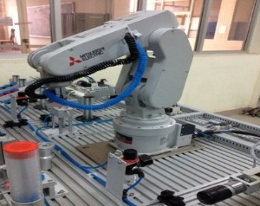

Fig. 2. Architecture of the proposed robust adaptive FNNs control system

|  |  |  |
| --- | --- | --- |
|  | $$e\left(t\right)=q_{d}(t)-q(t)$$ | (12) |
|  | $$s\left(t\right)=\dot{e}+λe$$ | (13) |

where $λ=diag\left(λ_{1},λ_{2}{,..,λ}_{n}\right)=λ^{T}>0$*.* It is typical to define an error metric $s\left(t\right)$ to be a performance measure. When the sliding surface $s\left(t\right)=0$, the sliding mode is governed by the following differential equation according to the theory of sliding mode control: $\dot{e}=-λe$. The behavior of the system on the sliding surface is determined by the structure of the matric $λ$. When the error metric $s\left(t\right)$ is smaller, the performance is better. Therefore, equation (1) can be rewritten as follows:

|  |  |  |
| --- | --- | --- |
| $$M\dot{s}+Cs=M{\ddot{q}}_{d}+\left(Mλ+C\right){\dot{q}}_{d}+Cλq_{d}+F\left(\dot{q}\right)+G\left(q\right)-Mλ\dot{q}-Cλq-τ+D_{e}$$ | | (14) |
|  | $$M\dot{s}=f\left(x\right)-τ+D_{e}-Cs$$ | (15) |

where $f\left(x\right)$ is defined as follows:

|  |  |  |
| --- | --- | --- |
|  | $$f\left(x\right)=M_{R}{\ddot{q}}_{d}+\left(M_{R}λ+C_{R}\right){\dot{q}}_{d}+C_{R}λq_{d}$$ | (16) |

For the dynamics of an n-link robot manipulator (1), the adaptive control law is proposed as:

|  |  |  |
| --- | --- | --- |
|  | $$τ=τ_{s}+K_{p}s+\hat{f}\left(x\right)+P\int_{0}^{t}{sdq}$$ $$+ F\left(\dot{q}\right)+G_{R}\left(q\right)-M_{R}λ\dot{q}-C_{R}λq$$ | (17) |

where $K_{p}$ is the positive definite matrix, and $K_{p}=diag(k_{1},k_{2},…,k_{n})$; P is positive definite, $τ_{s}$ is a sliding mode controller robust term that is used to suppress the effects of uncertainties and approximation errors. And $\hat{f}(x)$ is the approximation of the adaptive function $f(x)$, and is designed as:

|  |  |  |
| --- | --- | --- |
|  | $$\hat{f}\left(x\right)=\hat{W}r\left(x\right)$$ | (18) |

From (10) and (18), we have

|  |  |  |
| --- | --- | --- |
|  | $$\tilde{f}\left(x\right)=f^{*}\left(x\right)-\hat{f}\left(x\right)=\tilde{W}r\left(x\right)+ξ(x)$$ | (19) |

Where

$\tilde{W}=W^{*}-\hat{W}=arg\min_{\hat{W}∈M_{w}}\left[\sup_{x∈Ω}\left\|f\left(x\right)-\hat{W}r\left(x\right)\right\|\right]$.

with $M_{w}$ and $Ω∈R^{n}$ are the predefined compact sets of $\hat{W}$ and $x$.

The robust term $τ_{s}$ is designed as follows:

|  |  |
| --- | --- |
|  | (20) |

where $K_{s}$ is defined as: $K_{s}=\left(d_{e}+ξ_{0}\right)$, and $η_{α}$ is defined as: $η_{α}=\left(\frac{α_{w}^{2}}{4}+\frac{α_{δ}^{2}}{4}+\frac{α_{ρ}^{2}}{4}\right)$, and $γ>0$ is a positive real value.

Substituting (17) into (15) and using (19), yields

$$M\dot{s }=f\left(x\right)-\left(τ_{s}+K_{p}s+\hat{f}\left(x\right)+P\int_{0}^{t}{sdq}\right)+D_{e}Cs$$

|  |  |  |
| --- | --- | --- |
|  | $$M\dot{s }=\tilde{W}r\left(x\right)-\left(K_{p}+C\right)s-τ_{s}-P\int_{0}^{t}{sdq}+D_{e}+ξ(x)$$ | (21) |

*Theorem 1:* Consider an n-link robot manipulator represented by (1). If the adaptive update laws are designed as (22), and the robust term $τ_{s}$ is given by (20), then the convergence of network parameters and the tracking error of proposed system can be assured and approached to zero.

The parameters are updated by the following learning rules:

|  |  |  |
| --- | --- | --- |
|  |  | (22) |

where $λ_{w}=λ_{δ}=λ_{ρ}=γ>0$ is a positive adaptation rate, and $Θ_{w},Θ_{δ},Θ_{ρ}$ are positive and diagonal square matrices.

*Proof:* Consider the following Lyapunov function candidate:

|  |  |
| --- | --- |
| $V\left(s\left(t\right),\tilde{W,}\tilde{δ},\tilde{ρ}\right)=\frac{1}{2}s^{T}Ms+\frac{1}{2}{\left(\int_{0}^{t}{sdq}\right)}^{T}P\left(\int_{0}^{t}{sdq}\right)+\frac{1}{2Θ_{w}}tr\left({\tilde{W}}^{T}\tilde{W}\right)+\frac{1}{2Θ_{δ}}tr\left({\tilde{δ}}^{T}\tilde{δ}\right)+\frac{1}{2Θ_{ρ}}tr\left({\tilde{ρ}}^{T}\tilde{ρ}\right)$ | (23) |

where $\tilde{δ}=δ^{*}-\hat{δ}; \tilde{ρ}=ρ^{*}-\hat{ρ}$; and $Θ_{w}=Θ_{w}^{T},{Θ_{δ}=Θ}_{δ}^{T},{Θ_{ρ}=Θ}_{ρ}^{T}$ are positive adaptive gain matrices.

The derivative of $V\left(s\left(t\right),\tilde{W,}\tilde{δ},\tilde{ρ}\right)$ along to time as follows:

|  |  |
| --- | --- |
| $\dot{V}\left(s\left(t\right),\tilde{W,}\tilde{δ},\tilde{ρ}\right)=s^{T}M\dot{s}+\frac{1}{2}s^{T}\dot{M}s+s^{T}P\int_{0}^{t}{sdq}+\frac{1}{Θ_{w}}tr\left({\tilde{W}}^{T}\dot{\tilde{W}}\right)+\frac{1}{Θ_{δ}}tr\left({\tilde{δ}}^{T}\dot{\tilde{δ}}\right)+\frac{1}{Θ_{ρ}}tr\left({\tilde{ρ}}^{T}\dot{\tilde{ρ}}\right)$ | (24) |

Substituting (21) into (24), and since $\dot{\tilde{W}}=-\dot{\hat{W}};\dot{\tilde{δ}}=-\dot{\hat{δ}};\dot{\tilde{ρ}}=-\dot{\hat{ρ}}$, yields

|  |  |
| --- | --- |
| $\dot{V}\left(s\left(t\right),\tilde{W,}\tilde{δ},\tilde{ρ}\right)=s^{T}\left[\tilde{W}r\left(x\right)-\left(K_{p}+C\right)s-τ_{s}+D_{e}+ξ\left(x\right)-P\int_{0}^{t}{sdq}\right]+\frac{1}{2}\dot{s^{T}M}s+s^{T}P\int_{0}^{t}{sdq}-\frac{1}{Θ_{w}}tr\left({\tilde{W}}^{T}\dot{\hat{W}}\right)-\frac{1}{Θ_{δ}}tr\left({\tilde{δ}}^{T}\dot{\hat{δ}}\right)-\frac{1}{Θ_{ρ}}tr\left({\tilde{ρ}}^{T}\dot{\hat{ρ}}\right)$ | ­­­­  (25) |
| $$\dot{V}\left(s\left(t\right),\tilde{W,}\tilde{δ},\tilde{ρ}\right)=-s^{T}K_{P}s+\frac{1}{2}s^{T}\left(\dot{M}-2C\right)s$$ $$-s^{T}τ_{s}+s^{T}\left(D_{e}+ξ\left(x\right)\right)+s^{T}\tilde{W}r\left(x\right)$$ $$-\frac{1}{Θ_{w}}tr\left({\tilde{W}}^{T}\dot{\hat{W}}\right)-\frac{1}{Θ_{δ}}tr\left({\tilde{δ}}^{T}\dot{\hat{δ}}\right)-\frac{1}{Θ_{ρ}}tr\left({\tilde{ρ}}^{T}\dot{\hat{ρ}}\right)$$ |

Using *property 2*: $x^{T}\left[\dot{M}(q) – 2C(q,\dot{q})\right]x=0$, from the robustifying term (20) and adaptation law (22), equation (25) becomes:

|  |  |
| --- | --- |
|  | (26) |
|  |
|  |

From property 4: $\left\|D_{e}\right\|≤d_{e},$ and equation (11): $\left\|ξ\right\|≤{ ξ}_{0}$, with $K_{s}=\left(d_{e}+ξ_{0}\right)$, equation (26) becomes:

|  |  |
| --- | --- |
|  | (27) |

Since $tr\left[{\tilde{x}}^{T}\left(x^{*}-\tilde{x}\right)\right]≤\left\|\tilde{x}\right\|\left\|x^{*}\right\|-{\left\|\tilde{x}\right\|}^{2}, and$ from *Assumption 1*, we have:

$$\left\{\begin{matrix}tr\left[{\tilde{W}}^{T}\left(W^{*}-\tilde{W}\right)\right]≤\left\|\tilde{W}\right\|\left\|W^{*}\right\|-{\left\|\tilde{W}\right\|}^{2} ≤\left\|\tilde{W}\right\|(α_{w}-\left\|\tilde{W}\right\|) \\ tr\left[{\tilde{δ}}^{T}\left(δ^{*}-\tilde{δ}\right)\right]≤\left\|\tilde{δ}\right\|\left\|δ^{*}\right\|-{\left\|\tilde{δ}\right\|}^{2} ≤\left\|\tilde{δ}\right\|\left(α_{δ}-\left\|\tilde{δ}\right\|\right) \\ tr\left[{\tilde{ρ}}^{T}\left(ρ^{*}-\tilde{ρ}\right)\right]≤\left\|\tilde{ρ}\right\|\left\|ρ^{*}\right\|-{\left\|\tilde{ρ}\right\|}^{2} ≤\left\|\tilde{ρ}\right\|\left(α_{ρ}-\left\|\tilde{ρ}\right\|\right) \end{matrix}\right.$$

Now, equation (27) becomes:

$\dot{V}\left(s\left(t\right),\tilde{W,}\tilde{δ},\tilde{ρ}\right)≤-s^{T}K_{P}s+γ\left\|s\right\|\left(\frac{α_{w}^{2}}{4}+\frac{α_{δ}^{2}}{4}+\frac{α_{ρ}^{2}}{4}\right)$

$+γ\left\|s\right\|\left[\left\|\tilde{W}\right\|\left(α_{w}-\left\|\tilde{W}\right\|\right)+\left\|\tilde{δ}\right\|\left(α_{δ}-\left\|\tilde{δ}\right\|\right)+\left\|\tilde{ρ}\right\|\left(α_{ρ}-\left\|\tilde{ρ}\right\|\right)\right]$

$\dot{V}\left(s\left(t\right),\tilde{W,}\tilde{δ},\tilde{ρ}\right)≤-s^{T}K_{P}s-γ\left\|s\right\|\left[{\left(\left\|\tilde{W}\right\|-\frac{α_{w}}{2}\right)}^{2}+ {\left(\left\|\tilde{δ}\right\|-\frac{α_{δ}}{2}\right)}^{2}+{\left(\left\|\tilde{ρ}\right\|-\frac{α_{ρ}}{2}\right)}^{2}\right]$

$\dot{V}\left(s\left(t\right),\tilde{W,}\tilde{δ},\tilde{ρ}\right)≤-s^{T}K_{P}s$ (28)

According to (28), the results exist $\dot{V}\left(s\left(t\right),\tilde{W,}\tilde{δ},\tilde{ρ}\right)≤0$, $\dot{V}\left(s\left(t\right),\tilde{W,}\tilde{δ},\tilde{ρ}\right)$ is a negative function, that is $\dot{V}\left(s\left(t\right),\tilde{W,}\tilde{δ},\tilde{ρ}\right)≤\dot{V}\left(s\left(0\right),\tilde{W,}\tilde{δ},\tilde{ρ}\right)$, and at the initial $t=0$, if $s\left(t\right),\tilde{W,}\tilde{δ},\tilde{ρ}$ are bounded , then they will remain bounded with $t≥0$, therefore, they are also bounded with $t≥0$. Defining $Ι_{s}(t)=-s^{T}K_{P}s$, now, equation (28) can be rewritten as: $Ι_{s}(t)≤\dot{V}\left(s\left(t\right),\tilde{W,}\tilde{δ},\tilde{ρ}\right)$, and integrating $Ι_{s}(t)$ with respect to time, we have:

|  |  |  |
| --- | --- | --- |
|  | $$I=\int_{0}^{t}{Ι_{s}\left(σ\right)dσ≤V\left(s\left(0\right),\tilde{W,}\tilde{δ},\tilde{ρ}\right)-}V\left(s\left(t\right),\tilde{W,}\tilde{δ},\tilde{ρ}\right)$$ | (29) |

Since $V\left(s\left(0\right),\tilde{W,}\tilde{δ},\tilde{ρ}\right)$ is a bounded function, and $V\left(s\left(t\right),\tilde{W,}\tilde{δ},\tilde{ρ}\right)$ is a non increasing and bounded function, yields:

|  |  |  |
| --- | --- | --- |
|  | $$\lim_{t→∞}{\int_{0}^{t}{Ι_{s}\left(σ\right)dσ}<∞}$$ | (30) |

Thus, by Barbalat’s lemma, it can prove that $\lim_{t→0}{Ι_{s}(t)}=0$. Therefore, the stability of the system and the tracking errors are guaranteed, and converged to zero when the time tends to infinite by the adapting control law (22). This completes the *proof*.

# Simulation and Experimental Results

## Simulation Results

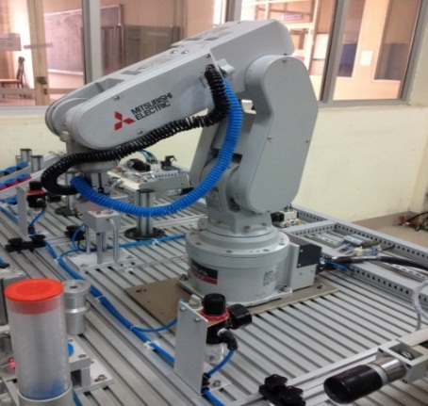We consider the two-link IRM in electric power substation model is shown in Fig. 3, the dynamic equation can be described by using Lagrange method.

Fig. 3. The two link IRM

$$\left[\begin{matrix}M_{11}(q_{2}) & M_{12}(q_{2}) \\ { M}_{21}(q_{2}) & M_{22}(q_{2})\end{matrix}\right]\left[\begin{matrix}{\ddot{q}}_{1} \\ {\ddot{q}}_{2}\end{matrix}\right]+\left[\begin{matrix}{ C}_{11}(q_{2}) & C_{12}(q_{2}) \\ { C}_{21}(q_{2}) & C_{22}(q_{2})\end{matrix}\right]\left[\begin{matrix}{\dot{ q}}_{1} \\ {\dot{ q}}_{2}\end{matrix}\right]+\left[ \begin{matrix}F_{1}\left({\dot{q}}_{1}\right) \\ F_{2}\left({\dot{q}}_{2}\right)\end{matrix}\right]+\left[\begin{matrix}{ G}_{1}\left(q_{1},q_{2}\right) \\ { G}_{2}\left(q_{1},q_{2}\right)\end{matrix}\right]+\left[ \begin{matrix}D_{e1} \\ D_{e2}\end{matrix}\right]=\left[ \begin{matrix}τ_{1} \\ τ_{2}\end{matrix}\right]$$

where

$\left[\begin{matrix}M_{11}\left(q_{2}\right) & M_{12}\left(q_{2}\right) \\ { M}_{21}\left(q_{2}\right) & M_{22}\left(q_{2}\right)\end{matrix}\right]=\left[\begin{matrix}\left(m_{1}+m_{2}\right)l_{1}^{2}+m_{2}l_{2}^{2}+2m_{2}l_{1}l_{2}cos\left(q_{2}\right) & m_{2}l_{2}^{2}+m_{2}l_{1}l_{2}cos\left(q_{2}\right) \\ m_{2}l_{2}^{2}+m_{2}l_{1}l_{2}cos\left(q_{2}\right) & m_{2}l_{2}^{2}\end{matrix}\right]$

$\left[\begin{matrix}{ C}_{11}(q_{2}) & C_{12}(q_{2}) \\ { C}_{21}(q_{2}) & C_{22}(q_{2})\end{matrix}\right]=\left[\begin{matrix}-m_{2}l_{1}l_{2}sin⁡(q_{2}){\dot{q}}_{2} & -m_{2}l_{1}l_{2}({\dot{q}}_{1}+{\dot{q}}_{2})sin⁡(q_{2}) \\ m_{2}l_{1}l_{2}sin⁡(q_{2}){\dot{q}}_{1} & 0\end{matrix}\right]$

$\left[ \begin{matrix}F_{1}\left({\dot{q}}_{1}\right) \\ F_{2}\left({\dot{q}}_{2}\right)\end{matrix}\right]=\left[ \begin{matrix}0.8 sign\left({\dot{q}}_{1}\right) \\ 0.5 sign\left({\dot{q}}_{2}\right)\end{matrix}\right]$

$\left[\begin{matrix}{ G}_{1}\left(q_{1},q_{2}\right) \\ { G}_{2}\left(q_{1},q_{2}\right)\end{matrix}\right]=\left[\begin{matrix}\left(m_{1}+m_{2}\right)l_{1}g cos\left(q_{2}\right)+m_{2}l_{2}g cos⁡(q_{1}+q_{2}) \\ m_{2}l_{2}g\cos\left(q_{1}+q_{2}\right) \end{matrix}\right]$

$D_{e1}=D_{e2}=0.5 sin(t)$; $τ=\left[ \begin{matrix}τ_{1} \\ τ_{2}\end{matrix}\right]$

where $m_{1} and m_{2}$ are links masses; $l_{1} and l_{2}$ are links lengths; $g=10(m/s^{2})$ is acceleration of gravity.

The parameters of two link IRM in electric power substation are given by table 1.

1. Parameters of IRM

|  |  |  |
| --- | --- | --- |
| **Link** | **Mass (kg)** | **Length (m)** |
| Link 1 | 2 | 0.8 |
| Link 2 | 1 | 1 |

The object is to design control input in order to force joint variables $q={\left[\begin{matrix}q_{1} & q_{2}\end{matrix}\right]}^{T}$ to track desired trajectories as time goes to infinity. The desired position trajectories of the two link IRM in electric power substation are chosen by $q_{d}(t)={\left[\begin{matrix}q_{d1} & q_{d2}\end{matrix}\right]}^{T}={\left[\begin{matrix}0.5\sin\left(πt\right) & 0.5\sin\left(πt\right)\end{matrix}\right]}^{T}$, and initial positions of joints are $q(0)={\left[\begin{matrix}0.1 & -0.1\end{matrix}\right]}^{T}$, and initial velocities of joints are $\dot{q}(0)={\left[\begin{matrix}0.0 & 0.0\end{matrix}\right]}^{T}$. The tracking errors are defined as: $e=q_{d}-q={\left[\begin{matrix}e_{1} & e_{2}\end{matrix}\right]}^{T}$. The parameter values used in the adaptive control system are chosen for the convenience of simulations as follows

$λ=diag[5,5]$; $K_{P}=diag[50,50]$; $K_{s}=diag[0.09,0.09]$

The element of the gain matrixes in the adaptive control law (22) are selected as: $Θ_{w}=10;Θ_{δ}=10;Θ_{ρ}=10$; $γ=0.001$

In the following passage, this proposed control scheme is applied to the IRM in comparison with the proportional integral differential (PID) control and the adaptive Fuzzy (AF) control [9]. The control law of the PID controller can be defined as follows

$$τ_{PID}=K_{P}e\left(t\right)+K_{I}\int_{0}^{t}{e\left(t\right)dt}+K_{D}\dot{e}(t)$$

where $K_{P},K_{I},K_{D}$ denote proportional, integral and differential gain matrices, respectively, and they are chosen according to the Ziegler-Nichols tuning rule based on the step response of the robot manipulators control system. They were selected as $K_{P}=diag\left[70,50\right]; K_{I}=diag\left[0.5,0.3\right], K_{D}=diag[500,350]$

The simulation comparisons of joint position responses, tracking errors and control torques of PID, AF control and this proposed scheme in following the desired trajectories for joint 1 and joint 2 are shown in Fig. 4. From these simulation results, this proposed intelligent control system converges to the desired trajectory more quickly and achieves tracking performance better than both the case with PID and AF control. Therefore, comparing with the existing results the use of this proposed scheme with adaptation weights can effectively improve the performance of the closed- loop system. It means that the robust tracking performance of this proposed intelligent control

## Experimemtal Results

In this experimental section, two different experimental cases were conducted to investigate the chattering phenomena when the load of manipulators changed. The first experimental case assumed that 2(kg) were added to the masses of two links IRM as in Table 1 with the same desired trajectories and the other parameters as in the simulation case. The robust tracking performance of the proposed intelligent control scheme applicability and the performance of the proposed technique to consider the performance under various environments which are the parameter variation, and the change of the external disturbance were evaluated. The mechanical structure, the control system, and working principle of the IRM system are shown in Figure 5, respectively.

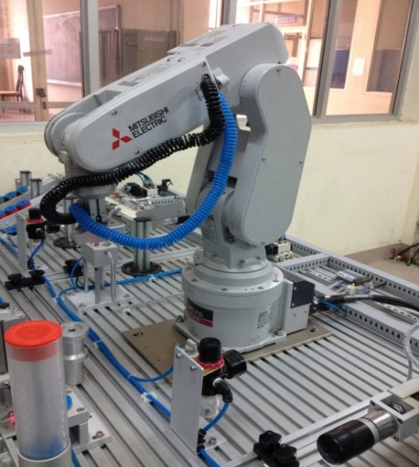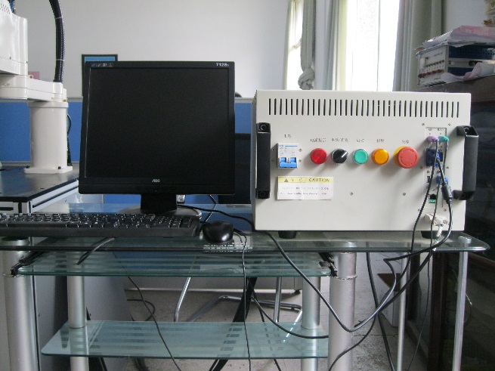

Fig.5. The experiment system of CDRM

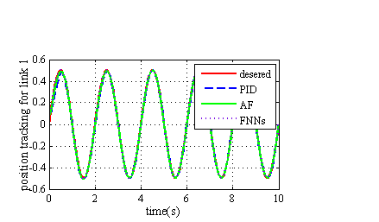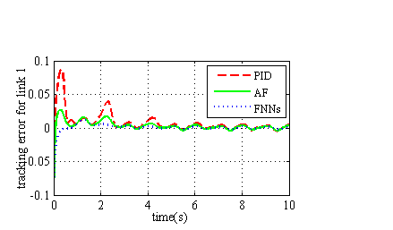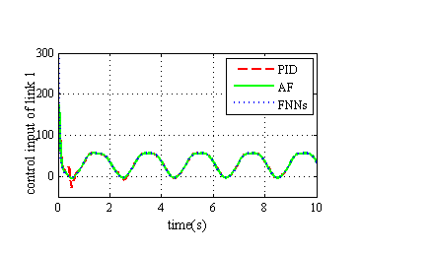

Fig. 4. Simulated results of position responses, tracking errors, control efforts of PID, AF control and the proposed control system

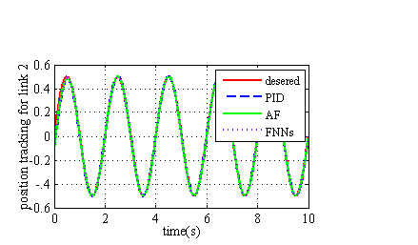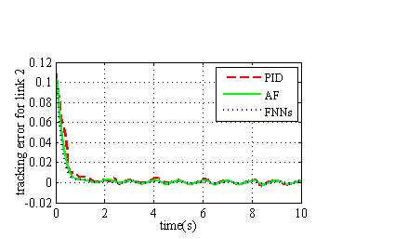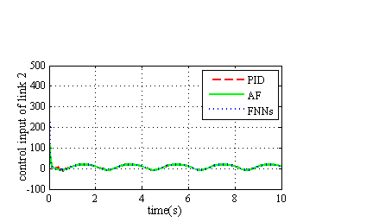

In the first experimental case, the masses of two links IRM were increased by 2(kg) as shown in Table 1. The desired trajectories and other parameters were kept the same as in the simulation case.

The experimental results of joint position responses, tracking errors, and control torques are presented in Figure 6. The results indicate that the responses and the tracking error norm of this proposed control scheme are significantly better than both PID and AF control methods. Additionally, Figure 6 implies that our control torques are less and smoother than the PID control and AF control in [22], which still exist the is better than the PID and AF control in [22] under parameter variation.

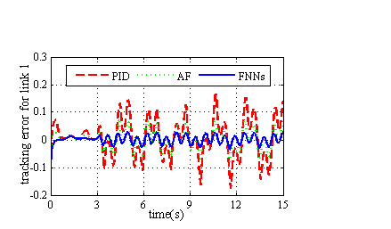

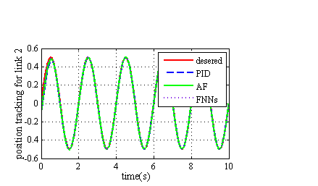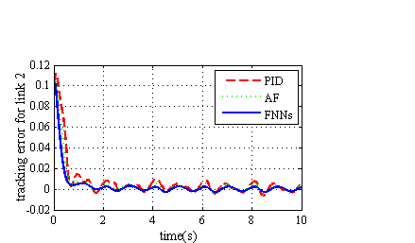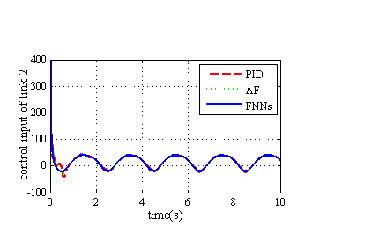

Fig. 6. Experimental results of position responses, tracking errors, and control efforts for the first case

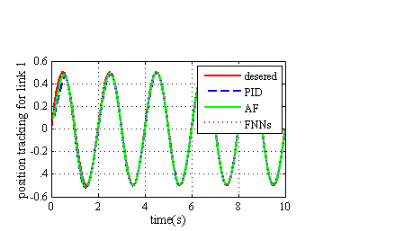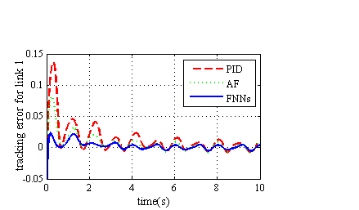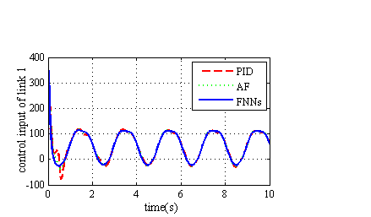

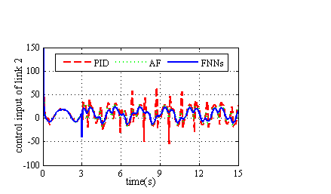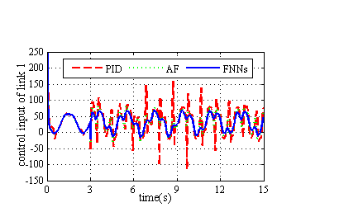

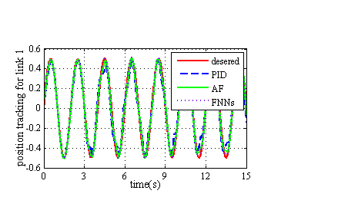





Fig.7. Experimental results of position responses, tracking errors, and control efforts for the second case

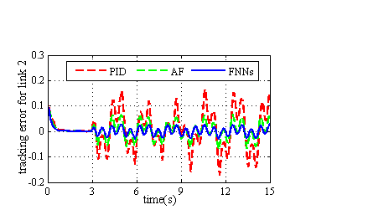

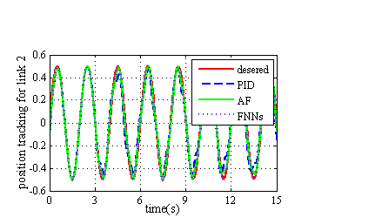



The second experimental case is assumed that the external disturbance $d_{e}\left(t\right)$ is suddenly injected more into control system when the robot is tracking a trajectory. This happened after the first 3s of the experimental time, and all other parameters are chosen as in the simulation case. The external disturbance shapes are expressed as follows:

$d_{e}\left(t\right)={\left[\begin{matrix}25\sin\left(15t\right) & 50\sin\left(15t\right)\end{matrix}\right]}^{T}$

The experimental responses of joint position, tracking error and control torque for the second case are shown in Fig.7. From these experimental results, we can find that, the performance of PID approach is seriously affected, while the performance of this proposed intelligent control approach is only slightly affected. Therefore, the control performance and robustness of this proposed intelligent controller under external disturbance are better than PID and AF controllers [22].

# Conclusion

This paper presents a successful design of an intelligent robust adaptive trajectory tracking Sliding Mode Control (SMC) using Fuzzy Neural Networks (FNNs) to control the joints of a two-link industrial robot manipulator (IRM) in an electric power substation. The proposed control scheme achieves high precision position tracking under various environments. All the adaptive learning laws of the control system are adjusted based on the Lyapunov stability theorem, ensuring the estimation convergence, stability robustness, uniformly ultimate boundedness, and tracking performance of this proposed intelligent control system. The simulation and experiment results were conducted on a two-link IRM, and comparisons were made with the performance of PID control and AF control. Finally, as demonstrated in the illustrated simulation and experiment results, the proposed intelligent control scheme not only achieves high precision position tracking and good robustness but also removes the chattering phenomenon in the trajectory tracking control of a two-link IRM in an electric power substation under various environments, which are joint friction, parameter variation, and external disturbances, over the existing results. This proposed intelligent method can be applied as a good alternative in the existing IRM control system.

##### Acknowledgment

This work was supported by National Natural Science Foundation of China (Grant No. 61175075) National Hightech Research and Development Projects (Grant Nos. 2012AA 112312, 2012AA11004). We acknowledge the support of time and facilities from Hunan University (HNU) and Hanoi University of Industry (HaUI) for this study.

##### References

[1] Jung, S, “Sliding Mode Control for a Hybrid Force Control Scheme of a Robot Manipulator Under Uncertain Dynamics*,” Int. J. Control Autom. Syst*. 21, pp. 1634–1643, 2023.

[2] Liang, J., Chen, Y., Lai, N. et al. “Robust Observer-based Trajectory Tracking Control for Unmanned Aerial Manipulator,” *Int. J. Control Autom. Syst*. 21, pp. 616–629, 2023.

[3] Huang, Z., Sun, C, “Adaptive Global Robust Tracking Control for Uncertain Dynamic Systems,” *Int. J. Control Autom. Syst*. 21, pp. 1070–1079, 2023.

[4] Bhardwaj, G., Sukavanam, N. & Raman, B, “Fast Terminal Discrete-time Sliding Mode Control with Fuzzy-based Impedance Modulation for Toe Foot Bipedal Robot Going Upstairs,” *Int. J. Control Autom. Syst.* 21, pp.1659–1669, 2023.

[5] Chen, J., Zhao, C., Tang, Q. et al. “Low Chattering Trajectory Tracking Control of Non-singular Fast Terminal Sliding Mode Based on Disturbance Observer*,” Int. J. Control Autom. Syst.* 21, pp. 440–451, 2023.

[6] Kargin, T.C., Kołota, J. A, “Reinforcement Learning Approach for Continuum Robot Control,” *J Intell Robot Syst,* vol. 109, no. 77, 2023.

[7] Hollweg, G.V., Evald, P.J.D., Tambara, R.V. et al. “A Modified Robust Adaptive Super-twisting Sliding Mode Controller for Grid-connected Converters,” *Int. J. Control Autom. Syst.* 21, pp. 3151–3165, 2023.

[8] Jiang, DG., Lv, LJ., Jiang, W. et al. “Nonsingular Fast Terminal Sliding Mode Control for Uncertain Nonlinear Systems Based on Adaptive Super-twisting Sliding Mode Disturbance Observer,”  *Int. J. Control Autom. Syst*. 21, pp. 3210–3223, 2023.

[9] Gholami, A., Sun, JQ. & Ehsani, R. “Neural Networks Based Optimal Tracking Control of a Delta Robot With Unknown Dynamics*,”  Int. J. Control Autom. Syst*. 21, pp. 3382–3390, 2023.

[10] Narayan, J., Abbas, M., Patel, B. et al. “Adaptive RBF neural network-computed torque control for a pediatric gait exoskeleton system: an experimental study,” *Intel Serv Robotics*, vol. 16, pp. 549–564, 2023.

[11] X. Zhao, Z. Liu, B. Jiang and C. Gao, "Switched Controller Design for Robotic Manipulator via Neural Network-Based Sliding Mode Approach," *in IEEE Transactions on Circuits and Systems II: Express Briefs,* vol. 70, no. 2, pp. 561-565, Feb. 2023.

[12] Brahmi, B., Driscoll, M., Laraki, M.H. *et al.* “Adaptive high-order sliding mode control based on quasi-time delay estimation for uncertain robot manipulator”. *Control Theory Technol.* Vol. **18**, pp. 279–292, 2020.

[13] Li, Z., Ma, L., Meng, Z. *et al.* “Improved sliding mode control for mobile manipulators based on an adaptive neural network”. *J Mech Sci Technol, vol.* **37**, pp. 2569–2580, 2023.

[14] Li, X., Gao, H., Xiong, L. *et al.* “A Novel Adaptive Sliding Mode Control of Robot Manipulator Based on RBF Neural Network and Exponential Convergence Observer”. *Neural Process Lett* **55**, pp.10037–10052, 2023.

[15] Bao, L., Kim, D., Yi, SJ. *et al. “* Design of a Sliding Mode Controller with Fuzzy Rules for a 4-DoF Service Robot”. *Int. J. Control Autom. Syst.* **19**, pp. 2869–2881, 2021.

[16] Xu, Z., Yang, X., Zhang, W. *et al.* “Backstepping Sliding Mode Control Based on Extended State Observer for Robotic Manipulators with LuGre Friction,” *Int. J. Control Autom. Syst.* vol. **20**, pp.2054–2066, 2022.

[17] Chen, X., Zhang, W., Zhang, H. et al. “Adaptive Control Design and Fractional Differential Inequality Approach to Complete Synchronization Analysis on Caputo Delayed Quaternion-valued Network Systems,” *Int. J. Control Autom. Syst*., vol. 21, pp. 3274–3284, 2023.

[18] Tao Zhao, Peng Qin, Songyi Dian, Bin Guo, “[Fractional order sliding mode control for an omni-directional mobile robot based on self-organizing interval type-2 fuzzy neural network](https://www.sciencedirect.com/science/article/pii/S0020025523014044),” *Information Sciences*, vol. 654, pp. 119819, 2024.

[19] Afaq, M., Jebelli, A. & Ahmad, R. “An Intelligent Thermal Management Fuzzy Logic Control System Design and Analysis Using ANSYS Fluent for a Mobile Robotic Platform in Extreme Weather Applications,”  *J Intell Robot Syst,* vol. 107, no. 11, 2023.

[20] Liu, Q., Ye, M., Wu, Z. et al. “Adaptive Fuzzy Finite Time Prescribed Performance Control for Long Stroke Hybrid Robots*,”  Int. J. Control Autom. Syst*. vol. 21, pp. 3116–3126, 2023.

[21] Kashyap, A.K., Parhi, D.R, “Modified type-2 fuzzy controller for intercollision avoidance of single and multi-humanoid robots in complex terrains,” *Intel Serv Robotics*, vol. 16, pp. 87–108, 2023.

[22] Sun F C, Sun Z Q, Feng G, “An adaptive fuzzy controller based on sliding mode for robot manipulators,” *Systems, Man, and Cybernetics, Part B: Cybernetics, IEEE Transactions on*, vol. 29, no. 5, pp. 661-667, 1999.

[23] Zhiyu X, Gang F, Hesketh T, “Piecewise Integral Sliding-Mode Control for T-S Fuzzy Systems,” *IEEE Transactions on*, vol. 19, no. 1, pp 65-74, 2010.

[24] Kunming Zheng, Qiuju Zhang, Li Peng, Shuisheng, “[Adaptive memetic differential evolution-back propagation-fuzzy neural network algorithm for robot control](https://www.sciencedirect.com/science/article/pii/S0020025523005091),” *Information Sciences,* vol. 637, pp. 118940, 2023

[25] Xunkai Gao, Haisheng Yu, Qing Yang, Xiangxiang Meng, Pengxin Zhang, “[Neural network based dynamic surface integral nonsingular fast terminal sliding mode control for manipulators with disturbance rejection](https://www.sciencedirect.com/science/article/pii/S0016003223004891),” *Journal of the Franklin Institute*, vol. 360, no.15, pp. 11032-11054, 2003.

[26] Xiuxing Yin, Li Pan, Shibo Cai, “[Robust adaptive fuzzy sliding mode trajectory tracking control for serial robotic manipulators](https://www.sciencedirect.com/science/article/pii/S0736584518302060),” *Robotics and Computer-Integrated Manufacturing*, vol. 72, pp 101884, 2021.

[27] Peng L, Peng-Yung W, “Neural-fuzzy control system for robotic manipulators. Control Systems,” IEEE, vol. 22, no. 1, pp. 53-63, 2002.

[28] Meng Joo E, Yang G, “Robust adaptive control of robot manipulators using generalized fuzzy neural networks. Industrial Electronics,” IEEE Transactions on, vol, 50, no. 3, pp. 620-628, 2003.

[29] Huang, J., Chen, J., Yang, H. et al. Vehicle Platoon Tracking Control Based on Adaptive Neural Network Algorithm. Int. J. Control Autom. Syst. 21, 3405–3418, 2023.

[30] Paszkowiak, W., Pelic, M. & Bartkowiak, T. A Neural-network-based Control System for a Dynamic Model of Tractor With Multiple Trailers System. Int. J. Control Autom. Syst. 21, 3456–3469 (2023)

[31] Benrabah, M., Kara, K., AitSahed, O. et al. Adaptive Fourier Series Neural Network PID Controller. Int. J. Control Autom. Syst. 19, 3388–3399, 2021.

[32] Wen, Q., Yang, X., Huang, C. et al. Disturbance Observer-based Neural Network Integral Sliding Mode Control for a Constrained Flexible Joint Robotic Manipulator. Int. J. Control Autom. Syst. 21, 1243–1257, 2023.

[33] Zhang, Z., Chen, J., Mo, Z. et al. “A Behavior-based Adaptive Dynamic Programming Method for Multiple Mobile Manipulators Coordination Control,” *Int. J. Control Autom. Syst*. vol. 21, pp.3022–3035, 2023.

[34] Guan, X., Hu, Y., Jin, Z. et al. Finite-time Sliding Mode Fault-tolerant Control for Networked Control Systems With Intermittent Fault Under Event-triggered Scheme. Int. J. Control Autom. Syst. 21, 3259–3273, 2023.

[35] Jiabin Hu, Dan Zhang, Zheng Guang Wu, Hongyi Li, “[Neural network-based adaptive second-order sliding mode control for uncertain manipulator systems with input saturation](https://www.sciencedirect.com/science/article/pii/S0019057822006164),” *ISA Transactions,* vol.136, pp 126-138, 2023.

[36] [Zhijun Zhang](https://ieeexplore.ieee.org/author/37085475581), [Lunan Zheng](https://ieeexplore.ieee.org/author/37086105744), [Zhuoming Chen](https://ieeexplore.ieee.org/author/37086590752), [Lingdong Kong](https://ieeexplore.ieee.org/author/37086560752), Hamid Reza Karimi, “ Mutual – Collision – Avoidance Scheme Synthesized by Neural Networks for Dual Redundant Robot Manipulators Executing Cooperative Tasks,” IEEE Transactions on on Neural Networks and Learning Systems, vol. 32, no. 3, pp. 1052-1066, 2021.

[37] [Zhan Li](https://ieeexplore.ieee.org/author/37085834060); [Shuai Li](https://ieeexplore.ieee.org/author/37086085139), “ Neural Network Model-Based Control for Manipulator,”[*IEEE Transactions on Neural Networks and Learning Systems*](https://ieeexplore.ieee.org/xpl/RecentIssue.jsp?punumber=5962385)*, vol.* 34, no. 6, pp. 2854-2868, 2023.

[38] [Vignesh Narayanan](https://ieeexplore.ieee.org/author/37085609582), [Sarangapani Jagannathan](https://ieeexplore.ieee.org/author/37275247700), [Kannan Ramkumar](https://ieeexplore.ieee.org/author/38246156200), “Event Sampled Feedback Output Control of Robot Manipulators Using Neural Networks,” IEEE Transactions on Neural Networks and Learning Systems, vol. 30, no. 6, pp. 1651-1658, 2019.

[39] [Xiaoxiao Li](https://ieeexplore.ieee.org/author/37088231106), [Zhihao Xu](https://ieeexplore.ieee.org/author/37086308586), [Shuai Li](https://ieeexplore.ieee.org/author/37086085139), [Hongmin Wu](https://ieeexplore.ieee.org/author/37085336289), [Xuefeng Zhou](https://ieeexplore.ieee.org/author/37406422900), “[Cooperative Kinematic Control for Multiple Redundant Manipulators Under Partially Known Information Using Recurrent Neural Network](https://ieeexplore.ieee.org/document/9000634/),” [*IEEE Access*](https://ieeexplore.ieee.org/xpl/RecentIssue.jsp?punumber=6287639), vol. 8, pp. 40029-40038, 2020.

[40] Mulero-Martinez J I, “Robust GRBF Static Neurocontroller With Switch Logic for Control of Robot Manipulators,” *Neural Networks and Learning Systems, IEEE Transactions on,* vol. 23, no. 7, pp 1053-1064, 2012.

[41] Min-Jung L, Young-Kiu C, “An adaptive neurocontroller using RBFN for robot manipulators,” *Industrial Electronics, IEEE Transactions on*, vol. 51, no. 3, pp. 711-717, 2004.

[42] Caswara F M, Unbehauen H, “A neurofuzzy approach to the control of a flexible-link manipulator*,” Robotics and Automation, IEEE Transactions on*, vol. 18, no. 6, pp. 932-944, 2002.

[43] Yang G, Meng Joo E, Song Y, “Adaptive control of robot manipulators using fuzzy neural networks,” *Industrial Electronics, IEEE Transactions on* , vol. 48, no. 6, pp. 1274-1278, 2001.

[44] Jiang, C., Sui, S., Li, Y. et al. “Adaptive NN Output Feedback Control of Electro-hydraulic System*,”  Int. J. Control Autom. Syst.* 21, pp. 2739–2747, 2023.

[45] Lu, Z., Li, Y. & Li, Y., “A Novel Decentralized Fixed-time Tracking Control for Modular Robot Manipulators,” *Theoretical and Experimental Verification. Int. J. Control Autom. Syst*., vol. 21, pp 3036–3047, 2023.

[46] [Yiming Jiang](https://ieeexplore.ieee.org/author/37085825335), [Yaonan Wang](https://ieeexplore.ieee.org/author/37281429000), [Zhiqiang Miao](https://ieeexplore.ieee.org/author/37072064400), [Jing Na](https://ieeexplore.ieee.org/author/37393548200), [Zhijia Zhao](https://ieeexplore.ieee.org/author/37086302705), [Chenguang Yang](https://ieeexplore.ieee.org/author/37404783000), “[Composite-Learning-Based Adaptive Neural Control for Dual-Arm Robots With Relative Motion](https://ieeexplore.ieee.org/document/9305975/),” [*IEEE Transactions on Neural Networks and Learning Systems*](https://ieeexplore.ieee.org/xpl/RecentIssue.jsp?punumber=5962385), vol, 33, no. 3, pp. 1010-1021, 2022.

[47] Li, H., Chou, W., “ Adaptive FNN Backstepping Control for Nonlinear Bilateral Teleoperation With Asymmetric Time Delays and Uncertainties,” *Int. J. Control Autom. Syst*., vol. 21, pp. 3091–3104, 2023.

[48] [Wei He](https://ieeexplore.ieee.org/author/37532768100), [Zichen Yan](https://ieeexplore.ieee.org/author/37086111584), [Yongkun Sun](https://ieeexplore.ieee.org/author/37086521242), [Yongsheng Ou](https://ieeexplore.ieee.org/author/37264969100), [Changyin Sun](https://ieeexplore.ieee.org/author/37279060100), “[Neural-Learning-Based Control for a Constrained Robotic Manipulator With Flexible Joints](https://ieeexplore.ieee.org/document/8334699/),” [*IEEE Transactions on Neural Networks and Learning Systems*](https://ieeexplore.ieee.org/xpl/RecentIssue.jsp?punumber=5962385)*,* vol. 29, no.12, pp. 5993-6003, 2018.

[49] Dechao Chen, Shuai Li, Qing Wu, “ A Novel Supertwisting Zeroing Neural Network With Application to Mobile Robot Manipulators,” *in IEEE*  [*Transactions on Neural Networks and Learning Systems*](https://ieeexplore.ieee.org/xpl/RecentIssue.jsp?punumber=5962385)*,* vol. 32, no. 4, pp. 1776-1787, 2021.

[50] [Shuang Zhang](https://ieeexplore.ieee.org/author/37897024300), [Yue Wu](https://ieeexplore.ieee.org/author/37089331152), [Xiuyu He](https://ieeexplore.ieee.org/author/37085563394), [Jingyuan Wang](https://ieeexplore.ieee.org/author/37089569706), “[Neural Network-Based Cooperative Trajectory Tracking Control for a Mobile Dual Flexible Manipulator](https://ieeexplore.ieee.org/document/9754702/),”[*IEEE Transactions on Neural Networks and Learning Systems*](https://ieeexplore.ieee.org/xpl/RecentIssue.jsp?punumber=5962385)*,* vol. 34, no.9, 2023.

[51] [Haohui Huang](https://ieeexplore.ieee.org/author/37087007911), [Chenguang Yang](https://ieeexplore.ieee.org/author/37404783000), [C. L. Philip Chen](https://ieeexplore.ieee.org/author/38252718600), “[Optimal Robot–Environment Interaction Under Broad Fuzzy Neural Adaptive Control](https://ieeexplore.ieee.org/document/9122395/),” [*IEEE Transactions on Cybernetics*](https://ieeexplore.ieee.org/xpl/RecentIssue.jsp?punumber=6221036)*,* vol. 51, no. 7, pp. 3824-3835, 2021.

[52] [Jia Guo](https://ieeexplore.ieee.org/author/37089913090);[Huu-Thiet Nguyen](https://ieeexplore.ieee.org/author/37087050111);[Chao Liu](https://ieeexplore.ieee.org/author/37280622900);[Chien Chern Cheah](https://ieeexplore.ieee.org/author/37282378800), “[Convolutional Neural Network-Based Robot Control for an Eye-in-Hand Camera](https://ieeexplore.ieee.org/document/10088167/), [*IEEE Transactions on Systems, Man, and Cybernetics: Systems*](https://ieeexplore.ieee.org/xpl/RecentIssue.jsp?punumber=6221021)*,* vol. 53, no. 8, pp. 4764-4775, 2023.

[53] Fan, Y., Jing, W. & Bernelli-Zazzera, F., “Nonlinear Tracking Differentiator Based Prescribed Performance Control for Space Manipulator,” *Int. J. Control Autom. Syst*., vol. 21, pp. 876–889, 2023.

[54] L. Teng, M. A. Gull and S. Bai, "PD-Based Fuzzy Sliding Mode Control of a Wheelchair Exoskeleton Robot," *in IEEE/ASME Transactions on Mechatronics,* vol. 25, no. 5, pp. 2546-2555, Oct. 2020.

[55] Mojtaba Hadi Barhaghtalab, Mohammadreza Askari Sepestanaki, Saleh Mobayen, Bbolfazl Jalilvand, Afef Fekih, Vahid Meigoli, “[Design of an adaptive fuzzy-neural inference system-based control approach for robotic manipulators](https://www.sciencedirect.com/science/article/pii/S1568494623009882),” *Applied Soft Computing*, vol 149, pp. 110970, 2023.

[56] Xie F, Liang G, Chien YR, “Highly Robust Adaptive Sliding Mode Trajectory Tracking Control of Autonomous Vehicles,” Sensors (Basel), vol. 23, no. 7, 2023

[57] [Lunan Zheng](https://ieeexplore.ieee.org/author/37086105744), [Zhijun Zhang](https://ieeexplore.ieee.org/author/37085475581), “[Time-Varying Quadratic-Programming-Based Error Redefinition Neural Network Control and Its Application to Mobile Redundant Manipulators](https://ieeexplore.ieee.org/document/9616370/),” [*IEEE Transactions on Automatic Control*](https://ieeexplore.ieee.org/xpl/RecentIssue.jsp?punumber=9), vol. 67, no. 11, pp. 6151-6158, 2022.

[58] [Dianye Huang](https://ieeexplore.ieee.org/author/37086287721), [Chenguang Yang](https://ieeexplore.ieee.org/author/37404783000), [Yongping Pan](https://ieeexplore.ieee.org/author/38063351100), [Long Cheng](https://ieeexplore.ieee.org/author/37292880600), “[Composite Learning Enhanced Neural Control for Robot Manipulator With Output Error Constraints](https://ieeexplore.ieee.org/document/8926368/),” [*IEEE Transactions on Industrial Informatics*](https://ieeexplore.ieee.org/xpl/RecentIssue.jsp?punumber=9424)*,* vol.17, no. 1, pp. 209 - 218, 2021.

[59] Wang, H., Wang, T., Chen, J. et al., “Design and locomotion analysis of an arm-wheel-track multimodal mobile robot,” *Intel Serv Robotics*, vol. 16, pp. 485–495, 2023.

[60] Rhee, I., Kang, G., Moon, S.J. et al., “Hybrid impedance and admittance control of robot manipulator with unknown environment,” *Intel Serv Robotics*, vol. 16, pp. 49–60, 2023.

[61] [Tianjiao An](https://ieeexplore.ieee.org/author/37086929769), [Yuexi Wang](https://ieeexplore.ieee.org/author/37088473831), [Guangjun Liu](https://ieeexplore.ieee.org/author/37293590600), [Yuanchun Li](https://ieeexplore.ieee.org/author/37292409700), [Bo Dong](https://ieeexplore.ieee.org/author/38075140600), “[Cooperative Game-Based Approximate Optimal Control of Modular Robot Manipulators for Human–Robot Collaboration](https://ieeexplore.ieee.org/document/10132597/),” [*IEEE Transactions on Cybernetics*](https://ieeexplore.ieee.org/xpl/RecentIssue.jsp?punumber=6221036), vol. 53, no,7, pp. 4691-470, 2023.

[62] Sai, H., Xu, Z., Zhang, E. et al., “Chattering-free Fast Fixed-time Sliding Mode Control for Uncertain Robotic Manipulators,” *Int. J. Control Autom. Syst*., vol. 21, pp. 630–644, 2023.

[63] [Chenguang Yang](https://ieeexplore.ieee.org/author/37404783000), [Guangzhu Peng](https://ieeexplore.ieee.org/author/37086086586), [Long Cheng](https://ieeexplore.ieee.org/author/37292880600), [Jing Na](https://ieeexplore.ieee.org/author/37393548200), [Zhijun Li](https://ieeexplore.ieee.org/author/37309823400), “[Force Sensorless Admittance Control for Teleoperation of Uncertain Robot Manipulator Using Neural Networks](https://ieeexplore.ieee.org/document/8751136/),”[*IEEE Transactions on Systems, Man, and Cybernetics: Systems*](https://ieeexplore.ieee.org/xpl/RecentIssue.jsp?punumber=6221021), vol. 51, no. 5, pp. 1-11, 2021.

[64] Ding, L., Liu, K., Zhu, G. et al., “Adaptive Robust Control via a Nonlinear Disturbance Observer for Cable-driven Aerial Manipulators,” *Int. J. Control Autom. Syst.,* vol. 21, pp. 604–615, 2023.

[65] [Zhihao Xu](https://ieeexplore.ieee.org/author/37086308586), [Shuai Li](https://ieeexplore.ieee.org/author/37086085139), [Xuefeng Zhou](https://ieeexplore.ieee.org/author/37406422900), [Songbin Zhou](https://ieeexplore.ieee.org/author/37088545622), [Taobo Cheng](https://ieeexplore.ieee.org/author/37085900342), [Yisheng Guan](https://ieeexplore.ieee.org/author/37402001000), “[Dynamic Neural Networks for Motion-Force Control of Redundant Manipulators: An Optimization Perspective](https://ieeexplore.ieee.org/document/8984689/),” [*IEEE Transactions on Industrial Electronics*](https://ieeexplore.ieee.org/xpl/RecentIssue.jsp?punumber=41)*,* vol. 34, no.8, pp. 1-11, 2023.

[66] Wang, Y., Yang, H. & Deng, W., “A New Practical Robust Adaptive Control of Cable-driven Robots,” *Int. J. Control Autom. Syst*., vol. 21, pp. 2685–2697, 2023.

[67] [Chengzhi Zhu](https://ieeexplore.ieee.org/author/37088553323), [Yiming Jiang](https://ieeexplore.ieee.org/author/37085825335), [Chenguang Yang](https://ieeexplore.ieee.org/author/37404783000), “[Fixed-Time Neural Control of Robot Manipulator With Global Stability and Guaranteed Transient Performance](https://ieeexplore.ieee.org/document/9732268/),” [*IEEE Transactions on Industrial Electronics*](https://ieeexplore.ieee.org/xpl/RecentIssue.jsp?punumber=41), vol.70, no.1, pp. 803-812, 2023.

[68] [Yuling Li](https://ieeexplore.ieee.org/author/37085792962), [Liping Wang](https://ieeexplore.ieee.org/author/37086914070), [Kun Liu](https://ieeexplore.ieee.org/author/37085579509), [Wei He](https://ieeexplore.ieee.org/author/37532768100), [Yixin Yin](https://ieeexplore.ieee.org/author/37291137500), [Rolf Johansson](https://ieeexplore.ieee.org/author/37301199800), “[Distributed Neural-Network-Based Cooperation Control for Teleoperation of Multiple Mobile Manipulators Under Round-Robin Protocol](https://ieeexplore.ieee.org/document/9612720/),” [*IEEE Transactions on Neural Networks and Learning Systems*](https://ieeexplore.ieee.org/xpl/RecentIssue.jsp?punumber=5962385), vol. 34, no.8, pp. 4841-4855, 2023.

[69] Lin F J, Shen P H, Hsu S P, “Adaptive backstepping sliding mode control for linear induction motor drive,” *Electric Power Applications, IEE Proceedings*, vol. 149, no. 3, pp. 184-194, 2002.

[70] Wadoo S A, “Sliding Mode Control of Crowd Dynamics,” *Control Systems Technology, IEEE Transactions on,* vol. 21, no. 3, pp. 1008-1015, 3013.

[71] Zhang Q, Benveniste A, “Wavelet networks. Neural Networks,” *IEEE Transactions on*, vol. 3, no. 6, pp. 889-898, 1992.

[72] Y. Su, "Comments on “A New Adaptive Sliding-Mode Control Scheme for Application to Robot Manipulators”," *in IEEE Transactions on Industrial Electronics*, vol. 67, no. 8, pp. 7116-7120, Aug. 2020.

[73] T. N. Truong, A. T. Vo and H. -J. Kang, "A Backstepping Global Fast Terminal Sliding Mode Control for Trajectory Tracking Control of Industrial Robotic Manipulators," *in IEEE Access*, vol. 9, pp. 31921-31931, 2021.

[74] R. -D. Xi, X. Xiao, T. -N. Ma and Z. -X. Yang, "Adaptive Sliding Mode Disturbance Observer Based Robust Control for Robot Manipulators Towards Assembly Assistance," *in IEEE Robotics and Automation Letters*, vol. 7, no. 3, pp. 6139-6146, July 2022.

[75] J. Choi, J. Baek, W. Lee, Y. S. Lee and S. Han, "Adaptive Model-Free Control With Nonsingular Terminal Sliding-Mode for Application to Robot Manipulators," *in IEEE Access*, vol. 8, pp. 169897-169907, 2020.

[76] Lewis F L, Abdallah C T, Dowson D M, “Control of Robot Manipulators,” New York:Macmillan, 1993.

[77] Shun-Feng S, Zne-Jung L, Yan-Ping W, “Robust and fast learning for fuzzy cerebellar model articulation controllers,” Systems, Man, and Cybernetics, Part B: Cybernetics, IEEE Transactions on., vol. 36, no. 1, pp. 203-208, 2006.

[78] Xingjian Sun, Lei Zhang, Juping Gu, “Neural-network based adaptive sliding mode control for Takagi-Sugeno fuzzy systems,” [*Information Sciences*](https://www.sciencedirect.com/journal/information-sciences)*,* vol 628, pp. 240-253, 2023

[79] Saim Ahmed, Ahmad Taher Azar , Ibrahim A. Hameed, “ Fractional-order Fixed-time Non-singular Sliding Mode Control for Nonlinear Robotic Manipulators,” [*IFAC-PapersOnLine*](https://www.sciencedirect.com/journal/ifac-papersonline), vol 56, no.2, pp. 8105-8110, 2023

[80] Dong Guo, [Jun Liu](https://ieeexplore.ieee.org/author/151583408304394), [Song Zheng](https://ieeexplore.ieee.org/author/37087915192), [Jian-Ping Cai](https://ieeexplore.ieee.org/author/37856598000), [Peng Jiang](https://ieeexplore.ieee.org/author/37089320600), “[Singularity-Free Fixed-Time Neuro-Adaptive Control for Robot Manipulators in the Presence of Input Saturation and External Disturbances](https://ieeexplore.ieee.org/document/10375375/),” *in IEEE Access,* vol 12, pp. 1794-1804, 2024.

[81] David Feller, “[Kinematics of a Novel Serial-Parallel, Compliant, Three-Legged Robot](https://ieeexplore.ieee.org/document/10247050/),” *in IEEE Access*, vol 12, pp. 1794-1804, 2024.

[82] Nigora Gafur, [Gajanan Kanagalingam](https://ieeexplore.ieee.org/author/37086438506);[Achim Wagner](https://ieeexplore.ieee.org/author/37089194505);[Martin Ruskowski](https://ieeexplore.ieee.org/author/37086405564), “[Dynamic Collision and Deadlock Avoidance for Multiple Robotic Manipulators](https://ieeexplore.ieee.org/document/9779146/),” *in IEEE Access,* vol 10, pp. 55766-55781, 2022.

[83] Hao-Lun Huang, [Ming-Yang Cheng](https://ieeexplore.ieee.org/author/37288099700), [Tzu-Yuan Huang](https://ieeexplore.ieee.org/author/37086748530), “[A Rapid Base Parameter Physical Feasibility Test Algorithm for Industrial Robot Manipulator Identification Using a Recurrent Neural Network](https://ieeexplore.ieee.org/document/10365150/),” *in IEEE Access*, vol 1, pp. 1-13, 2023.