Adaptive FVFH+ through Fuzzy Logic: A Case Study in Motion Planning for Quadcopters

Khitam Mohammed 1, Ali Aliedani 2, Alaa Al-Ibadi 3

1, 2, 3, Department of Computer Engineering, University of Basrah, Basrah, Iraq

Email: 1 engpg.khitam.mohamed@uobasrah.edu.iq, 2 ali.nabeel@uobasrah.edu.iq, 3 alaa.abdulhassan@uobasrah.edu.iq

*Abstract*—This study presents an enhancement of the vector field histogram plus (VFH+) motion planning algorithm to improve its performance in the navigation domains of autonomous quadcopters. The proposed method is based on the integration of fuzzy control to dynamically adjust VFH+ Look ahead distance (LAD) parameter based on a continuous analysis of the environment and motion conditions. The simulation was implemented in multiple environments including environments with large, few and medium number of obstacles, as well as waypoints. Simulation results demonstrated the effectiveness of this approach in improving the performance of the quadcopter's motion in variable environments. Performance was also measured in comparison with the classical VFH+, and the results showed a clear improvement in the quadcopter’s ability to avoid obstacles and achieve smooth motion with less travel time. Coherence in the face of uncertainty forms an essential part of the design of a real-time motion planning system. We use powerful motion planning to track the precise path of the quadcopter drone. Considering the environmental challenges of flying vehicles with using Fuzzy System knowledge base system to facilitate automatic tuning in our planning algorithm. The adaptive algorithm concept will enhance the quadcopter's ability to accommodate large uncertainty.

Keywords— Quadcopter; Motion planning; Fuzzy logic; VHF+; Unmanned aerial vehicles (UAVs); MATLAB; Parameters; Look_ ahead distance; Obstacle Avoidance.

# Introduction

Motion planning for quadcopters, also known as UAVs (Unmanned Aerial Vehicles), poses a fundamental challenge in robotic engineering and artificial intelligence [1]. These versatile devices find application in diverse fields, including exploration, monitoring high-risk individuals, delivering medical services for COVID-19, contactless food delivery, supplying medicines to homebound patients, improving obstacle avoidance through neural network-enhanced drone systems, aerial photography, and addressing logistical challenges with innovative solutions [2-10].

Despite the growing interest in quadcopters due to their ability to navigate complex environments effectively, challenges persist in achieving autonomous and reliable travel without human intervention [11-16]. To ensure successful flights and mission accomplishment, quadcopters must perform motion planning, a process crucial for determining their path and directing movement in the surrounding environment [17-20]. This planning requires a delicate balance between goal achievement, obstacle avoidance, and effective interaction with the environment, particularly in changing and unknown surroundings where quick adaptation to potential challenges is essential.

Motion planning stands out as a crucial challenge in autonomous robots, significantly influencing a quadcopter's performance in practical applications. Improving motion planning techniques becomes imperative for safe and successful operations, whether the goal is obstacle avoidance during flight or efficient navigation to accomplish a specific task [16, 21]. Modern motion planning techniques, leveraging artificial intelligence methods, strike a balance between navigation precision and effective responses to sudden environmental changes, making quadcopters more adaptable to various scenarios and challenges [22-25].

Guided by principles of achieving the best possible path, the focus lies on path smoothness, shortest distance, and minimal energy consumption, emphasizing the importance of ensuring the shortest path in the least amount of time [26]. Defining the trajectory planning of a mobile robot is crucial for safe navigation towards a known destination, driving research in autonomous robotics to develop and enhance algorithms and strategies for motion planning, ultimately ensuring superior navigation operations [27-29].

# Related Work

A variety of strategies have been suggested for UAV motion planning implementation. These methods are based on several factors, including the robot's capabilities, type of sensors, environment, and algorithms. They aim to progressively improve performance in terms of speed, distance, safety, cost, smoothness, and complexity [30, 31]. Additionally, sensing[32], mapping[33], and re-planning are other UAV planning strategies that have been discussed in the literature for operation under unpredictable environments[34]. Utilizing artificial intelligence extends to the enhancements in vector field histogram algorithm VFH methods [35]. Specifically, artificial neural networks (ANN) and fuzzy systems (FS) have been incorporated[36, 37].

AH Hamad (2010). presented an improvement of the VFH algorithm using a neural network and a fuzzy algorithm to overcome its limitations to increase target guidance to improve the path planning of the mobile robot[38].

A Babinec (2012) Provided improvements to the vector field graph method used as interactive navigation for a mobile robot by replacing the ultrasonic sensors with the Hokuyo URG-04LX Laser Distance Measurer. This change provides higher accuracy for measuring distance. [39].

Danial D. (2020) proposed an improved algorithm called VFH+D, which takes into account a different method of introducing cell occupancy decay, allowing dynamic obstacle avoidance and a new equation for the obstacle vector size of the cell in the active window. This method requires fewer parameter tuning iterations for VFH+. D and more easily. However, with this method, VFH+ failed to reach the target in 7 out of 10 trials[40].

BL Kazim (2010) introduce Modified Vector Field Histogram (MVFH) algorithm that has been developed to enhance path planning and obstacle avoidance for a mobile robot. The algorithm relies on the concept of the "vector space" and demonstrates effectiveness in addressing environmental challenges, leveraging a neural network model to learn critical environmental conditions. The obstacle avoidance path is improved through the use of a digital filter, albeit requiring additional time. The complexity of the environment influences the time needed to reach the goal [41].

Y Yan, (2018) introduced VFH#, a local path planning method for intelligent vehicles, effectively navigating obstacles by addressing limitations in the previous VFH method. VFH# enlarges obstacles to avoid collisions, improves sensitivity issues, and achieved excellent results on an electric vehicle. While promising, there are still areas for improvement, highlighting the need for further research and refinement[42].

In conjunction with other global planning techniques, VFH+ is frequently utilized as a local planner (Yim and Park, 2014; Sary et al., 2018) to offer a dependable solution to the navigation problem (Pandey et al., 2017). This is because it is quick and robust in obstacle avoidance [40]. The biggest weakness in the VFH+ algorithm is that it requires fine-tuning of many parameters, which can be a challenge in many applications[43]. For UAVs (quadcopters), if the advance look ahead distance is not fine-tuned, this leads to the algorithm being unable to make effective decisions quickly, especially in complex environments [44].

In this work we proposed a new adaptive and improved version of VFH+ called Fuzzy Vector Field Histogram Plus (FVFH+) that overcomes these shortcomings. The parameters were adjusted more interactively with multiple and different environmental conditions using fuzzy logic in this improved algorithm, so that the proposed algorithm has the ability to avoid various obstacles in complex and simple environments, while improving the speed of the quadcopter and its success rate in reaching the target point while avoiding collisions

# Vector Field Histogram Plus VFH+

The algorithm Vector filed histogram plus (VFH+) is the enhanced obstacle avoidance technique based on the VFH algorithm. In 1998, Borenstein and Ulrich developed and implemented it[45]. This approach incorporates additional improvements to facilitate path planning and achieve better performance for obstacle avoidance. VFH+ employs a data reduction process across four stages to determine the most optimal direction towards the goal, building upon the VFH algorithm. The first three stages are utilized to construct a one-dimensional polar histogram based on a two-dimensional grid graph. The final stage is then used to determine the steering direction based on the polar histogram and cost function [46-50].

By accounting for the drone's width and possible trajectories, the vector histogram plus (VFH+) method enhances the VFH algorithm. Instead of using the two-stage data reduction that the VFH algorithm utilizes, the VFH+ method uses a four-stage approach to achieve this (Ulrich & Borenstein, 1998). The two-dimensional Cartesian histogram grid is used by the VFH+ method to produce a one-dimensional main polar histogram in the first step, which accounts for the robot's breadth. When the primary polar histogram is generated, each obstacle cell in the active zone is increased to account for the robot's breadth. Each obstacle cell is expanded by the width of the quadcopter plus an extra safety zone. Therefore, rq+s , where rq+s = rquadcopter + rsafety, is the safety area surrounding the obstacle as shown in Figure 1[51, 52].

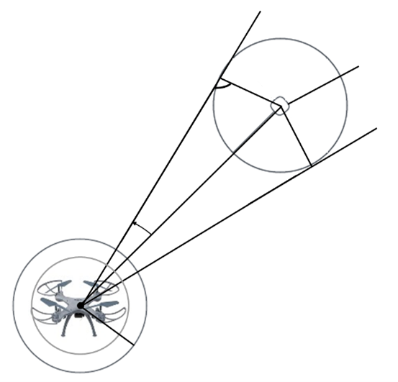

obstacle cell

Enlarged obstacle cell

rq+s

ϒji

dji

rq+s

1. The safety zone and width of the quadcopter (robot) are enlarging the obstacle (Ulrich & Borenstein, 1998).

In order to generate primary polar histograms in the first, second, and third stages—as well as steering candidate directions VFH+ uses computational data that includes a histogram grid. The following stages are taken by the VFH+ algorithm:

## Histogram Grid

For the ensuing computations, only the cells in an active window. Since the robot's center is located in the middle of the square-shaped active window *ws*× *w*, the number of cells on the edge of the active window must be odd. The number of cells on the border of the active window and the number of sectors (*k*) are empirical parameters that are optional and dependent on a variety of variables, including the robot's reaction time. Figure 2 illustrates an active window split into angular parts [53].

Equation 1 expresses the direction of an obstacle vector (β) from an active cell to the Vehicle Center Point (VCP) for each active cell (*i, j*) inside the 2D histogram grid:

$β_{i,j}= \tan^{-1}\left(\frac{y_{i}-y_{0}}{x_{i}-x_{0}}\right)$ (1)

Where:

$x_{0},y_{0}$ are the quadcopter's current position coordinates,

$x_{i},y_{i}$ are the active cell's coordinates



1. Histogram Grid.

In the original VFH technique, the robot's next step direction is determined by looking at only one histogram. In contrast, the VFH+ approach creates three histograms one at a time. Equation (2) is used to produce the first polar histogram, known as the principal one ($H_{p}$):

$H_{k}^{p}=\sum_{ij=c*}{m_{ij }.h_{ij}^{'} i; j ϵ k }$ (2)

The coordinates of the active cell c* in the active window C* are represented by the values i and j, whilst the index k indicates the sector number.

## First stage Histogram Polar

The sensor that measures distances at each angle resolution $d_{i}$ yields the Histogram Polar $H_{k}^{p}$. In an active window, the magnitude $m_{i}$ and angle $β_{i}$ of lidar sensor data are analyzed. The quadcopter's obstacles' positions ($x_{i}$, $y_{i}$). may be determined from the sensor readings. The quadcopter's location ($x_{0}$, $y_{0}$) is the source of $β_{i}$ and the obstacle to the current window ($x_{i}$, $y_{i}$). One may use Equation (1) to write angular equations $β_{i}$ Equation (3) represents the magnitude $m_{i}$ of the certainty value measurement sensor $c^{*}$, along with the distances $d_{i}$ in the active window:

$mi={\left(c_{i,j}^{*}\right)}^{2}.\left(a-b.{d_{i,j}^{2} d}_{i}\right)$ (3)

Where $a,b$ are positive constants,

$c_{i,j}^{*}$ i; j the active cell's (i, j) confidence value ,

$d_{i,j}$ is the distance between the VCP and the active cell *(i,j)*,

Equations

## Second stage Histogram Binary

After getting a polar histogram, the process of histogram binary $H^{b}$ is performed. This technique makes advantage of data processing, such as hysteresis properties, where the tuning process yields the lowest threshold *Ƭlow* τand maximum threshold *Ƭhigh* τ ..In order to transform polar obstacle density (POD) into binary numbers, open (0) and closed (1)[54].

$h_{k.i}^{b}=1 if h_{k.i}^{p} >$*Ƭhigh*

*Ƭlow*

Others

## Third stage The Masked Polar Histogram

the masked polar histogram *Hm* is used to determine if a region is possible for the robot to pass through based on its circular movement when avoiding obstacles , as seen in figure 3 [55, 56].



1. (Ulrich & Borenstein, 1998) shows the histogram representation of the primary polar histogram, binary polar histogram, and masked polar histogram.

## Forth stage steering direction

Based on the various candidate directions the VFH+ algorithm determines which direction to drive the robot in. , shown in figure 4,

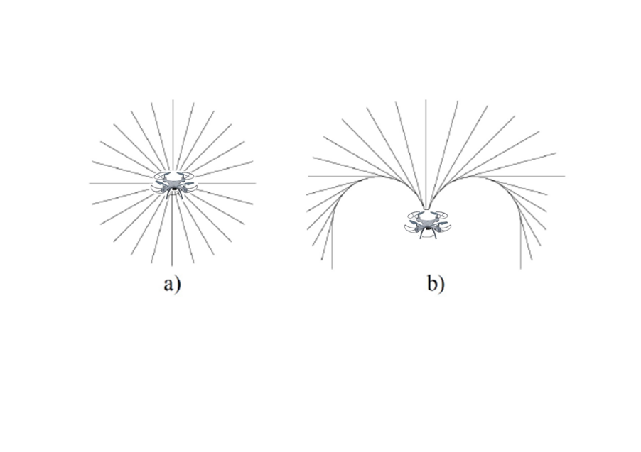

1. Quadcopter (robot) trajectories (Ulrich & Borenstein, 1998).

Figure 5 illustrates that the VFH+ algorithm's functioning might be summarized using a flowchart.

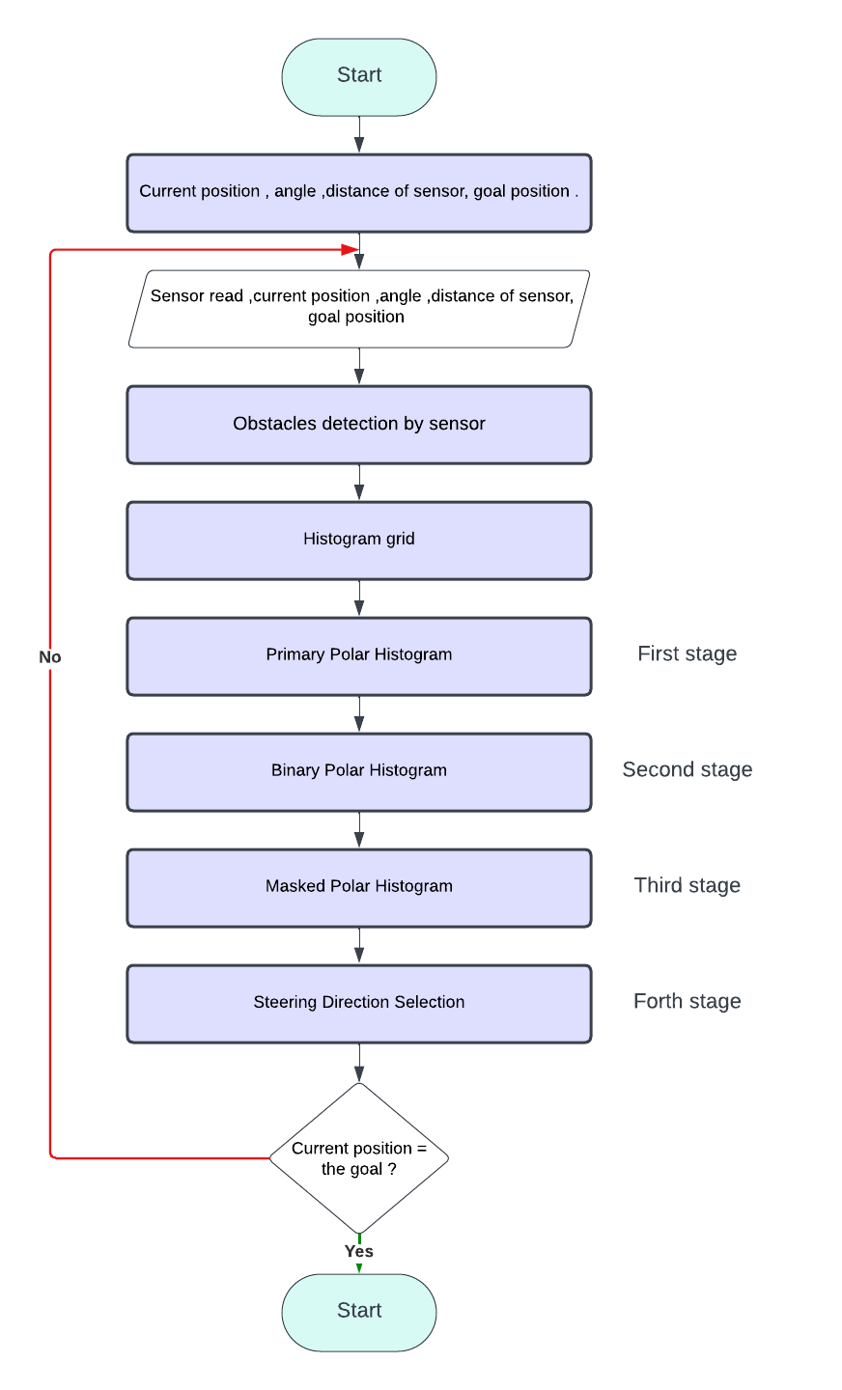

1. VFH+ algorithm flowchart.

# Fuzzy Logic

Numerous real-world applications have made use of the fuzzy logic system. Fuzzy logic systems are utilized to derive sophisticated non-linear systems since they are non-linear expressive systems between input and output variables. The process of designing a control system begins with the analysis and formulation of the dynamic behavior of the system that has to be regulated. Next, a control algorithm is developed with the aim of accomplishing predetermined control objectives. In essence, the majority of genuine systems in the world are conformal. Unlike conventional probabilistic models, fuzzy logic systems operate on a distinct premise. Systems using fuzzy logic operate without assuming anything about the operation of a probability distribution model. Because of this distinction, unstable systems can benefit greatly from the fuzzy logic system [55-57].

Fuzzy logic (FL) is one of the algorithms used in obstacle avoidance. Fuzzy algorithms use a method similar to how people come at questionable conclusions. Robots or autonomous systems can decide what is the "truth" or "untruth" of a situation by using fuzzy logic. The system can listen for and react to sensory data under specific conditions thanks to this algorithm. Robots that employ fuzzy logic for obstacle avoidance are able to make judgments based on data, including speed and distance and can react cautiously enough to the information they receive [58-62].

# Adaptive VFH+ By Fuzzy Logic

In this research, we implemented and tested an algorithm optimized by fuzzy logic for quadcopter navigation in an unknown workspace. The developed fuzzy control system features two inputs and one output. Fuzzy logic rules were manually mapped to represent human knowledge and address real-time needs of our algorithm. The system autonomously determines an appropriate fuzzy lookahead distance, calculated based on inputs reflecting environmental conditions and their changes.

Our efforts to enhance the VFH+ algorithm led us to a research initiative focused on integrating fuzzy logic to optimize the selection of the predefined lookahead distance a critical parameter in the algorithm[45, 65]. Initially, we engaged in manual tuning using trial and error methodologies across diverse environments, varying in obstacle density and the number of waypoints, both directly influencing the optimal lookahead distance. To elevate the system's intelligence, we introduced fuzzy logic for autonomous decision-making, leveraging real-time environmental data. The fuzzy logic framework enabled the creation of a self-adapting system capable of dynamically adjusting the lookahead distance based on surroundings. This approach empowers the algorithm to navigate environments with varying complexities, ensuring efficient obstacle avoidance and path planning[66-69]. The system of motion planning using fuzzy logic and the construction of fuzzy system are shown in figure 6 and figure 7.

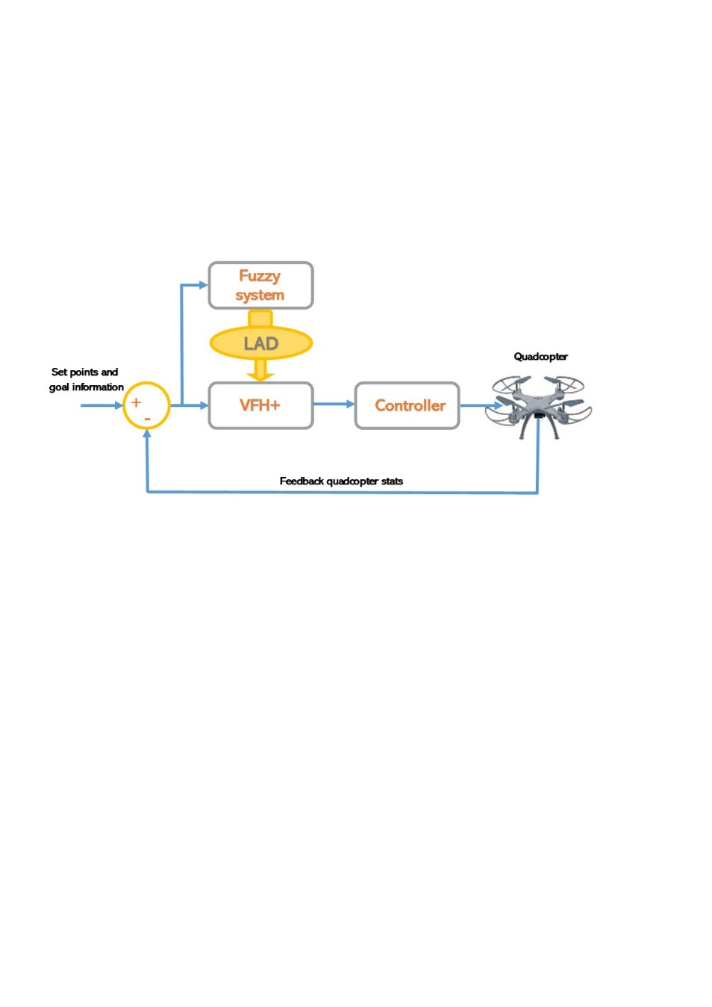

1. Motion planning system for quadcopter.

The seamless integration of fuzzy logic into the VFH+ algorithm results in a significantly improved system that autonomously adapts to different scenarios, achieving a more intelligent and versatile robotic navigation capability. This fusion not only enhances adaptability but also establishes the groundwork for autonomous decision-making in dynamic and unpredictable environments.

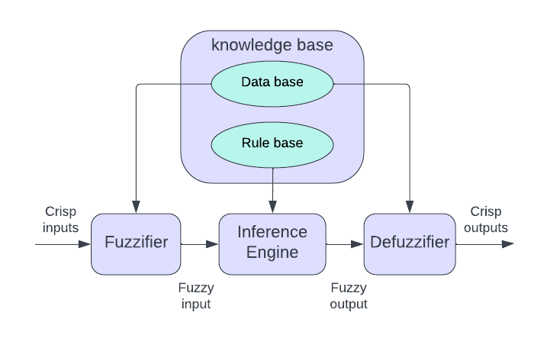

1. The construction of fuzzy system Authors and Affiliations

## Look ahead distance based on fuzzy logic

Our fuzzy logic system, with inputs of obstacle density and path waypoints, outputs an adaptive lookahead distance in quadcopter navigation figures 8,9 and 10 respectively.

The table fuzzy rule base is shown in table 1. This system dynamically adjusts the lookahead distance based on real-time changes in environmental conditions, enhancing adaptability in varying obstacle densities and path complexities. Integrated into the VFH+ algorithm, this approach contributes to intelligent and autonomous decision-making, establishing a robust foundation for versatile robotic navigation.

The input obstacles and waypoints are defined with linguistic variables ***Low(L), Mid(M), High***(***H***), while considered as a triangular type. The Fuzzy inference rules for selecting the winning LAD are as follows:

*If obstacle density is L AND waypoints is L Then LAD is L.*

*If obstacle density is M AND waypoints is L Then LAD is M.*

*If obstacle density is H AND waypoints is L Then LAD is H.*

*If obstacle density is L AND waypoints is M Then LAD is M.*

*If obstacle density is M AND waypoints is M Then LAD is M.*

*If obstacle density is H AND waypoints is M Then LAD is L.*

*If obstacle density is L AND waypoints is H Then LAD is L.*

*If obstacle density is M AND waypoints is H Then LAD is H.*

*If obstacle density is H AND waypoints is H Then LAD is H*

1. First Input of fuzzy system obstacle density membership.
2. Fuzzy Rule Base Table

|  |  |  |  |
| --- | --- | --- | --- |
| Obstacle no. | L | M | H |
| Waypoint No. |
| L | L | M | H |
| M | M | M | L |
| H | L | H | H |

1. Second Input waypoints density membership of fuzzy system.
2. Output of fuzzy system look ahead distance membership.

# Test And Simulation Result

To assess the performance of the enhanced algorithm, multiple environments were utilized in a MATLAB simulation system, incorporating obstacles of various shapes, sizes, and quantities, along with numerous path points. The quadcopter's goal and initial location were established for each environment, and the quadcopter's position was monitored using on-board sensors.

Numerous simulations were conducted for each scenario, exceeding a hundred trials for both the traditional and improved algorithms, as outlined in Table 1, maintaining identical initial conditions across all tests. The traditional VFH+ algorithm achieved success in reaching the target in only 80 out of 100 simulations, as detailed in Table 2. Figures 1-9 illustrate the paths taken in each of the nine fuzzy logic cases, comparing them with the outcomes of the traditional algorithm. The prior looking distance value was fixed at the optimal value for each case, determined through experimentation and testing.

Our findings suggest that the proposed FVFH+ algorithm boasts a higher success rate in navigating congested indoor environments, a quicker arrival rate, a reduced deviation rate from the original path, and, in most instances, a relatively shorter path length. These improvements stem primarily from algorithmic enhancements, allowing for real-time adjustments to the traveler's advance view during flight based on encountered conditions such as obstacles. In interpretation, we posit that the improved algorithm incorporates more effective information, facilitating more accurate decision-making regarding the optimal path to follow.

1. Success Rate To Reach The Goal

|  |  |  |  |
| --- | --- | --- | --- |
| Algorithm | Trials | Success rate | Obstacle collision |
| VFH+ | 100 | 80% | 80% |
| FVFH+ | 100 | 100% | 100% |

The trajectories presented in the following figures from 11 to 20 depict the simulation results for each of the nine fuzzy logic cases, accompanied by a comparison with the simulation outcomes of the traditional method.

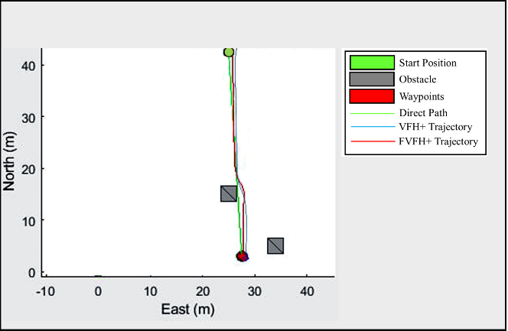

1. Simulation result of quadcopter motion planning in environment with low number of obstacle and low waypoints using VFH+ and FVFH+.

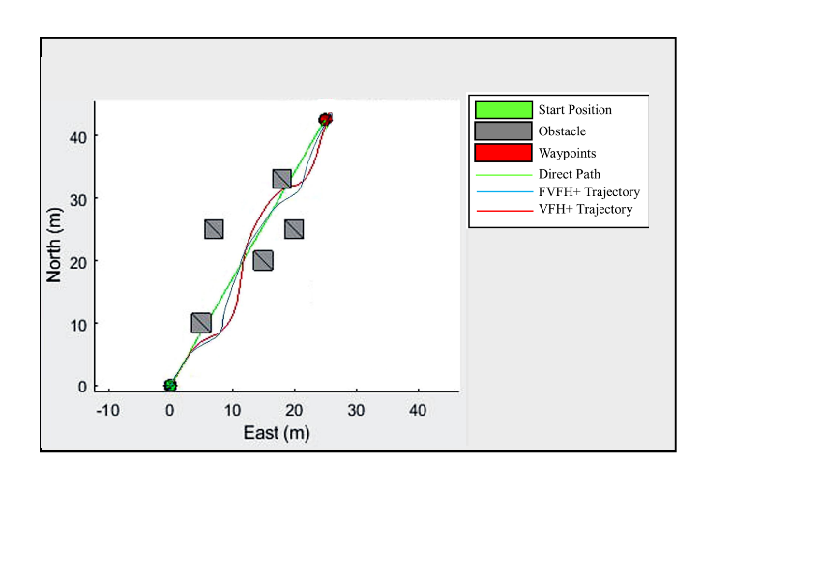

1. Simulation result with medium number of obstacle and low waypoints using VFH+ and FVFH+.

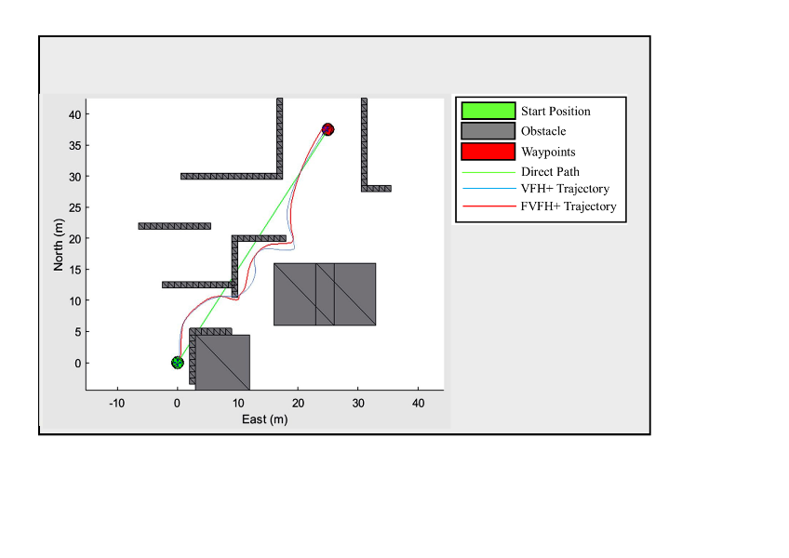

1. Simulation result with high number of obstacle and low waypoints using VFH+ and FVFH+.

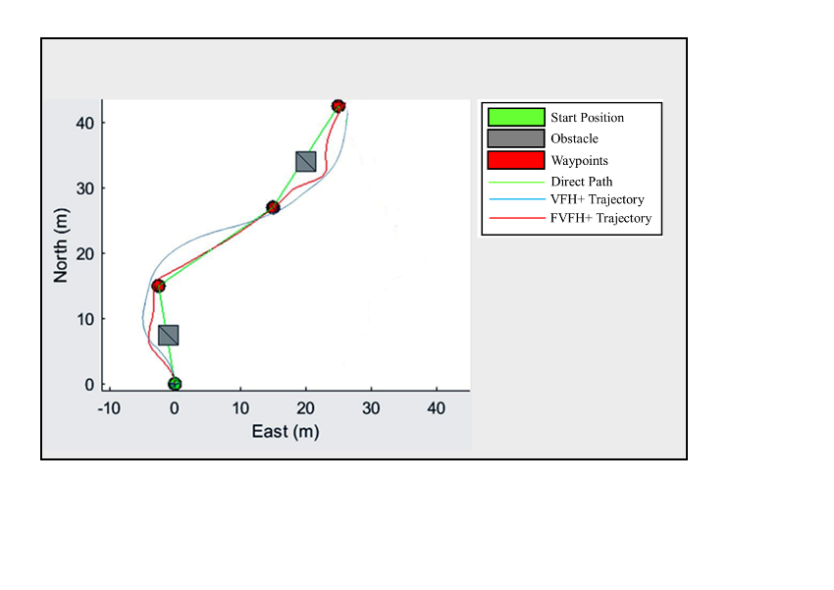

1. Simulation result of quadcopter motion planning in environment with low number of obstacle and medium waypoints using VFH+ and FVFH+.

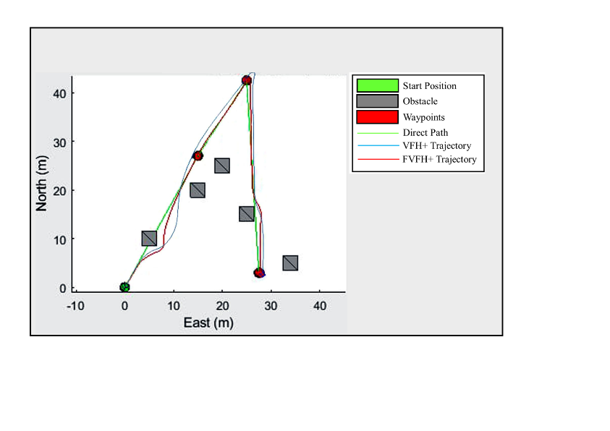

1. Simulation result with medium number of obstacle and medium waypoints using VFH+ and FVFH+.

Simulations of the improved algorithm were implemented using fuzzy logic in various environments, each characterized by different obstacle and path point densities. The density of obstacles and path points directly influences the determination of the prior looking distance, which is then compared to the traditional method that employs a fixed prior looking distance length. The flight period is predetermined before the start of the flight.

1. H Success Rate To Reach The Goal

|  |  |  |  |  |  |  |  |  |  |  |
| --- | --- | --- | --- | --- | --- | --- | --- | --- | --- | --- |
| Algorithm | Look ahead distance [m] | Desired path length [m] | Time traveled [sec] | | | | Trajectory length [m] | | | |
| min | max | avg | stdev | min | max | avg | stdev |
| VFH+ | 0.1-0.8 | 99.84 | 122.73 | 2,069.47 | 510.59 | 79.03 | 106.42 | 143.52 | 119.17 | 14.49 |
| FVFH+ | 0.1-0.8 | 99.84 | 141.14 | 333.68 | 244.29 | 25.66 | 101.08 | 121.73 | 110.9306 | 7.80 |

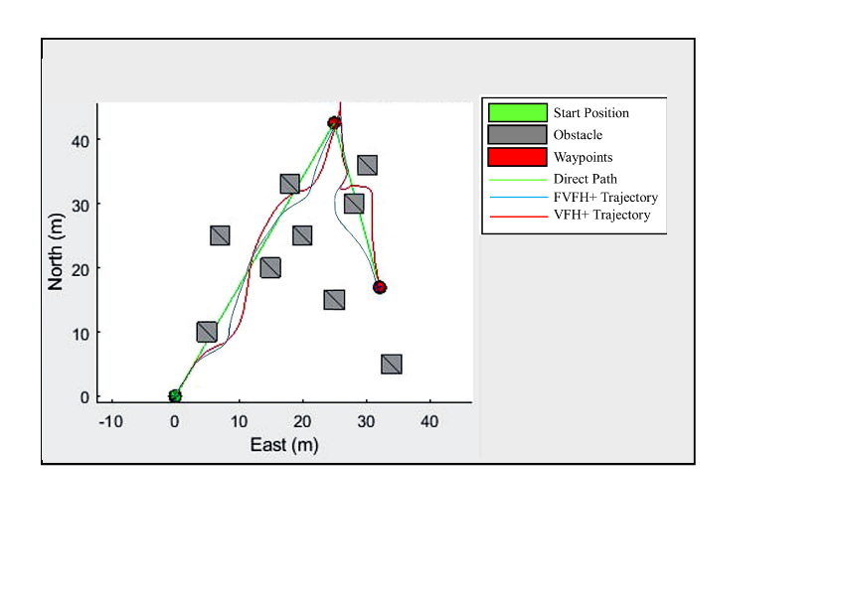

1. Simulation result with high number of obstacle and medium waypoints using VFH+ and FVFH+.

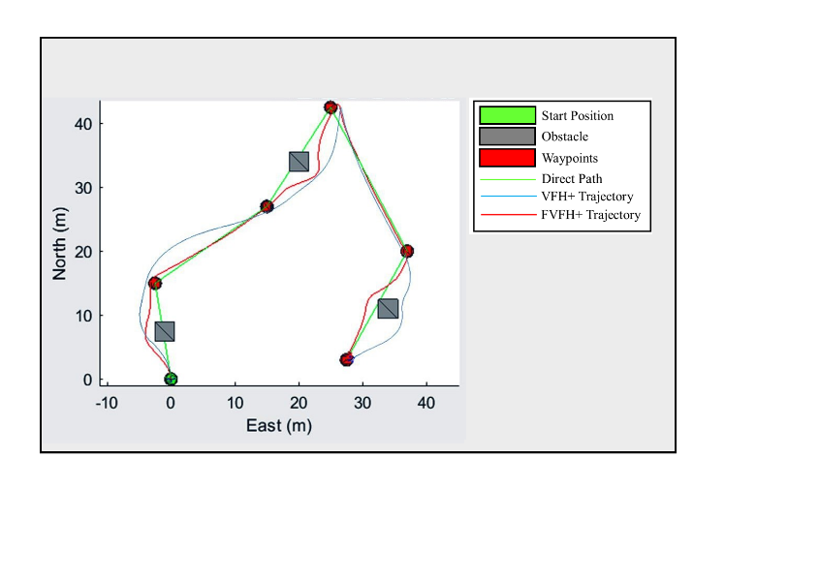

1. Simulation result with low number of obstacle and high waypoints using VFH+ and FVFH+.

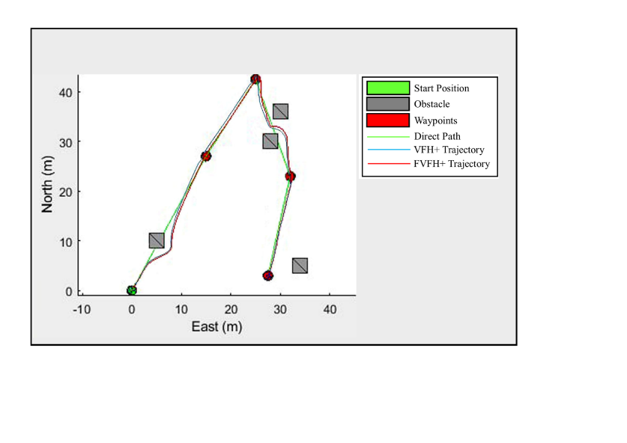

1. Simulation result with medium number of obstacle and high waypoints using VFH+ and FVFH+.

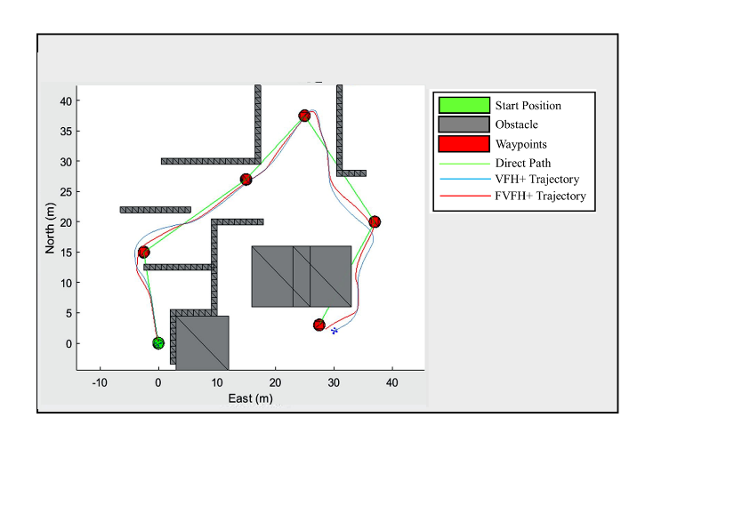

1. Simulation result of quadcopter motion planning in environment with high number of obstacle and high waypoints using VFH+ and FVFH+.

Through testing and simulation, we observed that the traditional VFH+ algorithm was successful in navigation across various environmental situations and conditions. However, it encountered difficulties in scenarios with changes in the environment and a significantly increased advance sight distance. This was attributed to the algorithm's inability to adjust the speed of the quadcopter adequately as the advance sight distance increased, leading to challenges in changing direction with the required speed. Consequently, this resulted in collisions with obstacles.

Moreover, in situations where the advance sight distance was very short, the traditional method failed to detect obstacles that were in close proximity to the quadcopter. This caused the aircraft to follow paths that might be unnecessary or more extended, resulting in increased time consumption. It is worth noting that the advance viewing distance in the traditional method remained fixed throughout the entire flight period, set before departure.

In contrast, the improved method FVFH+ demonstrated success in all conditions and environmental changes. The new method exhibited adaptability to varying environmental conditions and obstacles by dynamically adjusting the advance sight distance during the flight.

# Conclusion

In conclusion, this study presents a significant improvement to the VFH+ motion planning algorithm, enhancing its performance in the navigation domains of autonomous quadcopters. The key innovation lies in the integration of fuzzy logic control to dynamically adjust algorithm parameters, allowing for better adaptation to changing environments with various fixed obstacles. The simulation, conducted in diverse environments with varying obstacle distributions and waypoints, demonstrates the effectiveness of the proposed FVFH+ algorithm.

The adaptive nature of the algorithm, facilitated by fuzzy control, enables real-time adjustments to VFH+ parameters based on continuous environmental and motion condition analysis. Simulation results showcase the algorithm's superior performance compared to the conventional VFH+, particularly in successfully navigating variable environments. Metrics such as success rate, arrival rate, deviation rate, and path length highlight the algorithm's efficiency and effectiveness. The importance of this research extends to the broader field of motion planning for quadcopters, emphasizing the role of fuzzy control in improving performance in complex and changing environments. The adaptive algorithm presented in this study, in contrast to fixed-parameter algorithms, demonstrates a capability to self-adjust continuously, enhancing the quadcopter's ability to handle uncertainty and navigate effectively.

Furthermore, the study acknowledges the increasing importance of quadcopters in various applications, from healthcare to logistics, and underscores the critical role of motion planning in ensuring safe and successful operations. The proposed FVFH+ algorithm aligns with the continuous pursuit of developing technologies that make quadcopters more adaptable to diverse scenarios and challenges. Overall, this research contributes significantly to the advancement of motion planning techniques for quadcopters, providing a framework that combines traditional methods with fuzzy logic control for enhanced adaptability and performance in real-world environments.

##### References

1. N. M. Gachoki, A. M. Muhia, and M. N. Kiio, "A review of quad-rotor UAVs and their motion planning," in Proceedings of the Sustainable Research and Innovation Conference, 2022, pp. 117-121.
2. D. M. Harfina, Z. Zaini, and W. J. Wulung, "Disinfectant spraying system with quadcopter type unmanned aerial vehicle (UAV) technology as an effort to break the chain of the COVID-19 virus," Journal of Robotics and Control (JRC), vol. 2, no. 6, pp. 502-507, 2021.10.18196/jrc.26129
3. B. Chamberlain and W. Sheikh, "Design and Implementation of a Quadcopter Drone Control System for Photography Applications," in 2022 Intermountain Engineering, Technology and Computing (IETC), 2022: IEEE, pp. 1-7, doi: [10.1109/IETC54973.2022.9796735](https://doi.org/10.1109/IETC54973.2022.9796735)
4. M. F. Ahmed, M. N. Zafar, and J. Mohanta, "Modeling and analysis of quadcopter F450 frame," in 2020 international conference on contemporary computing and applications (IC3A), 2020: IEEE, pp. 196-201, doi:  [10.1109/IC3A48958.2020.233296](https://doi.org/10.1109/IC3A48958.2020.233296).
5. B. Chen, "Research on AI application in the field of quadcopter UAVs," in 2020 IEEE 2nd International Conference on Civil Aviation Safety and Information Technology (ICCASIT, 2020: IEEE, pp. 569-571, doi:  [10.1109/ICCASIT50869.2020.9368551](https://doi.org/10.1109/ICCASIT50869.2020.9368551).
6. M. Idrissi, M. Salami, and F. Annaz, "A review of quadrotor unmanned aerial vehicles: applications, architectural design and control algorithms," Journal of Intelligent & Robotic Systems, vol. 104, no. 2, p. 22, 2022, doi: 10.1007/s10846-021-01527-7
7. T. Shakeel et al., "A Comparative Study of Control Methods for X3D Quadrotor Feedback Trajectory Control," Applied Sciences, vol. 12, no. 18, p. 9254, 2022, doi: [10.3390/app12189254](https://www.mdpi.com/2076-3417/12/18/9254)
8. Á. Restás, "Drone applications fighting COVID-19 pandemic—Towards good practices," Drones, vol. 6, no. 1, p. 15, 2022, doi: [10.3390/drones6010015](https://www.mdpi.com/2504-446X/6/1/15).
9. Y. Akbari, N. Almaadeed, S. Al-Maadeed, and O. Elharrouss, "Applications, databases and open computer vision research from drone videos and images: a survey," Artificial Intelligence Review, vol. 54, pp. 3887-3938, 2021, doi: 10.1007/s10462-020-09943-1
10. P. Radoglou-Grammatikis, P. Sarigiannidis, T. Lagkas, and I. Moscholios, "A compilation of UAV applications for precision agriculture," Computer Networks, vol. 172, p. 107148, 2020, doi: [10.1016/j.comnet.2020.107148](https://doi.org/10.1016/j.comnet.2020.107148).
11. A. Marchidan and E. Bakolas, "Collision avoidance for an unmanned aerial vehicle in the presence of static and moving obstacles," Journal of Guidance, Control, and Dynamics, vol. 43, no. 1, pp. 96-110, 2020. [doi.org/10.2514/1.G004446](https://doi.org/10.2514/1.G004446)
12. R. Han et al., "Rda: An accelerated collision free motion planner for autonomous navigation in cluttered environments," IEEE Robotics and Automation Letters, vol. 8, no. 3, pp. 1715-1722, 2023, doi: [10.1109/LRA.2023.3242138](https://doi.org/10.1109/LRA.2023.3242138)
13. S. A. H. Mohsan, N. Q. H. Othman, Y. Li, M. H. Alsharif, and M. A. Khan, "Unmanned aerial vehicles (UAVs): Practical aspects, applications, open challenges, security issues, and future trends," Intelligent Service Robotics, vol. 16, no. 1, pp. 109-137, 2023, doi: 10.1007/s11370-022-00452-4
14. C. Lee, S. Kim, and B. Chu, "A survey: Flight mechanism and mechanical structure of the UAV," International Journal of Precision Engineering and Manufacturing, vol. 22, no. 4, pp. 719-743, 2021, doi: 10.1007/s12541-021-00489-y.
15. K.-J. Nam, J. Joung, and D. Har, "Tri-copter UAV with individually tilted main wings for flight maneuvers," IEEE Access, vol. 8, pp. 46753-46772, 2020, doi: [10.1109/ACCESS.2020.2978578](https://doi.org/10.1109/ACCESS.2020.2978578)
16. P. Wang, S. Gao, L. Li, B. Sun, and S. Cheng, "Obstacle avoidance path planning design for autonomous driving vehicles based on an improved artificial potential field algorithm," Energies, vol. 12, no. 12, p. 2342, 2019, doi: [10.3390/en12122342](https://www.mdpi.com/1996-1073/12/12/2342)
17. A. Marchidan and E. Bakolas, "Collision avoidance for an unmanned aerial vehicle in the presence of static and moving obstacles," Journal of Guidance, Control, and Dynamics, vol. 43, no. 1, pp. 96-110, 2020. [doi.org/10.2514/1.G004446](https://doi.org/10.2514/1.G004446)
18. J. Wang, M. Q.-H. Meng, and O. Khatib, "EB-RRT: Optimal motion planning for mobile robots," IEEE Transactions on Automation Science and Engineering, vol. 17, no. 4, pp. 2063-2073, 2020, doi: [10.1109/TASE.2020.2987397](https://doi.org/10.1109/TASE.2020.2987397)
19. C. Zhou, B. Huang, and P. Fränti, "A review of motion planning algorithms for intelligent robots," Journal of Intelligent Manufacturing, vol. 33, no. 2, pp. 387-424, 2022, doi: 10.1007/s10845-021-01867-z.
20. X. Xiao, B. Liu, G. Warnell, and P. Stone, "Motion planning and control for mobile robot navigation using machine learning: a survey," Autonomous Robots, vol. 46, no. 5, pp. 569-597, 2022, doi: 10.1007/s10514-022-10039-8
21. F. Umam, M. Fuad, I. Suwarno, A. Ma'arif, and W. Caesarendra, "Obstacle Avoidance Based on Stereo Vision Navigation System for Omni-directional Robot," Journal of Robotics and Control (JRC), vol. 4, no. 2, pp. 227-242, 2023. DOI: 10.18196/jrc.v4i2.17977.
22. N. Abu, W. Bukhari, M. Adli, and A. Ma’arif, "Optimization of an Autonomous Mobile Robot Path Planning Based on Improved Genetic Algorithms," Journal of Robotics and Control (JRC), vol. 4, no. 4, pp. 557-571, 2023. DOI: 10.18196/jrc.v4i4.19306
23. S. Aradi, "Survey of deep reinforcement learning for motion planning of autonomous vehicles," IEEE Transactions on Intelligent Transportation Systems, vol. 23, no. 2, pp. 740-759, 2020, doi: [10.1109/TITS.2020.3024655](https://doi.org/10.1109/TITS.2020.3024655)
24. V. Dwaracherla, S. Thakar, L. Vachhani, A. Gupta, A. Yadav, and S. Modi, "Motion planning for point-to-point navigation of spherical robot using position feedback," IEEE/ASME Transactions on Mechatronics, vol. 24, no. 5, pp. 2416-2426, 2019, doi: [10.1109/TMECH.2019.2934789](https://doi.org/10.1109/TMECH.2019.2934789)
25. L. Claussmann, M. Revilloud, D. Gruyer, and S. Glaser, "A review of motion planning for highway autonomous driving," IEEE Transactions on Intelligent Transportation Systems, vol. 21, no. 5, pp. 1826-1848, 2019, doi: [10.1109/TITS.2019.2913998](https://doi.org/10.1109/TITS.2019.2913998)
26. B. Song, Z. Wang, and L. Zou, "An improved PSO algorithm for smooth path planning of mobile robots using continuous high-degree Bezier curve," Applied Soft Computing, vol. 100, p. 106960, 2021. [doi.org/10.1016/j.asoc.2020.106960](https://doi.org/10.1016/j.asoc.2020.106960).
27. J. Yu, Y. Su, and Y. Liao, "The path planning of mobile robot by neural networks and hierarchical reinforcement learning," Frontiers in Neurorobotics, vol. 14, p. 63, 2020. [doi.org/10.3389/fnbot.2020.00063](https://doi.org/10.3389/fnbot.2020.00063)
28. J.-A. Delamer, Y. Watanabe, and C. P. Chanel, "Safe path planning for UAV urban operation under GNSS signal occlusion risk," Robotics and Autonomous Systems, vol. 142, p. 103800, 2021, doi: [10.1016/j.robot.2021.103800](https://doi.org/10.1016/j.robot.2021.103800)
29. M. N. Zafar and J. Mohanta, "Methodology for path planning and optimization of mobile robots: A review," Procedia computer science, vol. 133, pp. 141-152, 2018, doi: [10.1016/j.procs.2018.07.018](https://doi.org/10.1016/j.procs.2018.07.018)
30. F. Noroozi, M. Daneshmand, and P. Fiorini, "Conventional, Heuristic and Learning-Based Robot Motion Planning: Reviewing Frameworks of Current Practical Significance," Machines, vol. 11, no. 7, p. 722, 2023, doi: [10.3390/machines11070722](https://www.mdpi.com/2075-1702/11/7/722)
31. N. Abu, W. Bukhari, M. Adli, S. Omar, and S. Sohaimeh, "A Comprehensive Overview of Classical and Modern Route Planning Algorithms for Self-Driving Mobile Robots," Journal of Robotics and Control (JRC), vol. 3, no. 5, pp. 666-678, 2022, doi: 10.18196/jrc.v3i5.14683.
32. N. Abu, W. Bukhari, M. Adli, and A. Ma’arif, "Optimization of an Autonomous Mobile Robot Path Planning Based on Improved Genetic Algorithms," *Journal of Robotics and Control (JRC),* vol. 4, no. 4, pp. 557-571, 2023.[//doi.org/10.1016/j.tifs.2021.11.018](https://doi.org/10.1016/j.tifs.2021.11.018).
33. C. Tonola, M. Faroni, M. Beschi, and N. Pedrocchi, "Anytime informed multi-path replanning strategy for complex environments," *IEEE Access,* vol. 11, pp. 4105-4116, 2023. **DOI:**[10.1109/ACCESS.2023.3235652](https://doi.org/10.1109/ACCESS.2023.3235652)
34. A. Mazen, M. Faied, and M. Krishnan, "Tuning of Robot Navigation Performance Using Factorial Design," Journal of Intelligent & Robotic Systems, vol. 105, no. 3, p. 50, 2022. [doi.org/10.3389/fnbot.2020.00063](https://doi.org/10.3389/fnbot.2020.00063).
35. S. Sahloul, D. B. H. Abid, and C. REKIK, "An hybridization of global-local methods for autonomous mobile robot navigation in partially-known environments," Journal of Robotics and Control (JRC), vol. 2, no. 4, pp. 221-233, 2021.DOI: <https://doi.org/10.18196/jrc.2483>.
36. V. Kramar, O. Kramar, and A. Kabanov, "Self-Collision Avoidance Control of Dual-Arm Multi-Link Robot Using Neural Network Approach," Journal of Robotics and Control (JRC), vol. 3, no. 3, pp. 309-319, 2022. DOI: <https://doi.org/10.18196/jrc.v3i3.14318>
37. S. Sahloul, D. B. H. Abid, and C. REKIK, "An hybridization of global-local methods for autonomous mobile robot navigation in partially-known environments," Journal of Robotics and Control (JRC), vol. 2, no. 4, pp. 221-233, 2021. DOI: <https://doi.org/10.18196/jrc.2483>
38. A. H. Hamad and F. B. Ibrahim, "Path Planning of Mobile Robot Based on Modification of Vector Field Histogram using Neuro-Fuzzy Algorithm," Int. J. Adv. Comp. Techn., vol. 2, no. 3, pp. 129-138, 2010, doi: 10.4156/ijact.
39. A. Babinec, M. Dekan, F. Duchoň, and A. Vitko, "Modifications of VFH navigation methods for mobile robots," Procedia Engineering, vol. 48, pp. 10-14, 2012, doi: [10.1016/j.proeng.2012.09.478](https://doi.org/10.1016/j.proeng.2012.09.478)
40. D. Díaz and L. Marín, "VFH+ D: An improvement on the VFH+ algorithm for dynamic obstacle avoidance and local planning," IFAC-PapersOnLine, vol. 53, no. 2, pp. 9590-9595, 2020, doi: [10.1016/j.ifacol.2020.12.2450](https://doi.org/10.1016/j.ifacol.2020.12.2450)
41. B. I. Kazem, A. H. Hamad, and M. M. Mozael, "Modified vector field histogram with a neural network learning model for mobile robot path planning and obstacle avoidance," Int. J. Adv. Comp. Techn., vol. 2, no. 5, pp. 166-173, 2010, doi: 10.4156/ijact.
42. Y. Yan, Y. Du, and W. Zhou, "Study on the local path planning for intelligent vehicles based on an improved VFH method," International Journal of Embedded Systems, vol. 10, no. 6, pp. 445-452, 2018, doi: [10.1504/IJES.2018.095747](https://doi.org/10.1504/IJES.2018.095747)
43. S. Choi, E. Kim, and S. Oh, "Real-time navigation in crowded dynamic environments using Gaussian process motion control," in 2014 IEEE International Conference on Robotics and Automation (ICRA), 2014: IEEE, pp. 3221-3226, doi: [10.1109/ICRA.2014.6907322](https://doi.org/10.1109/ICRA.2014.6907322)
44. S. Raikwar, J. Fehrmann, and T. Herlitzius, "Navigation and control development for a four-wheel-steered mobile orchard robot using model-based design," *Computers and Electronics in Agriculture,* vol. 202, p. 107410, 2022[.doi.org/10.1016/j.compag.2022.107410](https://doi.org/10.1016/j.compag.2022.107410).
45. I. Ulrich and J. Borenstein, "VFH+: Reliable obstacle avoidance for fast mobile robots," in Proceedings. 1998 IEEE international conference on robotics and automation (Cat. No. 98CH36146), 1998, vol. 2: IEEE, pp. 1572-1577, doi: [10.1109/ROBOT.1998.677362](https://doi.org/10.1109/ROBOT.1998.677362)
46. P. Pappas, M. Chiou, G.-T. Epsimos, G. Nikolaou, and R. Stolkin, "Vfh+ based shared control for remotely operated mobile robots," in 2020 IEEE International Symposium on Safety, Security, and Rescue Robotics (SSRR), 2020: IEEE, pp. 366-373. [10.1109/SSRR50563.2020.9292585](https://doi.org/10.1109/SSRR50563.2020.9292585)
47. X. Wang, M. Cheng, S. Zhang, and H. Gong, "Multi-UAV Cooperative Obstacle Avoidance of 3D Vector Field Histogram Plus and Dynamic Window Approach," Drones, vol. 7, no. 8, p. 504, 2023, doi: [10.3390/drones7080504](https://doi.org/10.3390/drones7080504)
48. T. Dong, Y. Zhang, Q. Xiao, and Y. Huang, "The Control Method of Autonomous Flight Avoidance Barriers of UAVs in Confined Environments," Sensors, vol. 23, no. 13, p. 5896, 2023, doi: [10.3390/s23135896](https://www.mdpi.com/1424-8220/23/13/5896)
49. J. Lee, Y. Cho, C. Nam, J. Park, and C. Kim, "Efficient obstacle rearrangement for object manipulation tasks in cluttered environments," in 2019 International Conference on Robotics and Automation (ICRA), 2019: IEEE, pp. 183-189, doi: [10.1109/ICRA.2019.8793616](https://doi.org/10.1109/ICRA.2019.8793616)
50. Y. Chen, G. Bai, Y. Zhan, X. Hu, and J. Liu, "Path planning and obstacle avoiding of the USV based on improved ACO-APF hybrid algorithm with adaptive early-warning," Ieee Access, vol. 9, pp. 40728-40742, 2021,**DOI:**[10.1109/ACCESS.2021.3062375](https://doi.org/10.1109/ACCESS.2021.3062375)
51. S.-g. Woo, C. Park, D. Lee, and S.-y. Lee, "Collision avoidance for unmanned aerial vehicles based on safety radius of the formation geometry," in 2020 20th International Conference on Control, Automation and Systems (ICCAS), 2020: IEEE, pp. 179-183. DOI: [10.23919/ICCAS50221.2020.9268210](https://doi.org/10.23919/ICCAS50221.2020.9268210)
52. W. Chen, C. Yang, and Y. Feng, "Shared control for omnidirectional mobile robots," in 2019 Chinese Control And Decision Conference (CCDC), 2019: IEEE, pp. 6185-6190. **DOI:**[10.1109/CCDC.2019.8833017](https://doi.org/10.1109/CCDC.2019.8833017)
53. I. P. Sary, Y. P. Nugraha, M. Megayanti, E. Hidayat, and B. R. Trilaksono, "Design of obstacle avoidance system on hexacopter using vector field histogram-plus," in 2018 IEEE 8th International Conference on System Engineering and Technology (ICSET), 2018: IEEE, pp. 18-23, doi:  [10.1109/ICSEngT.2018.8606388](https://doi.org/10.1109/ICSEngT.2018.8606388)
54. C.-F. Wu, Y.-L. Wang, L. Ma, and A. Rakić, "VFH+ Based Local Path Planning for Unmanned Surface Vehicles," in 2021 IEEE International Conference on Recent Advances in Systems Science and Engineering (RASSE), 2021: IEEE, pp. 1-6, doi: [10.1109/RASSE53195.2021.9686856](https://doi.org/10.1109/RASSE53195.2021.9686856).
55. A. Jain and A. Sharma, "Membership function formulation methods for fuzzy logic systems: A comprehensive review," *Journal of Critical Reviews,* vol. 7, no. 19, pp. 8717-8733, 2020.
56. K. Mittal, A. Jain, K. S. Vaisla, O. Castillo, and J. Kacprzyk, "A comprehensive review on type 2 fuzzy logic applications: Past, present and future," Engineering Applications of Artificial Intelligence, vol. 95, p. 103916, 2020. <https://doi.org/10.1016/j.engappai.2020.103916>
57. A. Jain and A. Sharma, "Membership function formulation methods for fuzzy logic systems: A comprehensive review," Journal of Critical Reviews, vol. 7, no. 19, pp. 8717-8733, 2020. /doi.org/10.1080/21642583.2021.1907259
58. J. Zheng, B. Liu, Z. Meng, and Y. Zhou, “Integrated real time obstacle avoidance algorithm based on fuzzy logic and L1 control algorithm for unmanned helicopter,” in 2018 Chinese Control And Decision Conference, pp. 1865–1870, 2018 doi: 10.1109/CCDC.2018.8407430.
59. A. Nasrinahar and J. H. Chuah, “Intelligent motion planning of a mobile robot with dynamic obstacle avoidance,” Journal on Vehicle Routing Algorithms, vol. 1, no. 2–4, pp. 89–104, 2018, doi: 10.1007/s41604-018- 0007-4.
60. M. Nadour, M. Boumehraz, L. Cherroun, and V. Puig, “Hybrid Type-2 Fuzzy logic Obstacle avoidance System based on Horn-Schunck Method,” Electrotehnica, Electronica, Automatica, vol. 67, no. 3, pp. 45-51, 2019.
61. A. Shitsukane, W. Cheruiyot, C. Otieno, and M. Mvurya, “Fuzzy logic Sensor Fusion for Obstacle avoidance Mobile robot,” in 2018 IST-Africa Week Conference, pp. 1-8, 2018
62. F. Valdez, "A review of optimization swarm intelligence-inspired algorithms with type-2 fuzzy logic parameter adaptation," Soft Computing, vol. 24, no. 1, pp. 215-226, 2020. doi.org/10.1007/s00500-019-04290-y
63. M. Wu, S.-L. Dai, and C. Yang, "Mixed reality enhanced user interactive path planning for omnidirectional mobile robot," Applied Sciences, vol. 10, no. 3, p. 1135, 2020, doi: [10.3390/app10031135](https://www.mdpi.com/2076-3417/10/3/1135)
64. Y. Niu, H. Qazi, and Y. Liang, "Building a Flexible Mobile Robotics Teaching Toolkit by Extending MATLAB/Simulink with ROS and Gazebo," in 2021 7th International Conference on Mechatronics and Robotics Engineering (ICMRE), 2021: IEEE, pp. 10-16, doi: [10.1109/ICMRE51691.2021.9384836](https://doi.org/10.1109/ICMRE51691.2021.9384836)
65. F. A. Andrade et al., "Unmanned aerial vehicles motion control with fuzzy tuning of cascaded-pid gains," Machines, vol. 10, no. 1, p. 12, 2021, doi: [10.3390/machines10010012](https://www.mdpi.com/2075-1702/10/1/12)
66. B. Wu, T. Cheng, T. L. Yip, and Y. Wang, "Fuzzy logic based dynamic decision-making system for intelligent navigation strategy within inland traffic separation schemes," Ocean Engineering, vol. 197, p. 106909, 2020, doi: [10.1016/j.oceaneng.2019.106909](https://doi.org/10.1016/j.oceaneng.2019.106909)
67. S. A. Mostafa, R. Darman, S. H. Khaleefah, A. Mustapha, N. Abdullah, and H. Hafit, "A general framework for formulating adjustable autonomy of multi-agent systems by fuzzy logic," in Agents and Multi-Agent Systems: Technologies and Applications 2018: Proceedings of the 12th International Conference on Agents and Multi-Agent Systems: Technologies and Applications (KES-AMSTA-18) 12, 2019: Springer, pp. 23-33, doi: 10.1007/978-3-319-92031-3_3
68. D. Phan, A. Bab-Hadiashar, M. Fayyazi, R. Hoseinnezhad, R. N. Jazar, and H. Khayyam, "Interval type 2 fuzzy logic control for energy management of hybrid electric autonomous vehicles," IEEE Transactions on Intelligent vehicles, vol. 6, no. 2, pp. 210-220, 2020, doi: [10.1109/TIV.2020.3011954](https://doi.org/10.1109/TIV.2020.3011954).