Comprehensive Study on Detecting Multi-Class Classification of IoT Attack Using Machine Learning Methods

Tamara Zhukabayeva1,2, Lazzat Zholshiyeva1, Khu Ven-Tsen1,4, Yerik Mardenov1, Aigul Adamova1, Nurdaulet Karabayev1

1International Science Complex «ASTANA», Astana 010000, Kazakhstan

2L.N. Gumilyov Eurasian National University, Astana 010000, Kazakhstan

3Mukhtar Auezov South Kazakhstan University, Shymkent 160021, Kazakhstan

Email: 1 tamara_kokenovna@mail.ru, 2*lazzat.zhol.81@gmai.com, 3qbcba@bk.ru, 4 emardenov@gmail.com, 5aigul.adamova@astanait.edu.kz, 6222240@astanait.edu.kz

*Abstract*— Attack detection represents a key challenge in securing Internet of Things (IoT) devices. Due to the scarcity of resources and the heterogeneous characteristics of IoT devices, they are frequently susceptible to a wide range of attacks. Out of all the threats, botnets are very dangerous and can seriously endanger the IoT, perhaps resulting in grave consequences. Several studies have investigated the use of machine learning (ML) methods to accurately identify and reduce botnet attacks. However, given the specific nature of IoT, achieving high detection accuracy with reasonable utilization of computational resources is still a challenging task. This study experimental analysis of the effectiveness of several ML algorithms in detecting attacks in IoT. Using a publicly available N-BaIoT dataset, our study includes a comparative analysis of algorithms including XGBoost, LGBM, Random Forest, and Decision Tree. We developed a botnet attack detection model with multi-class classification. The proposed model is shown to be highly effective. The attack detection accuracy reaches 99.18% for XGBoost, 99.20% for Random Forest, 99.85% for LGBM and 99.17% for Decision Tree. The findings of this study can serve as both scientific insights and practical guidelines for IoT cybersecurity enterprises and organizations.

Keywords — Wireless sensor networks, IoT, Identification attacks, Anomalies, Botnets

# Introduction

To share and acquire data, all network devices connect. Today, wireless sensor networks (WSNs) are more widespread and are becoming an important tool in different areas of life. Due to this, the risk of attacks that jeopardize the data security and privacy of users is also increasing. The security and data aggregation technology in WSNs is relevant. The main challenges in WSNs are security and power consumption. To prevent attacks on networks and data transmission, data must be secured. In addition, data aggregation can be achieved by reducing the number of messages in the network, which reduces the overall energy consumption. Since data aggregation can help to extend the lifetime of WSNs, the choice of a specific data aggregation algorithm is important [1]. Data aggregation techniques can eliminate data redundancy, reduce energy consumption and optimize the utilization of network resources in WSNs.

The IoT sphere encompasses a variety of commercial and consumer devices. One of the major threats is the ability to access sensitive information collected and transmitted by IoT devices, especially given the anticipated growth in the use of these devices, which increases the risk of attack by malicious actors. The widespread adoption of IoT can also pose security challenges as potential hackers are attracted by the large amount of data and the ubiquitous presence of IoT devices [2]. To cause maximum damage with minimum speed, hackers use botnets, which can independently infiltrate and infect other devices. Botnet attacks often go undetected because they affect multiple devices. There are many types of botnets, such as DDos and DoS attacks on IoT applications usually have a large effect [3], [4], [5]. Because there are not as many sensor devices available, DoS attacks against IoT apps typically have a big impact. The more IoT-connected devices are used, the more botnets turn and the more powerful they become. Combating botnets is an important challenge for IoT cybersecurity. Many methods and technologies have been developed to detect, prevent, and resolve botnet attacks, but not all of these are enough. It is possible to combat botnets by implementing strong user authentication methods, secure remote updates, secure bootstrapping, behavioural analysis, automation, machine learning, and artificial intelligence [6]. A key element of this process is the application of machine learning techniques to detect and prevent security threats. Classical WSN security techniques such as cryptography and key management [7] are ineffective in detecting attacks. ML algorithms offer versatile solutions and continuously improve their performance [8]. ML algorithms efficiently classify attacks and perform data aggregation and forwarding tasks to the receiving node. ML algorithms can also be applied to identify and classify botnet attacks based on device type and stage of attack, which helps to gain a more detailed understanding of attack characteristics [9].

The objective of the study is to evaluate the effectiveness of ML models in detecting multi-class classification attacks in IoT networks, which provides improved detection performance and reduced processing time for the data used. The study also aimed at comparing different methods at each step of the machine learning workflow, including the selection of meaningful feature subsets, the impact of separating training and test data on model performance, and the performance of three supervised ML classifiers in terms of accuracy, recall, and F1-score. In the conducted study, four ML algorithms were considered, for attack detection in IoT: XGBoost, LGBM, Decision Tree and Random Forest, A publicly available N-BaIoT dataset was used to evaluate the performance of the selected algorithms, which reflects a wide range of attack features and anomalies in IoT. Based on the obtained results, the proposed multi-class classification attack model is developed.

A. MOTIVATION AND RESEARCH QUESTIONS

Due to the diversity of applications and devices, the IoT network is characterized by heterogeneity. According to many researchers, attack detection is a classification task because the main goal is to determine the legitimacy or maliciousness of a data packet, which shows a solution to half of the problem.

The reason for writing this paper is due to the growing concerns about the threats posed by IoT and the need for robust attack detection mechanisms. As the IoT evolves, the vulnerabilities and potential for large-scale botnet intrusions become increasingly apparent. ML models have shown significant potential in overcoming this challenge. Nevertheless, there is a need to methodically review and summarize the existing literature to gain an understanding of current methodologies, their effectiveness, limitations, and future research directions.

The research questions formulated for this study were as follows:

1. What ML methodologies are currently being used to identify and remediate botnet intrusions in the IoT?

2. What are the main limitations and challenges associated with applying ML strategies to detect IoT attacks?

3. What research areas show potential for improving the effectiveness of ML strategies in detecting and preventing attacks?

4. How do different evaluation metrics affect the performance evaluation of ML architectures in detecting IoT attack?

B. CONTRIBUTIONS AND ORGANIZATION

Threats in IoT are everywhere and the spread of IoT usage is driven by the successful application of smart homes and cities around the world. However, IoT devices operate on public networks with limited processing power, storage capacity and bandwidth, which makes them more vulnerable to attacks compared to other endpoint devices. To address these challenges, this study includes the following contributions:

- We have developed a new effective methodology to identify different types of botnet attacks on IoT devices. This approach is based on the use of sequential architecture and machine learning algorithms such as XGBoost, Random Forest, Light GBM and Decision Tree. This model takes into account the features of resource-constrained IoT devices and incorporates data preprocessing mechanisms to improve the accuracy of multi-class classification.

- The study proposed an integrated attack evaluation model for multi-class classification. This model significantly improves the attack identification and classification process, enhancing the overall performance of botnet detection systems in IoT networks.

The paper consists of the following sections: Section I presents the introduction, contributions and organization, motivation and research question. Section II describes research methodology and search strategy where research questions, background methodology, botnet, ML models and a complete review of related works are discussed and disclosed. Section III deals with experimental results and proposed method, where the application of machine learning techniques XGBoost, Random Forest, LGBM and Decision Tree which detects various types of botnets with dataset, experimental comparison of the performance of machine learning algorithms and model evaluation of them and discussion are proposed. In addition, the last IV section describes the conclusion and future work. The overall structure of the paper can be seen in Figure 1.

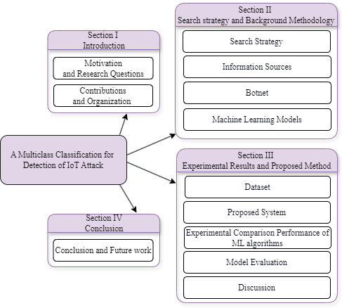

1. Paper structure.

# RESEARCH METHODOLOGY AND SEARCH STRATEGY

This section describes the methodology and an overview of related research papers on botnet attack detection, and defence mechanisms against them using various security technologies and ML models for detecting attacks in IoT.

Researched the review articles with keywords from reliable research sources. A brief overview of botnets, IoT vulnerabilities, botnet malware, various methods to detect them, and the application of ML algorithms in the articles were considered.

A work based on research questions was conducted covering the metrics of IoT research released from 2020 to 2024, which investigates ML algorithms in the IoT domain, different types of attacks and attack models, methodologies, and evaluation criteria.

## SEARCH KEYWORDS

To find answers to the research questions that were formulated during the study, the search queries utilized various keywords. By conducting the research, the keywords were combined with logical operators to create appropriate search queries that would help to get answers to the questions related to the topic under study:

RQ1- RQ4: (TITLE_ABS_KEY ("ML algorithms in IoT") OR TITLE_ABS_KEY(attack) AND TITLE_ABS_KEY (botnet) OR TITLE_ABS_KEY ("evaluation metrix and results") AND TITLE_ABS_KEY ("dataset in IoT") OR TITLE_ABS_KEY(methodology) OR TITLE_ABS_KEY (attack) AND TITLE_ABS_KEY (models) AND PUBYEAR > 2019 AND PUBYEAR < 2025 AND ("Mirai") OR ("IOT attacks") OR ("WSN Attack") OR ("Machine learning") OR ("WSN") OR ("DoS") OR ("BASHLITE”) OR ("DDoS") OR ("Gafgyt" ) OR ( "IoT" )).

## INFORMATION SOURCES

The research articles were selected from academic database sources such as Scopus, MDPI, Elsevier, Springer Link, IEEE Xplore, and Hindawi (figure 2).

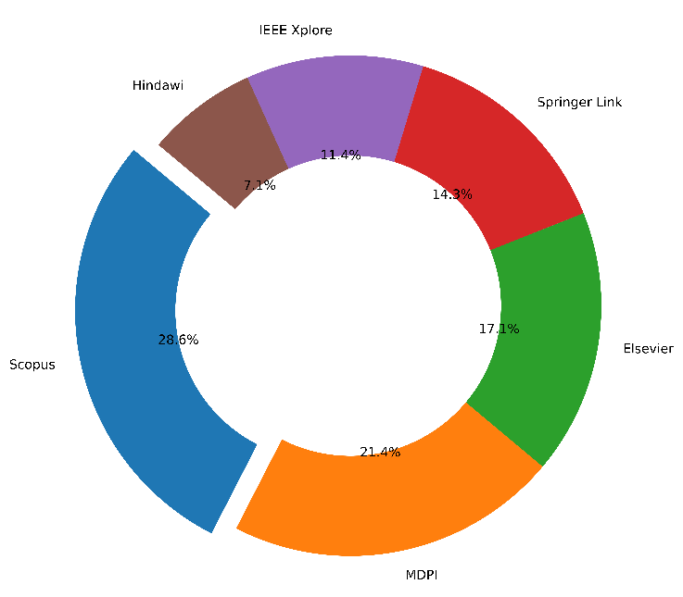

1. Include papers from databases.

From these databases, articles from journals and conferences from 2020-2024 were selected. Figure 3 shows the distribution of included articles by year and the distribution of publications by identified topics.

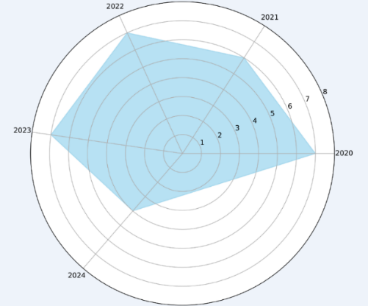

1. Distribution of publication year.

After researching the selected articles, papers focused on attacks in WSNs and IoT, ML methods, anomalies, and attacks are selected. Next, a selection of articles are selected by computer science and engineering fields. Figure 4 illustrates the algorithm of article search and selection methodology.

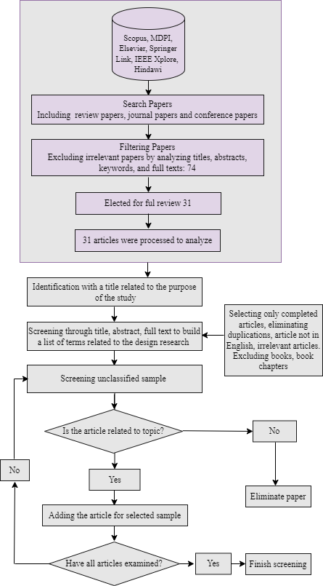

1. Search methodology.

From these databases, articles from journals and conferences from 2020-2024 were selected. Figure 3 shows the distribution of included articles by year and the distribution of publications by identified topics.

As from Figure 4, these articles were selected with our queries, resulting in 74 articles. To answer our research questions, we scrutinized all 74 primary studies. We examined the abstracts of the selected articles and filtered them according to our inclusion and exclusion criteria, double-checking the content of the articles if necessary. After analyzing the articles, 31 articles were included for further study. We extracted the following information for each study: full reference, short abstract and type of contribution, areas of application, integration with other testing methods, and evaluation details.

We further analyzed the article abstracts, which show the general trend of sentiment in the IoT security research community and provide insight into how researchers perceive and discuss security issues related to IoT.

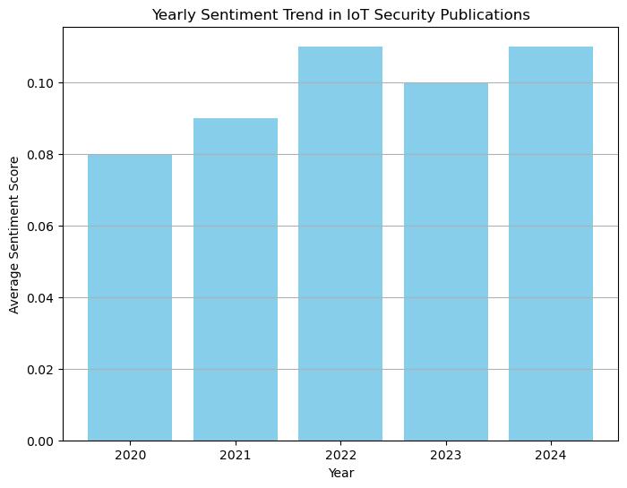

1. Yearly Sentiment Trend in IoT Security Publications.

The Figure 5 shows the evolution of average sentiment analysis scores obtained from annotations of IoT security publications from 2020 to 2024. According to Table 1, the subject of the statistical study is sentiment analysis in analyzing attacks in IoT. By analyzing the publications, we found that various ML models are most commonly used to classify sentiment in IoT attacks. In the field of cybersecurity in IoT environments, the use of machine learning algorithms to detect breaches and intrusions has been the subject of numerous research studies. The results of the selected 31 articles are contained in Table 1 with methods and results of attack detection.

Comparative analysis of IoT Attack Detection

|  |  |  |  |  |
| --- | --- | --- | --- | --- |
| Author | Year | Dataset | Method | Accuracy, % |
| Bijalwan *et al.* [10] | 2020 | Botnet Dataset | AdaBoost-DT  AdaBoost-KNN  Bagging-DT  Bagging-KNN  Bagging SVM  Voting-KNN+DT  Voting DT+SVM  Voting-SVM+KNN | 98.36%  94.65%  95.30%  94.77%  75.99%  95.47%  85.06%  94.65% |
| Lakshmi Prasanna  *et al.* [11] | 2024 | BoT-IoT training dataset | NB  Logistic  models  RF  KNN  Multi-class Fast Parallel DT and Multi-Class Feature rank Gaussian Kernel | 74%  75%  76%  79%  98% |
| Zhou  *et al.* [12] | 2020 | NSL-KDD  ARWID  SIS-IDS2017 | CFS-BA: Ensemble  C4.5  RF  Forest PA | 99.8%  98.8%  99.1%  98.7% |
| Verma  *et al.*[13] | 2020 | CIDDS-001  UNNSW-NB15  NSL-KDD | RF  CART  MLP  AB  GBM  XGBoost  ETC | 94.94%  96.74%  82.76%  97.94%  99.53%  98.76%  82.99% |
| Sarwar  *et al.*[14] | 2023 | IoTID20  MedBIoT  UNSW-NB15  N-BaIoT | Extra Tree Random Voting Ensemble Classifier  (ER-VEC) | 99.99%  99.91%  95.64%  100% |
| Zixu  *et al.*[15] | 2022 | UNSW BoT-IoT | GANs + AE | 97.11% |
| Nadem  *et al.*[16] | 2021 | NSL-KDD  Selected sub-features of the dataset | SVM | 95.98%  87.74% |
| Kumar  *et al.*[17] | 2021 | NSL-KDD  BoT-IoT  DS2OS | RF  KNN  XGB | 99% |
| Farahmand-Nejad *et al.*[18] | 2020 | N_BaIoT | WCC-SVM  PSO-SVM  GA-SVM  ACO-SVM | 95%  93 %  87%  88% |
| Tikekar  *et al.*[19] | 2024 | Botnets | NB | 90.62% |
| Liaqat  *et al.*[20] | 2020 | Bot-IoT | CNN-cuDNN LSTM  DNN-GRU  LTSM-GRU | 99.99%  99.96%  99.98% |
| Wani A. and Revathi S. [21] | 2020 | - | IoTSDN-RAN  IoT-SVM | 97.91%  97.48% |
| Huč *et al.* [22] | 2021 | DS2OS | DT | 98% |
| Devprasad *et al.*[23] | 2022 | NSL  KDD  UNSW-NB15 | DT  SVM | 98.77%  89.43% |
| Vishwakarma *et al.*[24] | 2022 | ToN-IoT | DNN | 69.53% |
| Karthik  *et al.* [25] | 2021 | - | HSBABO  MCELIECE | 94% |
| Mohamed *et al.* [26] | 2023 | UNSW-NB15, ToN-IoT | EHIDS  CF-OSELM-PRFF  ABA-IDS  ICNN-FCID | 96.47%, 95,36%  94.70%, 91.31%  90.88%, 90.03%  92.38%, 92.26% |
| Awajan [27] | 2023 | Observed data | DNN, SVM | 93.71% |
| Alrayes *et al*.[28] | 2022 | N_BaIoT | BND-BMOML | 99.32% |
| Kim  *et al*.[29] | 2020 | N_BaIoT | RNN, LSTM | 97% |
| Sharma  *et al.*[30] | 2023 | UNSW-NB15 | CNN | 84% |
| Rani  *et al.*[31] | 2023 | DS2OS | LGBM-IDS | 99,42% |
| ALMahadin *et al.* [32] | 2022 | UNBS-NB 15 and KDD99 | SVM | 99.62% |
| Mustafa *et al.* [33] | 2023 | N_BaIoT | DBSCAN | 96.66% |
| Jain *et al.* [34] | 2022 | NSL-Botnet UNSW-NB15 | LSTM | 99.4%  93% |
| Çtin *et al.* [35] | 2022 | CICIDS2017 | Genetic algorithm | 91% |
| Raju *et al*. [36] | 2023 | CICIoT2023 | DT | 99.17% |
| Ali *et al.* [37] | 2024 | UNSW-NB15 | ANN+CNN+LSTM+RNN (ACLR) | 96.98% |
| Alkahtani Hasan  *et al*. [38] | 2021 | N-BaIoT | CNN-LSTM | 90.88% |
| Ullah  *et al.* [39] | 2021 | BoT-IoT | CGANs + FNN | 77.01% |
| Chu *et al*. [40] | 2023 | ToN-IoT | GANs | 98.53% |

Table 1 highlights the evolution of research in botnet detection, including their algorithms, and attack detection security. However, issues such as the dynamic nature of botnet attacks, the evolution of attack models, and the need for scalable detection mechanisms remain a challenge for future research. A review of 31 research papers on botnet detection highlights the approaches, methodology, and emerging trends in combating the botnet threat. IoT defense requires a multifaceted approach that includes deploying sophisticated mechanisms to detect anomalies and pinpoint intrusions. The research community has made significant strides in utilizing ML models to address these critical challenges (figure 6).

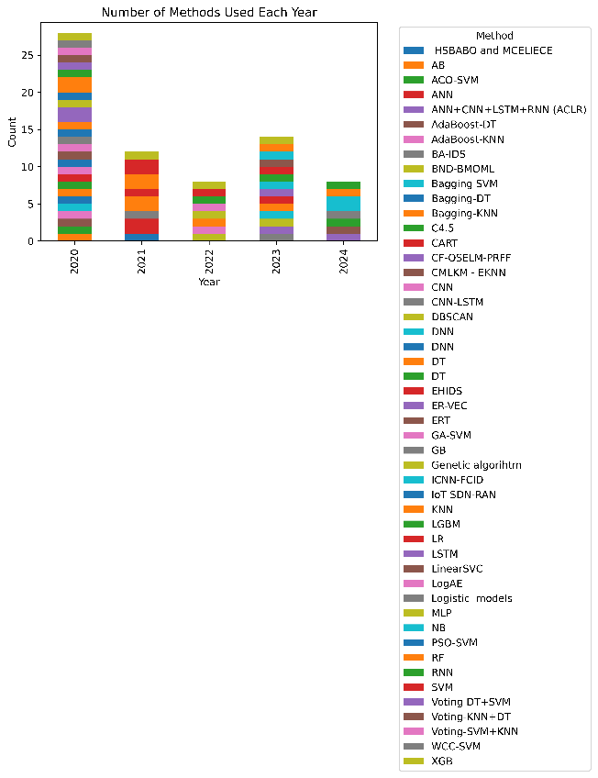

1. Number of methods of each year.

The use of ML discussed [10] that uses an ensemble of classifiers in eight variants that significantly improve the detection and prevention of botnet attacks, outperforming single classifiers in terms of accuracy. There is the paper [41] about the DBSCAN-GWO model outperforms traditional DBSCAN, OPTICS and other methods in detecting botnet data in various IoT device datasets, achieving 98% accuracy. In a systematic review [42], the goal especially focuses on malware detection using permission analysis. The following studies discuss ML defence mechanisms [43, 44], they also discuss ML algorithms by reducing the cost of securing WSN in several areas. The authors [45] showed a comprehensive survey of ML algorithms used to support WSNs is provided considering WSN-specific constraints including security. The authors of [46] compared different ML algorithms in terms of anomaly detection. The research [47] used WSNs that utilize several ML methods are discussed. Among the machine learning methods used in practice, XGBoost is one of the most effective methods in many applications. The research [48, 49] used a new algorithm considering data sparsity and weighted point sketch for approximate tree learning is described and proposed. An intrusion detection model based on XGBoost is proposed.

The currently proposed botnet detection methods can be categorized based on the specific stage of work to be detected and the approach to detecting attacks. An anomaly detection autoencoder to protect nine IoT devices from botnet attacks is proposed. N-BaIoT is the first dataset used to build an autoencoder. BASHLITE (Gafgyt) and Mirai attacks are common botnets attacking IoT devices [50]. Collectively, the findings highlight the diversity of strategies, models, and technologies used in the research to counter botnet attacks, enhance the security of the IoT, and effectively address evolving cyber threats, especially in the areas of botnet detection and protection of IoT applications.

B. BOTNET

Today, there is an active proliferation of botnets that identify potential IoT victims by scanning the network for open ports and subsequently infiltrating using exploits or weak credential leaks. Such attacks are characterized by their simplicity and ability to automatically propagate through the network by using worm-like mechanisms. This indicates a lack of user awareness of IoT security and that appropriate protection measures are not always in place. Mirai and Gafgyt have evolved into an entire family of botnets. Its diverse variants have reached the level of implementing distributed denial of service (DDoS) attacks, vulnerability scanning, command execution, and dynamic malware download and launch [51]. In the Gafgyt network, administrators use its infrastructure to manage the range of attack directives provided by users, respond to queries, and facilitate collaborative discussions.

Gafgyt operates as an IoT attack, using several smart routers as both bot nodes and targets. Typically, once infected, the IoT device hosting Gafgyt initiates a network-wide scan to identify the responding nodes and then attempts to breach their defences by password mining or exploiting vulnerabilities. This modus operandi facilitates the spread of the botnet as infected devices are transformed into additional bot nodes, which aids in its propagation. Notably, Gafgyt favours smart routers among IoT devices due to their ubiquitous presence, extensive vulnerability landscape, and weak management practices [51].

According to SonicWall's mid-year update of its 2023 Cyber Threat Report, global IoT malware grew 37% in the first six months of 2023 [52].

The biggest culprits are the Mirai, NyaDrop and Gafgyt botnets. These malware families still account for 66% of the attack payload, creating botnets from infected IoT devices. The research also shows that cybercriminals are targeting outdated vulnerabilities: 34 of the 39 most popular IoT exploits specifically target vulnerabilities that are more than three years old. Geographic differences in IoT malware attacks. The landscape of IoT malware attacks in 2023 shows significant geographic variation. While North America saw a moderate decline in attacks, regions such as Asia and Latin America saw significant growth. This uneven distribution emphasizes the different levels of vulnerability in different regions. In countries with rapid digitalization, especially in Asia and Latin America, the IoT is being adopted at a pace that outpaces the development of appropriate cybersecurity measures. Regions with less developed cybersecurity systems are more susceptible to attack.

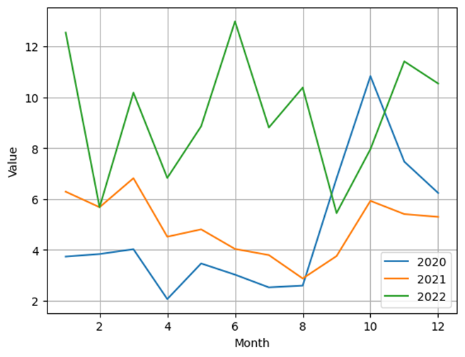

1. Number Global IoT attacks 2020-2022 years [52].

In December 2022, the number of IoT attacks worldwide exceeded 10.54 million (Figure 7) [52]. Nevertheless, in the corresponding month of 2021, the quantity of documented IoT assaults decreased to nearly six million. The peak monthly attack volume was registered in June 2022, reaching almost 13 million attacks.

## MACHINE LEARNING MODELS

After This section provides an overview of selected ML algorithms: XGBoost, LGBM, RF, and DT used in this paper.

## XGBOOST ALGORITHM

XGBoost (eXtreme gradient boosting) is an optimized model that can run on its own as a standalone algorithm; however, it has several features that outperform other algorithms. One of the features is regularization, which is used to prevent overfitting and enhance the generalization of the model. This feature is useful for dealing with large datasets and high-dimensional spaces. It incorporates cross-validation without the use of external libraries. Because of this capability, it is possible to stop at an early stage preemptively. XGBoost is also handled for speed and scalability. The XGBoost is very accurate, quick, and versatile; it may be used for a variety of tasks, including classification issues. This algorithm minimizes computing time and enhances the gradient-boosting method of determining the objective function [53]. Big data research challenges are answered efficiently and precisely during the training phase thanks to parallel computing [54]. Applying, the enhanced XGBoost model offers the best balance between performance and training time [55]. XGBoost was able to minimize the regularized objective function (L1 and L2). The training process uses iterative methods where new trees are added to predict the errors and residuals of previous trees and then combined with the previous trees to produce the final predictions. This method is called gradient boosting because it uses the gradient descent algorithm to minimize the loss when adding new models.

*E. LGBM algorithm*

LightGBM (LGBM) is a framework from Microsoft, the main advantage of which is the speed of training on large data sets. It is based, as in the case of CatBoost'a and XGBoost'a, on the algorithm of gradient-based decision tree bousting. The difference in training is summarized in Figure - Differences between the LGBM training algorithm and other models. The preparation of data for predictions with LGBM is done in the same way as for the linear regression model for XGBoost. LGBM uses a novel gradient-based one-way sampling (GOSS) technique to filter the data instances to find the separation value, while XGBoost uses a pre-sorted algorithm and a histogram-based algorithm to compute the best separation. LGBM is another efficient machine learning algorithm which is also used for classification and regression tasks, similar to XGBoost but with some differences in architecture and speed [56].

*F. RF algorithm*

The essence of the random forest (RF) method is to apply a set (ensemble) of decision trees (DT), each of which individually gives a residually low quality of classification, but in the aggregate due to their large number a higher result is obtained. This method is used for classification tasks, in which case a decision is made by majority voting, and in regression, the answers of trees are averaged. The RF method is based on the so-called wisdom of crowds. The performance of a random forest is determined by the following rule: "A large number of relatively uncorrelated trees working together will outperform any of their components" [57]. Some of the trees may be incorrect, but the majority will be correct and as a result, the population of trees may follow the correct direction. The prerequisites for successful prediction can be considered to be some meaningful signal in the features (so that the models are more accurate than random guessing), and a weak correlation between the predictions (and errors) of individual trees.

*G. DT algorithm*

The DT method is based on the process of recursive partitioning of the initial set of objects into subsets previously assigned to the specified classes. Decision rules are used to perform the partitioning, and attribute values are checked according to a given condition. There are two main elements of the structure - nodes and leaves. Nodes contain decisive rules and subsets of observations satisfying them. Leaves contain observations classified by the tree. Each leaf belongs to one of the classes and the object is assigned the corresponding class label. The nodes specify the rules that partition the observations it contains, and the leaves are in turn labeled with the class label of the class whose objects fall into that leaf. If the class defined by the tree matches the target class, the object is recognized, otherwise it is unrecognized. The topmost node is called the root node, it contains all training and working datasets. The DT is a linear classifier; objects are partitioned in two-dimensional space by lines (in multidimensional space - by planes) [58].

# EXPERIMANTAL RESULTS

This section provides an explanation of the confusion matrix and the evaluation metrics used for comparison and describes the results of the experiment. This is followed by a discussion of the results.

Throughout the model-building and testing procedures, the system used in the experiments remained unchanged. The model was trained and evaluated using ML algorithms XGBoost, RF, LGBM and DT. The multi-calss classification attack detection accuracy rate was used as a benchmark metric for evaluating the algorithm preference.

*A. DATASET*

The use of the N-BaIoT in this study is due to the difference in real data. The dataset [59, 60] was used to classify: benign, g-jank, g-combo, g-scan, g-tcp and g-udp (figure 8).

This dataset is designed to address the lack of published botnet datasets for IoT. It used real data collected from 7.5 GB datasets for different types of common Internet of Things devices. The dataset characteristics are described in Table 2.

Characteristics of dataset

|  |  |  |  |  |
| --- | --- | --- | --- | --- |
| Name | Characteristics | Name | Characteristics | Name |
| Benign (Class_1) | A secure class, designated as Class_1, covers network traffic devoid of any malicious intent or action | Benign (Class_1) | A secure class, designated as Class_1, covers network traffic devoid of any malicious intent or action | Benign (Class_1) |

Trained and optimized a deep autoencoder on 2/3 of its robust training dataset. This was done to track common network traffic patterns. Each device's test data included the remaining 1/3 of the secure data plus all malicious data.

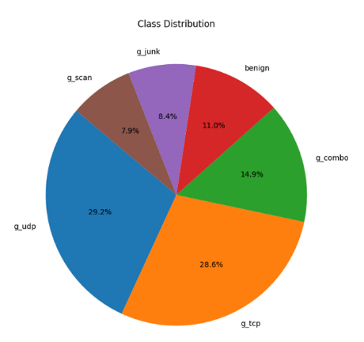

1. Botnet attacks class distribution diagram.

*B. PROPOSED MODEL*

This section details the development of the detection model designed to recognize attack behavior. The design phase consists of several sub-phases, and the data used in this research is in the public domain and can be retrieved from the dataset [59]. Figure 9 depicts an algorithm describing the complete attack detection process.

The main objective is to develop an intrusion detection model capable of detecting attacks in IoT-based intelligent environments. The model includes three steps: data preparation and preprocessing, classifier training, and decision-making. All processes are performed based on a practical dataset. An illustration of the operation of the proposed multi-classification detection model is shown in Figure 9. We presented a new efficient model to detect different types of botnet attacks on IoT devices. This method is based on sequential structure and application of machine learning algorithms such as XGBoost, Random Forest, LGBM and Decision Tree.

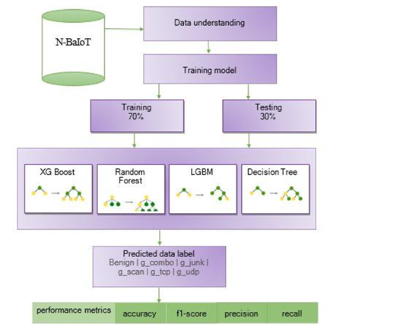

1. Proposed model.

The attribute "type of attack" was chosen as the target variable; accordingly, the other attributes will act as independent variables (predictors). Before training the models, the data set was divided into two samples: training and test. The first sample is for training the classification models and the second sample is for evaluating the quality of performance of the classification models. The method "sklearn.model_selection.train_test.split()" was used to split the data, taking as parameters the dependent and independent variables, also the size of the test sample. The model is tested on training and test samples of 70% and 30% respectively.

*C. EXPERIMENTAL COMPARISON OF PERFORMANCE OF MACHINE LEARNING ALGORITHMS*

During model training and testing, a confusion matrix was created for each set of devices for testing and validation. The estimation of the threat detection rate can be effectively represented using the confusion matrix. Figure 10 shows the confusion matrix, which estimates the classification accuracy by dividing the total number of observations by the predicted and actual values. It identifies model defects: vertical columns represent predictions and horizontal rows represent actual data.

|  |  |
| --- | --- |
| https://lh7-us.googleusercontent.com/G88NJvJZhsFaiaU6Af1tJY9zCX10KxxbSwSOalDdnKL6w1dIKGJsdz81X0DT9ejTQS-SNURzeJsiK-w0N5f-860QCCsaGLAUGQEkwkLH8h9sErDr433EUanuQwt-PAy59yXzx9VMvlpC7XeU_A3Iqw | https://lh7-us.googleusercontent.com/F9aP5vT2YAAAhZlULT9twnKjuKdDWWz9XMR5ii0Ay_6XAOkQ_NSeNxhsJcxnSoa_KjHAQxRtToHgJ9oEIO-veXgbmfMr1H19fsPXkNmPiEfhJDPZrFAnJ8xl_RotVhWmcdhQqF3F7G6suSloVcwejg |
| (a) | (b) |
| https://lh7-us.googleusercontent.com/e-yINx2puaXjzzhhFoS4qOjC7HoGv6iPKT6C2azFdn7vTzxSjJ4d6BdFPmfBdwabqKVgzY_oBjIBfCzQjQqjz3Rsor9Z1Y9ebmu5l5zyZQFhQheYa81txEOXqFt8e0jR7WDiJdNSJ6_iAK4LrXCspA | https://lh7-us.googleusercontent.com/gndjU2jSKoiIh6utJRLUFvSHs7uRlLvxoRsh71XXCCQHpeZz1dLwWCge0KUtE4r0d_oGE5NabnEuwYIYATPGfw7bIfU_jYtgLSuMX_wsTy4lXm1kY6RmB6ntYKjzqk0LpvAzhEDD8RVxibqFOf-QSQ |
| (c) | (d) |

1. Confusion matrix of XGBoost (a), RF (b), LGBM (c), DT (d).

Figure 10 shows the confusion matrix for multi-class classification detection performed by XGBoost, RF, LGBM, and DT algorithms. Demonstrates the best performance in multi-class classification detection achieving an accuracy of 99.18% for XGBoost, 99.20% for RF, 99.85% for LGBM and 99.17% for DT. LGBM performed the highest in all other metrics.

*D. MODEL EVALUATION*

In this experimental study, we evaluate four algorithms for multi-class classification of attack detection. A high f1-score indicates that the model performs well in detecting intrusions and minimizing false alarms. Another key metric in this area is recall, which reflects the model's ability to detect all intrusion occurrences. A high recall indicates that the model finds almost all intrusions, even if this results in a certain number of false positives. It is critical to consider both of these metrics when detecting intrusions, as missing even a single intrusion can have serious consequences. Therefore, models in this area should aim for high values of both f1 and recall to find a balance between accuracy and completeness of intrusion detection.

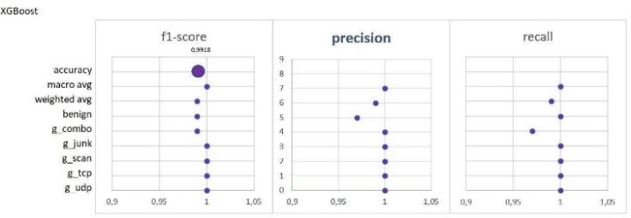

1. Example of a figure caption.

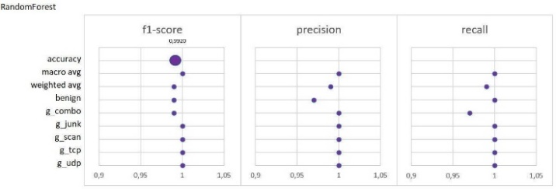

1. Classification report of XGBoost.

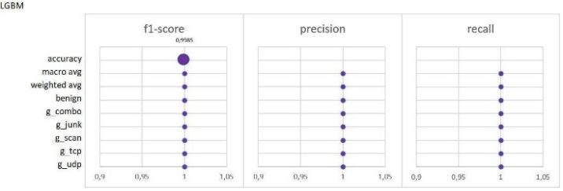

1. Classification report of RF.

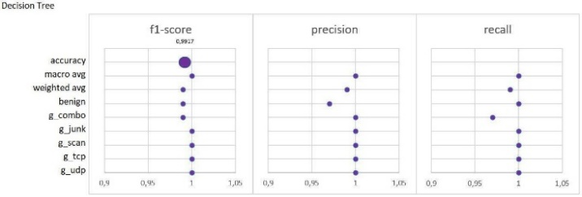

1. Classification report of LGBM.

The evaluation metrics are computed and shown in Figures 11-14. In the field of intrusion detection, the f1 metric plays an important role in evaluating the overall performance of a model. It shows how successful the model is in recognizing real intrusions and reducing false alarms.

|  |  |
| --- | --- |
| https://lh7-us.googleusercontent.com/D9s0jviO65DPzxT0QOiz9yByO9BD5swBUxKV7BuqDwV3hb6p60jm5Cx8xdE6pImWggyRGjOqHy_hDJgc4Fc6exOe6MHMl2_i9h8Kdj33bKLdU6TvLcpZKqdgKQCn19wcbtdHzyg8tOwdj6The4D5Ow | https://lh7-us.googleusercontent.com/PkED_TekmJ4ZE6TyuFccc5yCjXm8uIEQIp4XHDbVwcoEWwtP4yL3vkZiBD3bg_JkYNEW59kcBNSBRMcBHbvfDSDG64Rcq97luqO6eP1cEOBD-buFicvOaoOYWVvtyk8AtQ9QjbgtGdXpz5rr9kQkQQ |
| (a) | (b) |
| https://lh7-us.googleusercontent.com/GsryJ5uSgwKCVePQdqhAmYlsOIPAU_oWG4ljl3nyMGqBIjzeF2Mgc0BSudb9Ty7hDk4UhvsVkIa3mX3-tOsGrnXUcci5tQ-JYxD4WAdOEKV3DHSuZcLUpDs-G-zWwrNuoteIYAhqaz2rYJBa99UCPw | https://lh7-us.googleusercontent.com/stTsMD2D1Oo6agVga6xYuuOWvWxXSQKXymAhF8rGn5_3dozKqkOOByc1Q42H4gD9IjYgmm-BQ3aajwGUgz46ekZ6C-8cW6BZZS1XXrF79IMlR_utwsj92zlwzPWh6b6kxkPbtr2esF71OPe4GH1Ttg |
| (c) | (d) |

1. Classification report of DT.

The precision-recall curves (Fig.15 a-d) show the high performance of the trained classifiers. Figure 15 shows several Precision-Recall curves, one for each class, with precision values on the y-axis and recall values on the x-axis. The area under each curve is annotated, with values ranging from 0.97 to 1.00, indicating high precision and recall for the respective classes.

Overall, judging from the Precision-Recall curves, the XGBoost, RF and LGBM models outperform the DT model in terms of accuracy and recall for multi-class classification detection.

*E. DISCUSSION*

We used the N-BaIoT dataset containing real data collected from network-connected IoT devices infected by botnets such as Gafgyt (BASHLITE), as shown in Figure 8. The training and test datasets are separated in the ratio of 70% and 30% respectively. The structure of the proposed model for anomaly detection and feature extraction for multi-class classification detection is shown in Figure 9. The dataset contains normal data and attack samples. The results of the study on N-BaIoT dataset shows about the effectiveness of the proposed methods in terms of accuracy.

In Figure 16, we compare our proposed model results with other literature from Table 1, which shows the comparative analysis of IoT attack detection, which utilizes a multi-class classification model.

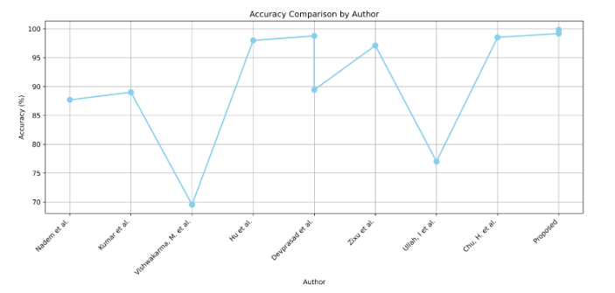

1. Comparison of the effectiveness of multi-class classification attacks.

Figure 16 shows higher accuracy compared to other models for botnet detection. This indicates the effectiveness and feasibility of using the proposed model for attack detection.

# CONCLUSION

This paper presents the comprehensive study of botnet detection methodologies in IoT networks using machine learning methods. We have developed a new efficient methodology to identify different types of attacks on IoT. Our proposed model takes into account the features of IoT devices with limited resources and incorporates data preprocessing mechanisms to improve the accuracy of multi-class classification.

The proposed model results demonstrated the superiority of LGBM algorithms over other algorithms on multi-class classification of attack detection. XGBoost, Random Forest, LGBM and Decision Trees algorithms, showed high accuracy rates of 99.18%, 99.20%, 99.85% and 99.17% respectively.

The developed model classifiers exhibit a high degree of accuracy and are suitable for integration into complex attack detection systems. The practical applications of these results are significant: the models proposed here can contribute significantly to the architecture design of robust attack detection systems in IoT networks .However, despite the current advances in classification accuracy, further research is needed to further improve the performance and adaptability of these models to different environments and datasets. Future research is expected to explore the possibility of applying additional algorithms to improve the detection process.

##### Acknowledgment

This research has been funded by the Science Committee of the Ministry of Education and Science of the Republic of Kazakhstan (Grant No. No AP19680345).

The authors would like to thank the "IoT Research Lab" for their valuable contributions to this study.

##### References

1. M. Kaur and A. Munjal, “Data aggregation algorithms for wireless sensor networks: A review,” Ad Hoc Networks, vol. 100, p. 102083, Apr. 2020, doi: 10.1016/j.adhoc.2020.102083.
2. T. Sasi, A. H. Lashkari, R. Lu, P. Xiong, and S. Iqbal, “A comprehensive survey on IoT attacks: Taxonomy, detection mechanisms and challenges,” Journal of Information and Intelligence, Dec. 2023, doi: 10.1016/j.jiixd.2023.12.001.
3. M. Asad, M. Asim, T. Javed, M. O. Beg, H. Mujtaba, and S. Abbas, “DeepDetect: Detection of Distributed Denial of Service Attacks Using Deep Learning,” The Computer Journal, vol. 63, no. 7, pp. 983–994, Jul. 2019, doi: 10.1093/comjnl/bxz064.
4. A. Tekerek, “A novel architecture for web-based attack detection using convolutional neural network,” Computers &amp; Security, vol. 100, p. 102096, Jan. 2021, doi: 10.1016/j.cose.2020.102096.
5. V. Adat and B. B. Gupta, “Security in Internet of Things: issues, challenges, taxonomy, and architecture,” Telecommunication Systems, vol. 67, no. 3, pp. 423–441, Jun. 2017, doi: 10.1007/s11235-017-0345-9.
6. U. Tariq, I. Ahmed, A. K. Bashir, and K. Shaukat, “A Critical Cybersecurity Analysis and Future Research Directions for the Internet of Things: A Comprehensive Review,” Sensors, vol. 23, no. 8, p. 4117, Apr. 2023, doi: 10.3390/s23084117.
7. P. Sinha, V. K. Jha, A. K. Rai, and B. Bhushan, “Security vulnerabilities, attacks and countermeasures in wireless sensor networks at various layers of OSI reference model: A survey,” 2017 International Conference on Signal Processing and Communication (ICSPC), Jul. 2017, doi: 10.1109/cspc.2017.8305855.
8. A. Ehsan, C. Catal, and A. Mishra, “Detecting Malware by Analyzing App Permissions on Android Platform: A Systematic Literature Review,” Sensors, vol. 22, no. 20, p. 7928, Oct. 2022, doi: 10.3390/s22207928.
9. A. Nazir et al., “Advancing IoT security: A systematic review of machine learning approaches for the detection of IoT botnets,” Journal of King Saud University - Computer and Information Sciences, vol. 35, no. 10, p. 101820, Dec. 2023, doi: 10.1016/j.jksuci.2023.101820.
10. A. Bijalwan, “Botnet Forensic Analysis Using Machine Learning,” Security and Communication Networks, vol. 2020, pp. 1–9, Feb. 2020, doi: 10.1155/2020/9302318.
11. B. L. Prasanna, M. S., “Reddy A Parallel Rank Based Multi-Class Ensemble Classification Framework on ISOT Cyber Threat Detection, “International Journal of Intelligent Systems and Applications in Engineering, vol. 12(10s), 2024, pp. 556–566.
12. Y. Zhou, G. Cheng, S. Jiang, and M. Dai, “Building an efficient intrusion detection system based on feature selection and ensemble classifier,” Computer Networks, vol. 174, p. 107247, Jun. 2020, doi: 10.1016/j.comnet.2020.107247.
13. A. Verma and V. Ranga, “Machine Learning Based Intrusion Detection Systems for IoT Applications,” Wireless Personal Communications, vol. 111, no. 4, pp. 2287–2310, Nov. 2019, doi: 10.1007/s11277-019-06986-8.
14. A. Sarwar et al., “IoT networks attacks detection using multi-novel features and extra tree random - voting ensemble classifier (ER-VEC),” Journal of Ambient Intelligence and Humanized Computing, vol. 14, no. 12, pp. 16637–16651, Aug. 2023, doi: 10.1007/s12652-023-04666-x.
15. T. Zixu, K. S. K. Liyanage, and M. Gurusamy, “Generative Adversarial Network and Auto Encoder based Anomaly Detection in Distributed IoT Networks,” GLOBECOM 2020 - 2020 IEEE Global Communications Conference, Dec. 2020, doi: 10.1109/globecom42002.2020.9348244.
16. P. Hadem, D. K. Saikia, and S. Moulik, “An SDN-based Intrusion Detection System using SVM with Selective Logging for IP Traceback,” Computer Networks, vol. 191, p. 108015, May 2021, doi: 10.1016/j.comnet.2021.108015.
17. P. Kumar, G. P. Gupta, and R. Tripathi, “Toward Design of an Intelligent Cyber Attack Detection System using Hybrid Feature Reduced Approach for IoT Networks,” Arabian Journal for Science and Engineering, vol. 46, no. 4, pp. 3749–3778, Jan. 2021, doi: 10.1007/s13369-020-05181-3.
18. A. Farahmand Nejad and S. Noferesti, “A real-time botnet detection model based on an efficient wrapper feature selection method,” International Journal of Security and Networks, vol. 15, no. 1, p. 36, 2020, doi: 10.1504/ijsn.2020.10028190.
19. P. C. Tikekar, S. S. Sherekar, and J. Kumar, “An Approach for Detection of Botnet Based on Machine Learning Classifier,” SN Computer Science, vol. 5, no. 3, Mar. 2024, doi: 10.1007/s42979-024-02636-4.
20. S. Liaqat, A. Akhunzada, F. S. Shaikh, A. Giannetsos, and M. A. Jan, “SDN orchestration to combat evolving cyber threats in the Internet of Medical Things (IoMT),” Computer Communications, vol. 160, pp. 697–705, Jul. 2020, doi: 10.1016/j.comcom.2020.07.006.
21. A. Wani and S. Revathi, “Ransomware protection in IoT using software defined networking,” International Journal of Electrical and Computer Engineering (IJECE), vol. 10, no. 3, p. 3166, Jun. 2020, doi: 10.11591/ijece.v10i3.pp3166-3175.
22. A. Huč, J. Šalej, and M. Trebar, “Analysis of Machine Learning Algorithms for Anomaly Detection on Edge Devices,” Sensors, vol. 21, no. 14, p. 4946, Jul. 2021, doi: 10.3390/s21144946.
23. K. D. Devprasad, S. Ramanujam, and S. B. Rajendran, “Context adaptive ensemble classification mechanism with multi-criteria decision making for network intrusion detection,” Concurrency and Computation: Practice and Experience, vol. 34, no. 21, Jun. 2022, doi: 10.1002/cpe.7110.
24. M. Vishwakarma and N. Kesswani, “DIDS: A Deep Neural Network based real-time Intrusion detection system for IoT,” Decision Analytics Journal, vol. 5, p. 100142, Dec. 2022, doi: 10.1016/j.dajour.2022.100142.
25. M. Karthik and M. Krishnan, “Securing an Internet of Things from Distributed Denial of Service and Mirai Botnet Attacks Using a Novel Hybrid Detection and Mitigation Mechanism,” International Journal of Intelligent Engineering and Systems, vol. 14, no. 1, pp. 113–123, Feb. 2021, doi: 10.22266/ijies2021.0228.12.
26. D. Mohamed and O. Ismael, “Enhancement of an IoT hybrid intrusion detection system based on fog-to-cloud computing,” Journal of Cloud Computing, vol. 12, no. 1, Mar. 2023, doi: 10.1186/s13677-023-00420-y.
27. A. Awajan, “A Novel Deep Learning-Based Intrusion Detection System for IoT Networks,” Computers, vol. 12, no. 2, p. 34, Feb. 2023, doi: 10.3390/computers12020034.
28. F. S. Alrayes et al., “Modeling of Botnet Detection Using Barnacles Mating Optimizer with Machine Learning Model for Internet of Things Environment,” Electronics, vol. 11, no. 20, p. 3411, Oct. 2022, doi: 10.3390/electronics11203411.
29. J. Kim, H. Won, M. Shim, S. Hong, and E. Choi, “Feature Analysis of IoT Botnet Attacks based on RNN and LSTM,” International Journal of Engineering Trends and Technology, vol. 68, no. 4, pp. 43–47, Apr. 2020, doi: 10.14445/22315381/ijett-v68i4p208s.
30. B. Sharma, L. Sharma, C. Lal, and S. Roy, “Anomaly based network intrusion detection for IoT attacks using deep learning technique,” Computers and Electrical Engineering, vol. 107, p. 108626, Apr. 2023, doi: 10.1016/j.compeleceng.2023.108626.
31. D. Rani, N. S. Gill, P. Gulia, F. Arena, and G. Pau, “Design of an Intrusion Detection Model for IoT-Enabled Smart Home,” IEEE Access, pp. 1–1, 2023, doi: 10.1109/access.2023.3276863.
32. Dfd\
33. Duaa Haider Mustafa, and Idress Mohammed Husien, “Adaptive DBSCAN with Gray Wolf Optimizer for Botnet Detection,” International Journal of Intelligent Engineering and Systems, vol. 16, no. 4, pp. 409–421, Aug. 2023, doi: 10.22266/ijies2023.0831.33.
34. S. Jain, P. M. Pawar, and R. Muthalagu, “Hybrid Intelligent Intrusion Detection System for Internet of Things,” SSRN Electronic Journal, 2022, doi: 10.2139/ssrn.4097433.
35. G. Çtin, “An Effective Classifier Model for Imbalanced Network Attack Data,” Computers, Materials &amp; Continua, vol. 73, no. 3, pp. 4519–4539, 2022, doi: 10.32604/cmc.2022.031734.
36. V. S. A. Raju and S. B, “Network Intrusion Detection for IoT-Botnet Attacks Using ML Algorithms,” 2023 7th International Conference on Computation System and Information Technology for Sustainable Solutions (CSITSS), Nov. 2023, doi: 10.1109/csitss60515.2023.10334188.
37. M. Ali, M. Shahroz, M. F. Mushtaq, S. Alfarhood, M. Safran, and I. Ashraf, “Hybrid Machine Learning Model for Efficient Botnet Attack Detection in IoT Environment,” IEEE Access, vol. 12, pp. 40682–40699, 2024, doi: 10.1109/access.2024.3376400.
38. H. Alkahtani and T. H. H. Aldhyani, “Botnet Attack Detection by Using CNN-LSTM Model for Internet of Things Applications,” Security and Communication Networks, vol. 2021, pp. 1–23, Sept. 2021, doi: 10.1155/2021/3806459.
39. I. Ullah and Q. H. Mahmoud, “A Framework for Anomaly Detection in IoT Networks Using Conditional Generative Adversarial Networks,” IEEE Access, vol. 9, pp. 165907–165931, 2021, doi: 10.1109/access.2021.3132127.
40. H.-C. Chu and Y.-J. Lin, “Improving the IoT Attack Classification Mechanism with Data Augmentation for Generative Adversarial Networks,” Applied Sciences, vol. 13, no. 23, p. 12592, Nov. 2023, doi: 10.3390/app132312592.
41. W. Xu and Y. Fan, “Intrusion Detection Systems Based on Logarithmic Autoencoder and XGBoost,” Security and Communication Networks, vol. 2022, pp. 1–8, Apr. 2022, doi: 10.1155/2022/9068724.
42. S. M. Tahsien, H. Karimipour, and P. Spachos, “Machine learning based solutions for security of Internet of Things (IoT): A survey,” Journal of Network and Computer Applications, vol. 161, p. 102630, Jul. 2020, doi: 10.1016/j.jnca.2020.102630.
43. R. Ahmad and I. Alsmadi, “Machine learning approaches to IoT security: A systematic literature review,” Internet of Things, vol. 14, p. 100365, Jun. 2021, doi: 10.1016/j.iot.2021.100365.
44. R. Ahmad, R. Wazirali, and T. Abu-Ain, “Machine Learning for Wireless Sensor Networks Security: An Overview of Challenges and Issues,” Sensors, vol. 22, no. 13, p. 4730, Jun. 2022, doi: 10.3390/s22134730.
45. A. Mehta, J. K. Sandhu, and L. Sapra, “Machine Learning in Wireless Sensor Networks: A Retrospective,” 2020 Sixth International Conference on Parallel, Distributed and Grid Computing (PDGC), Nov. 2020, doi: 10.1109/pdgc50313.2020.9315767.
46. S. H. Haji and S. Y. Ameen, “Attack and Anomaly Detection in IoT Networks using Machine Learning Techniques: A Review,” Asian Journal of Research in Computer Science, pp. 30–46, Jun. 2021, doi: 10.9734/ajrcos/2021/v9i230218.
47. M. Mamdouh, M. A. I. Elrukhsi, and A. Khattab, “Securing the Internet of Things and Wireless Sensor Networks via Machine Learning: A Survey,” 2018 International Conference on Computer and Applications (ICCA), Aug. 2018, doi: 10.1109/comapp.2018.8460440.
48. S. Ismail, D. W. Dawoud, and H. Reza, “Securing Wireless Sensor Networks Using Machine Learning and Blockchain: A Review,” Future Internet, vol. 15, no. 6, p. 200, May 2023, doi: 10.3390/fi15060200
49. M. Alqahtani, H. Mathkour, and M. M. Ben Ismail, “IoT Botnet Attack Detection Based on Optimized Extreme Gradient Boosting and Feature Selection,” Sensors, vol. 20, no. 21, p. 6336, Nov. 2020, doi: 10.3390/s20216336.
50. R. Hallman, J. Bryan, G. Palavicini, J. Divita, and J. Romero-Mariona, “IoDDoS—The Internet of Distributed Denial of Sevice Attacks - A Case Study of the Mirai Malware and IoT-Based Botnets,” Proceedings of the 2nd International Conference on Internet of Things, Big Data and Security, 2017, doi: 10.5220/0006246600470058.
51. C. Kolias, G. Kambourakis, A. Stavrou, and J. Voas, “DDoS in the IoT: Mirai and Other Botnets,” Computer, vol. 50, no. 7, pp. 80–84, 2017, doi: 10.1109/mc.2017.201.
52. Monthly number of IoT attacks global 2022| Statista: [Online].Available: https://www.statista.com/statistics/1322216/worldwide-internet-of-things-attacks/
53. T. Chen and C. Guestrin, “XGBoost,” Proceedings of the 22nd ACM SIGKDD International Conference on Knowledge Discovery and Data Mining, Aug. 2016, doi: 10.1145/2939672.2939785.
54. T. Kim, L. F. Vecchietti, K. Choi, S. Lee, and D. Har, “Machine Learning for Advanced Wireless Sensor Networks: A Review,” IEEE Sensors Journal, vol. 21, no. 11, pp. 12379–12397, Jun. 2021, doi: 10.1109/jsen.2020.3035846.
55. S. Bhattacharya et al., “A Novel PCA-Firefly Based XGBoost Classification Model for Intrusion Detection in Networks Using GPU,” Electronics, vol. 9, no. 2, p. 219, Jan. 2020, doi: 10.3390/electronics9020219.
56. M. Al-kasassbeh, M. A. Abbadi, and A. M. Al-Bustanji, “LightGBM Algorithm for Malware Detection,” Intelligent Computing, pp. 391–403, 2020, doi: 10.1007/978-3-030-52243-8_28.
57. R. Bukhowah, A. Aljughaiman, and M. M. H. Rahman, “Detection of DoS Attacks for IoT in Information-Centric Networks Using Machine Learning: Opportunities, Challenges, and Future Research Directions,” Electronics, vol. 13, no. 6, p. 1031, Mar. 2024, doi: 10.3390/electronics13061031.
58. J. Su, S. He, and Y. Wu, “Features selection and prediction for IoT attacks,” High-Confidence Computing, vol. 2, no. 2, p. 100047, Jun. 2022, doi: 10.1016/j.hcc.2021.100047.
59. Kaggle. (2023). N-BaIoT Dataset To Detect IoT Botnet Attacks. [Online]. Available: https://www.kaggle.com/datasets/mkashifn/nbaiot-dataset (accessed on 2 December 2023), doi: 10.7717/peerj-cs.1998/table-1
60. Y. Meidan et al., “N-BaIoT—Network-Based Detection of IoT Botnet Attacks Using Deep Autoencoders,” IEEE Pervasive Computing, vol. 17, no. 3, pp. 12–22, Jul. 2018, doi: 10.1109/mprv.2018.03367731.