   | Article Type: Literature Review  Green Innovation: Trend Research Using Bibliometric Analysis  Nuryakin*  Abstract  This study aims to explore and analyze research trends in green innovation. A literature review was used in this study by conducting a bibliometric analysis of green innovation by measuring research trends on green innovation in the last five years. This study also performed descriptive data and analysis on research trends and proposed an agenda for further studies on green innovation. This study approach carried out bibliographical analysis by taking the Scopus Database. Then filtering research articles was carried out in the 2019 – 2021 period. Bibliometric analysis techniques, citation analysis, and co-citation analysis were also conducted. Findings – This study revealed the nature and direction of research that the green innovation field has undertaken over the past five years. Five clusters existed as themes that appeared in the green innovation literature. Furthermore, this research also discovered the most influential authors, institutions, and countries related to research on green innovation with possible future research directions.  Keywords: green innovation, bibliometric analysis, Scopus, co-citation analysis, co-occurrence  Introduction  Green innovation is a key factor in maintaining the survival of organizations and the environment (Huang & Li, 2018; Jun, Ali, Bhutto, Hussain, & Khan, 2019; Khan & Johl, 2019). Green innovation is also crucial for organizations and communities and environmental issues. This study mainly investigated the increasing trend of green innovation over the last few years. Environmental change and damage have become major threats to human survival. Several companies and social organizations have been directed to develop green innovation to achieve environmental sustainability and economic and energy growth (Jiang, Lyu, Ye, & Zhou, 2020).  Environmental sustainability and commitment to increasing economic well-being are vital issues (Li, Tang, & Jiang, 2019; Mushtaq, Zubair, Khan, & Khurram, 2019). Green innovation is a sustainable competitive advantage strategy (Juniati, Sinaga, Effendi, & Rashid, 2019). The study of green innovation has become an important strategy for businesses to increase their market share and survive in the long term.  Green innovation assists organizations in meeting customer demands to protect the existing environment (Nuryakin & Maryati, 2020). “Green innovation” or “Eco-friendly innovation” can be defined as processes that contribute to the creation of new productions and technologies to reduce environmental risks, such as pollution and the negative consequences of resource exploitation (e.g., energy) (Castellacci & Lie, 2017). Innovation has been divided into product/service innovation and process innovation. The ultimate goal of product/service innovation is to improve product and service functionality for customers and clients.  Successful green innovation can improve market position, attract customers, provide environmentally friendly services, and achieve sustainable competitive advantages (Chen & Chang, 2013). Green innovation is also on the agenda of managers of many organizations and researchers in achieving ethical behavior and marketing strategies. Research on the topic of innovation is driven by innovation theory.  Green innovation is categorized into technology, management functions, product design, and production processes. Green innovation during product life cycle assessment includes modifying existing product designs to reduce the impact of exploitation on the environment (Saunila, Ukko, & Rantala, 2018). Song and Yu (2018) found that green innovation is an important strategy and organizational identity that significantly influences the internal environment’s success.  El-Kassar and Singh (2019) presented that companies are likelier to adopt big data in developing environmental innovation strategies to place a high value on and care for the environment. Other studies have categorized green innovation into product, process, and technology innovation and tackled the challenges of selecting green suppliers to increase the competitiveness of firms (Ilg, 2019; Khan & Johl, 2019; Tariq, Badir, & Chonglerttham, 2019).  Regarding aspects of green innovation, Aarstad and Jakobsen (2020) stated that green industry strategies by innovative companies will collaborate between companies and are an important part of the company’s life cycle. Green strategies are pursued by companies pursuing growth, which have undertaken mergers or acquisitions and reduced costs. Meanwhile, Vachon and Klassen (2008) focused on how companies utilize manufacturing processes, technology, and capabilities and integrate environmental concerns to increase competitive advantage. Senior management support is one of the keys to successfully implementing green innovation.  This study aims to explore and analyze research trends in green innovation. A literature review is used in this study by conducting a bibliometric analysis of green innovation by measuring research trends on green innovation in the last five years.
AFFILIATION:
¹ Master of management Department. Universitas Muhammadiyah Yogyakarta.

*CORRESPONDENCE:
nuryakin@umy.ac.id

THIS ARTICLE IS AVAILABLE IN: http://journal.umy.ac.id/index.php/mb

DOI: 10.18196/mb.xxxxxxxxx

CITATION:
Name. (20xx). Title. Jurnal Manajemen Bisnis, xx(x), xx-xx.

ARTICLE HISTORY
Received:

Revised:

Accepted:

Research Methods
This study examined ‘green innovation’ by conducting a data investigation process with data sourced from the scopus.com website from 2019 to 2021. In these five years, the study discussed green innovation. Finally, there is a potential trend of increased research over the five years. ‘Green innovation’ has been extensively researched in the last few years of the decade.
Furthermore, testing was carried out by mapping and clustering analysis by taking data from scopus.com. The coupling technique bibliographical approach was carried out using the VosViewer program. The data collected was then carried out by importing process, and then the relationships were mapped through the visualization of the similarity of methods using VosViewer for bibliometric mapping. VosViewer focuses on the graphical representation of bibliometric maps and can present graphical views according to an easy-to-interpret way.

Results and Discussion

The development of annual publications
Based on the data processing with the VosViewer program, as shown in Figure 1, the frequency of annual publication developments regarding green innovation can be shown. The average trend shows an increase in publications in 2019 - 2021. In 2018 and 2019, only 19 documents were published. Then in 2020 – 2021, the number of scientific publications increased and reached a maximum growth in 2021, with 63 documents. Following are the results of the development of annual publications regarding green innovation.

Figure 1.
The development of annual publications on green innovation

Author Citations
Author citations describe metrics that explain the author’s expertise in a particular research area. Identification of the author’s expertise shows Stucki T with 4 documents, Zhang Y with 3 documents, Yin S with 3 documents, Yang Z with 4 documents, Tzai SB with 3 documents, Sun J with 2 documents, Agustia D with 2 documents, Chau with 2 documents, Chalkias M with 2 documents and Arabatzis with 2 documents. The results also found that these 10 authors had published less than 5 articles, while a small number published partially relevant works, making a greater contribution to the development of knowledge on green innovation. The following is the distribution of authors on green innovation and the number of papers published.

Figure 2.
Publication by Outhor

Geographic distribution
The data processing found the geographic distribution described in Table 1, depicting the distribution of citations by country. Publications come from 10 different countries. The data analysis indicated greater interest in China and Pakistan, which contributed 109 and 23 documents, respectively. Then followed by the United Kingdom and the United States were the next two countries, with 38 and 27 documents, followed by Malaysia and Indonesia, with 9 documents. In addition, Thailand and Saudi Arabia contributed 8 documents each. Meanwhile, Brazil and Switzerland had few publications. The following are the publication developments based on geographical area coverage of green innovation.

Figure 3.
Linkage and Clustering of text data in a Green Innovation

Green Innovation theme clustering
The image below explains green innovation in several visualizations related to the research theme. Furthermore, their review with VOSviewer revealed nine concept clusters, as seen in Figure 5. This finding suggests a concept derived from the cluster density view. Furthermore, each color code is used to see a list of concepts that stand out from each cluster. The aim is to identify as many themes as possible that have been frequently discussed in previous research and used in future research. The following figure shows that different colors distinguish the cluster density of each cluster.
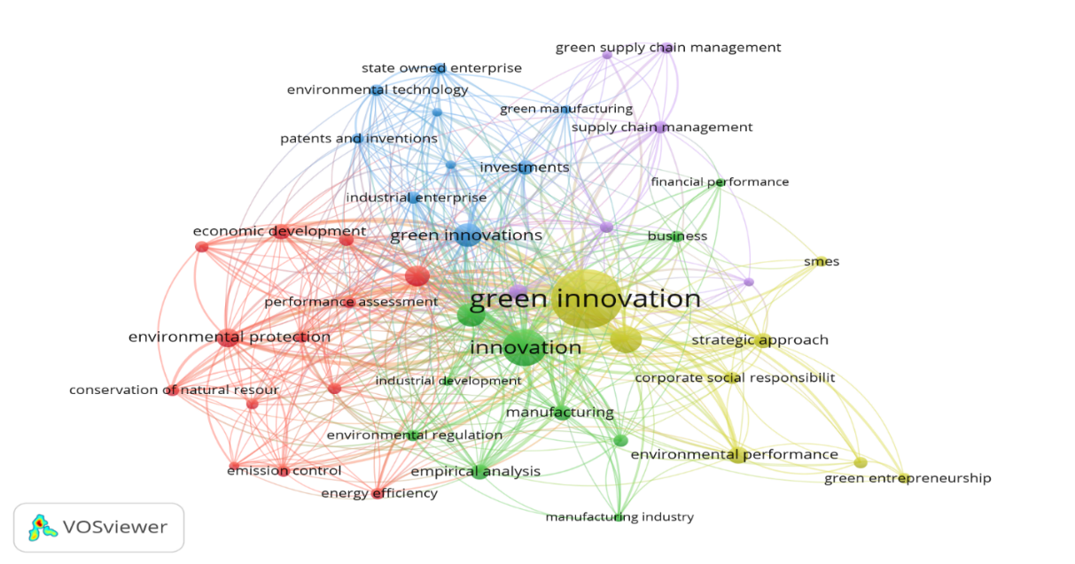
Figure 4.
theme clustering

The table below explains green innovation in several visualizations related to the theme of this study. Then a review of the VOSviewer display reveals five clusters, as seen in the following figure. It demonstrates a concept derived from the cluster density view. Furthermore, each color code is used to see a list of concepts that stand out from each cluster. The aim is to identify as many themes as possible that have been frequently discussed in previous research and used in future research. Figure 5 shows that different colors distinguish the cluster density of each cluster. Some of these clusters can be explained in the following table.

Table 1. Themes Clustering in Green Innovation
Cluster | Items | Total
Cluster 1 (13 Items) | Commerce, Conservation of Natural, Corporate Strategy, Economic Development, Emission Control, Energy Efficiency, Environmental Economic, Environmental Policy, Environmental Protection, Environmental Regulations, Environmental Sustainability, Performance Assessment, Regulatory Framework | 2.6%
Cluster 2 (10 Items) | Business, Economic Growth, Empirical Analysis, Environmental Regulation, Financial Performance, Industrial Development, Innovation, Manufacturing, Manufacturing Industry, Sustainable Development | 2%
Cluster 3 (9 Items) | Environmental Technology, Green Development, Green Innovations, Green Manufacturing, Industrial Enterprise, Investments, Patents and Inventions, Research and Development, State-Owned Enterprise | 1.8%
Cluster 4 (8 Items) | Competitive Advantage, Corporate Social Response, Environmental Performance, Green Economy, Green Entrepreneurship, Green Innovation, SMEs, Strategic Approach | 1.6%
Cluster 5 (6 Items) | Eco-Innovation, Environmental Management, Green Supply Chain, Green Supply Chain Management, Supply Chain Management, Technological Development | 1.2%

Overlay visualization of the green innovation theme
Overlay visualization was done by analyzing metadata and then processing it with VOSviewer. The visualization step was carried out by loading the existing theme by looking at the node’s color with the theme’s appearance and the year of publication. Each color determines the growth trend of studies on green innovation. The following figure explains topics related to green innovation, such as eco-innovation, SMEs, financial performance, green manufacturing, environmental technology, corporate social responsibility, and others that have yet to be widely discussed from 2018 to the end of 2021. Next are topics included in the scope of green innovation studied a lot between 2018 - 2021. Then from 2020 to 2021, green innovation was widely studied in environmental, energy, observation, and emission issues. This visualization has made it easier for researchers to study green innovation studies by looking at portraits of studies every year, as shown in the following figure.
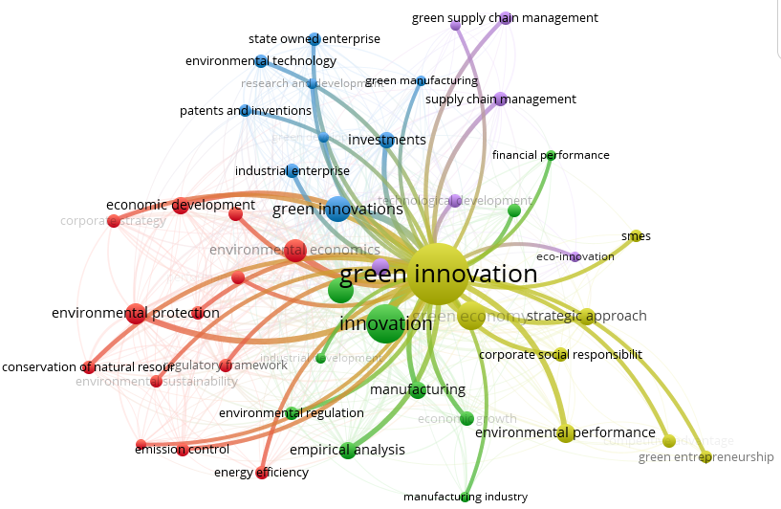

Figure 5.
Overlay visualization

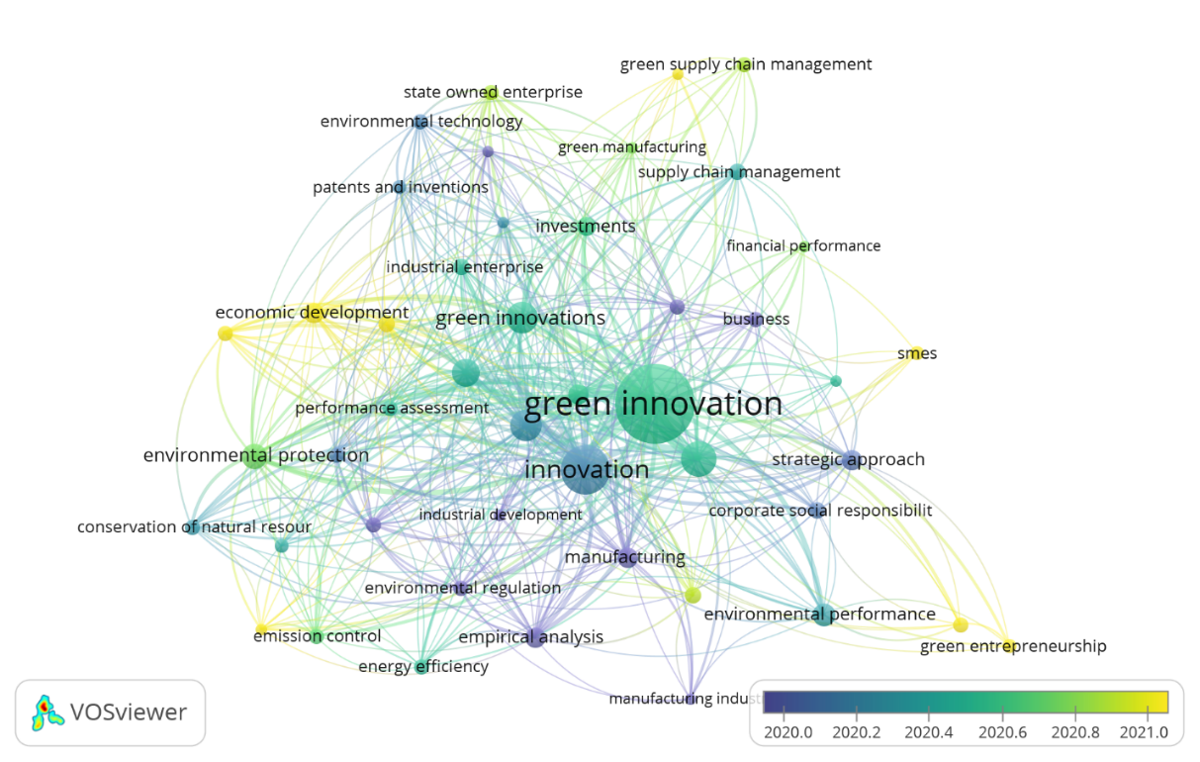
Figure 6. Overlay visualization green innovation topic

Density Visualization in Text Data
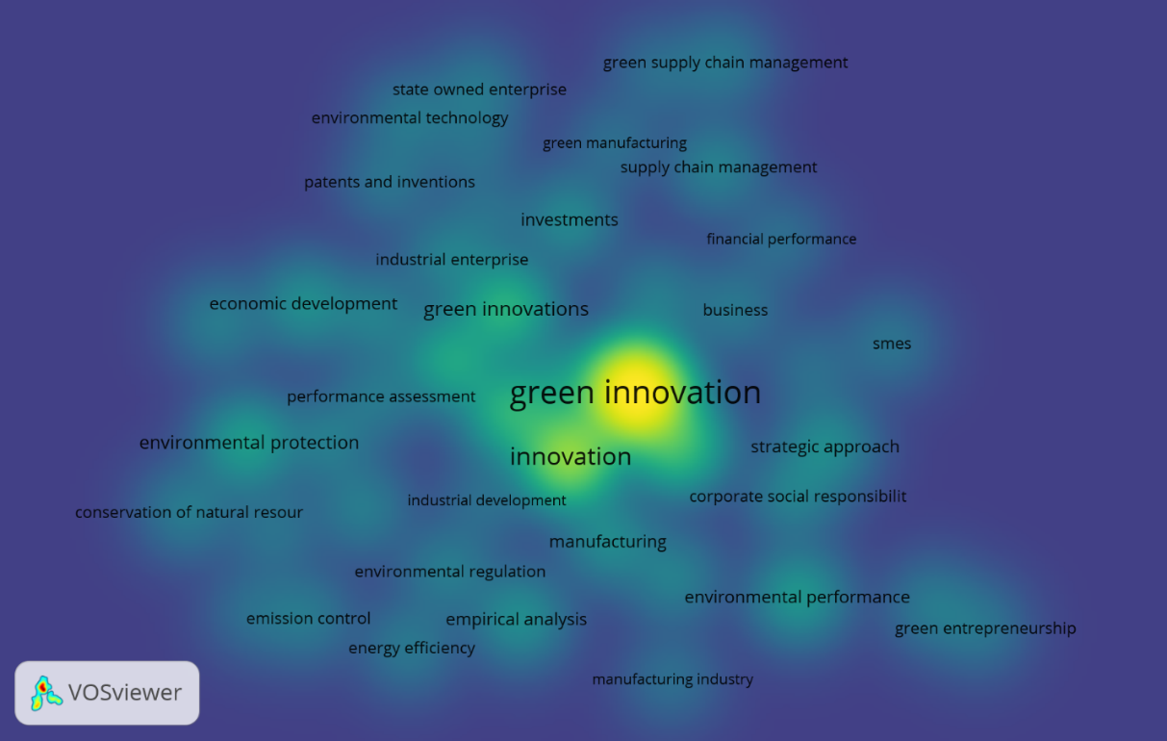

Figure 7. Density Visualization in Text Data

Discussion
This study aims to explore and analyze research trends in green innovation. A literature review was done through bibliometric analysis of green innovation by measuring research trends in the last five years. This study also aims to conduct a descriptive study of data and analysis on research trends and propose an agenda for further studies on green innovation. The literature review also helped to study green innovation and map research developments over the past five years.
The results measured the development of green innovation studies by conducting a rigorous bibliometric analysis of selected articles between 2018 and 2022. The average trend showed an increase in publications in 2019 - 2021. Nineteen documents were published under green innovation in 2018 and 2019. In 2020 – 2021, scientific publications increased to 63 documents. Further analysis was carried out with a bibliometric study involving citation analysis, co-citation analysis, and co-occurrence of author keywords techniques. Then a citation analysis technique was performed to test the research questions.
The geographical distribution of authors came from 10 different countries. China and Pakistan contributed 109 and 23 documents, respectively. The United Kingdom and the United States contributed 38 and 27 documents, while Malaysia and Indonesia had 9 documents. Thailand and Saudi Arabia had 8 documents. The overlay visualization explained the growing trend of studies on green innovation topics such as eco-innovation, SMEs, financial performance, green manufacturing, environmental technology, corporate social responsibility, and others that have yet to be widely discussed from 2018 to the end of 2021.
Those studies also contributed academically and managerially. The theoretical implications of this study provide several important arguments for contributions to the field of green innovation and also contribute to several studies, journals, and institutions that have established studies in this field. The findings align with Takalo and Tooranloo (2021), finding articles on green innovation with topics such as the benefits of implementing green innovation having the highest share. The articles are divided by study area, the industrial sector has more than one industry, and the largest share is the manufacturing industry. Similarly, Schiederig, Tietze, and Herstatt (2012) found the total number of green innovation publications to have sufficient research in this subject area (managing green innovation) and a need for more comprehensive literature reviews.
This study also provides a practical contribution to practitioners regarding a detailed understanding of green innovation, which can assist organizations in gaining a comprehensive understanding of the concept before implementing it as an organizational strategy. That is, this research will assist managers in understanding green innovation as a strategy, helping organizations consider the concept part of a business strategy.

Managerial implications
This study makes practical and theoretical contributions to green innovation. Only a few studies have discussed green innovation with a literature review approach discussed in previous studies. This study took data from the scopus.com database. It needs a strong effort to understand green innovation in future studies. The research approach with literature review has provided valuable opportunities to focus on studies within the scope of green innovation research to contribute to knowledge by considering suggestions for further research. The results recommended the most productive researchers and geographical coverage in green innovation research. The findings will help practitioners who are interested in green innovation. Furthermore, efforts need to be made in collaboration with other researchers to generate, plan, and manage projects on research topics on green innovation.

References

Aarstad, J., & Jakobsen, S. E. (2020). Norwegian firms’ green and new industry strategies: A dual challenge. Sustainability (Switzerland), 12(1). doi:10.3390/SU12010361
Castellacci, F., & Lie, C. M. (2017). A taxonomy of green innovators: Empirical evidence from South Korea. Journal of Cleaner Production, 143, 1036-1047.
Chen, Y. S., & Chang, K. C. (2013). The nonlinear effect of green innovation on the corporate competitive advantage. Quality and Quantity, 47(1), 271-286. doi:10.1007/s11135-011-9518-x
El-Kassar, A. N., & Singh, S. K. (2019). Green innovation and organizational performance: The influence of big data and the moderating role of management commitment and HR practices. Technological Forecasting and Social Change, 144, 483-498. doi:10.1016/j.techfore.2017.12.016
Huang, J.-W., & Li, Y.-H. (2018). How resource alignment moderates the relationship between environmental innovation strategy and green innovation performance. Journal of Business & Industrial Marketing, Vol. 33(3), pp. 316-324. doi:10.1108/JBIM-10-2016-0253
Ilg, P. (2019). How to foster green product innovation in an inert sector. Journal of Innovation and Knowledge, 4(2), 129-138. doi:10.1016/j.jik.2017.12.009
Jiang, Z., Lyu, P., Ye, L., & Zhou, Y. W. (2020). Green innovation transformation, economic sustainability and energy consumption during China’s new normal stage. Journal of Cleaner Production, 273. doi:10.1016/j.jclepro.2020.123044
Jun, W., Ali, W., Bhutto, M. Y., Hussain, H., & Khan, N. A. (2019). Examining the determinants of green innovation adoption in SMEs: a PLS-SEM approach. European Journal of Innovation Management, 24(1), 67-87. doi:10.1108/EJIM-05-2019-0113
Juniati, S., Sinaga, O., Effendi, K. A., & Rashid, A. Z. A. (2019). The effect of relationship learning in driving green innovation, green customer capital and firm’s competitive advantage. International Journal of Supply Chain Management, 8(1), 311-318.
Khan, P. A., & Johl, S. K. (2019). Nexus of Comprehensive Green Innovation, Environmental Management System-14001-2015 and Firm Performance. Cogent Business and Management, 6(1). doi:10.1080/23311975.2019.1691833
Li, D., Tang, F., & Jiang, J. (2019). Does environmental management system foster corporate green innovation? The moderating effect of environmental regulation. Technology Analysis and Strategic Management, 31(10), 1242-1256. doi:10.1080/09537325.2019.1602259
Mushtaq, S., Zubair, S. S., Khan, M. A., & Khurram, S. (2019). Mediating role of environmental commitment between green organizational identity and green innovation performance. Pakistan Journal of Commerce and Social Science, 13(2), 385-408.
Nuryakin, & Maryati, T. (2020). Green product competitiveness and green product success. Why and how does mediating affect green innovation performance? Entrepreneurship and Sustainability Issues, Vol. 7(4), pg. 3061 - 3076. doi:10.9770/jesi.2020.7.4(33
Saunila, M., Ukko, J., & Rantala, T. (2018). Sustainability as a driver of green innovation investment and exploitation. Journal of Cleaner Production, 179, 631-641. doi:10.1016/j.jclepro.2017.11.211
Schiederig, T., Tietze, F., & Herstatt, C. (2012). Green innovation in technology and innovation management–an exploratory literature review. R& D Management, 42(2), 180-192.
Song, W., & Yu, H. (2018). Green Innovation Strategy and Green Innovation: The Roles of Green Creativity and Green Organizational Identity. Corporate Social Responsibility and Environmental Management, 25(2), 135-150. doi:10.1002/csr.1445
Takalo, S. K., & Tooranloo, H. S. (2021). Green innovation: A systematic literature review. Journal of Cleaner Production, 279, 122474.
Tariq, A., Badir, Y., & Chonglerttham, S. (2019). Green innovation and performance: moderation analyses from Thailand. European Journal of Innovation Management, 22(3), 446-467. doi:10.1108/EJIM-07-2018-0148
Vachon, S., & Klassen, R. D. (2008). Environmental management and manufacturing performance: The role of collaboration in the supply chain. International Journal of Production Economics, 111(2), 299-315.

