Correlations

Correlations
 |  | TransferPengetahuan
X1.1 | Pearson Correlation | .893
X1.1 | Sig. (2-tailed) | .000
X1.1 | N | 151
X1.2 | Pearson Correlation | .894
X1.2 | Sig. (2-tailed) | .000
X1.2 | N | 151
X1.3 | Pearson Correlation | .859
X1.3 | Sig. (2-tailed) | .000
X1.3 | N | 151
X1.4 | Pearson Correlation | .923
X1.4 | Sig. (2-tailed) | .000
X1.4 | N | 151
X1.5 | Pearson Correlation | .795
X1.5 | Sig. (2-tailed) | .000
X1.5 | N | 151
TransferPengetahuan | Pearson Correlation | 1
TransferPengetahuan | N | 151

Reliability

Scale: ALL VARIABLES

Case Processing Summary
 |  | N | %
Cases | Valid | 151 | 100.0
Cases | Excludedª | 0 | .0
Cases | Total | 151 | 100.0
a. Listwise deletion based on all variables in the procedure.

Reliability Statistics
Cronbach's Alpha | N of Items
.907 | 5

Correlations

Correlations
 |  | ManajemenKualitas
X2.1 | Pearson Correlation | .864
X2.1 | Sig. (2-tailed) | .000
X2.1 | N | 151
X2.2 | Pearson Correlation | .876
X2.2 | Sig. (2-tailed) | .000
X2.2 | N | 151
X2.3 | Pearson Correlation | .839
X2.3 | Sig. (2-tailed) | .000
X2.3 | N | 151
X2.4 | Pearson Correlation | .902
X2.4 | Sig. (2-tailed) | .000
X2.4 | N | 151
X2.5 | Pearson Correlation | .900
X2.5 | Sig. (2-tailed) | .000
X2.5 | N | 151
ManajemenKualitas | Pearson Correlation | 1
ManajemenKualitas | N | 151

Reliability

Scale: ALL VARIABLES

Case Processing Summary
 |  | N | %
Cases | Valid | 151 | 100.0
Cases | Excludedª | 0 | .0
Cases | Total | 151 | 100.0
a. Listwise deletion based on all variables in the procedure.

Reliability Statistics
Cronbach's Alpha | N of Items
.924 | 5

Correlations

Correlations
 |  | Inovasi
Y1.1 | Pearson Correlation | .916
Y1.1 | Sig. (2-tailed) | .000
Y1.1 | N | 151
Y1.2 | Pearson Correlation | .918
Y1.2 | Sig. (2-tailed) | .000
Y1.2 | N | 151
Y1.3 | Pearson Correlation | .945
Y1.3 | Sig. (2-tailed) | .000
Y1.3 | N | 151
Y1.4 | Pearson Correlation | .915
Y1.4 | Sig. (2-tailed) | .000
Y1.4 | N | 151
Y1.5 | Pearson Correlation | .930
Y1.5 | Sig. (2-tailed) | .000
Y1.5 | N | 151
Inovasi | Pearson Correlation | 1
Inovasi | N | 151

Reliability

Scale: ALL VARIABLES
Case Processing Summary
 |  | N | %
Cases | Valid | 151 | 100.0
Cases | Excludedª | 0 | .0
Cases | Total | 151 | 100.0
a. Listwise deletion based on all variables in the procedure.

Reliability Statistics
Cronbach's Alpha | N of Items
.957 | 5

Correlations

Correlations
 |  | KinerjaLingkungan
Y2.1 | Pearson Correlation | .787
Y2.1 | Sig. (2-tailed) | .000
Y2.1 | N | 151
Y2.2 | Pearson Correlation | .883
Y2.2 | Sig. (2-tailed) | .000
Y2.2 | N | 151
Y2.3 | Pearson Correlation | .932
Y2.3 | Sig. (2-tailed) | .000
Y2.3 | N | 151
Y2.4 | Pearson Correlation | .929
Y2.4 | Sig. (2-tailed) | .000
Y2.4 | N | 151
Y2.5 | Pearson Correlation | .924
Y2.5 | Sig. (2-tailed) | .000
Y2.5 | N | 151
Y2.6 | Pearson Correlation | .909
Y2.6 | Sig. (2-tailed) | .000
Y2.6 | N | 151
KinerjaLingkungan | Pearson Correlation | 1
KinerjaLingkungan | N | 151

Reliability

Scale: ALL VARIABLES

Case Processing Summary
 |  | N | %
Cases | Valid | 151 | 100.0
Cases | Excludedª | 0 | .0
Cases | Total | 151 | 100.0
a. Listwise deletion based on all variables in the procedure.

Reliability Statistics
Cronbach's Alpha | N of Items
.924 | 6

Descriptives

Descriptive Statistics
 | N | Minimum | Maximum | Mean | Std. Deviation
X1.1 | 151 | 2 | 6 | 4.79 | 1.022
X1.2 | 151 | 2 | 6 | 4.72 | 1.098
X1.3 | 151 | 1 | 6 | 4.67 | 1.141
X1.4 | 151 | 1 | 6 | 4.65 | 1.047
X1.5 | 151 | 1 | 6 | 4.11 | 1.554
TransferPengetahuan | 151 | 2.80 | 6.00 | 4.5868 | 1.01526
Valid N (listwise) | 151

Descriptives

Descriptive Statistics
 | N | Minimum | Maximum | Mean | Std. Deviation
X2.1 | 151 | 2 | 6 | 4.64 | 1.091
X2.2 | 151 | 2 | 6 | 4.64 | 1.042
X2.3 | 151 | 1 | 6 | 4.52 | 1.101
X2.4 | 151 | 2 | 6 | 4.64 | 1.055
X2.5 | 151 | 2 | 6 | 4.56 | 1.056
ManajemenKualitas | 151 | 2.80 | 6.00 | 4.6000 | .93609
Valid N (listwise) | 151

Descriptives

Descriptive Statistics
 | N | Minimum | Maximum | Mean | Std. Deviation
Y1.1 | 151 | 1 | 6 | 4.44 | 1.152
Y1.2 | 151 | 2 | 6 | 4.56 | .970
Y1.3 | 151 | 2 | 6 | 4.59 | 1.103
Y1.4 | 151 | 2 | 6 | 4.46 | .998
Y1.5 | 151 | 1 | 6 | 4.66 | 1.077
Inovasi | 151 | 1.80 | 6.00 | 4.5417 | .98077
Valid N (listwise) | 151

Descriptives

Descriptive Statistics
 | N | Minimum | Maximum | Mean | Std. Deviation
Y2.1 | 151 | 1 | 6 | 3.92 | 1.619
Y2.2 | 151 | 3 | 6 | 4.65 | .850
Y2.3 | 151 | 2 | 6 | 4.76 | .985
Y2.4 | 151 | 3 | 6 | 4.88 | .879
Y2.5 | 151 | 3 | 6 | 4.89 | .891
Y2.6 | 151 | 2 | 6 | 4.83 | .870
KinerjaLingkungan | 151 | 3.00 | 6.00 | 4.6545 | .89548
Valid N (listwise) | 151

Regression Model 1

Variables Entered/Removedª
Model | Variables Entered | Variables Removed | Method
1 | ManajemenKualitas, TransferPengetahuan^{b} | . | Enter
a. Dependent Variable: Inovasi
b. All requested variables entered.

Model Summary^{b}
Model | R | R Square | Adjusted R Square | Std. Error of the Estimate | Durbin-Watson
1 | .907ª | .823 | .821 | .41535 | 1.474
a. Predictors: (Constant), ManajemenKualitas, TransferPengetahuan
b. Dependent Variable: Inovasi

ANOVAª
Model |  | Sum of Squares | df | Mean Square | F | Sig.
1 | Regression | 118.755 | 2 | 59.377 | 344.184 | .000^{b}
1 | Residual | 25.532 | 148 | .173
1 | Total | 144.287 | 150
a. Dependent Variable: Inovasi
b. Predictors: (Constant), ManajemenKualitas, TransferPengetahuan

Coefficientsª
Model |  | Unstandardized Coefficients |  | Standardized Coefficients | t | Sig. | Collinearity Statistics
 |  | B | Std. Error | Beta | t | Sig. | Tolerance | VIF
1 | (Constant) | .301 | .170 |  | 1.771 | .079
1 | TransferPengetahuan | .579 | .078 | .600 | 7.474 | .000 | .186 | 5.385
1 | ManajemenKualitas | .344 | .084 | .328 | 4.094 | .000 | .186 | 5.385
a. Dependent Variable: Inovasi

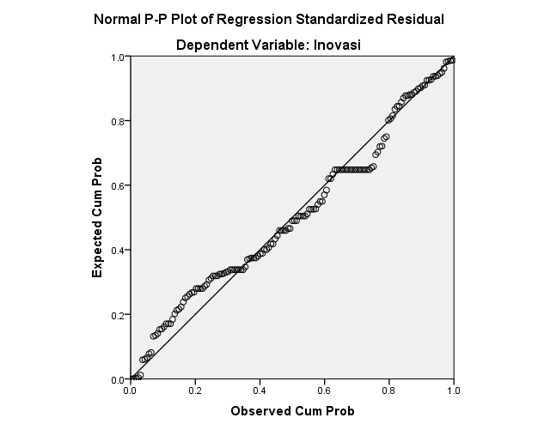

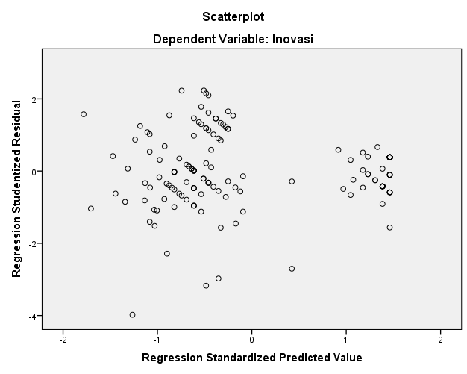

Regression Model 2

Variables Entered/Removedª
Model | Variables Entered | Variables Removed | Method
1 | Inovasi, ManajemenKualitas, TransferPengetahuan^{b} | . | Enter
a. Dependent Variable: KinerjaLingkungan
b. All requested variables entered.

Model Summary^{b}
Model | R | R Square | Adjusted R Square | Std. Error of the Estimate | Durbin-Watson
1 | .901ª | .812 | .808 | .39257 | 1.689
a. Predictors: (Constant), Inovasi, ManajemenKualitas, TransferPengetahuan
b. Dependent Variable: KinerjaLingkungan

ANOVAª
Model |  | Sum of Squares | df | Mean Square | F | Sig.
1 | Regression | 97.629 | 3 | 32.543 | 211.168 | .000^{b}
1 | Residual | 22.654 | 147 | .154
1 | Total | 120.283 | 150
a. Dependent Variable: KinerjaLingkungan
b. Predictors: (Constant), Inovasi, ManajemenKualitas, TransferPengetahuan

Coefficientsª
Model |  | Unstandardized Coefficients |  | Standardized Coefficients | t | Sig. | Collinearity Statistics
 |  | B | Std. Error | Beta | t | Sig. | Tolerance | VIF
1 | (Constant) | .717 | .163 |  | 4.409 | .000
1 | TransferPengetahuan | .315 | .086 | .357 | 3.666 | .000 | .135 | 7.417
1 | ManajemenKualitas | .414 | .084 | .433 | 4.944 | .000 | .167 | 5.994
1 | Inovasi | .129 | .078 | .141 | 2.659 | .039 | .177 | 5.651
a. Dependent Variable: KinerjaLingkungan

