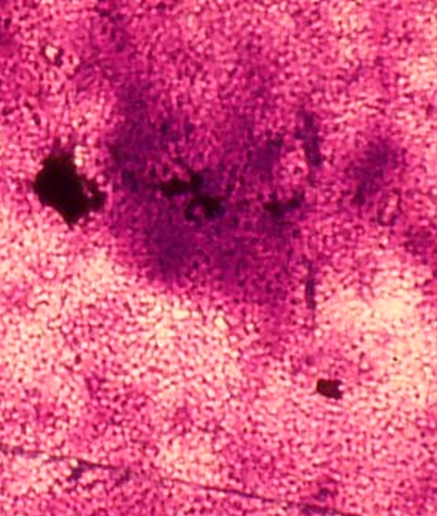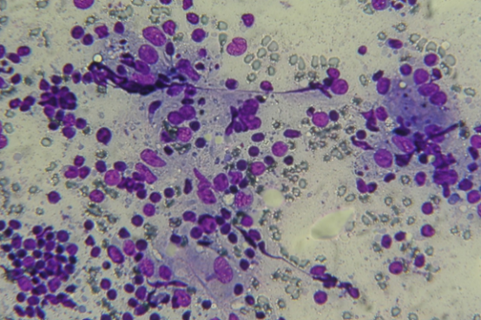
Figure 1. Dark specks Features with Finely Granular Eosinophilic Amorphous Mass in the Background (MGG, 400x) | Figure 2. Dark Oval Bodies Feature with Dark Shrinking Oval Bodies in the Collections of Macrophages (MGG, 400x)

Figure 3. Positive Expression of Rabbit Polyclonal of Mycobacterium tuberculosis Antibody in Dark Specks in the Entire Field of View (ICC, 400x) | Figure 4. Positive Expression of Rabbit Polyclonal of Mycobacterium tuberculosis Antibody in Dark Oval Bodies (ICC, 400x)

