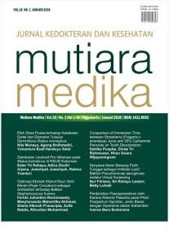
Author Statement Form:
Manuscript Originality and Copyright Transfer Agreement Mutiara Medika: Jurnal Kedokteran dan Kesehatan (MMJKK)
ISSN: 2614-0101 (online) & 1411-8033 (print) https://journal.umy.ac.id/index.php/mm/index

Name of Principal/Corresponding Author*
Indri Lestari
Address of Principal/Corresponding Author*
Jl. Garuda Gg. Mawar Blok RC 25 No. 3 Kel. Pinang Jaya Kec. Kemiling Kota Bandar Lampung Provinsi Lampung
Telephone*
082289270626
E-mail*
indiesta2786@gmail.com
Fax*
-
All author(s) name*
Indri Lestari
Dyah Wulan Sumekar Rengganis W
Jhons Fatriyadi Suwandi
Samsul Bakri
Date of submitted*
……………………………………………………………………………………………………………………………………………………………………………………………………………………….. Manuscript title*
Pengaruh Lingkungan Sosial Teman, keluarga dan Masyarakat Terhadap Kasus HIV AIDS di Kota Bandar Lampung

- Declare that the article above is original. my own thoughts not translated, and has not been published elsewhere or currently not in the process of other journal publications. I am willing to be responsible if there are parties who feel disadvantaged privately and/or based on a lawsuit in the future by the publication of this article.
- I also declare that any and all rights in and to the article including, without limitation, all copyrights are transferred to Mutiara Medika: Jurnal Kedokteran dan Kesehatan (MMJKK). Therefore, the copyright transfer hands it the power and authority to edit, reproduce, distribute copies, and to publish the article partly or fully.

Corresponding Author’s Name & Signature Date
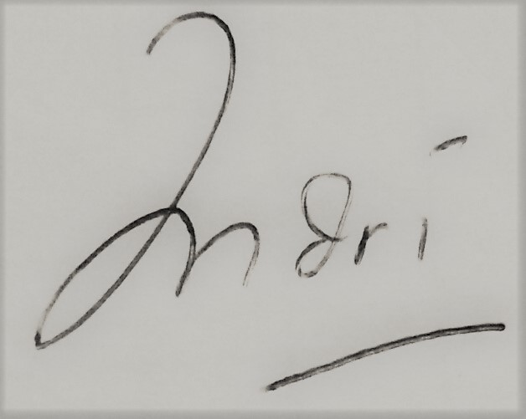

Editorial Office Mutiara Medika: Jurnal Kedokteran dan Kesehatan
Journal Room, G1 (Biomedic) Building, Ground Floor, Faculty of Medicine and Health Science, Universitas Muhammadiyah Yogyakarta, Jalan Lingkar Selatan (Brawijaya), Tamantirto, Kasihan, Bantul, Daerah Istimewa Yogyakarta, Indonesia 55183.
Phone: +62 274 387 656 (ext: 231) Email: mmjkk@umy.university

