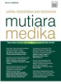Author Statement Form:

Manuscript Originality and Copyright Transfer Agreement Mutiara Medika: Jurnal Kedokteran dan Kesehatan (MMJKK)

ISSN: 2614-0101 (online) & 1411-8033 (print)

https://journal.umy.ac.id/index.php/mm/index

Name of Principal/Corresponding Author\*

Athiyya Salma Hamida/Tri Wahyuliati

Address of Principal/Corresponding Author\*

Universitas Muhammadiyah Yogyakarta/ Universitas Muhammadiyah Yogyakarta

Telephone\*

081318252200/081328672509

E-mail\*

athiyyasalma@gmail.com/tri.wahyuliati@yahoo.com

Fax\*

-

All author(s) name\*

Athiyya Salma Hamida

Tri Wahyuliati

Date of submitted\*

February, 10th 2022

Manuscript title\*

The Comparison of Various Types of Antihypertensive Drugs and the Incidence of Acute Stroke

(1) Declare that the article above is original. my own thoughts not translated, and has not been  published elsewhere or currently not in the process of other journal publications. I am willing to be  responsible if there are parties who feel disadvantaged privately and/or based on a lawsuit in the  future by the publication of this article.

(2) I also declare that the transfer of copyright for the first publication is granted to Mutiara Medika: Jurnal Kedokteran dan Kesehatan (MMJKK).

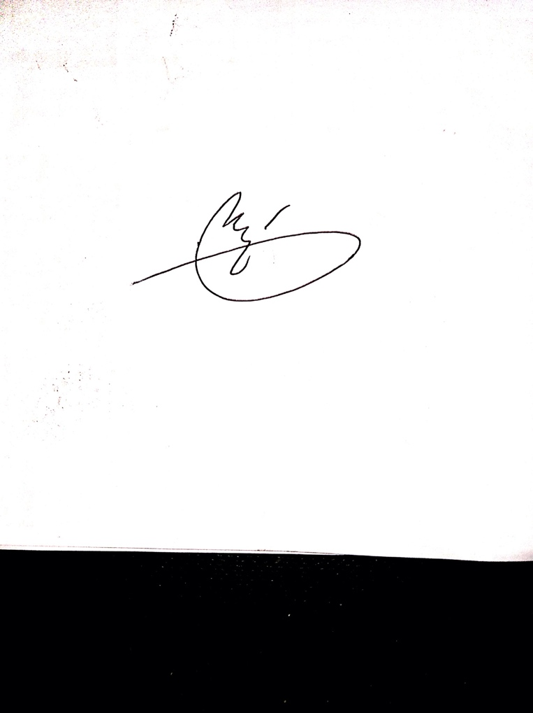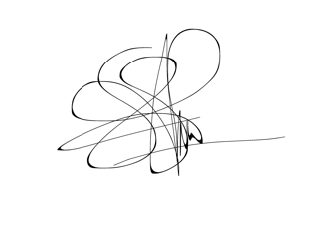

Athiyya Salma Hamida Dr. dr. Tri Wahyuliati, Sp.S., M. Kes

February, 10th 2022

Editorial Office Mutiara Medika: Jurnal Kedokteran dan Kesehatan

Journal Room, G1 (Biomedic) Building, Ground Floor, Faculty of Medicine and Health Science, Universitas Muhammadiyah Yogyakarta, Jalan Lingkar  Selatan (Brawijaya), Tamantirto, Kasihan, Bantul, Daerah Istimewa Yogyakarta, Indonesia 55183.

Phone: +62 274 387 656 (ext: 231) Email: mmjkk@umy.university