LAND MANAGEMENT FOR AGRICULTURE AFTERT THE 2010 MERAPI ERUPTION

Sri Nuryani Hidayah Utami¹), Benito Heru Purwanto¹), Djaka Marwasta²),
Centre Study for Land Reources, Universitas Gadjah Mada, Yogyakarta
1) Faculty of Agriculture, Universitas Gadjah Mada, 2) Faculty of Geograpgy Universitas Gadjah Mada, Yogyakarta, Indonesia, 55281
Cp: nuryani@ugm.ac.id

ABSTRACT

The great eruptions of Mount Merapi in 2010 still have many problems till date. The severe damages caused by the impacts of the volcanic eruptions have drawn a great deal of attention from both national and international media.The month-long eruptions killed more than 200 people, displaced over 100,000 residents, killed over 1,000 livestock and destroyed over 1,000 hectares of productive farming fields.Incidentally, agriculture is one of the livelihood sectors that suffered heavily. Further, it impacted farmers the most as they depend on farming activities as their main source of livelihood. The rehabilitation strategy covers several cross-cutting issues across the region, and presents three main objectives: 1. Rehabilitation and improvement of farm production system, 2. Rehabilitation and development of agri-business and income diversification, 3. Support to the community and government-led institutions and policies to promote recovery, rehabilitation and development.After theeruption, land management became basedonmaterialtypeandcondition ofthe land. Nutrient availability in volcanic ash dissolution process is determined by fragility of an eye / destruction by water, as well as the size of the ashes, the ashes of volcano, and the environment in which the ashes are scattered. Principles of land management involve the provision of appropriate environmental needs of plants, the availability of moisture, nutrients, colloidal holdng nutrients, andaeration. In short, they entail the technical aspects of recovery after the eruption of plants based on the conditions of the land. Also included are crop diversification (intercropping cultivation, crops rotation, mixed farmingetc) and intensification of yard (horticulture crops, hedge rows); as well as reinforcing of core and source of cattle nutrition, for example gliricedea; fast growingand producing crops are needed but those that need highcapital / major costs for planting and care are not required. Furthermore the concept of post-eruption land arrangements need to be formulated based on the configuration of the land which is mainly related to local circumstances such as topography, hydrology, meteorology, and natural drainage systems.
Keywords : land management, agriculture, Merapi eruption

NTRODUCTION

Mount Merapi is a strato type volcano located 30 km North of Yogyakarta, Central Java. Its peak reaches 3,000 m above sea level. Being Indonesia's most active volcano, it erupts every four years on the average. Apart from other damage, volcanic activity can disrupt the surrounding river networks by abrupt deposition and subsequent flow of large amounts of sediments. This can increase the risk of floods, including flash floods; change the planform of the river network; and destroy roads, bridges, buildings and other structures. However, the impacts are manageable to some extent. Appropriate preparedness and determined mitigation efforts can not prevent the damage, but can reduce it significantly (Sumaryono, 2011).
Vulnerability of land is associated with the threat of natural disasters. It needs to be given attention for it to be reduced through technical and non-technical measures. This will be a fundamental strategy in supporting the success of agriculture to be developed. This should be done in additon to land conservation efforts that can improve land productivity and sustainability of the environment.
Preparation of the carrying capacity of land zoning area slopes of Mount Merapi eruption after 2010 is intended to reduce the risk of disasters and to minimize losses. With the zoning it is expected that farmers and ranchers in the area of ​​the slopes of Mount Merapi can live in harmony with nature.These lands are located in the vicinity of Mount Merapi, formed from volcanic ash. Volcanic ash is the material of volcanic eruptions that is released as a results of volcanoes in the form of dust, gravel, and hot stone.
The situation on the upper slopes of MountMerapi is periodically amended following the eruption period. Given these changes, there is some variability of soil characteristics at the various locations in the slopes. Soil conditions on the slopes of Mount Merapi were dominated by young earth. Young soils also vary in the period following the eruption and have both physical and chemical properties that differ. Development of land is also followed by the growth of vegetation on it, because developed land provides nutrients for plants. Land on the upper slopes of MountMerapiconsists of Regosol (Entisolsand Inceptisol). Regosol land is a relatively young soil, so has no development profile. This soilhas gray to black ground color with a relatively coarse texture; it is sandy. The soil structure is also not established; it is granular. In addition to Regosol,Andisol soil is found there as well. This soil type is found in district and subdistrict of CepogoSelo. The soil is characterized by silty loam texture, with crumb or blocky structure; itsbulk density is about 0.9 g.cm⁻³, and has medium permeability to low organic matter, with pH 5.0 to 5.5cation exchange capacity; its base saturation is high (Anonymous, 2008).
The area of MountMerapi, which is generally a plateau region, a catchment area and being infiltrated with rain water, is excellent. Ability to retain water is affected by physical properties such as texture and presence of vegetation in the area. Utilization of the upper slopes of MountMerapi as a conservation area should be developed and preserved. In addition to the storm water, the upper slopes of MountMerapican also be used for forestry, national parks, or even as tourist area.

MATERIAL AND METHODS
1.Desk evaluation: based on existing maps (visual map of the earth, geological maps, soilmaps, zoning maps Merapi threat of National Board For Disaster Management etc.)
2.Field observations and sampling of ash and sand volcan Merapi eruption results from various locations continued analysis in the laboratory
3. The field survey tod etermine the boundary area(zone), with RappidA ssessment methods
4.Analysis of sand and ash volcan for further data analysis: soil pH, EC, total P, N, Si, Al, Mg, Ca, K, Na, Fe, Mn, Cu, Zn (Tan, 1996))
5.Preparation of the maps and recommendations

RESULT AND DISCUSSION
Material during eruption
In general,the distribution of pyroclastic deposits that consist of a mixture of granular material ash, lapilli and blocks of the mountain is strongly influenced by the amount of material, the force of gravity, and topographic areas affected by the initial eruption. More and more pyroclastic material issued by the distribution of the hot cloudis also more extensive. Due to gravity, the pyroclastic deposits are mainly coarse-grained (lapilli-boulders) and are more concentrated in riverv alleys. The deeper and alot of river valleys as a result of intensive vertical erosion of the distribution of pyroclastic deposits will be more limited, as it is pretty deposited in the river valley area. Conversely, if the valley of the river is a bit then the shallow pyroclastic deposits will be widespread (Brontoetal.2003).

Agriculture
Volcanic activity includes the formation of magma and magma discharged fromt he mouth of the crater which can be either in the form of the flow of molten lava or volcanic bursts of various sizes; this shapes the material in the air and falls to the earth's surface following the gravitational force that is also affected by wind direction and speed. The chemical composition and bursts of lava rock are determined by the drafters of magma (aluminum silicate of igneous rock), and material of non-magma (hydrothermal, mineral salts and non-rocks andesitic/basaltic).
The results of the analysis of the mineral contents in the ash and sandv olcanic eruption of Mount Merapi2010, conducted att he Department of Soil Science, Faculty of Agriculture, Gadjah Mada Universityis presented in table1.

Table 1.Analyses of sand and volcanic ashes from Merapi eruption of 2010
Parameters | Sand | Volcanic ashes
pH | 4.89 | 4.86
EC (mS) | 4.4 | 5.87
Total N (%) | 0.003 | 0.01
Available P (µg/g) | 199.18 | 213.18
Soil water P (µg/g) | 156.29 | 191.28
Total S (µg/g) | 4.58 | 4.83
Total Cl (µg/g) | 36.83 | 6.44
SiO₂ (µg/g) |  | 53.92
Al₂O₃ (µg/g) |  | 18.34
Total Mg (µg/g) | 0.07 | 0.06
Total Ca (µg/g) | 0.31 | 0.49
Total Na (µg/g) | 0.07 | 0.14
Total K (µg/g) | 0.15 | 0.51
Total Fe (µg/g) | 0.66 | 0.75
Total Mn (µg/g) | 0.01 | 0.13
Total Cu (µg/g) | 30.98 | 39.49
Total Zn (µg/g) | 26.24 | 35.08

The data in table 1 show that the ash quality is quite good; just needs to be rinsed thoroughly to remove soluble salts in the form of base cations, aluminum, sulfatea nd chloride nions.The results of the analysis show the pH of the Merapi volcanic sh; its sandis acidic, and electrical conductivity is 4-5mS.Though, agricultural crops generally can survive in soil with electricity conductivity of less than 2mS.Agricultural crops such as vegetable sand fruits such as chili, watermelon, salacca, and so many die not only by the weight of the leaves falling from volcanic material, but also because of high electrical conductivity of volcanic material. But the volcanic ash also contains elements that are beneficial to plants, dominated by the nutrient content of 54%silica. Silica is a very useful element for the rice plant. It makes rice to stand upright, and to resistrice pests and diseases (Elawad and Green, 1979; Lee et al, 1985; Osuna-Canizales et al, 1991; Seebold et al, 2000). The ash also has sulfur and chloride, which are also the nutrients that plants need. Looking at the chemical characteristics ofv olcanic material, it can be saidt hat there are no problems for farmers to replanting their farms, in order for the soil to mix with native soil.
Rehabilitation of agricultural land is not just a matter of the chemistry or element contents inside the volcanic material, but also a physical problem. This isb ecause it depends on the thickness of the deposits, the process of precipitation andt he size of the material that is deposited/buried. Center for the Study of Land Resources, Gadjah Mada University divides land types affected by the eruption of Merapi as follows (Utami et al, 2010).
(1)Agricultural land is buried/exposed to the direct influence of the hot cloud, as in the District of Cangkringan;the thickness of the depositsis very great, with coarse material pile ofs and and gravel. The thickness and roughness of a pile of volcanic material shows that the agricultural lands in this area are buried by new material. Investment in this area will have to wait until the soil temperature cools by rain water. As the material is still loose(fragile, yet bound to a solid structure) it will be easily carried by wind or rain. So, one needs to be careful with the possibility of erosion, if the slope of the ground is high; especially for areas that are close to the trim(eg 5 km). It shouldn ot apply to plants that are productive, but forest plants that have strong roots. If the leaves fall easily, weathering happens, unlike pine and acacia in which weathering is difficult.
(2)The land affected by a burst of volcanic material such as a shorsand and even gravel. Agricultural lands affected by ash/sand/gravel are widely distributed,such as Muntilan, Sleman, Klaten even to some distant place like Purworejo to Bandung. If these volcanic materials cover the ground with a thickness of not more than 5cm, for example, in the District of Turi and Tempel, Sleman, and some in Srumbung, Magelang, then the soil can be directly processed as in the past; if the material is a fine dust, it can increase the contentof soil nutrient. But ifthevolcanic materialthicknessis greater than10cm, deep tillage of 20 cm is required. The addition of organic materials is very important in this area, especially if its deposits are coarse materials such as sand and gravel mixture.
(3) Agricultural land covered by the cold lava in the left or right of the river, which empties into the trim such as Boyong, Kuning, Gendol, Krasa, Code, Opak, and Progo. Material cold land could be fine to coarse, depending on the distance to the trim. Cold lava is of course due to water-borne, so that the contents of useful elements for the plant are unwashed. So, it is necessary to understand the typology of the agricultural land, its boundaries and the characteristics of rehabilitaton.
Rehabilitation of agricultural land can be accelerated by adding nutrients that plants need and the provision of manure. A soil is fertile if it contains mineral and organic materials. Mineral ingredients provide elements for plants; the nutrients can be derived from inorganic and organic fertilizers that can be supplied. Then the irrigation water needs to be prepared, so that agricultural land can be restored to normal in a short time.Truly,a very important thing is to recover as soon as the spirit of the farmers wakes up to cultivate the slopes of Merapi. This will further accelerate the recovery of the agricultural sector. In many places with a lot of lands, farmers cultivatet heir landb ack, and all they needed were support from the government, availability of seeds, composting counter machines, and irrigation water. Integration of livestock and agriculture will be of much help, because the cattle will make available sufficient organic fertilizer.
In short, the technical aspect of recovery after eruption is seeking to plant in accordance with the land conditions. This can easily be seen with pre-existing plants. If these plants can grow well and produce, that means they are appropriate / suitable. To be more precise, they should use a Land Suitability Map. This can be done to reduce the risk of crop failure due to eruption of Merapi. One of the conditions is: crop diversification (intercropping cultivation, mixed farming, etc..) In principle, plantsthat are fast-growing, rapidly produce and do not require capital / major costs for planting and care should be selected. High economic value crops such as bark have high risk because generally after four years to produce well, it needs capital. On the slopes of Merapi, a highly vulnerable plant should be avoided unless there is already an existing one.
Plants that require a lot of water (in number) should be avoided because of the eruption and in case of damaged water resources it needs a lot of time and capital for the recovery / rehabilitation. To further make the farmers better prepared for disasters is to get money savings and cattle. Cattle can be a sheep, beef; poultry manure can be utilized as manure. Intensification of the yard should be encouraged. Many kinds of fruit trees and horticultural crops should be planted as well as reinforcing the porch railing and animal food sources such as gliricedea.
On the slopes of Merapi,agricultural application that involves low energy input (low energy input) is more in accordance with the conditions of hazardous eruption of the application of agricultural inputs (high energy input), with high capital. Learning from the experience of green revolution and also of intensive farming in developed countries, sustainable agriculture paradigm still using natural environment is not based anymore on the soil's ability to tolerate high input material, but rather based on elasticity (resilience) of the land to damage, if the land is used for agricultural production (Sanchez, 1994; FAO, 1995).
The government should implement policies and fiscal environment that encourage farmers to utilize germplasm of local resources, develop low-input farming systems (Low External Iinput Sustainable Agriculture), or real farm system according to the state of the environment and distinctive character of small farmers (FAO, 1997). Noteworthy is creating a more productive farming systemintegrated in marginal land, such as crop-livestock systems, crop and agro-forestry-fishery (agroforestry). One of the keys to success in implementing the new strategy is to combine traditional site-specific technology and new technology management of crops and livestock (Sutanto, 2000).

Resilience of agricultural systems
Many farms, particularly those on the southern and western flanks of Merapi, are expected to lose up to 100% of damaged crops during the current rotation. However, because of the warm climate, fertile soils and good access to water (on the lowlands and during the wet season), the farms are anticipated to recover rapidly following cessation of tephra falls, with many farmers predicting 2-3 harvests within the next 12 months. Thus, the year-round growing season contributes substantially to resilience within this agricultural system, particularly for lowland farms. Lowland farmers are therefore able to choose preferred crops, such as rice, that will maximise returns. Upland farms are somewhat more vulnerable during the dry season, but farmers are still able to replant immediately if required (Wilson et al., 2007, Utami et al., 2010). Upland farmers add greater diversity to their selection of cash crops, to build more resilience into their farming systems, due to the unreliable water supply in upland regions. But the increased resilience also helps to reduce the impact of volcanic activity. The attitude that ‘if one crop fails then others will survive’ was frequently encountered by the team, with respect to crop selection practices. Wilson et al., 2007 stated that their observations supported the effectiveness of this approach, with some farms affected by heavy ashfalls showing severe damage to some crops and virtually no damage to others. For instance, chilli pepper plants would be severely affected while other crops plantedbetween them, such as carrots, would be almost unaffected. The naturally-high resilience of agricultural systems in the Merapi area is to some extent offset by the inability of most farmers to absorb financial losses. Farming in the area is onlyslightly above a subsistence level and many farmers spoken to by the team considered themselves unable to absorb the loss of even one crop rotation. This level of hardship was probably a motivating cause of farmers returning to the exclusion zone after being evacuated. Many farmers reported that they had few other options, and felt that they must ‘ride out’ the eruption (particularly those in the upland regions) and wait for the rains to wash crops and help integrate the tephra into the soil (Wilson et al., 2007).

CONCLUSIONS AND RECOMMENDATIONS

Disaster risk reduction activities can be managed properly if the nature and character of the land can be properly assessed. Disaster risk reduction activities are the only one that can be done for minimizing losses due to a natural disaster.Based on field analysis, data analysis of volcanic ash, thematic maps and the results of image analysis, the researches belonging to the Center for Land Resources filed Merapi Slopes Zoning Recommendation concept are based on the carrying capacity of land for agriculture and animal husbandry as a post-eruption could be seen on the Map (Attachment).

ACKNOWLEGMENT
We would like to thank to the Ministry of Reaserch and Higher Education, Indonesia (RistekDikti) for giving the oppurtunity to do this research and provided budget.

REFERENCES

Anonymous, (2008). National Park of MountMerapi. DG PHKA. Jakarta.
Bronto, S., D.S. Sayudi and G. Ho. , (2003). Heat clouds slide variation and danger of MountMerapi. Association of Indonesian geologists.Yogyakarta.

Elawad, S. H., and Green, V. E. (1979). Silicon and the rice plant environment: A review of recent research. Riv. Riso 28:235-253.

FAO (1995) The State of Food and Agriculture; Rome, Italy, 1997.
Sanchez, P.A. 1994. Tropical soil fertility research: towards the secondparadigm. Transactions 15th World Congress of Soil Science,Acapulco, Volume J. 65-88.

Lee, K. S., Ahn, S. B., Rhee, G. S., Yeon, B. Y., and Park, J. K. (1985). Studies of silica application to nursery beds on rice seedling growth. Farm Prod. Utiliz. 27:23-27.

Sartohadi, J. (2010). Land geomorphology and its application to disaster risk reduction. Speech Pengukuhan Position Professor at the School of Geography, University of Gadjah Mada.

Seebold, K. W., Datnoff, L. E., Correa-Victoria, F. J., Kucharek, T. A., and Snyder, G. H. (2000). Effect of silicon rate and host resistance on blast, scald, and yield of upland rice. Plant Dis. 84:871-876.

Sumaryono, A. (2011). Managing the Mount Merapi sediments. Center for River Basin Organizations and Management, Solo, Central Java, Indonesia www.crbom.org, info@crbom.org.

Sutanto, R. (2000). Global challenges toward food security and the role of indigenous knowledge in agriculture development. Paper presented in the Seminar “ The Role of Indigeneous Knowledge for National Food Security”. USD, Yogyakarta.

Tan, K.H. (1996). Soil Sampling, Preparation and Analysis. Marcel Dekker, Inc. New York.

Osuna-Canizales, F. J., De Datta, S. K., and Bonman, J. M. (1991). Nitrogen form and silicon nutrition effects on resistance to blast disease of rice. Plant Soil 135:223-231.

Utami, S.N.H., Darmanto, A.Maas, E. Martono, B.H. Purwanto, G. Murdjito, A. Kusumandari, R. Jayadi, D. Kastono, Jamhari. (2010). .Daya dukung kawasan lereng Merapi untuk Pertanian dan Peternakan. Laporan Penelitian Hibah Merapi. PSSL UGM.

Wilson, T.; Kaye, G., Stewart, C. and Cole, J. (2007) Impacts of the 2006 eruption of Merapi volcano, Indonesia, on agriculture and infrastructure. GNS Science Report 2007/07 69p.

Figure 1. Recent Land Resources Condition Map of The 2nd and 3rd Danger Zone Merapi Volcano

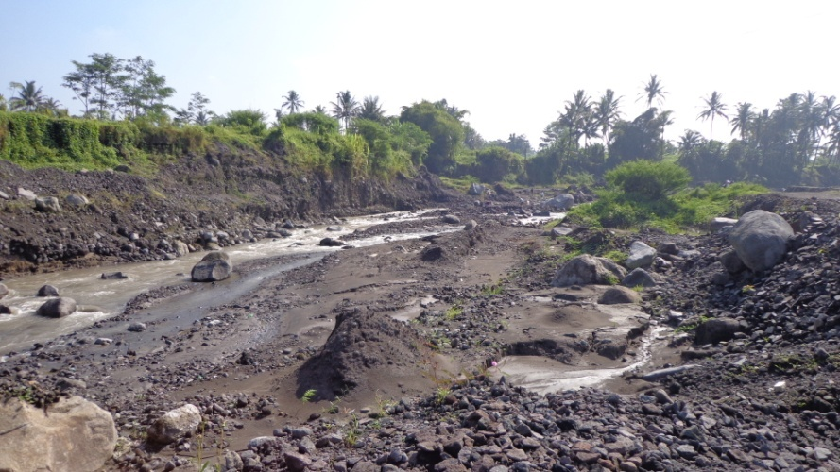

Figure 2. Agricultural land damaged by the brunt of lava and participate eroded by lava flows after the 2010 Merapi eruption. The agricultural land can not be planted again because now become part of the river

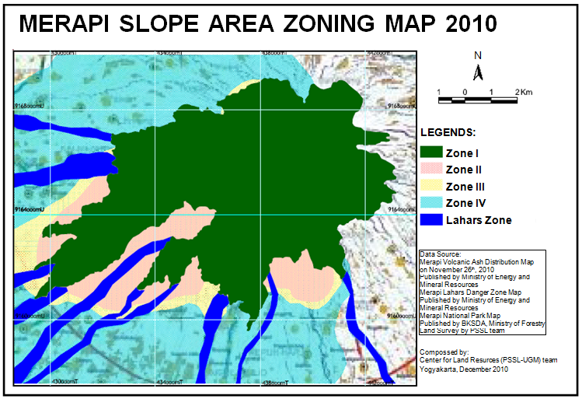

Figure 3. Merapi slope area zoning concept based on the agricultural land resources support and livestock.

ZONE I : National park. The forbidden zone for occupancy
ZONE II . This is hazard zone. There shoud not public service here
ZONE III : Residential and agricultural area
ZONE IV : Residential and agricultural area

