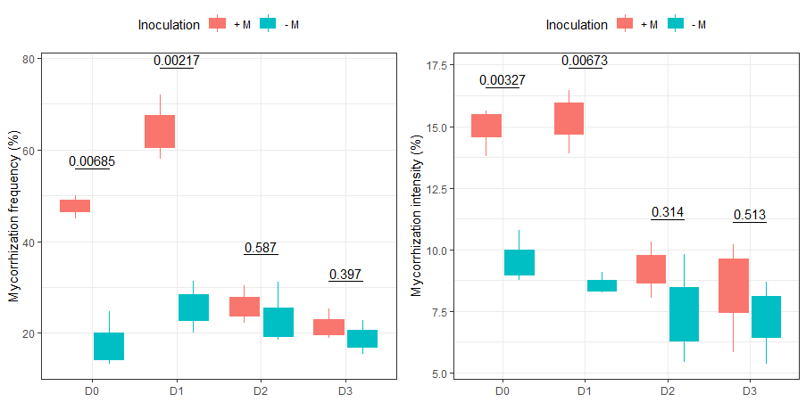

Fig 1. Arbuscular mycorrhizal fungal colonized root length in percent of the total root length (mycorrhizal frequency and mycorrhizal intensity). The plants were supplied with triple superphosphate at three fertilization levels: 0, 30, 60 and 120 kg P ha-1

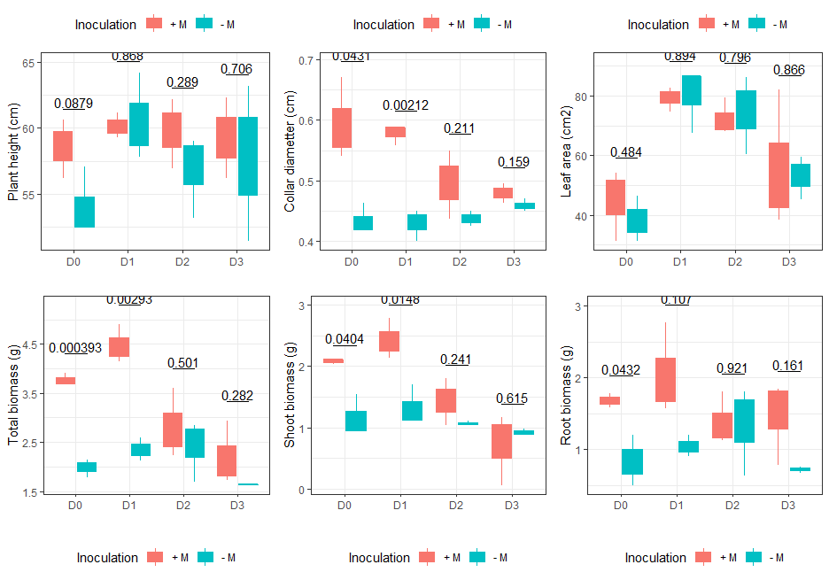

Figure 2. Plant height, Collar diameter, leaf area, total biomass, Shoot biomass and root biomass of common bean under mycorrhizal inoculation (+M and –M) and phosphorus doses application (D0=0, D1=30, D2=60 and D3=120 kg P ha-1)

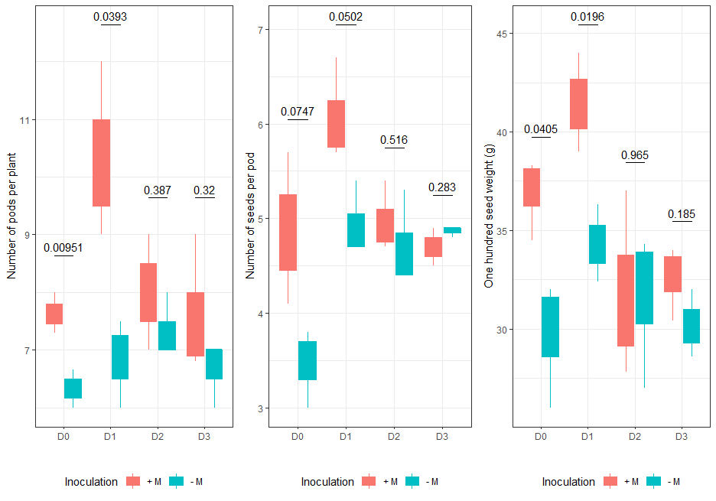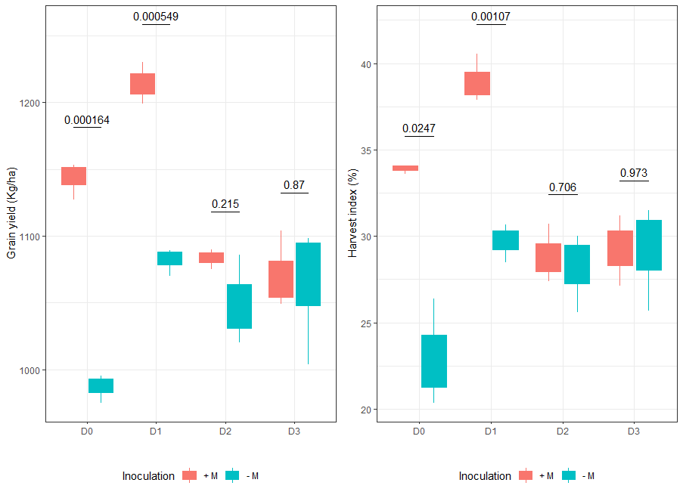

Figure 3. Bean yield-related parameters (Number of pods per plant, Number of seeds per pod, one hundred weight, average grain yield and harvest index) as affected by *R irregularis* mycorrhizal inoculation and phosphorus levels application.

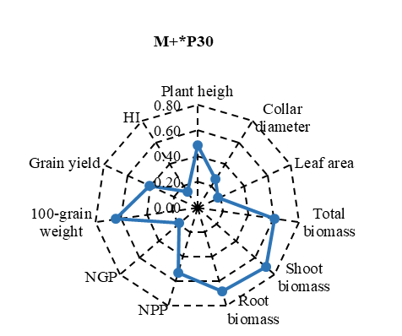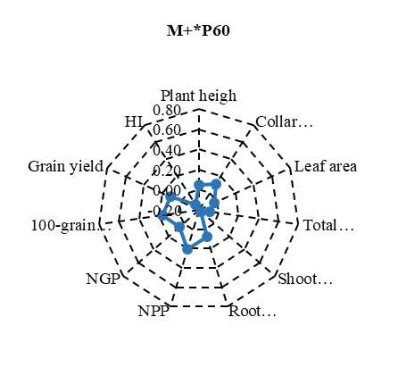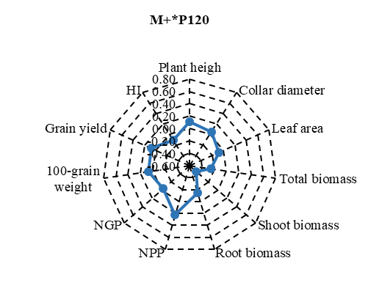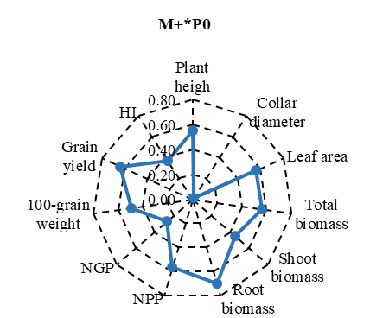

Figure 4: Mycorrhizal Inoculation Effect (MIE) for the growth and yield-related parameters of bean according to the mycorrhizal treatments M+*P0, M+*P30, M+*P60, M+*P120



Figure 5: Pearson’s correlation matrix and regression analysis among growth, and yield-related parameters, considering AM inoculation and non-inoculated treatments.



**A**

**B**

Figure 6: Principal component analysis (PCA) with the 11 growth and yield-related parameters of bean plants according in blue arrows the different treatments (A) and the phosphorus levels application (B) at and the two AMF parameters, MF (% of AM frequency of the root system), MI (% of AM intensity of the root system). The 16 different colored individuals at the 95% level represent all P treatments (M+*P0, M+*P30, M+*P60 and M+*P120) in A and P levels P0 (no phosphorus applied), P30 (application of 30 kg P ha-1), P60 (application of 60 kg P ha-1) and P120 (application of 120 kg P ha-1 ).